## National StatisticsStatistical Note: Ambulance Quality Indicators (AQI)

* The latest Systems Indicators for Ambulance Services in England showed that in April 2015, two of the standards in the Handbook[1] to the NHS constitution were met for the first time in 2015.
* The latest Clinical Outcomes data for patients transported by Ambulance Services in January 2015 show increasing proportions of stroke patients receiving the appropriate care bundle, but lower survival from cardiac arrest.

## A. Systems Indicators

### A1 Emergency response in 8 minutes (Figure 1)

In April 2015, of Category[2] A Red 1 calls in England resulting in an emergency response, the proportion arriving within 8 minutes was 75.6%.

In April 2015, of Category A Red 2 calls in England resulting in an emergency response, the proportion arriving within 8 minutes was 72.4%.

Red 2 data from February to April 2015 are not completely comparable across England; see section A2 on the Dispatch on Disposition pilot.

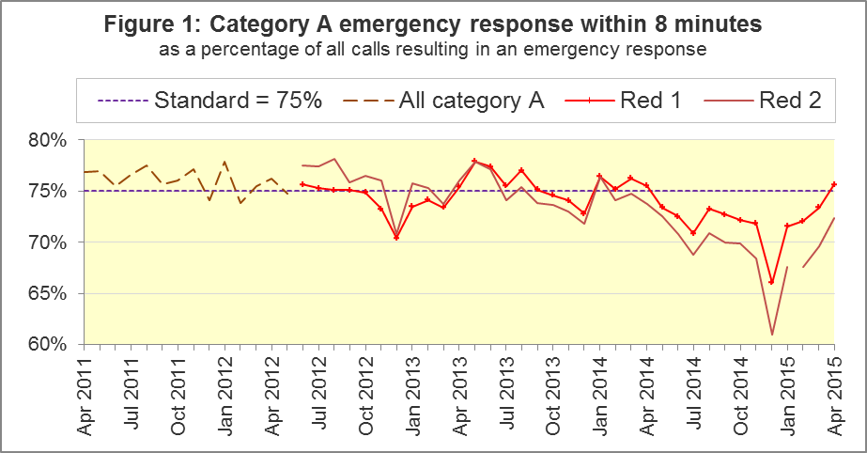

The standard for Ambulance Services is to send an emergency response, with a defibrillator, within 8 minutes to 75% of Category A calls. Figure 1 shows that for England, the Red 1 standard was met in April 2015 for the first time since April 2014.

The April 2015 Red 1 proportion was above the standard for seven of the eleven Ambulance Services in England: East Midlands, West Midlands (largest with 81.2%), East of England, South Central, South East Coast, South Western and Isle of Wight.

Four trusts were below the 75% standard: North East, North West, Yorkshire and London (smallest with 69.5%).

### A2 Dispatch on Disposition (DoD) pilot

The Dispatch on Disposition (DoD) pilot[3] allows more time for triage (to identify the clinical situation and take appropriate action), based upon clinical advice that this would be likely to improve the overall outcomes for ambulance patients.

The pilot covers all calls received by London Ambulance Service (LAS) and South Western Ambulance Service (SWAS) from 10 February 2015. Therefore, after that date, for those services, data for the 8 minute Red 2 or 19 minute Category A measures are not comparable with other services or earlier dates.

The Systems Indicators Time Series spreadsheet on the AQI landing page <http://bit.ly/NHSAQI> has an extra tab of numerators, denominators, and percentages, for those two measures, for all England, and for England excluding LAS and SWAS.

That tab, and Figure 2, shows that for all England, the Red 2 measure increased from 69.6% in March 2015 to 72.4% in April 2015. With LAS and SWAS excluded, the measure had a similar increase, from 71.6% to 74.5%.

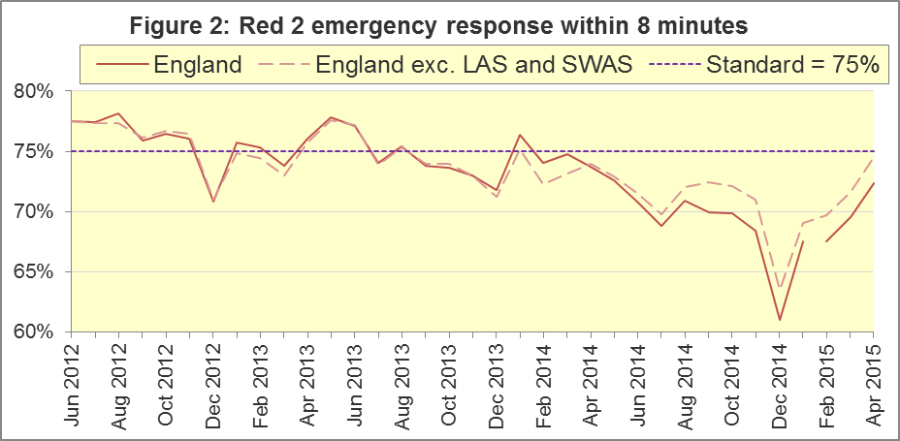

In April 2015, North East, West Midlands, South East Coast and South Central had more than 75% of Red 2 responses within 8 minutes. London and South Western had fewer than 70%.

The vast majority of Category A calls are Red 2 calls, so the pilot affects not only the 8 minute Red 2 measure, but also the 19 minute Category A measure.

### A3 Category A Ambulance response in 19 minutes

The other standard for Ambulance Services in the Handbook to the NHS Constitution is for trusts to send, within 19 minutes, a fully-equipped ambulance vehicle, able to transport the patient in a clinically safe manner, to 95% of Category A calls. Figure 3 shows that for England as a whole, this standard was just met in April 2015, after increasing from 94.1% to 95.03%. Excluding LAS and SWAS, the increase was similar, from 94.6% to 95.5%.

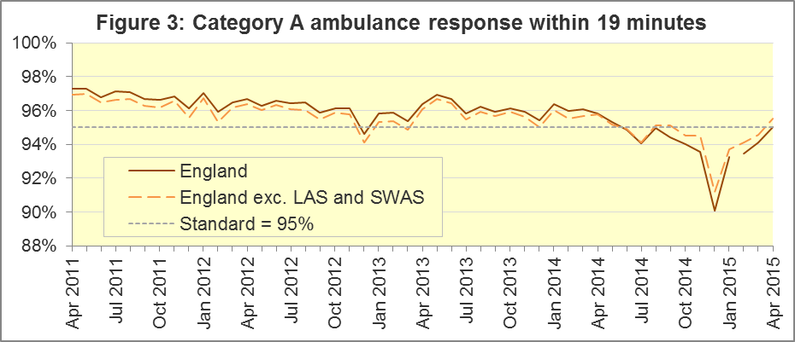

North West (93.3%), East Midlands (94.0%), London (94.2%) and South Western (92.7%) did not achieve this standard in April 2015. The largest proportion was 97.6% in West Midlands.

There will always be uncertainty over what the Red 2 measure for all England would have been without the DoD pilot. However, Figures 2 and 3 suggest that the difference between LAS & SWAS, and the rest of England, is similar in the few months before and after the start of the pilot.

Other Systems Indicators are still measured consistently. The extra triage time in the pilot may have increased the proportion of calls closed with telephone advice. In February, March and April 2015, SWAS exceeded 11% for this, having never previously reached 11%; and London had larger proportions of calls closed with telephone advice than all other trusts. However, London also had the largest proportions in all months from June 2014, well before the pilot started.

### A4 Revisions

This month includes exceptional revisions for South Central Ambulance Service, received since the previous publication on 30 April 2015. Red 1, Red 2 and Category A emergency responses are affected, for all months of 2014-15 except March. For SCAS, the changes are all less than one percentage point, and only Red 1 in November and January changed by more than 0.5 percentage points, see Figure 4. For England as a whole, all changes were less than 0.05 percentage points.

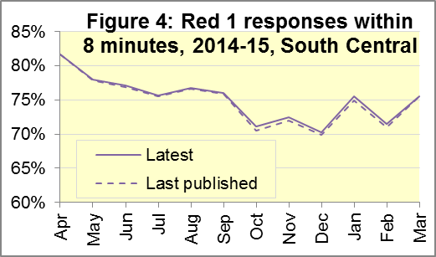The revisions mean that for South Central, for all 2014-15:

The Red 1 measure was revised from 74.8% to 75.03%, so this standard was met;

The Red 2 measure was unchanged at 74.5%, not met;

The 19 minute measure was unchanged at 95.5%, met.

The only other revision this month was for calls presented to the switchboard in East Midlands in April 2014, from 61,963 to 64,706. The proportion of calls abandoned for East Midlands and all England were unaffected at 0.3% and 0.9% respectively.

### A5 Systems Indicators: Ambulance volumes (Figure 5)

The number[4] of emergency telephone calls presented to switchboard in April 2015 was 653,006, an average of 22 thousand per day. However, that excludes East of England (normally about 10% of calls in England) which did not provide data, so the average would probably have been close to the 2014 average of 25 thousand per day.

There were 517,964 emergency calls that received a face-to-face response from the ambulance service in April 2015. The average of 17 thousand per day was the same as in all previous months in 2015.

There were 377,812 incidents requiring emergency patient journeys to Type 1 or Type 2 A&E[5] in April 2015. The average of 13 thousand per day was also the same as in all previous months in 2015.

There were 250,917 Category A calls that resulted in a fully-equipped ambulance vehicle arriving at the scene of the incident in April 2015, or 8,364 per day, which was fewer than in each of the previous six months, but more than in each of the 32 months before December 2013.

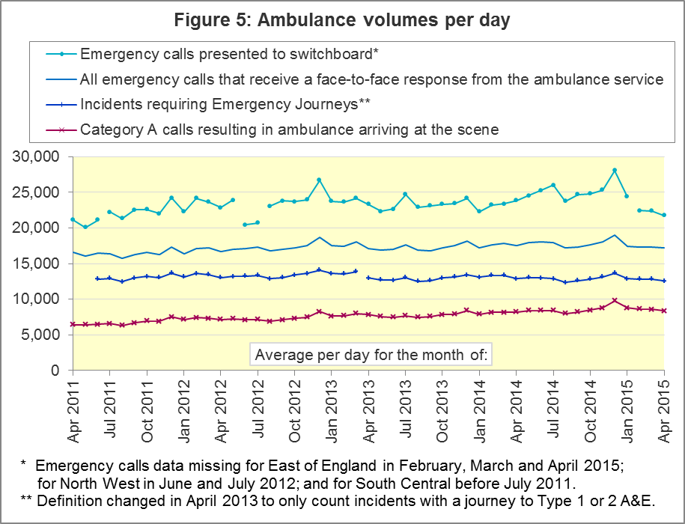

### A6 Latest monthly data for other Systems Indicators, April 2015

|  |  |  |  |  |  |
| --- | --- | --- | --- | --- | --- |
| Indicator | England | Lowest Trust | | Highest Trust | |
| Calls abandoned before being answered | 0.5% [6] | London | 0.1% | Yorkshire [7] | 0.9% |
| Calls resolved through telephone assessment | 9.4% | West Midlands | 5.0% | London | 13.9% |
| Calls resolved without transport to Type 1 or Type 2 A&E | 36.6% | North West | 28.2% | South Western | 52.1% |
| Recontact rate following discharge by telephone advice | 6.9% | Yorkshire | 1.7% | South Western | 14.0% |
| Recontact rate following face-to-face treatment at scene | 5.3% | North West | 3.2% | London | 8.4% |
| Number of emergency journeys | 377,812 | North  East 7 | 20,633 | London | 61,535 |

## B. Clinical Outcomes

No thresholds to denote “poor” care are set for Clinical Outcomes. Commissioners are expected to examine trends in these data, and work in collaboration with ambulance trusts to achieve sustained improvements over time improvement in patient outcomes over time; but commissioners are not expected to use Clinical Outcomes to performance manage trusts, because there will be significant variations in the populations served.

The DoD pilot described in section A2 will not affect these measures.

### B1 Cardiac arrest: return of spontaneous circulation (ROSC) (Figure 6)

Patients in cardiac arrest will typically have no pulse and will not be breathing. In January 2015 in England, resuscitation was commenced or continued by ambulance staff out-of-hospital for 3,293 such patients. Of these, 869 (26%) had ROSC, with a pulse, on arrival at hospital.

This proportion was similar to the average for the year ending September 2014 of 27%. The largest[8] proportion in January 2015 was 43% for South Central, and the smallest was 17% for East Midlands.

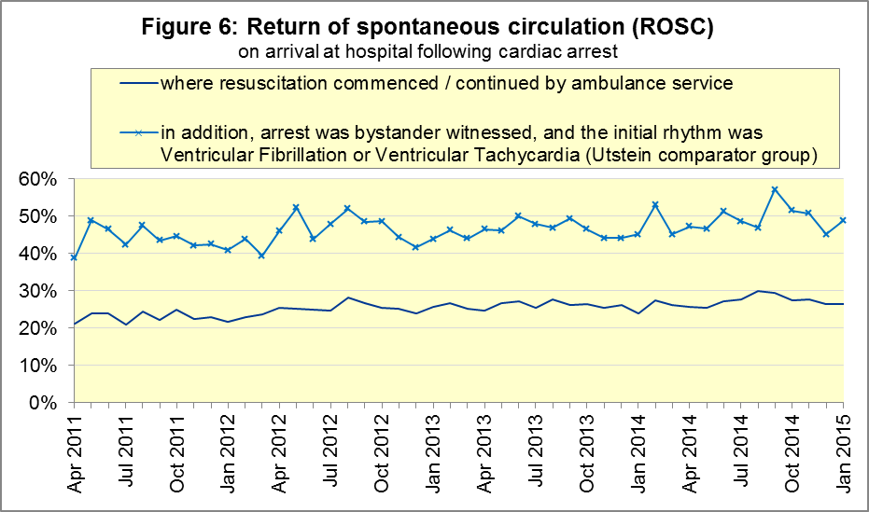

The Utstein group comprises patients who had resuscitation commenced or continued by the Ambulance Services, following an out-of-hospital cardiac arrest of presumed cardiac origin, where the arrest was bystander witnessed, and the initial rhythm was Ventricular Fibrillation or Ventricular Tachycardia.[9] The Utstein group therefore have a better chance of survival.

There are usually fewer than 50 patients in the Utstein group in most trusts each month, so percentages calculated for them can vary considerably, and changes are often not statistically significant.

There were 401 such patients in England in January 2015, of which 196 (49%) had ROSC on arrival at hospital, similar to the average for the year ending September 2014 of 48%. The largestproportion in the month of January 2015 was 57% for East of England and South East Coast, and the smallest[10] was 29% for East Midlands.

### B2 Cardiac arrest: survival to discharge (Figure 6)

The proportion of cardiac arrest patients in England discharged from hospital alive was 7% in January 2015, lower than in all months in 2013 and 2014, and significantly less than the average of 9% for the year ending September 2014.

The largestproportion for survival to discharge in the month of January 2015 was 16% for South Central, and the smallest10 was 2% for East Midlands.

For the Utstein group in January 2015, survival to discharge was 25% in England, similar to the average of 26% for the year ending September 2014, so the low proportion for all cardiac patients was not apparent in the Utstein subgroup.

The largest proportion in the month of January 2015 for the Utstein subgroup was 40% for Yorkshire, and the smallest10 was 9% for East Midlands.

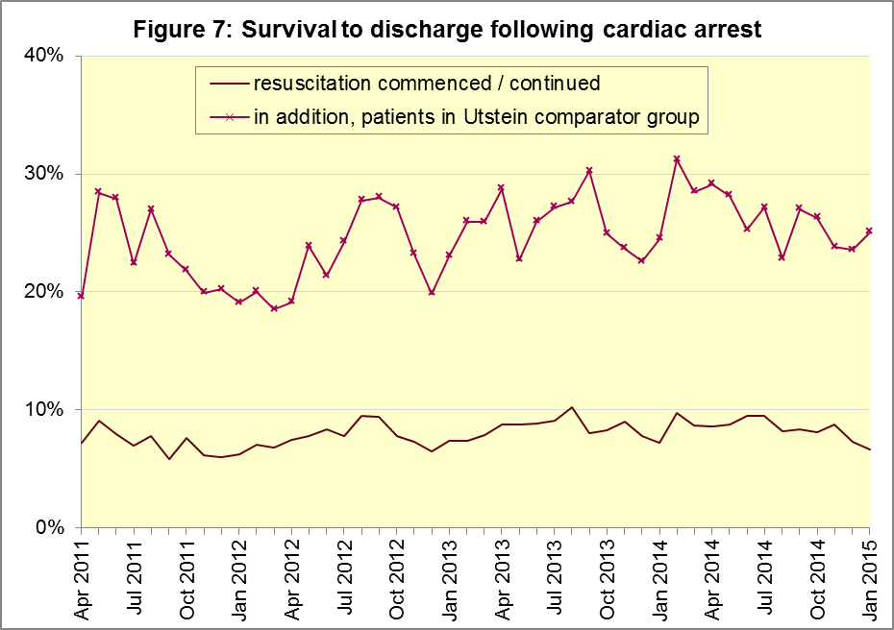

### B3 ST-Elevation myocardial infarction (Figure 7)

ST-segment elevation myocardial infarction (STEMI) is a type of heart attack, determined by an electrocardiogram (ECG) test. Early access to reperfusion, where blocked arteries are opened to re-establish blood flow, and other assessment and care interventions, are associated with reductions in STEMI mortality and morbidity.

In January 2015, of 1,513 patients with an acute STEMI in England, 1,212 (80%) received the appropriate care bundle[11], the same proportion as for the year ending September 2014. The largest proportion for the month of January 2015 was 93% for North East, and the smallestwas 59% for South Central.

Of 942 STEMI patients receiving primary angioplasty in January 2015 in England, 823 (87%) of them received it within 150 minutes of the call being connected to the ambulance service, also the same proportion as for the year ending September 2014. South Central had the largestproportion for the month of January 2015, with 97%, and the smallest[12] was 72% for South Western.

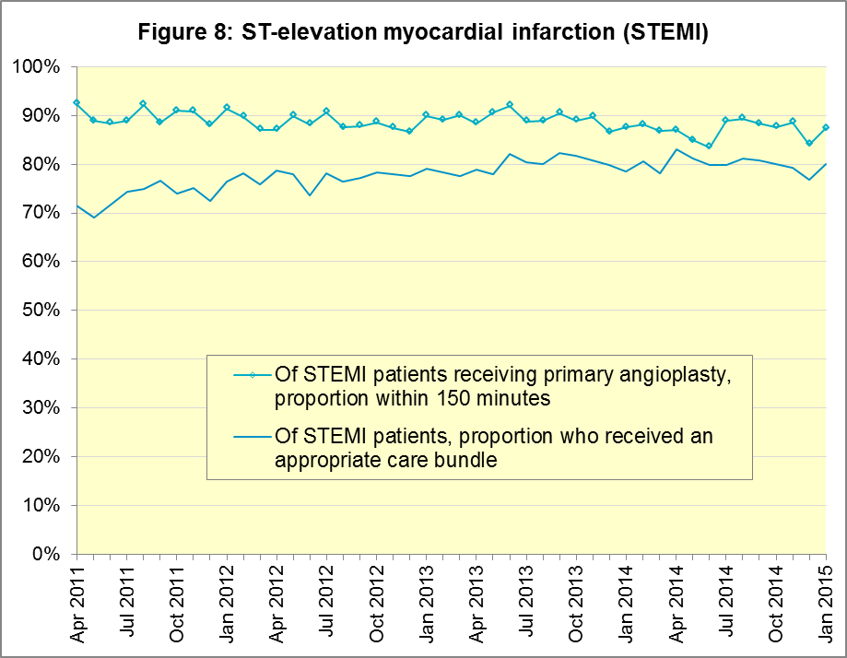

### B4 Stroke (Figure 8)

The FAST procedure helps assess whether someone has suffered a stroke:

* **F**acial weakness: can the person smile? Has their mouth or eye drooped?
* **A**rm weakness: can the person raise both arms?
* **S**peech problems: can the person speak clearly and understand what you say?
* **T**ime to call 999 for an ambulance if you spot any one of these signs.

In January 2015, of 3,113 FAST positive patients in England, assessed face to face, and potentially eligible for stroke thrombolysis within agreed local guidelines, 1,741 (56%) arrived at hospitals with a hyperacute stroke unit within 60 minutes of an emergency call connecting to the ambulance service.

This was significantly less than the average for the year ending September 2014 of 62%. However, like January 2013 and January 2014, the January 2015 proportion was an increase upon the previous month.

The largest[13] proportion in the month of January 2015 was 63% for South East Coast, and the smallest was 42% for West Midlands.

There were 7,472 stroke patients assessed face to face in January 2015 in England, and 7,269 (97.3%) received the appropriate care bundle. All trusts had a proportion of at least 95%.

The January proportion of 97.3% for England was the highest since monthly data collection began in April 2011. It was a statistically significant increase upon the proportion for the year ending September 2014 (96.8%), even though the increase was small.

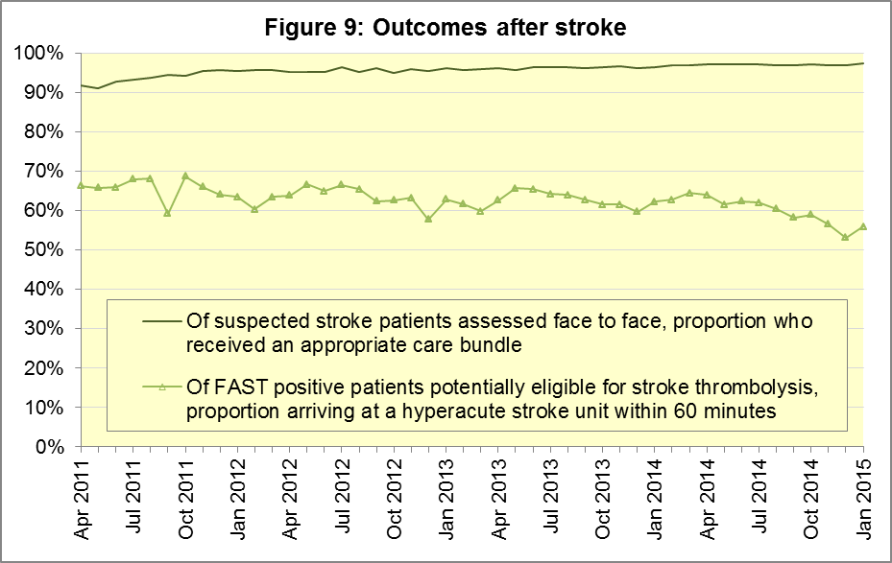

## C. Further information on AQI

### C1 The AQI landing page and Quality Statement

[www.england.nhs.uk/statistics/statistical-work-areas/ambulance-quality-indicators](http://www.england.nhs.uk/statistics/statistical-work-areas/ambulance-quality-indicators), or <http://bit.ly/NHSAQI>, is the AQI landing page, and it holds:

* a Quality Statement for these statistics, which includes information on relevance, accuracy, timeliness, coherence, and user engagement;
* the specification guidance for those who supply the data;
* timetables for data collection and publication;
* text files and time series spreadsheets containing all data from April 2011 up to the latest month;
* links to individual web pages for each financial year.

The web pages for each financial year hold:

* separate spreadsheets of each month’s data;
* this Statistical Note, and equivalent versions from previous months;
* the list of people with pre-release access to the data.

### C2 Revisions

Revisions usually follow a six-monthly cycle. The dates for past and future AQI scheduled revisions are below. The AQI Quality Statement above contains a more detailed revisions policy.

| Publication date |  | Series revised |  | Months affected |
| --- | --- | --- | --- | --- |
| 5 November 2015 |  | Systems Indicators |  | April 2015 to August 2015 |
| 3 September 2015 |  | Clinical Outcomes |  | April 2014 to March 2015 |
| 4 June 2015 |  | Systems Indicators |  | April 2014 to February 2015 |
| 30 April 2015 |  | Systems Indicators |  | April 2014 to February 2015 |
| 5 March 2015 |  | Clinical Outcomes |  | April 2014 to September 2014 |
| 6 November 2014 |  | Systems Indicators |  | April 2013 to August 2014 |
| 5 September 2014 |  | Clinical Outcomes |  | April 2013 to March 2014 |
| 2 May 2014 |  | Systems Indicators |  | April 2013 to February 2014 |
| 7 March 2014 |  | Clinical Outcomes |  | April 2013 to September 2013 |
| 1 November 2013 |  | Systems Indicators |  | April 2013 to August 2013 |
| 2 August 2013 |  | Clinical Outcomes |  | April 2012 to March 2013 |
| 3 May 2013 |  | Systems Indicators |  | April 2012 to March 2013 |
| 1 February 2013 |  | Clinical Outcomes |  | April 2012 to August 2012 |
| 11 January 2013 |  | Systems Indicators |  | April 2011 to October 2012 |
| 31 August 2012 |  | Clinical Outcomes |  | April 2011 to March 2012 |

### C3 AQI Scope

The Ambulance Quality Indicators (AQI) include calls made by dialling either the usual UK-wide number 999 or its EU equivalent 112.

As described in the specification guidance document mentioned above, calls made to NHS 111 are not included in the AQI measures for calls abandoned (SQU03_1_1), re-contacts (SQU03_2_1 and SQU03_2_2), frequent callers (SQU03_2_3), time to answer calls (SQU03_8_1_1) and calls resolved by telephone advice (SQU03_10_1).

All other Systems Indicators involve the dispatch of an ambulance, and include ambulances dispatched as a result of a call to NHS 111, as well as 999 or 112.

### C4 Related statistics in England

The AQI appear in a Clinical Dashboard, available from the AQI landing page, the websites of the Ambulance Trusts (listed in the AQI Quality Statement), and <http://aace.org.uk/national-performance/national-clinical-dashboards>. One of the aims of these Dashboards is to use statistical process control, to indicate whether variation in proportions reflects underlying change, or merely natural variance, unavoidable even when a health system is performing well.

The AQI are also used in the latest annual Ambulance Services publication [www.hscic.gov.uk/article/2021/Website-Search?productid=15165](http://www.hscic.gov.uk/article/2021/Website-Search?productid=15165) by the Health and Social Care Information Centre (HSCIC), which includes additional annual analysis and commentary. Originally, this publication used the KA34 data collection, which was similar to the AQI Systems Indicators, but annual, and ceased collection in March 2013. The HSCIC publication therefore uses AQI data thereafter.

The AQI Quality Statement described in section C1 contains more information on the HSCIC publication. It also contains details of weekly ambulance situation reports that NHS England collected for six months from November 2010.

### C5 Rest of United Kingdom

Ambulance statistics for other countries of the UK can be found at the following websites. The AQI Quality Statement described in section C1 contains more information about the comparability of these statistics.

|  |  |
| --- | --- |
| Wales: | <http://wales.gov.uk/statistics-and-research/ambulance-services/?lang=en> |
| Scotland: | See Quality Improvement Indicators (QII) documents at [www.scottishambulance.com/TheService/BoardPapers.aspx](http://www.scottishambulance.com/TheService/BoardPapers.aspx) |
| Northern Ireland: | [www.dhsspsni.gov.uk/index/statistics/hospital/emergency-care/ambulance-statistics.htm](http://www.dhsspsni.gov.uk/index/statistics/hospital/emergency-care/ambulance-statistics.htm) |

### C6 Contact information

For press enquiries, please contact the NHS England press office on 0113 825 0958 or [nhsengland.media@nhs.net](mailto:nhsengland.media@nhs.net).

The Government Statistical Service (GSS) statistician responsible for producing these data is:

Ian Kay, Analytical Services (National), Finance Directorate, NHS England

Room 5E24, Quarry House, Leeds, LS2 7UE; 0113 825 4606; [i.kay@nhs.net](mailto:i.kay@nhs.net)

### C7 National Statistics

In May 2015, the UK Statistics Authority designated these statistics as National Statistics, in accordance with the Statistics and Registration Service Act 2007 and signifying compliance with the Code of Practice for Official Statistics.

Designation can be broadly interpreted to mean that the statistics:

* meet identified user needs;
* are well explained and readily accessible;
* are produced according to sound methods; and
* are managed impartially and objectively in the public interest.

Once statistics have been designated as National Statistics it is a statutory requirement that the Code of Practice shall continue to be observed.

1. Page 30 of the Handbook to the NHS Constitution has Ambulance response time standards, [www.nhs.uk/choiceintheNHS/Rightsandpledges/NHSConstitution/Pages/Overview.aspx](http://www.nhs.uk/choiceintheNHS/Rightsandpledges/NHSConstitution/Pages/Overview.aspx).
2. On 1 June 2012, Category A (immediately life-threatening) calls were split into Red 1 and Red 2. Red 1 calls are the most time critical, and cover cardiac arrest patients who are not breathing and do not have a pulse, and other severe conditions such as airway obstruction. Red 2 calls are serious, but less immediately time critical, and cover conditions such as stroke and fits. [www.gov.uk/government/news/changes-to-ambulance-response-time-categories](http://www.gov.uk/government/news/changes-to-ambulance-response-time-categories)

   Due to the differences in clock start definitions for Red 1 and Red 2 it is not possible to aggregate them into a single proportion for Category A against the 8 minute standard.
3. DoD pilot announcement in January 2015: [www.parliament.uk/business/publications/written-questions-answers-statements/written-statement/Commons/2015-01-16/HCWS201](http://www.parliament.uk/business/publications/written-questions-answers-statements/written-statement/Commons/2015-01-16/HCWS201)
4. The number of emergency calls presented to switchboard does not usually include calls made to NHS 111 requiring an ambulance. 111 calls requiring an ambulance are usually transferred electronically direct to ambulance dispatch, and not routed via 999 call handlers. Occasionally, manual requests for ambulance are made between 111 and 999 call handlers, and such calls are included in the number of emergency calls presented to switchboard.
5. Type 1 are consultant-led 24 hour emergency departments with full resuscitation facilities.

   Type 2 offer a consultant-led speciality A&E service such as ophthalmology or dental.

   Type 3 is A&E / minor injury activity that may be doctor-led or nurse-led.

   Type 4 are NHS walk-in centres. ([www.datadictionary.nhs.uk/data_dictionary/attributes/a/acc/](http://www.datadictionary.nhs.uk/data_dictionary/attributes/a/acc/accident_and_emergency_department_type_de.asp)  
   [accident_and_emergency_department_type_de.asp](http://www.datadictionary.nhs.uk/data_dictionary/attributes/a/acc/accident_and_emergency_department_type_de.asp))
6. No data for calls abandoned supplied by East of England since January 2015.
7. Due to its small size, performance on Isle of Wight tends to vary more than other trusts. If it has the largest or smallest value, the Table in A6 has a footnote marker to show that it is the extreme, and shows the second largest or smallest value. The Clinical Outcomes in section B also use this system.
8. Excluding Isle of Wight. See footnote 7 on page 5.
9. This definition was proposed at Utstein Abbey in Norway by an international group of cardiologists and other health professionals in 1990. <http://circ.ahajournals.org/content/84/2/960.citation>
10. Excluding Isle of Wight. See footnote 7 on page 5.
11. Pages 27 to 30 of the specification guidance for data suppliers on the AQI landing page at [www.england.nhs.uk/statistics/statistical-work-areas/ambulance-quality-indicators](http://www.england.nhs.uk/statistics/statistical-work-areas/ambulance-quality-indicators) describe the care bundles, and certain exclusions, for the STEMI and stroke indicators.
12. Excluding Isle of Wight. See footnote 7 on page 5.
13. Excluding Isle of Wight. See footnote 7 on page 5.