Statistical Note: Ambulance Quality Indicators (AQI)
- The latest Systems Indicators for Ambulance Services in England showed that in May 2015, as in April 2015, two of the standards in the Handbook to the NHS constitution were met.
- The latest Clinical Outcomes data for patients transported by Ambulance Services in February 2015 show that the proportions of stroke patients receiving the appropriate care bundle continue to increase.

A. Systems Indicators

A1 Emergency response in 8 minutes (Figure 1)
In May 2015, of Category A Red 1 calls in England resulting in an emergency response, the proportion arriving within 8 minutes was 76.7%.
In May 2015, of Category A Red 2 calls in England resulting in an emergency response, the proportion arriving within 8 minutes was 73.2%.
Red 2 data from February 2015 onwards are not completely comparable across England; see section A2 on the Dispatch on Disposition pilot.
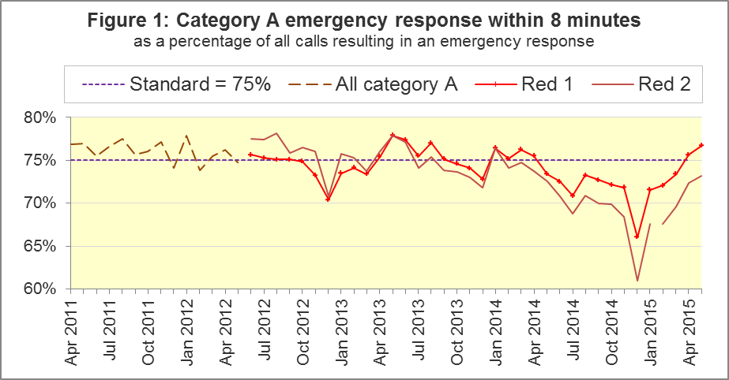
The standard for Ambulance Services is to send an emergency response, with a defibrillator, within 8 minutes to 75% of Category A calls. Figure 1 shows that for England, the Red 1 standard was met in April and May 2015, after not being met for most of 2014-15.
The North West had the highest proportion of any trust in May 2015, after an increase of ten percentage points to 81.5%, its largest proportion since Red 1 started in June 2012. It was one of eight Ambulance Services to meet the standard in May, alongside North East, East Midlands, West Midlands, East of England, South Central, South Western and Isle of Wight.
The other three trusts were below the 75% standard: Yorkshire, London (lowest proportion, 67.1%) and South East Coast.

A2 Dispatch on Disposition (DoD) pilot
Because of the Dispatch on Disposition (DoD) pilot, London Ambulance Service (LAS) and South Western Ambulance Service (SWAS) data, for the 8 minute Red 2 measure, and the 19 minute Category A measure, are not comparable with other services from 10 February 2015 onwards.
Figure 2 shows the Red 2 measure excluding the affected trusts. For all England, it increased from 72.4% in April 2015 to 73.2% in May 2015. With LAS and SWAS excluded, the measure had a similar increase, from 74.5 to 75.6%.
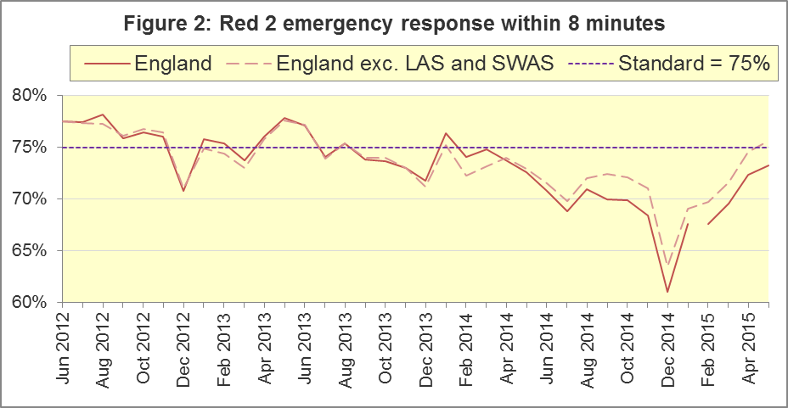
In May 2015, six trusts had more than 75% of Red 2 responses within 8 minutes: North East, North West (largest with 79.4%), West Midlands, South East Coast, South Central, and Isle of Wight. In contrast, East of England, London, and South Western had fewer than 70%.
The vast majority of Category A calls are Red 2 calls, so the DoD pilot affects not only the 8 minute Red 2 measure, but also the 19 minute Category A measure.

A3 Category A Ambulance response in 19 minutes
The other standard for Ambulance Services in the Handbook to the NHS Constitution is for trusts to send, within 19 minutes, a fully-equipped ambulance vehicle, able to transport the patient in a clinically safe manner, to 95% of Category A calls. Figure 3 shows that for England as a whole, this measure increased from 95.0% in April 2015 to 95.3% in May 2015, the largest proportion for a year. Excluding LAS and SWAS, the increase was similar, from 95.5% to 95.9%.
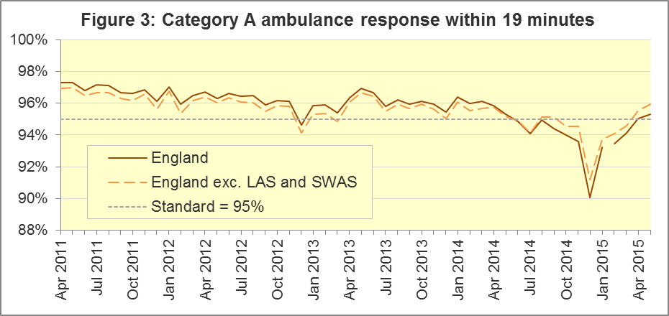
West Midlands had the largest proportion, 97.6%.East Midlands, East of England, London, and South Western (lowest with 91.8%) did not achieve this standard in May.
Other Systems Indicators are still measured consistently.

A5 Systems Indicators: Ambulance volumes (Figure 4)
The number of emergency telephone calls presented to switchboard in May 2015 was 741,171, an average of 24 thousand per day.
There were 534,296 emergency calls that received a face-to-face response from the ambulance service in May 2015. This was an average of 17 thousand per day, the same as in all previous months in 2015.
There were 385,583 incidents requiring emergency patient journeys to Type 1 or Type 2 A&E in May 2015, an average of 12 thousand per day. In the last twelve months, only August 2014 had fewer per day.
There were 260,279 Category A calls that resulted in a fully-equipped ambulance vehicle arriving at the scene of the incident in May 2015, or 8,396 per day. Figure 4 shows that these increased steadily from around 6,500 per day in 2011 to around 8,500 per day in 2014, but now appear to have stabilised.
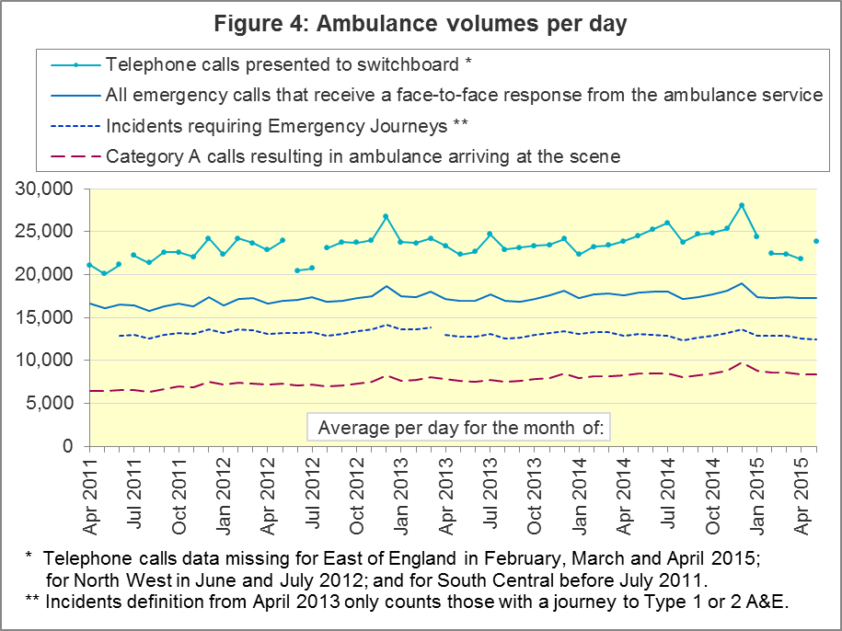

A6 Latest monthly data for other Systems Indicators, May 2015
Indicator | England | Lowest Trust |  | Highest Trust
Calls abandoned before being answered | 0.4% | North  West | 0.2% | South Central | 0.8%
Calls resolved through telephone assessment | 9.5% | West Midlands | 5.1% | London | 14.0%
Calls resolved without transport to Type 1 or Type 2 A&E | 37.0% | East Midlands | 30.3% | South Western | 52.3%
Recontact rate following discharge by telephone advice | 7.1% | Yorkshire | 1.8% | North East | 14.4%
Recontact rate following face-to-face treatment at scene | 5.1% | North  West | 3.3% | London | 7.6%
Incidents requiring a patient journey | 385,583 | North  East ⁷ | 20,934 | London | 63,445

B. Clinical Outcomes
No thresholds to denote “poor” care are set for Clinical Outcomes. Commissioners are expected to examine trends in these data, and work in collaboration with ambulance trusts to achieve sustained improvements over time improvement in patient outcomes over time; but commissioners are not expected to use Clinical Outcomes to performance manage trusts, because there will be significant variations in the populations served.

B1 Cardiac arrest: return of spontaneous circulation (ROSC) (Figure 5)
Patients in cardiac arrest will typically have no pulse and will not be breathing. In February 2015 in England, resuscitation was commenced or continued by ambulance staff out-of-hospital for 2,552 such patients. Of these, 698 (27%) had ROSC, with a pulse, on arrival at hospital.
This proportion was similar to the average for the year ending September 2014 of 27%. The largest proportion in February 2015 was 33% for London, and the smallest was 23% for South Western.
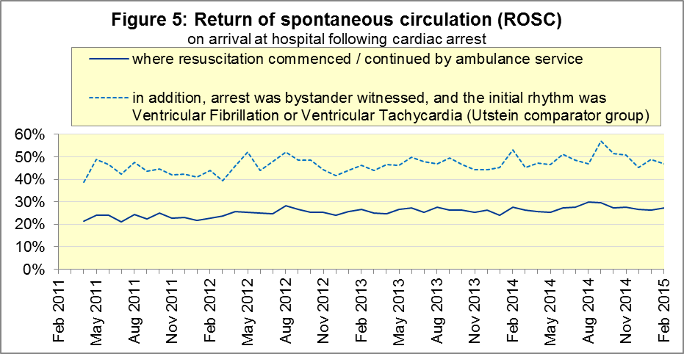
The Utstein group comprises patients who had resuscitation commenced or continued by the Ambulance Services, following an out-of-hospital cardiac arrest of presumed cardiac origin, where the arrest was bystander witnessed, and the initial rhythm was Ventricular Fibrillation or Ventricular Tachycardia. The Utstein group therefore have a better chance of survival.
There are usually fewer than 50 patients in the Utstein group in most trusts each month, so percentages calculated for them can vary considerably, and changes are often not statistically significant.
There were 337 such patients in England in February 2015, of which 158 (47%) had ROSC on arrival at hospital, similar to the average for the year ending September 2014 of 48%. The largest proportion in the month of February 2015 was 70% for North East, and the smallest was 24% for South Central.

B2 Cardiac arrest: survival to discharge (Figure 6)
The proportion of cardiac arrest patients in England discharged from hospital alive was 7% in February 2015. The average for the year ending September 2014 was 9%.
The largest proportion for survival to discharge in the month of February 2015 was 13% for South Central, and the smallest⁹ was 3% for East of England.
For the Utstein group in February 2015, survival to discharge was 26% in England, the same as the average of 26% for the year ending September 2014.
The largest proportion in the month of February 2015 for the Utstein subgroup was 54% for Yorkshire, and the smallest⁹ was 14% for West Midlands.
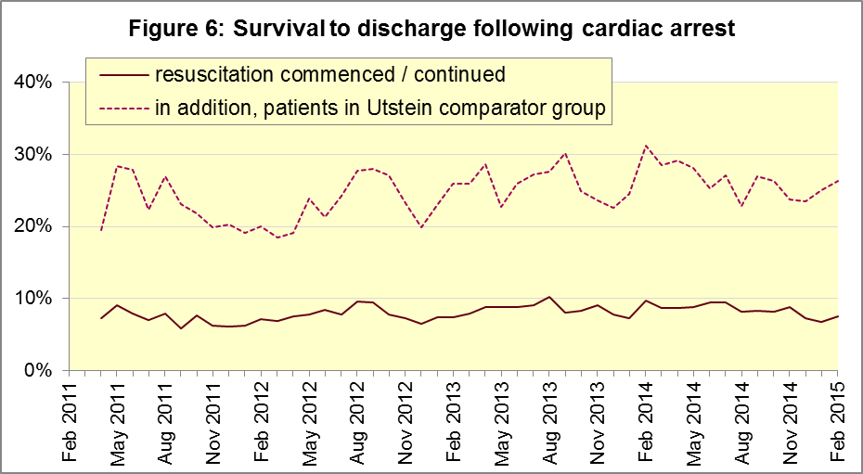

B3 ST-Elevation myocardial infarction (Figure 7)
ST-segment elevation myocardial infarction (STEMI) is a type of heart attack, determined by an electrocardiogram (ECG) test. Early access to reperfusion, where blocked arteries are opened to re-establish blood flow, and other assessment and care interventions, are associated with reductions in STEMI mortality and morbidity.
In February 2015, of 1,343 patients with an acute STEMI in England, 1,080 (80%) received the appropriate care bundle, the same proportion as for the year ending September 2014. The largest proportion for the month of February 2015 was 93% for North East, and the smallest was 56% for South Central.
Of 936 STEMI patients receiving primary angioplasty in February 2015 in England, 822 (88%) of them received it within 150 minutes of the call being connected to the ambulance service, similar to the proportion for the year ending September 2014 (87%). East of England had the largest¹¹ proportion for the month of February 2015, with 96%, and the smallest was 75% for South Western.
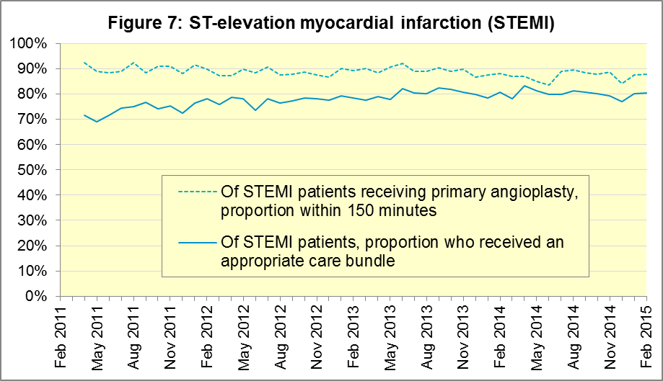

B4 Stroke (Figure 8)
The FAST procedure helps assess whether someone has suffered a stroke:
- Facial weakness: can the person smile? Has their mouth or eye drooped?
- Arm weakness: can the person raise both arms?
- Speech problems: can the person speak clearly and understand what you say?
- Time to call 999 for an ambulance if you spot any one of these signs.
In February 2015, of 2,647 FAST positive patients in England, assessed face to face, and potentially eligible for stroke thrombolysis within agreed local guidelines, 1,479 (56%) arrived at hospitals with a hyperacute stroke unit within 60 minutes of an emergency call connecting to the ambulance service, the same proportion as in January 2015, but significantly less than the average for the year ending September 2014 of 62%.
The largest proportion in the month of February 2015 was 68% for North West, and the smallest was 49% for South Western.
There were 6,401 stroke patients assessed face to face in February 2015 in England, and 6,229 (97.3%) received the appropriate care bundle. All trusts had a proportion of at least 95%.
The February proportion of 97.3% for England was only a fraction of a percent higher than in January 2015, but was nevertheless the highest proportion since monthly data collection began in April 2011, and a statistically significant increase upon the proportion for the year ending September 2014 (96.8%).
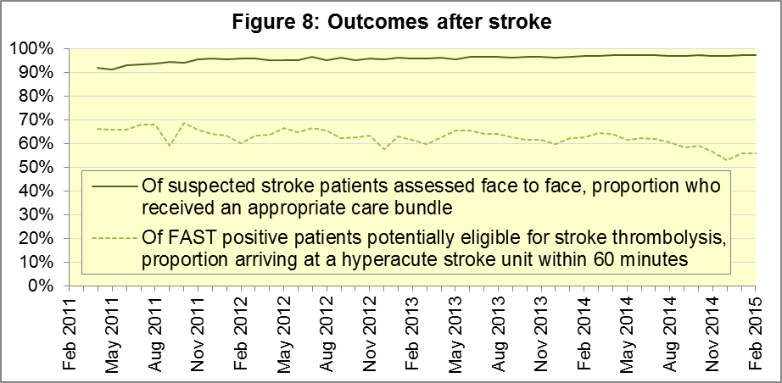

C. Further information on AQI

C1 The AQI landing page and Quality Statement
www.england.nhs.uk/statistics/statistical-work-areas/ambulance-quality-indicators, or http://bit.ly/NHSAQI, is the AQI landing page, and it holds:
- a Quality Statement for these statistics, which includes information on relevance, accuracy, timeliness, coherence, and user engagement;
- the specification guidance document for those who supply the data;
- timetables for data collection and publication;
- text files and time series spreadsheets containing all data from April 2011 up to the latest month;
- links to individual web pages for each financial year.
The web pages for each financial year hold:
- separate spreadsheets of each month’s data;
- this Statistical Note, and equivalent versions from previous months;
- the list of people with pre-release access to the data.

C2 Revisions
Revisions usually follow a six-monthly cycle. The dates for past and future AQI scheduled revisions are below. The AQI Quality Statement above contains a more detailed revisions policy.
Publication date |  | Series revised |  | Months affected
12 November 2015 |  | Systems Indicators |  | April 2015 to August 2015
10 September 2015 |  | Clinical Outcomes |  | April 2014 to March 2015
4 June 2015 |  | Systems Indicators |  | April 2014 to February 2015
30 April 2015 |  | Systems Indicators |  | April 2014 to February 2015
5 March 2015 |  | Clinical Outcomes |  | April 2014 to September 2014
6 November 2014 |  | Systems Indicators |  | April 2013 to August 2014
5 September 2014 |  | Clinical Outcomes |  | April 2013 to March 2014
2 May 2014 |  | Systems Indicators |  | April 2013 to February 2014
7 March 2014 |  | Clinical Outcomes |  | April 2013 to September 2013
1 November 2013 |  | Systems Indicators |  | April 2013 to August 2013
2 August 2013 |  | Clinical Outcomes |  | April 2012 to March 2013
3 May 2013 |  | Systems Indicators |  | April 2012 to March 2013
1 February 2013 |  | Clinical Outcomes |  | April 2012 to August 2012
11 January 2013 |  | Systems Indicators |  | April 2011 to October 2012
31 August 2012 |  | Clinical Outcomes |  | April 2011 to March 2012

C3 AQI Scope
The Ambulance Quality Indicators (AQI) include calls made by dialling either the usual UK-wide number 999 or its EU equivalent 112.
As described in the specification guidance in section C1, calls made to NHS 111 are not included in the AQI measures for calls abandoned (SQU03_1_1), re-contacts (SQU03_2_1 and SQU03_2_2), frequent callers (SQU03_2_3), time to answer calls (SQU03_8_1_1) and calls resolved by telephone advice (SQU03_10_1).
All other Systems Indicators involve the dispatch of an ambulance, and include ambulances dispatched as a result of a call to NHS 111, as well as 999 or 112.

C4 Related statistics in England
The AQI appear in a Clinical Dashboard, available from the AQI landing page, the websites of the Ambulance Trusts (listed in the AQI Quality Statement), and http://aace.org.uk/national-performance/national-clinical-dashboards. One of the aims of these Dashboards is to use statistical process control, to indicate whether variation in proportions reflects underlying change, or merely natural variance, unavoidable even when a health system is performing well.
The AQI are also used in the “Ambulance Services” publication by the Health and Social Care Information Centre (HSCIC), which includes additional annual analysis and commentary. Until March 2013, the HSCIC publication used the KA34 data collection, which was similar to the AQI Systems Indicators, but annual rather than monthly. After that date, the HSCIC publication used AQI data. www.hscic.gov.uk/article/2021/Website-Search?q=ambulance+-accident&sort=Title
Ambulance handover delays of over 30 minutes at each Emergency Department were collected and published by NHS England each winter: www.england.nhs.uk/statistics/statistical-work-areas/winter-daily-sitreps
The AQI Quality Statement described in section C1 contains more information on the HSCIC publication. It also contains details of weekly ambulance situation reports that NHS England collected for six months from November 2010.

C5 Rest of United Kingdom
Ambulance statistics for other countries of the UK can be found at the following websites. The AQI Quality Statement described in section C1 contains more information about the comparability of these statistics.
Wales: | http://wales.gov.uk/statistics-and-research/ambulance-services/?lang=en
Scotland: | See Quality Improvement Indicators (QII) documents at www.scottishambulance.com/TheService/BoardPapers.aspx
Northern Ireland: | www.dhsspsni.gov.uk/index/statistics/hospital/emergency-care/ambulance-statistics.htm

C6 Contact information
For press enquiries, please contact the NHS England press office on 0113 825 0958 or nhsengland.media@nhs.net.
The Government Statistical Service (GSS) statistician responsible for producing these data is:
Ian Kay, Analytical Services (National), Finance Directorate, NHS England
Room 5E24, Quarry House, Leeds, LS2 7UE; 0113 825 4606; i.kay@nhs.net

C7 National Statistics
The UK Statistics Authority has designated these statistics as National Statistics, in accordance with the Statistics and Registration Service Act 2007 and signifying compliance with the Code of Practice for Official Statistics.
Designation can be broadly interpreted to mean that the statistics:
- meet identified user needs;
- are well explained and readily accessible;
- are produced according to sound methods; and
- are managed impartially and objectively in the public interest.
Once statistics have been designated as National Statistics it is a statutory requirement that the Code of Practice shall continue to be observed.

Page 30 of the Handbook to the NHS Constitution has Ambulance response time standards, www.nhs.uk/choiceintheNHS/Rightsandpledges/NHSConstitution/Pages/Overview.aspx.
On 1 June 2012, Category A (immediately life-threatening) calls were split into Red 1 and Red 2. Red 1 calls are the most time critical, and cover cardiac arrest patients who are not breathing and do not have a pulse, and other severe conditions such as airway obstruction. Red 2 calls are serious, but less immediately time critical, and cover conditions such as stroke and fits. www.gov.uk/government/news/changes-to-ambulance-response-time-categories Due to the differences in clock start definitions for Red 1 and Red 2 it is not possible to aggregate them into a single proportion for Category A against the 8 minute standard.
DoD pilot announcement in January 2015: www.parliament.uk/business/publications/written-questions-answers-statements/written-statement/Commons/2015-01-16/HCWS201. For more information, see the 9 April, 30 April or 4 June 2015 Statistical Note.
The number of emergency calls presented to switchboard does not usually include calls made to NHS 111 requiring an ambulance. 111 calls requiring an ambulance are usually transferred electronically direct to ambulance dispatch, and not routed via 999 call handlers. Occasionally, manual requests for ambulance are made between 111 and 999 call handlers, and such calls are included in the number of emergency calls presented to switchboard.
Type 1 are consultant-led 24 hour emergency departments with full resuscitation facilities. Type 2 offer a consultant-led speciality A&E service such as ophthalmology or dental. Type 3 is A&E / minor injury activity that may be doctor-led or nurse-led. Type 4 are NHS walk-in centres. (www.datadictionary.nhs.uk/data_dictionary/attributes/a/acc/ accident_and_emergency_department_type_de.asp)
Due to its small size, performance on Isle of Wight tends to vary more than other trusts. If it has the largest or smallest value, the Table in A6 has a footnote marker to show that it is the extreme, and shows the second largest or smallest value. The Clinical Outcomes in section B also use this system.
Excluding Isle of Wight. See footnote 6 on page 4.
This definition was proposed at Utstein Abbey in Norway by an international group of cardiologists and other health professionals in 1990. http://circ.ahajournals.org/content/84/2/960.citation
Excluding Isle of Wight. See footnote 6 on page 4.
Pages 27 to 30 of the specification guidance for data suppliers on the AQI landing page at www.england.nhs.uk/statistics/statistical-work-areas/ambulance-quality-indicators describe the care bundles, and certain exclusions, for the STEMI and stroke indicators.
Excluding Isle of Wight. See footnote 6 on page 4.
Excluding Isle of Wight. See footnote 6 on page 4.

