Statistical Note: Ambulance Quality Indicators (AQI)
- The latest Systems Indicators for April 2016 for Ambulance Services in England showed the standards in the Handbook to the NHS constitution were not met.

A. Systems Indicators

A1 Emergency response in 8 minutes (Figure 1)
In April 2016, of Category, A Red 1 calls in England resulting in an emergency response, the proportion arriving within 8 minutes was 71.3%.
In April 2016, of Category² A Red 2 calls in England resulting in an emergency response, the proportion arriving within 8 minutes was 65.2%.
Red 2 data from February 2015 onwards are not completely comparable across England; see section A2 on Dispatch on Disposition.
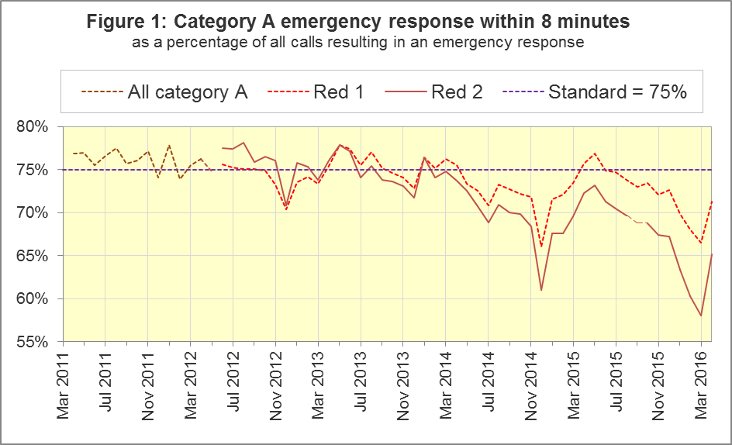
The standard for Ambulance Services is to send an emergency response, with a defibrillator, within 8 minutes to 75% of Category A calls. Figure 1 shows that for England, Red 1 performance increased to 71.3% in April 2016, although it has been below 75% for the past eleven months.
For Red 1, three trusts had a proportion exceeding 75%: North West (76.5%), West Midlands (76.8%) and South Central (75.1%). Eight trusts had proportions of less than 75%: North East (69.1%), Yorkshire⁴ (69.7%), East Midlands (66.3%), East of England (60.8%), South Western⁴ (72.7%), London (70.0%), South East Coast (70.1%) and Isle of Wight (53.1%).

A2 Dispatch on Disposition (DoD)
In January 2015, the Secretary of State for Health announced the introduction of Dispatch on Disposition (DoD), allowing up to two additional minutes for triage (to identify the clinical situation and take appropriate action). This was based upon clinical advice that it would be likely to improve the overall outcomes for ambulance patients.
For Red 1 calls, the clock start time is still the instant that the telephone call connects. However, from 10 February 2015, all other calls received by London Ambulance Service (LAS) and South Western Ambulance Service (SWAS) use DoD.
During October 2015, DoD was introduced in the Ambulance Services of North East (NEAS), Yorkshire (YAS), West Midlands (WMAS) and South Central (SCAS), and the potential extra time was increased further for SWAS. Details of the clock start time for the various cohorts are shown in the table below.
Cohort | Clock start time, excluding Red 1
LAS and SWAS up to 10 February 2015;  NEAS, YAS, WMAS and SCAS up to October 2015;  continually used for the rest of England: | Earliest of:  - chief complaint or NHS Pathways initial disposition (Dx) code obtained;  - first vehicle assigned;  - 60 seconds after call connect.
LAS from 10 February 2015;  NEAS from 8 October 2015;  YAS from 21 October 2015;  WMAS and SCAS from 19 October 2015;  SWAS, 10 February to 5 October 2015: | Earliest of:  - chief complaint or NHS Pathways initial Dx code obtained;  - first vehicle assigned;  - 180 seconds after call connect.

SWAS from 5 October 2015: | As above for 5 October 2015 except;  - 240 seconds after call connect.
SWAS from 14 December 2015 | As above for 5 October 2015 except;  - 300 seconds after call connect.
SWAS from 1 March 2016 | As above for 14 December 2015 except;  - 240 seconds after call connect.
YAS from 16 March 2016 | As above for 21 October 2015 except;  - 240 seconds after call connect.
SCAS from 07 April 2016 | As above for 19 October 2015 except;  - 240 seconds after call connect.
The differing clock start times mean that data for the different cohorts are not comparable with each other. Red 2 calls comprise the vast majority of Category A calls, so 19 minute Category A data are also not comparable for the different cohorts.
Figure 2 shows the Red 2 measure for each cohort.
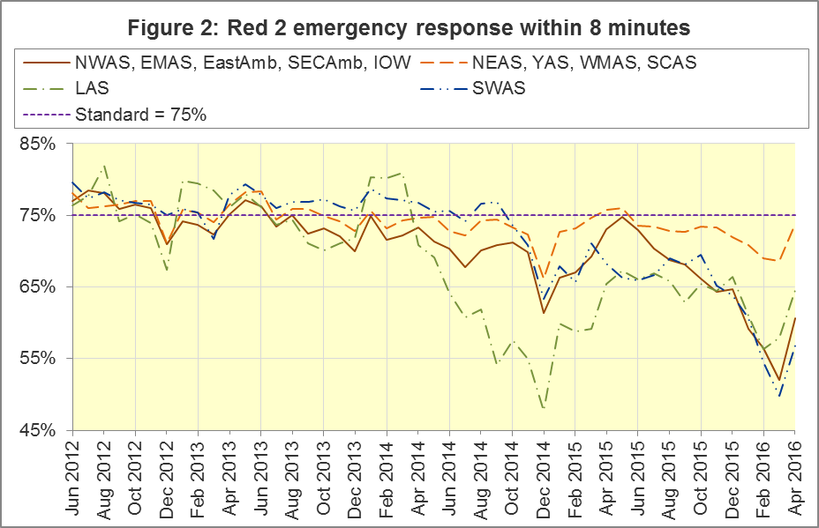
The numerators and denominators for the above proportions are displayed in the Systems Indicators Time Series spreadsheet at http://bit.ly/NHSAQI, on the “DoD R2” tab, and the “DoD A19” tab shows equivalent figures for the 19 minute measure below.

A3 Clinical Coding Review
As the next stage of the Ambulance Response Programme, a clinically led evidence based review of the current call coding categorisations has been undertaken. The aim of this review is to re-categorise calls to focus on ensuring patients receive the most appropriate response. The existing Category A (Red 1 and Red 2), Green 1, Green 2, Green 3 and Green 4 categories will be replaced with the following new categories:
Category Red: Life threatening. The patient needs immediate treatment at the scene to preserve life where life can be saved.
Category Amber: Emergency. The patient needs an emergency response. This group is further divided into:
Amber R (Response): Patient requires a face to face assessment at scene, possible treatment at scene and a vehicle that can convey to hospital.
Amber F (Face to Face): Patient treatment (at scene) is a priority; the patient may or may not need subsequent transportation to hospital, depending on the circumstances.
Amber T (Transport): Patient transportation is a priority because they require the services of a hospital, often a specialist facility.
Category Green: Urgent. The patient needs an urgent response. This group is further divided into:
Green F (Face to Face): Patient requires assessment and management at scene by an ambulance clinician, which may include transport to hospital or another location.
Green T (Transport): Transport only.
Green H (Hear and Treat): Patient suitable for “hear and treat” (advice over telephone, including referral to other services).
These new categorisations are initially being piloted in 2 Ambulance Trusts, and were introduced in South Western Ambulance Service and Yorkshire Ambulance Service on the 19th April 2016 and the 21st April 2016 respectively. With this introduction, data for the Red1, Red 2 and Category A measures will no longer be available for the Trusts involved from these dates. Partial data will therefore be supplied covering April 2016.
It should be noted that the new call categorisations are not comparable with previous categorisations for the following reasons. The review has assessed all available disposition codes and for each re-assigned the code to a new group i.e. the new Red category does not contain the same code set as the old Red 1 or Red 2 category. In addition detailed changes have been made to the “clock stop” criteria, where appropriate.

A4 Category A Ambulance response in 19 minutes (Figure 3)
The other ambulance standard in the Handbook to the NHS Constitution is for trusts to send, within 19 minutes, a fully-equipped ambulance vehicle, able to transport the patient in a clinically safe manner, to 95% of Category A calls. This measure is also affected by DoD. For England as a whole, this measure increased to 92.2% in April 2016 from 88.0% in March 2016. The performance for providers (North West, East Midlands, Eastern, South East Coast and Isle of Wight) not undertaking DoD was 89.8%.
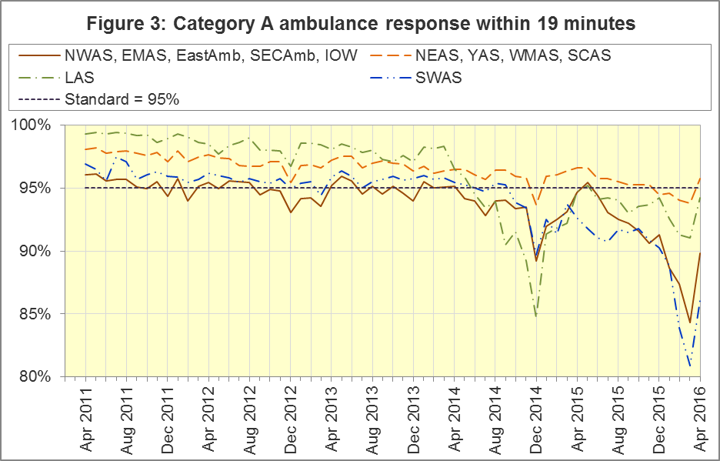
DoD does not affect how other indicators are measured, but it may lead to changes in the levels for other indicators. For example, a longer triage time may mean fewer ambulances dispatched, leading to better ambulance availability, and more timely responses to Red 1 calls. A longer triage time may also mean more calls are closed on the telephone. However, any such effects will be difficult to detect within the habitual variation of the many Ambulance Quality Indicators.

A5 Systems Indicators: Ambulance volumes (Figure 4)
The number of emergency telephone calls presented to switchboard in April 2016 was 745,032, an average of 24.8 thousand per day. Figure 4 shows that there is a fair amount variation in call volume.
There were 547,685 emergency calls that received a face-to-face response from the ambulance service in April 2016, an average of 18.3 thousand per day.
There were 391,469 incidents with a patient transported to Type 1 or Type 2 A&E in April 2016, an average of 13.0 thousand per day.
There were 261,708 Category A calls that resulted in a fully-equipped ambulance vehicle arriving at the scene of the incident in April 2016, this equates to 9.3 thousand per day (based on data available). Figure 4 shows how this has increased steadily between 2011 and 2016.
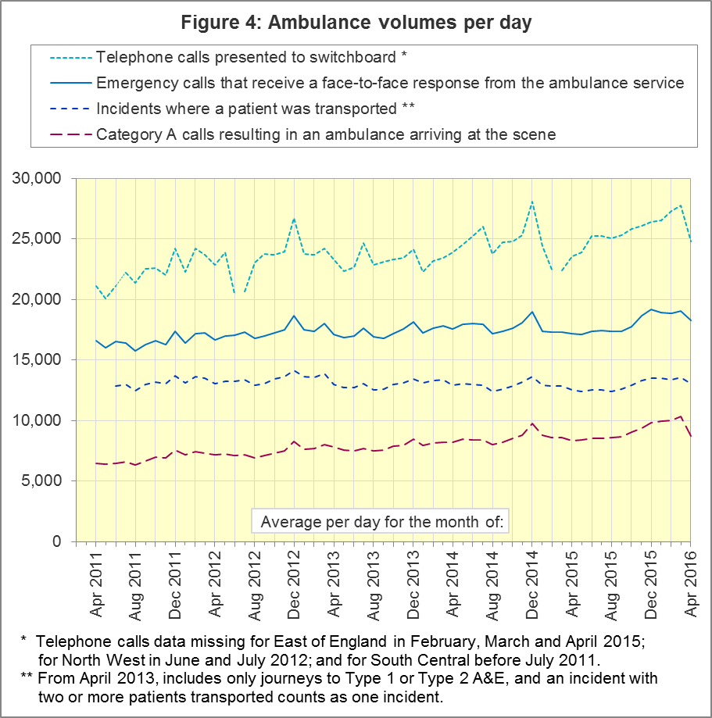

A6 Latest monthly data for other Systems Indicators, April 2016
Indicator | England | Lowest Trust |  | Highest Trust
Calls abandoned before being answered | 0.7% | London | 0.0% | South Western | 1.6 %
Calls resolved through telephone assessment | 8.9% | West Midlands | 5.2% | East Midlands | 13.2%
Calls resolved without transport to Type 1 or Type 2 A&E | 38.0% | Yorkshire | 30.2% | South East Coast | 49.8%
Recontact rate following discharge by telephone advice | 6.8% | London¹¹ | 3.2% | West Midlands | 14.4%
Recontact rate following face-to-face treatment at scene | 5.2% | Yorkshire | 2.5% | London | 8.1%
Incidents where a patient was transported | 391,469 | North  East¹¹ | 19,776 | London | 65,300

In April 2016, the proportion of calls resolved through telephone assessment was 8.9%, lower than the 10.0% recorded in April 2015.
Of emergency calls resolved with telephone advice, the proportion where the patient subsequently re-contacts 999 within 24 hours was 6.8% in April 2016.

B. Clinical Outcomes
No thresholds to denote “poor” care are set for Clinical Outcomes. Commissioners are expected to examine trends in these data, and work in collaboration with ambulance trusts to achieve sustained improvement in patient outcomes over time; but commissioners are not expected to use Clinical Outcomes to performance manage trusts, because there will be significant variations in the populations served.

B1 Cardiac arrest: return of spontaneous circulation (ROSC)
Patients in cardiac arrest will typically have no pulse and will not be breathing. In January 2016 in England, resuscitation was commenced or continued by ambulance staff out-of-hospital for 2,882 such patients. Of these, 763 (26.5%) had ROSC, with a pulse, on arrival at hospital (Figure 5), slightly below the average for 2014-15 of 27.3%. The largest proportion in January 2016 was 36.0% for North West. The smallest proportion reported was 18.9% for North East¹¹.
The Utstein group comprises patients who had resuscitation commenced or continued by the Ambulance Services, following an out-of-hospital cardiac arrest of presumed cardiac origin, where the arrest was bystander witnessed, and the initial rhythm was Ventricular Fibrillation or Ventricular Tachycardia. The Utstein group therefore have a better chance of survival.
There were 347 such patients in England in January 2016, of which 156 (45.0%) had ROSC on arrival at hospital (Figure 5). Below the England average for 2014-15 of 49.1%. The largest proportion in the January 2015 was reported in North West with 61.2%, and the smallest was 25.9% in East Midlands.
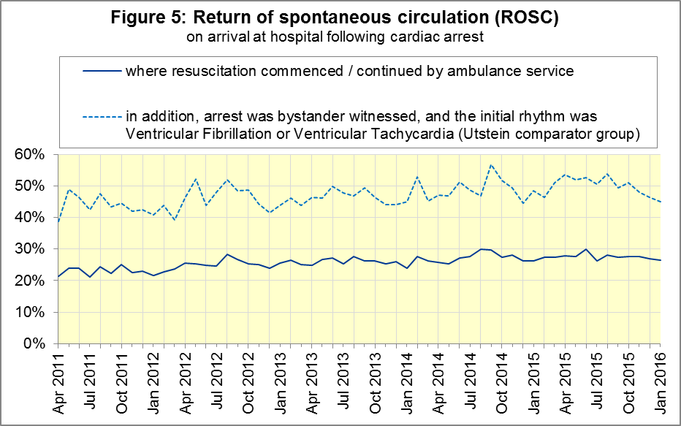

B2 Cardiac arrest: survival to discharge
The proportion of cardiac arrest patients in England discharged from hospital alive was 6.4% in January 2016 (Figure 6), significantly below data for the previous year and below the average for 2014-15 of 8.6%. The largest proportion in January 2016 was 13.4% for South Central; the smallest was 3.2% for South East Coast¹³.
For the Utstein group, survival to discharge in January 2016 was significantly¹⁴ down at 20.6% and lower than the average for 2014-15 of 26.3%. The largest proportion was 33.3% for North East; the smallest was 16.2% for East of England¹³.
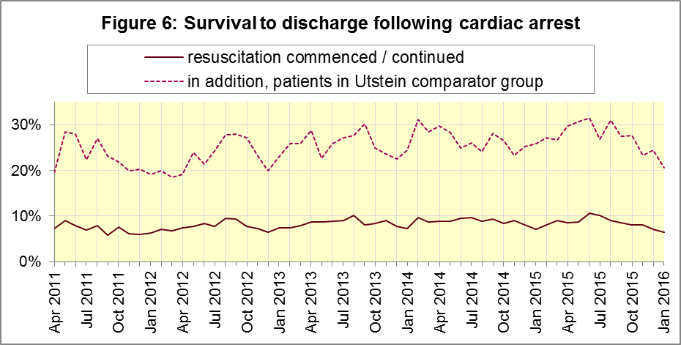

B3 ST-Elevation myocardial infarction
ST-segment elevation myocardial infarction (STEMI) is a type of heart attack, determined by an electrocardiogram (ECG) test. Early access to reperfusion, where blocked arteries are opened to re-establish blood flow, and other assessment and care interventions, are associated with reductions in STEMI mortality and morbidity.
941 STEMI patients received primary angioplasty in January 2016 in England. Of these 941 patients, 823 (87.5%) of them received it within 150 minutes of the call being connected to the ambulance service (Figure 7), similar to the average for 2014-15. The largest proportion for January 2015 was 95.2% for London, and the smallest was 79.0% for Yorkshire.
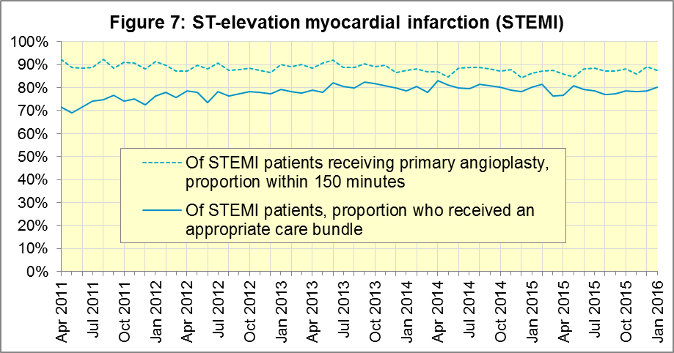
In January 2016, of 1,419 patients with an acute STEMI in England, 1,136 (80.1%) received the appropriate care bundle. This was similar to the average for 2014-15 of 80.0%. East of England had the largest proportion with 93.4%, and the smallest was South East Coast with 65.7%.

B4 Stroke
The FAST procedure helps assess whether someone has suffered a stroke:
- Facial weakness: can the person smile? Has their mouth or eye drooped?
- Arm weakness: can the person raise both arms?
- Speech problems: can the person speak clearly and understand what you say?
- Time to call 999 for an ambulance if you spot any one of these signs.
In January 2016, of 3,507 FAST positive patients in England, assessed face to face, and potentially eligible for stroke thrombolysis within agreed local guidelines, 1,812 (51.7%) arrived at hospitals with a hyperacute stroke unit within 60 minutes of an emergency call connecting to the ambulance service, below the average for 2014-15 of 59.0% and the lowest recorded proportion since data collection began in April 2011.
The largest proportion for January 2016 was 61.8% for London and the smallest was 41.1% for East Midlands.
There were 7,518 stroke patients assessed face to face in January 2016 in England, and 7,352 (97.8%) received the appropriate care bundle, similar to the average for 2014-15 of 97.1%. The highest proportion was recorded in the North West¹⁷ with 100% of patients receiving the appropriate care bundle.
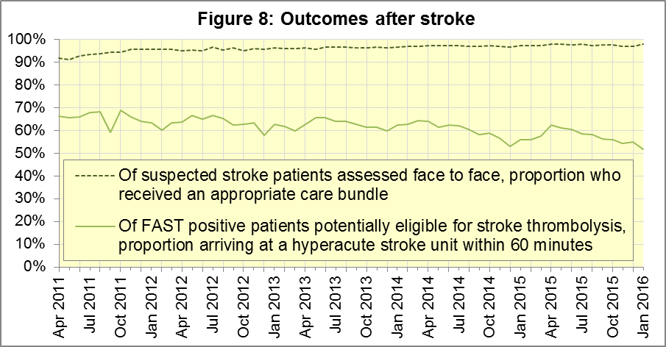

C. Further information on AQI

C1 The AQI landing page and Quality Statement
www.england.nhs.uk/statistics/statistical-work-areas/ambulance-quality-indicators, or http://bit.ly/NHSAQI, is the AQI landing page, and it holds:
- a Quality Statement for these statistics, which includes information on relevance, accuracy, timeliness, coherence, and user engagement;
- the specification guidance document for those who supply the data;
- timetables for data collection and publication;
- text files and time series spreadsheets containing all data from April 2011 up to the latest month;
- links to individual web pages for each financial year.
The web pages for each financial year hold:
- separate spreadsheets of each month’s data;
- this Statistical Note, and equivalent versions from previous months;
- the list of people with pre-release access to the data.
Publication dates are also at www.gov.uk/government/statistics/announcements.

C2 Revisions Timetable
Revisions usually follow a six-monthly cycle. The dates for past and future AQI scheduled revisions are below. The AQI Quality Statement above contains a more detailed revisions policy.
Publication date |  | Series revised |  | Months affected
12 May 2016 |  | Systems Indicators |  | April 2015 to February 2016
10 March 2016 |  | Clinical Outcomes |  | April 2015 to September 2015
10 September 2015 |  | Clinical Outcomes |  | April 2014 to March 2015
4 June 2015 |  | Systems Indicators |  | April 2014 to February 2015
30 April 2015 |  | Systems Indicators |  | April 2014 to February 2015
5 March 2015 |  | Clinical Outcomes |  | April 2014 to September 2014
6 November 2014 |  | Systems Indicators |  | April 2013 to August 2014
5 September 2014 |  | Clinical Outcomes |  | April 2013 to March 2014
2 May 2014 |  | Systems Indicators |  | April 2013 to February 2014
7 March 2014 |  | Clinical Outcomes |  | April 2013 to September 2013
1 November 2013 |  | Systems Indicators |  | April 2013 to August 2013
2 August 2013 |  | Clinical Outcomes |  | April 2012 to March 2013
3 May 2013 |  | Systems Indicators |  | April 2012 to March 2013
1 February 2013 |  | Clinical Outcomes |  | April 2012 to August 2012
11 January 2013 |  | Systems Indicators |  | April 2011 to October 2012
31 August 2012 |  | Clinical Outcomes |  | April 2011 to March 2012

C3 AQI Scope
The AQI include calls made by dialling either the usual UK-wide number 999 or its international equivalent 112.
As described in the specification guidance in section C1, calls made to NHS 111 are not included in the AQI measures for calls abandoned, re-contacts, frequent callers, time to answer calls and calls resolved by telephone advice.
All other Systems Indicators involve the dispatch of an ambulance, and include ambulances dispatched as a result of a call to NHS 111, as well as 999 or 112.

C4 Related statistics in England
The AQI appear in a Clinical Dashboard, available from the AQI landing page, the websites of the Ambulance Trusts (listed in the AQI Quality Statement), and http://aace.org.uk/national-performance/national-clinical-dashboards. One of the aims of these Dashboards is to use statistical process control, to indicate whether variation in proportions reflects underlying change, or merely natural variance, unavoidable even when a health system is performing well.
The AQI are also used in the “Ambulance Services” publication by the Health and Social Care Information Centre (HSCIC), which includes additional annual analysis and commentary. Until March 2013, the HSCIC publication used the KA34 data collection, which was similar to the AQI Systems Indicators, but annual rather than monthly. After that date, the HSCIC publication used AQI data. www.hscic.gov.uk/article/2021/Website-Search?q=ambulance+-accident&sort=Title
Ambulance handover delays of over 30 minutes at each Emergency Department were collected and published by NHS England each winter until 2014-15: www.england.nhs.uk/statistics/statistical-work-areas/winter-daily-sitreps
The AQI Quality Statement described in section C1 contains more information on the HSCIC publication. It also contains details of weekly ambulance situation reports that NHS England collected for six months from November 2010.

C5 Rest of United Kingdom
Ambulance statistics for other countries of the UK can be found at the following websites. The AQI Quality Statement described in section C1 contains more information about the comparability of these statistics.
Wales: | http://wales.gov.uk/statistics-and-research/ambulance-services/?lang=en
Scotland: | See Quality Improvement Indicators (QII) documents at www.scottishambulance.com/TheService/BoardPapers.aspx
Northern Ireland: | www.dhsspsni.gov.uk/index/statistics/hospital/emergency-care/ambulance-statistics.htm

C6 Contact information
For press enquiries, please contact the NHS England press office on 0113 825 0958 or nhsengland.media@nhs.net.
The statistician responsible for producing this publication is:
Ian Kay, Operational Information for Commissioning (National), NHS England
Room 5E24, Quarry House, Leeds, LS2 7UE; 0113 825 4606; i.kay@nhs.net

C7 National Statistics
The UK Statistics Authority has designated these statistics as National Statistics, in accordance with the Statistics and Registration Service Act 2007 and signifying compliance with the Code of Practice for Official Statistics.
Designation can be broadly interpreted to mean that the statistics:
- meet identified user needs;
- are well explained and readily accessible;
- are produced according to sound methods; and
- are managed impartially and objectively in the public interest.
Once statistics have been designated as National Statistics it is a statutory requirement that the Code of Practice shall continue to be observed.

Page 34 of the July 2015 Handbook to the NHS Constitution has Ambulance response time standards, www.gov.uk/government/publications/the-nhs-constitution-for-england.
Due to the introduction of Clinical Coding Review data for South Western Ambulance Service and Yorkshire Ambulance Service are only available up to and including the 18th April 2016 and 20th April 2016 respectively.
On 1 June 2012, Category A (immediately life-threatening) calls was split into Red 1 and Red 2. Red 1 calls are the most time critical, and cover cardiac arrest patients who are not breathing and do not have a pulse, and other severe conditions such as airway obstruction. Red 2 calls are serious, but less immediately time critical, and cover conditions such as stroke and fits. www.gov.uk/government/news/changes-to-ambulance-response-time-categories Due to the differences in clock start definitions for Red 1 and Red 2 it is not possible to aggregate them into a single proportion for Category A against the 8 minute standard.
See footnote 3 on Page 1
Dispatch on Disposition announcement: www.parliament.uk/business/publications/written-questions-answers-statements/written-statement/Commons/2015-01-16/HCWS201
Further information on the Ambulance Response Programme is available from the NHS England Website https://www.england.nhs.uk/ourwork/qual-clin-lead/arp/
See footnote 3 on page 1
The number of emergency calls presented to switchboard does not usually include calls made to NHS 111 requiring an ambulance. 111 calls requiring an ambulance are usually transferred electronically direct to ambulance dispatch, and not routed via 999 call handlers. Occasionally, manual requests for ambulance are made between 111 and 999 call handlers, and such calls are included in the number of emergency calls presented to switchboard.
Type 1 are consultant-led 24 hour emergency departments with full resuscitation facilities. Type 2 offer a consultant-led speciality A&E service such as ophthalmology or dental. Type 3 is A&E / minor injury activity that may be doctor-led or nurse-led. Type 4 are NHS walk-in centres. (www.datadictionary.nhs.uk/data_dictionary/attributes/a/acc/ accident_and_emergency_department_type_de.asp)
See footnote 3 on Page 1
Due to its small size, performance on Isle of Wight tends to vary more than other trusts. If it has the largest or smallest value, the Table in A6 shows the second largest or smallest value, but has a footnote marker to show that Isle of Wight is more extreme. The Clinical Outcomes in section B also uses this system.
This definition was proposed at Utstein Abbey in Norway by an international group of cardiologists and other health professionals in 1990. http://circ.ahajournals.org/content/84/2/960.citation
Excluding Isle of Wight. See footnote 11 on page 7
Significance test used is t-test
Excluding Isle of Wight. See footnote 11 on page 7.
Pages 27 to 30 of the specification guidance for data suppliers on the AQI landing page at www.england.nhs.uk/statistics/statistical-work-areas/ambulance-quality-indicators describe the care bundles, and certain exclusions, for the STEMI and stroke indicators.
Excluding Isle of Wight. See footnote 11 on page 7

