Dental Commissioning Statistics – March 2016

1. Summary

- As at 31st March 2016, there are 89,022,675 UDAs commissioned to be provided between 1st April 2016 and 31st March 2017.
- This is an increase of 71,000 compared to the previous quarter, equivalent to a 0.1% change.
- It is 308,000 UDAs, or 0.3%, higher than the number of UDAs commissioned by March 2015 to be provided between 1st April 2015 and 31st March 2016.
- The largest change from the previous quarter at Local Office level was a decrease of 27,000, or 0.5%, in South Central.
- The largest change from the previous year at Local Office level was an increase of 336,000, or 4.9% in Central Midlands.
- The number of UDAs commissioned in contracts which are not yet delivering services remains low, at 33,000, in Lancashire and Greater Manchester and London.

2. Changes at regional level

At a national level, the total UDAs commissioned by March 2016 is higher (by 71,000) than in December 2015 (0.1% increase).

Compared to the previous quarter, the South region showed the greatest decrease in UDAs commissioned, with 728 fewer UDAs commissioned in March 2016 compared to December 2015 (0.003% decrease). Midlands and East region had the highest increase (0.1%) in UDAs commissioned compared to the previous quarter, with 37,000 more UDAs commissioned in March 2016 compared to December 2015.

Table 1: Units of Dental Activity Commissioned by Quarterly Change counts and Percentage Change
England, commissioning regions
 | Total UDAs |  | Quarterly  Change | Percentage Change
 | December 2015 | March 2016
England | 88,951,978 | 89,022,675 | 70,697 | 0.1%
North | 27,913,410 | 27,947,579 | 34,169 | 0.1%
Midlands and East | 26,874,569 | 26,911,825 | 37,256 | 0.1%
London | 12,649,666 | 12,649,666 | 0 | 0.0%
South | 21,514,333 | 21,513,605 | -728 | 0.0%

Compared to the previous year, at a national level, the total UDAs commissioned by March 2016 is higher (by 308,000) than in March 2015 (0.3% increase).

At commissioning region level, the largest annual decrease was in the South region with 153,000 fewer UDAs commissioned (-0.7%) compared to March 2015. Midlands and East region had the highest increase (1.9%) in UDAs commissioned compared to the previous year.

Table 2: Units of Dental Activity Commissioned by Annual Change counts and Percentage
England, commissioning regions
 | Total UDAs |  | Annual  Change | Percentage Change
 | March 2015 | March 2016
England | 88,714,190 | 89,022,675 | 308,485 | 0.3%
North | 28,038,589 | 27,947,579 | -91,010 | -0.3%
Midlands and East | 26,398,697 | 26,911,825 | 513,128 | 1.9%
London | 12,610,101 | 12,649,666 | 39,565 | 0.3%
South | 21,666,803 | 21,513,605 | -153,198 | -0.7%

At Local Office level, the largest annual decrease was in Cumbria and the North East with 97,000 fewer UDAs commissioned (-1.6%) compared to March 2015. Central Midlands had the highest increase (4.9%) in UDAs commissioned compared to the previous year, at 340,000 more.

Compared to the previous quarter, South Central showed the greatest decrease in UDAs commissioned compared to the previous quarter, with 27,000 fewer UDAs commissioned in March 2016 compared to December 2015 (0.5% decrease). Yorkshire and the Humber had the highest increase (0.4%) in UDAs commissioned compared to the previous quarter, with 40,000 more UDAs commissioned.

Between December 2015 and March 2016, out of the 13 Regional Teams, nine showed increases in commissioned UDAs, three showed decreases compared to the previous quarter, and one showed no change.

Table 3: Units of Dental Activity Commissioned, Quarterly and Annual Changes
England, Local Offices
 | Total UDAs | Annual change |  | Quarterly change
 |  | Counts | % Change | Counts | % Change
ENGLAND | 89,022,675 | 308,485 | 0.3% | 70,697 | 0.1%
Wessex | 4,317,076 | 8,053 | 0.2% | 1,373 | 0.0%
London | 12,649,666 | 39,565 | 0.3% | 0 | 0.0%
Yorkshire and the Humber | 9,611,633 | -32,090 | -0.3% | 40,171 | 0.4%
Lancashire and Greater Manchester | 7,454,817 | 44,767 | 0.6% | 17,638 | 0.2%
Cumbria and North East | 6,020,253 | -97,424 | -1.6% | -11,763 | -0.2%
Cheshire and Merseyside | 4,860,876 | -6,263 | -0.1% | -11,877 | -0.2%
North Midlands | 5,909,534 | -12,869 | -0.2% | 9,498 | 0.2%
West Midlands | 6,817,161 | 87,175 | 1.3% | 8,090 | 0.1%
Central Midlands | 7,245,533 | 335,742 | 4.9% | 17,535 | 0.2%
East | 6,939,597 | 103,080 | 1.5% | 2,133 | 0.0%
South West | 5,652,225 | -17,484 | -0.3% | 7,732 | 0.1%
South East | 6,545,906 | -71,700 | -1.1% | 17,145 | 0.3%
South Central | 4,998,398 | -72,067 | -1.4% | -26,978 | -0.5%

3. Quarterly changes

The data from March 2016 shows that there has been an increase in the amount of UDAs commissioned (0.1%) compared to the previous quarter. In the quarter before that, December 2015, there was a 0.001% decrease.

As the chart below shows, there have been seasonal variations affecting the quarter to quarter changes. Historically, large dips have been seen in the June quarter (for precise figures see Annex 1). This is most likely due to non-recurrent commissioning contracts coming to an end (end of the financial year) and new commissioning for the year not yet decided upon.

Figure 1: Percentage change of Units of Dental Activity Commissioned quarter on quarter.
England, March 2008 to March 2016.
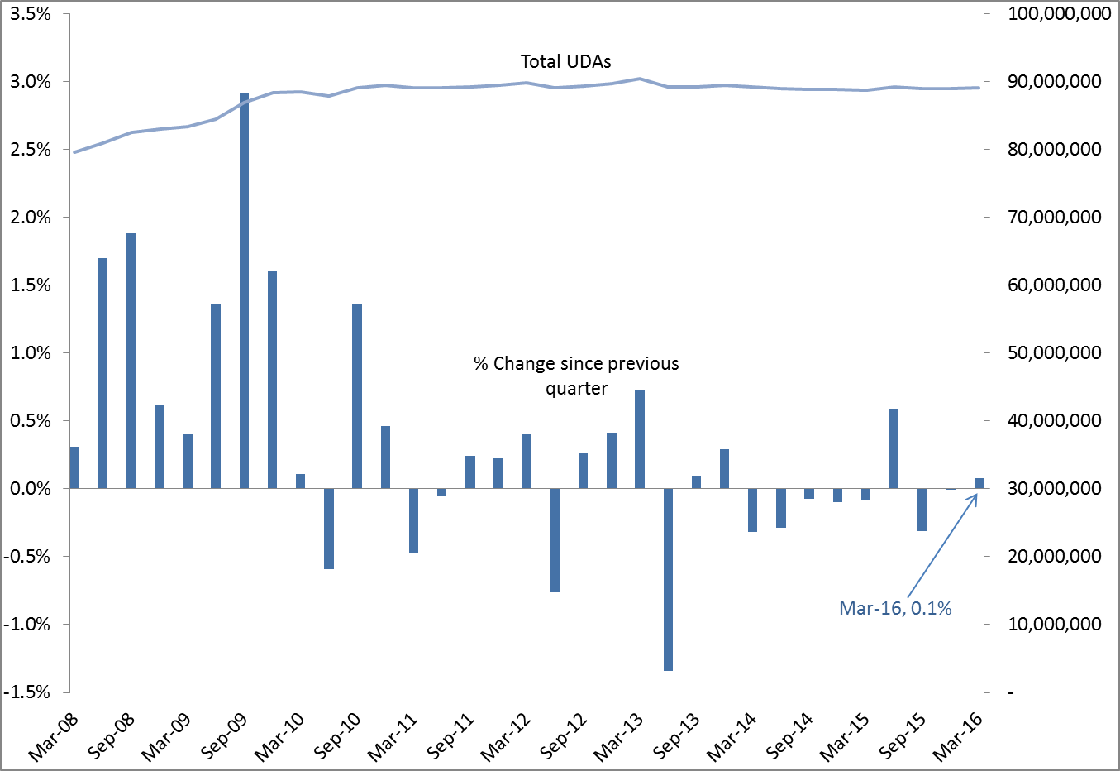

4. Annual changes

The annual change for total UDAs commissioned has now been positive for four quarters, having previously been negative since September 2013. The total UDAs in March 2016 is 310,000 higher than in March 2015 (0.3% increase), the up and running services for the same time period have also increased by 0.4% (370,000).
For each quarter between March 2009 and June 2010, the total number of UDAs commissioned was at least 4.0% higher than at the same time 12 months earlier. The percentage increase declined to around 1.0% or below from December 2010 onwards. March 2014 marked the most negative percentage change across the time period of -1.3%. The most recent quarter (March 2016) registered a 0.3% increase in units of dental activity commissioned, see Figure 2 below.
Figure 2: Percentage change of Units of Dental Activity Commissioned year on year.
England, March 2009 to March 2016.
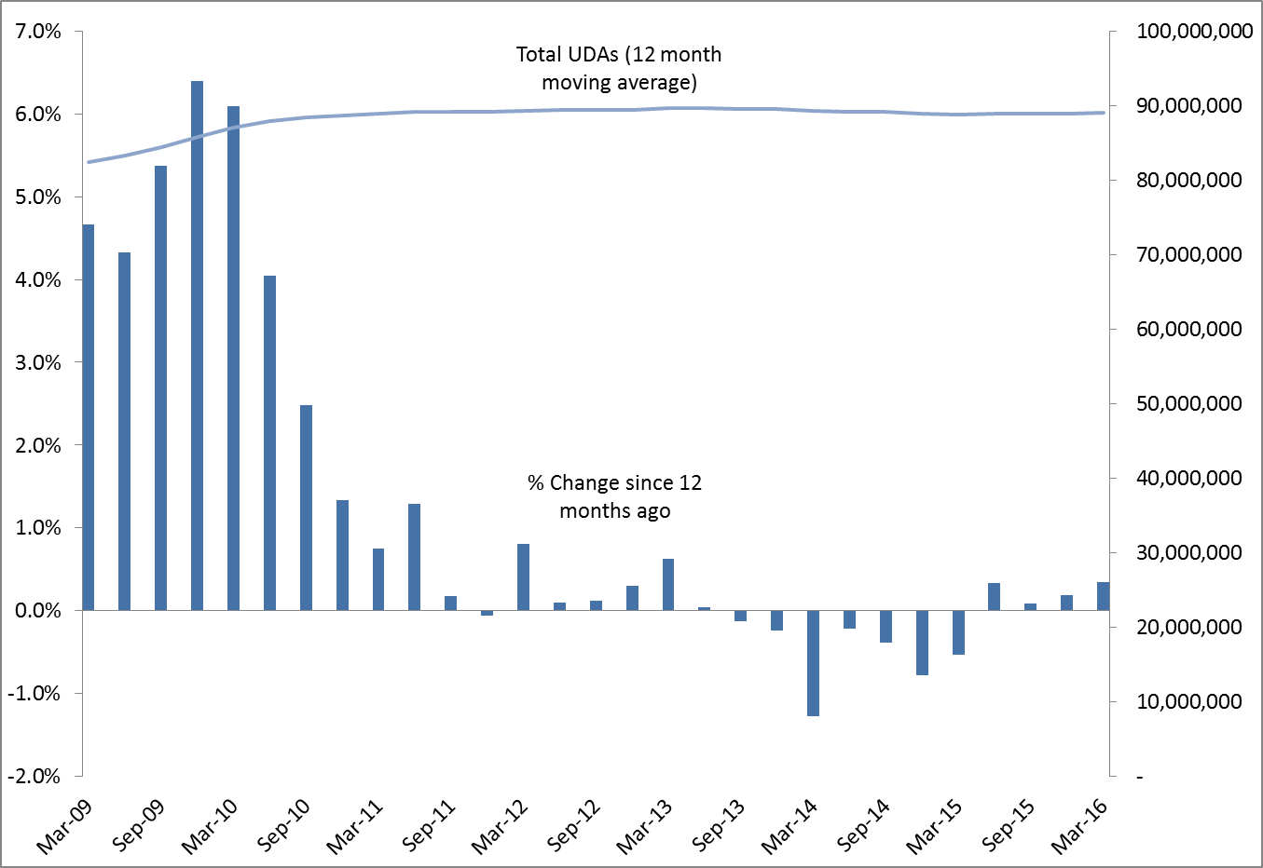

5. ‘Up and running’ UDAs

Over time, the gap between the total number of UDAs commissioned and the ‘up and running’ UDAs has narrowed. The most recent quarter shows the number of UDAs commissioned in contracts which are not yet delivering services is 33,000 (0.04% of all UDAs commissioned). This is a decrease from 38,000, from last quarter, and a decrease from 96,000, from the previous year.

Since March 2011, UDAs commissioned in contracts which are not yet delivering services have represented 1.0% or less of the total UDAs commissioned. The data from June 2014 showed the smallest proportion seen over time of UDAs not yet delivering services (0.003%).

Figure 3: Time Series of Units of Dental Activity Commissioned
England, March 2008 to March 2016.
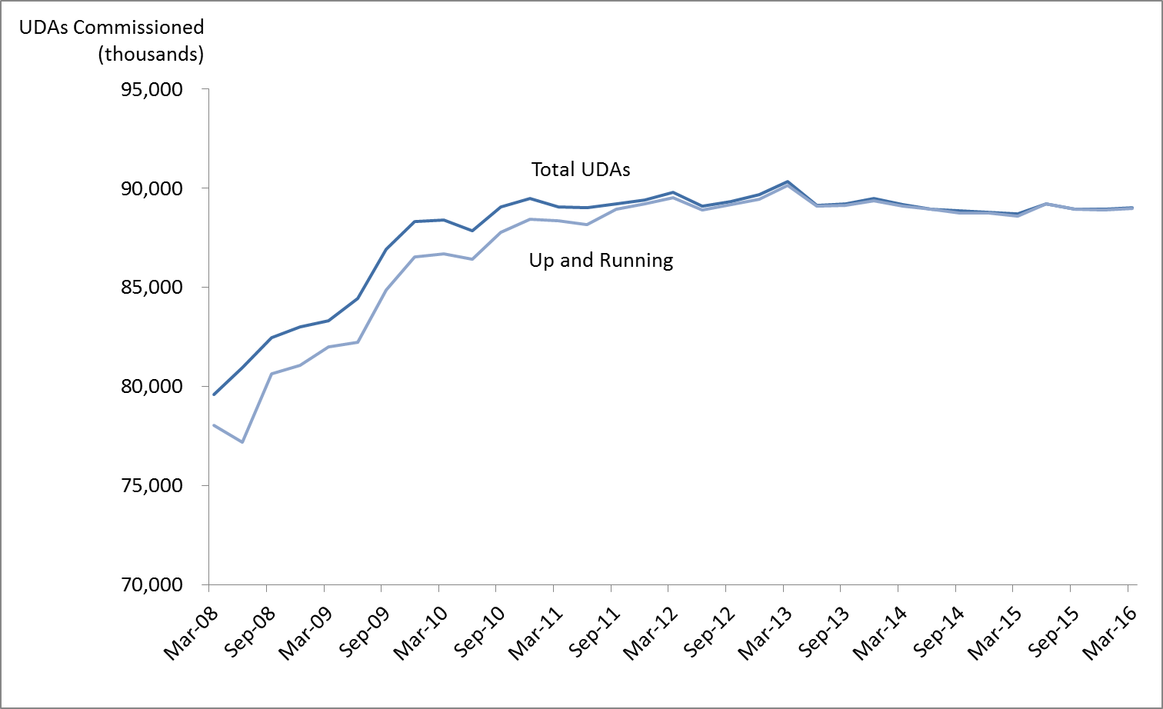

Annex 1

Table 4: Units of Dental Activity (UDAs) Commissioned
England, March 2009 to March 2016
Reporting period | Annual services commissioned + up and running | Contracts not yet delivering services | Total annual services commissioned*
as of March 2009 | 81,989,867 | 1,340,108 | 83,329,975
as of June 2009 | 82,224,496 | 2,240,289 | 84,464,785
as of September 2009 | 84,876,778 | 2,044,575 | 86,921,353
as of December 2009 | 86,531,325 | 1,779,416 | 88,310,741
as of March 2010 | 86,713,183 | 1,691,265 | 88,404,448
as of June 2010 | 86,410,349 | 1,471,597 | 87,881,946
as of September 2010 | 87,797,178 | 1,279,192 | 89,076,370
as of December 2010 | 88,442,502 | 1,043,909 | 89,486,411
as of March 2011 | 88,373,545 | 693,691 | 89,067,236
as of June 2011 | 88,182,055 | 833,609 | 89,015,664
as of September 2011 | 88,931,847 | 297,480 | 89,229,327
as of December 2011 | 89,212,421 | 218,773 | 89,431,194
as of March 2012 | 89,537,613 | 251,330 | 89,788,943
as of June 2012 | 88,895,085 | 207,517 | 89,102,602
as of September 2012 | 89,171,087 | 165,942 | 89,337,029
as of December 2012 | 89,440,435 | 257,890 | 89,698,325
as of March 2013 | 90,144,430 | 202,302 | 90,346,732
as of June 2013 | 89,118,011 | 16,000 | 89,134,011
as of September 2013 | 89,140,430 | 77,692 | 89,218,122
as of December 2013 | 89,382,784 | 96,211 | 89,478,995
as of March 2014 | 89,122,113 | 70,801 | 89,192,914
as of June 2014 | 88,935,606 | 2,247 | 88,937,853
as of September 2014 | 88,740,473 | 132,702 | 88,873,175
as of December 2014 | 88,773,154 | 10,240 | 88,783,394
as of March 2015 | 88,618,075 | 96,115 | 88,714,190
as of June 2015 | 89,218,798 | 12,900 | 89,231,698
as of September 2015 | 88,940,241 | 12,900 | 88,953,141
as of December 2015 | 88,913,840 | 38,138 | 88,951,978
as of March 2016 | 88,989,806 | 32,869 | 89,022,675

*Commissioned UDAs cover contracted UDAs in the next 12 months in GDS and PDS contracts and in VDP arrangements. This excludes salaried services where there are no contracted UDAs.

