Statistical Note: Ambulance Quality Indicators (AQI)
The latest Systems Indicators for November 2016 for Ambulance Services in England showed the standards in the Handbook to the NHS constitution were not met.
The latest Clinical Outcomes data are stable for patients transported by Ambulance Services in August 2016.

A. Systems Indicators

A1 Emergency response in 8 minutes (Figure 1)
In November 2016, of Category, A Red 1 calls in England, resulting in an emergency response, the proportion arriving within 8 minutes was 67.8%.
In November 2016, of Category^{2, 3} A Red 2 calls in England resulting in an emergency response, the proportion arriving within 8 minutes was 63.4%.
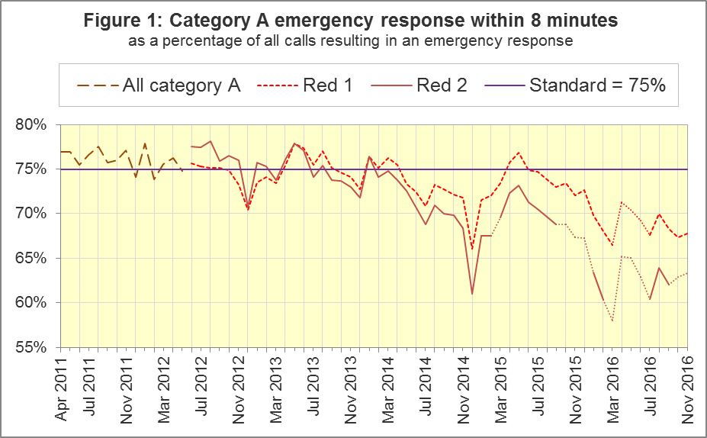
The standard for Ambulance Services is to send an emergency response, with a defibrillator, within 8 minutes to 75% of Category A calls. Figure 1 shows that for England, Red 1 performance slightly increased to 67.8% in November 2016.
For Red 1, out of the eight trusts where Category A still applied, none met the 75% standard in November 2016. Four trusts had proportions of less than 70%: North East (64.9%), North West (62.8%), South East Coast (65.6%) and Isle of Wight (67.6%).

A2 Dispatch on Disposition
In January 2015, the Secretary of State for Health announced the introduction of Dispatch on Disposition (DoD). This was the first change affecting the AQI due to the Ambulance Response Programme (ARP). It does not apply to Red 1 calls.
It meant that response data were still available across England, but for any affected Ambulance Service, Red 2 and Category A response data were no longer comparable before and after when DoD was introduced.
DoD increases the maximum time for triage, which means to identify the clinical situation and to take appropriate action. The change was based upon clinical advice that it would be likely to improve the overall outcomes for ambulance patients.
Other than Red 1 calls, until 10 February 2015, the start time up was the earliest of:
- chief complaint or NHS Pathways initial disposition (Dx) code obtained;
- first vehicle assigned;
- 60 seconds after call connect.
From 10 February 2015, option 3 was increased from 60 seconds to 180 seconds for London (LAS) and South Western (SWAS) Ambulance Services. From October 2015, further changes were tested in a variety of Ambulance Services on different dates, which are listed in full in the 8 December 2016 AQI Statistical Note. During October 2016, all Ambulance Services in England except the Isle of Wight (IOW) were aligned with a maximum start time of 240 seconds.

A3 Clinical Coding Review
The second change affecting the AQI due to the ARP was the Clinical Coding Review (CCR). This was a clinically-led evidence based review of the call coding categorisations, to ensure patients receive the most appropriate response.
The existing Category A (Red 1 and Red 2), Green 1, Green 2, Green 3 and Green 4 categories were replaced with new categories that were not comparable with those used previously.
The new categorisations were piloted by South Western, Yorkshire (YAS) and West Midlands (WMAS) Ambulance Services from 19 April, 21 April and 8 June 2016 respectively. Therefore from these dates, Red 1, Red 2 and Category A no longer apply to these Trusts, and consequently response data for these categories are no longer available for these Trusts. Data in the AQI Statistical Notes and accompanying spreadsheets contain partial data for YAS and SWAS for April 2016, and for WMAS for June 2016.

A4 Emergency Response in 8 minutes for Red 2 (Figure 2)
Figure 2 shows that the Red 2 measure for England last met the 75% standard in January 2014, and that performance has been below 70% since August 2015.
North West (NWAS), East Midlands (EMAS), East of England (EastAmb) and South East Coast (SECAmb) Ambulance Services have always used the same DoD maximum clock start time as each other. All other Ambulance Services implemented DoD according to a unique timetable. Figure 2 shows that, for the four Services where the Red 2 measure is always comparable, the Red 2 measure follows a similar decline to England as a whole.

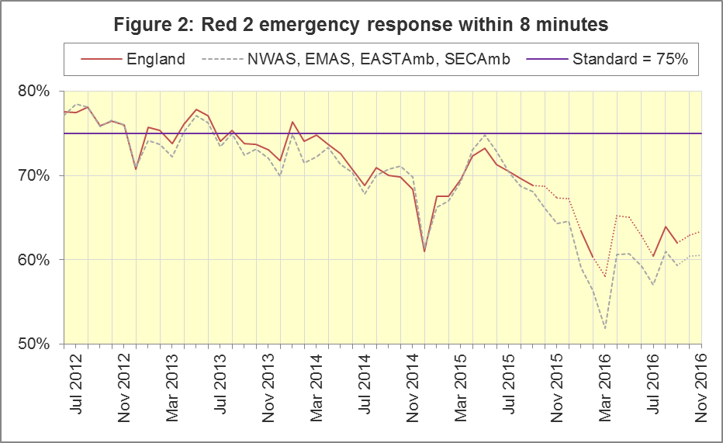

A5 Category A Ambulance response in 19 minutes (Figure 3)
The other ambulance standard in the Handbook to the NHS Constitution is for trusts to send, within 19 minutes, a fully-equipped ambulance vehicle, able to transport the patient in a clinically safe manner, to 95% of Category A calls. For England⁷, and for the four trusts with the same DoD implementation timetable, this measure has followed the same trend as Red 2. That is not surprising because Red 2 calls comprise more than 90% of Category A calls.
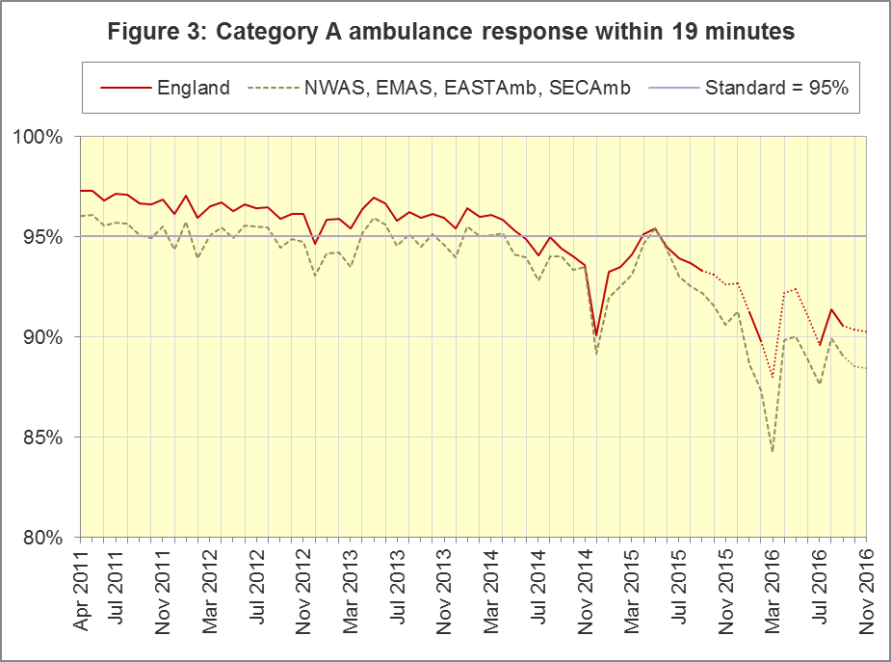
The numerators and denominators for Figures 2 and 3 are on the “DoD R2” tab and the “DoD A19” tab respectively, in the Systems Indicators Time Series spreadsheet at http://bit.ly/NHSAQI.
For other Systems Indicators, DoD and the CCR do not affect comparability, but may lead to changes in levels. For example, a longer triage time may mean fewer ambulances dispatched, leading to better ambulance availability, and more timely responses to Red 1 calls. A longer triage time may also mean more calls are closed on the telephone. However, any such effects may be difficult to detect within the habitual variation of the many AQI.

A6 Systems Indicators: Ambulance volumes (Figure 4)
The number of emergency telephone calls presented to switchboard in November 2016 was 819,120, an average of 27.3 thousand per day.
There were 578,228 emergency calls that received a face-to-face response from the ambulance service in November 2016, an average of 19.3 thousand per day. This is only the fifth month since the series began in April 2011 with an average of more than 19 thousand per day; all five have been in the last twelve months.
There were 408,366 incidents with a patient transported to Type 1 or Type 2 A&E in November 2016, an average of 13.6 thousand per day.
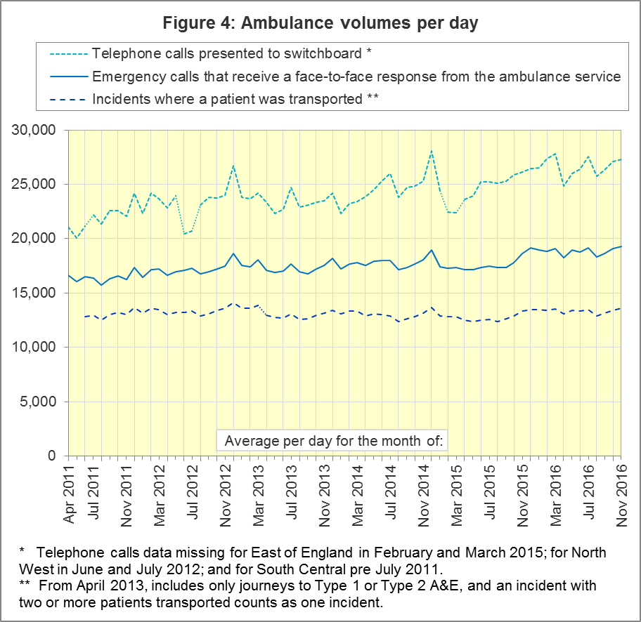

A7 Latest monthly data for other Systems Indicators, November 2016
Of calls in November 2016 that received a face-to-face response from the ambulance service, the proportion managed without need for transport to Type 1 and Type 2 A&E was 37.2%; this was a significant decrease from the twelve months ending September 2016, and the lowest proportion recorded since April 2015.

Indicator | England | Lowest Trust |  | Highest Trust
Calls abandoned before being answered | 1.5% | North East | 0.5% | North West | 4.4 %
Calls resolved through telephone assessment | 10.1% | West Midlands | 5.0% | East Midlands | 16.0%
Calls resolved without transport to Type 1 or Type 2 A&E | 37.2% | East Midlands | 22.1% | South Western | 49.7%
Recontact rate following discharge by telephone advice | 6.1% | East Midlands | 1.0% | West Midlands | 14.1%
Recontact rate following face-to-face treatment at scene | 5.3% | Yorkshire | 1.5% | London | 9.2%
Incidents where a patient was transported | 408,366 | North  East¹¹ | 19,915 | London | 66,828

B. Clinical Outcomes
No thresholds to denote “poor” care are set for Clinical Outcomes. Commissioners are expected to examine trends in these data, and work in collaboration with ambulance trusts to achieve sustained improvement in patient outcomes over time; but commissioners are not expected to use Clinical Outcomes to performance manage trusts, because there will be significant variations in the populations served.

B1 Cardiac arrest: return of spontaneous circulation (ROSC)
Patients in cardiac arrest will typically have no pulse and will not be breathing. In August 2016, in England, resuscitation was commenced or continued by ambulance staff out-of-hospital for 2,407 such patients. Of these, 655 (27%) had ROSC, with a pulse, on arrival at hospital (Figure 5), similar to the England average for 2015-16 of 28%. The largest proportion in August 2016 was 35% for North West and the smallest proportion was 23% for North East.
The Utstein group comprises patients who had resuscitation commenced or continued by the Ambulance Services, following an out-of-hospital cardiac arrest of presumed cardiac origin, where the arrest was bystander witnessed, and the initial rhythm was Ventricular Fibrillation or Ventricular Tachycardia. The Utstein group therefore have a better chance of survival.
There were 326 such patients in England, in August 2016, of which 172 (53%) had ROSC on arrival at hospital (Figure 5), similar to the average for 2015-16 of 51%. The largest proportion in the August 2016 was 66% for Yorkshire and the smallest was 34% for South Western¹¹.
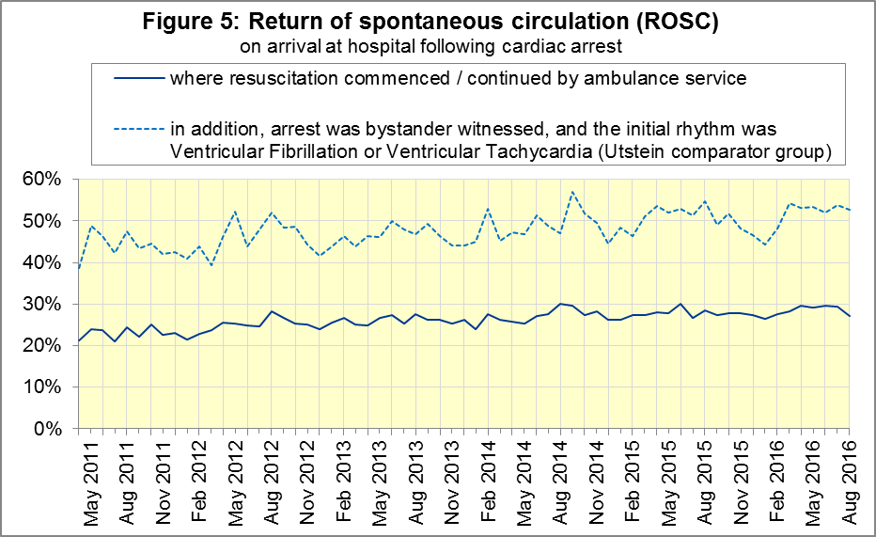

B2 Cardiac arrest: survival to discharge
The proportion of cardiac arrest patients in England discharged from hospital alive was 9% in August 2016 (Figure 6), similar to the average for 2015-16 of 8%. The largest proportion in August 2016 was 12% for East Midlands; the smallest was 7% for North East.
For the Utstein group, survival to discharge in August 2016 was 29%, above the average for 2015-16 of 27%. The largest proportion was 50% for North East; the smallest was 16% for South Western¹³.
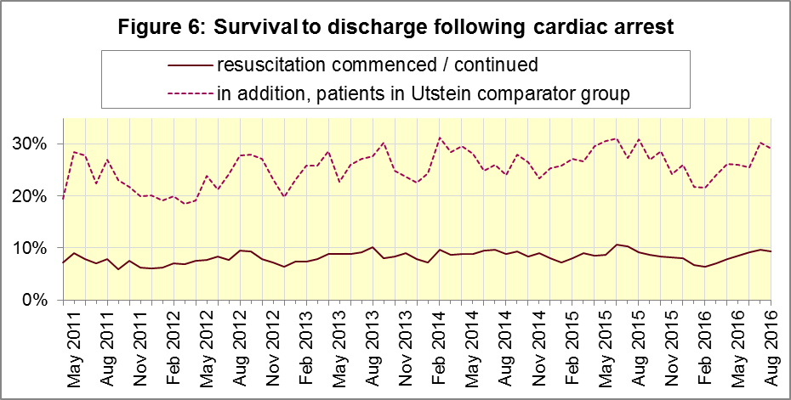

B3 ST-Elevation myocardial infarction
ST-segment elevation myocardial infarction (STEMI) is a type of heart attack, determined by an electrocardiogram (ECG) test. Early access to reperfusion, where blocked arteries are opened to re-establish blood flow, and other assessment and care interventions, are associated with reductions in STEMI mortality and morbidity.
785 STEMI patients received primary angioplasty in August 2016, in England. Of these patients, 674 (86%) of them received it within 150 minutes of the call being connected to the ambulance service (Figure 7), similar to the average for 2015-16 of 87%. The largest proportion in August 2016 was 100% for North East and the smallest was 71% for South Western.
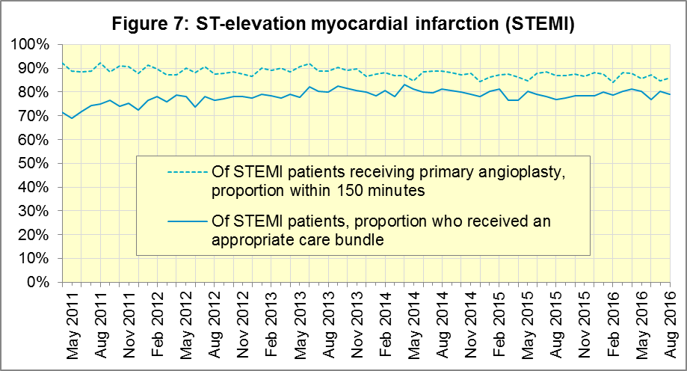
In August 2016, of 1,448 patients with an acute STEMI in England, 1,144 (79%) received the appropriate care bundle, the same as the 2015-16 average. East of England had the largest proportion with 90% and the smallest was London with 65%.

B4 Stroke
The FAST procedure helps assess whether someone has suffered a stroke:
- Facial weakness: can the person smile? Has their mouth or eye drooped?
- Arm weakness: can the person raise both arms?
- Speech problems: can the person speak clearly and understand what you say?
- Time to call 999 for an ambulance if you spot any one of these signs.
In August 2016, of 3,036 FAST positive patients in England, assessed face to face, and potentially eligible for stroke thrombolysis within agreed local guidelines, 1,719 (57%) arrived at hospitals with a hyperacute stroke unit within 60 minutes of an emergency call connecting to the ambulance service. The largest proportion for August 2016 was 68% for London and the smallest was 30% for South Central.
There were 6,848 stroke patients assessed face to face in August 2016 in England, and 6,671 (97%) received the appropriate care bundle, similar to the average for 2015-16 of 98%.
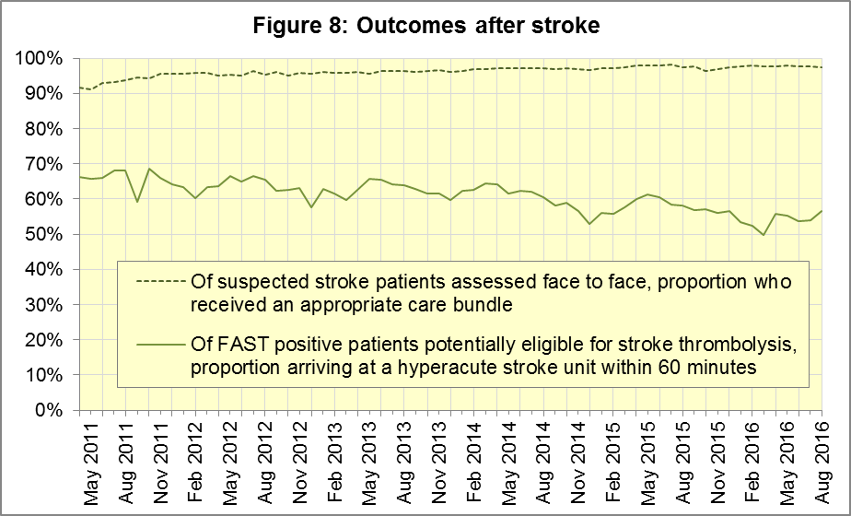

C. Further information on AQI

C1 The AQI landing page and Quality Statement
www.england.nhs.uk/statistics/statistical-work-areas/ambulance-quality-indicators, or http://bit.ly/NHSAQI, is the AQI landing page, and it holds:
- a Quality Statement for these statistics, which includes information on relevance, accuracy, timeliness, coherence, and user engagement;
- the specification guidance document for those who supply the data;
- timetables for data collection and publication;
- text files and time series spreadsheets containing all data from April 2011 up to the latest month;
- links to individual web pages for each financial year.
The web pages for each financial year hold:
- separate spreadsheets of each month’s data;
- this Statistical Note, and equivalent versions from previous months;
- the list of people with pre-release access to the data.
Publication dates are also at www.gov.uk/government/statistics/announcements.

C2 Revisions Timetable
Revisions usually follow a six-monthly cycle. The dates for past and future AQI scheduled revisions are below. The AQI Quality Statement above contains a more detailed revisions policy.
Publication date |  | Series revised |  | Months affected
11 May 2017 |  | Systems Indicators |  | April 2016 to February 2017
9 March 2017 |  | Clinical Outcomes |  | April 2016 to September 2016
10 November 2016  8 September 2016  12 May 2016 |  | Systems Indicators  Clinical Outcomes  Systems Indicators |  | April 2016 to August 2016  April 2015 to April 2016  April 2015 to February 2016
10 April 2016 |  | Clinical Outcomes |  | April 2015 to September 2015
10 September 2015 |  | Clinical Outcomes |  | April 2014 to March 2015
4 June 2015 |  | Systems Indicators |  | April 2014 to February 2015
30 April 2015 |  | Systems Indicators |  | April 2014 to February 2015
5 March 2015 |  | Clinical Outcomes |  | April 2014 to September 2014
6 November 2014 |  | Systems Indicators |  | April 2013 to August 2014
5 September 2014 |  | Clinical Outcomes |  | April 2013 to March 2014
2 May 2014 |  | Systems Indicators |  | April 2013 to February 2014
7 March 2014 |  | Clinical Outcomes |  | April 2013 to September 2013
1 November 2013 |  | Systems Indicators |  | April 2013 to August 2013
2 August 2013 |  | Clinical Outcomes |  | April 2012 to March 2013
3 May 2013 |  | Systems Indicators |  | April 2012 to March 2013
1 February 2013 |  | Clinical Outcomes |  | April 2012 to August 2012
11 January 2013 |  | Systems Indicators |  | April 2011 to October 2012
31 August 2012 |  | Clinical Outcomes |  | April 2011 to March 2012

C3 AQI Scope
The AQI include calls made by dialling either the usual UK-wide number 999 or its international equivalent 112.
As described in the specification guidance mentioned in section C1, calls made to NHS 111 are not included in the AQI measures for calls abandoned, re-contacts, frequent callers, time to answer calls, or calls resolved by telephone advice.
All other Systems Indicators involve the dispatch of an ambulance, and include ambulances dispatched as a result of a call to NHS 111, as well as 999 or 112.

C4 Related statistics in England
The AQI appear in a Clinical Dashboard, available from the AQI landing page, which presents an alternative layout for the same data. Because of the Ambulance Response Programme, described in section A2, and consequent lack of comparability, NHS England no longer updates this dashboard.
The AQI were also used in the “Ambulance Services” publications by NHS Digital, which included additional annual analysis and commentary. The April 2013 and earlier NHS Digital publications used the KA34 data collection, which was similar to the AQI Systems Indicators collection, but annual rather than monthly. The final two publications, before NHS Digital ended this publication, used AQI data. http://content.digital.nhs.uk/article/2021/Website-Search?q=ka34
The AQI Quality Statement described in section C1 contains more information on the NHS Digital publication. It also contains details of weekly ambulance situation reports that NHS England collected for six months from November 2010.
Ambulance handover delays of over 30 minutes at each Emergency Department were collected and published by NHS England each winter until 2014-15: www.england.nhs.uk/statistics/statistical-work-areas/winter-daily-sitreps

C5 Rest of United Kingdom
Ambulance statistics for other countries of the UK can be found at the following websites. The AQI Quality Statement described in section C1 contains more information about the comparability of these statistics.
Wales: | http://wales.gov.uk/statistics-and-research/ambulance-services/?lang=en
Scotland: | See Quality Improvement Indicators (QII) documents at www.scottishambulance.com/TheService/BoardPapers.aspx
Northern Ireland: | www.health-ni.gov.uk/articles/emergency-care-and-ambulance-statistics

C6 Contact information
For press enquiries, please contact the NHS England press office on 0113 825 0958 or nhsengland.media@nhs.net.
The person responsible for producing this publication is:
Ian Kay, Operational Information for Commissioning (National), NHS England
Room 5E24, Quarry House, Leeds, LS2 7UE; 0113 825 4606; i.kay@nhs.net

C7 National Statistics
The UK Statistics Authority has designated these statistics as National Statistics, in accordance with the Statistics and Registration Service Act 2007 and signifying compliance with the Code of Practice for Official Statistics.
Designation can be broadly interpreted to mean that the statistics:
- meet identified user needs;
- are well explained and readily accessible;
- are produced according to sound methods; and
- are managed impartially and objectively in the public interest.
Once statistics have been designated as National Statistics it is a statutory requirement that the Code of Practice shall continue to be observed.

Page 34 of the July 2015 Handbook to the NHS Constitution has Ambulance response time standards, www.gov.uk/government/publications/supplements-to-the-nhs-constitution-for-england.
From February 2015, changes in operational practice meant that Red 2 response data are still available but not always comparable; see section A2 on Dispatch on Disposition. Also, after June 2016, Category A only applies to 8 of the 11 Ambulance Services in England, so Red 1 and Red 2 response data are not available for the other 3; see section A3 on the Clinical Coding Review.
On 1 July 2012, Category A (immediately life-threatening) calls was split into Red 1 and Red 2. Red 1 calls are the most time critical, and cover cardiac arrest patients who are not breathing and do not have a pulse, and other severe conditions such as airway obstruction. Red 2 calls are serious, but less immediately time critical, and cover conditions such as stroke and fits. www.gov.uk/government/news/changes-to-ambulance-response-time-categories
England excludes YAS and SWAS after April 2016, and WMAS after June 2016. See section A3.
Dispatch on Disposition announcement: www.parliament.uk/business/publications/written-questions-answers-statements/written-statement/Commons/2015-01-16/HCWS201
Ambulance Response Programme information: www.england.nhs.uk/ourwork/qual-clin-lead/arp
England excludes YAS and SWAS after April 2016, and WMAS after June 2016. See section A3.
The number of emergency calls presented to switchboard does not usually include calls made to NHS 111 requiring an ambulance. 111 calls requiring an ambulance are usually transferred electronically direct to ambulance dispatch, and not routed via 999 call handlers. Occasionally, manual requests for ambulance are made between 111 and 999 call handlers, and such calls are included in the number of emergency calls presented to switchboard.
Type 1 are consultant-led 24 hour emergency departments with full resuscitation facilities. Type 2 offer a consultant-led speciality A&E service such as ophthalmology or dental. Type 3 is A&E / minor injury activity that may be doctor-led or nurse-led. Type 4 are NHS walk-in centres. (www.datadictionary.nhs.uk/data_dictionary/attributes/a/acc/ accident_and_emergency_department_type_de.asp)
Significance calculations used are Student’s t-test with 95% significance.
Due to its small size, performance on Isle of Wight tends to vary more than other trusts. If it has the largest or smallest value, the Table in Section A7 shows the second largest or smallest value, but has a footnote marker to show that Isle of Wight is more extreme. The Clinical Outcomes in section B also use this system.
This definition was proposed at Utstein Abbey in Norway by an international group of cardiologists and other health professionals in 1990. http://circ.ahajournals.org/content/110/21/3385
Excluding Isle of Wight. See footnote 11 on page 6.
Pages 27 to 30 of the specification guidance for data suppliers on the AQI landing page at www.england.nhs.uk/statistics/statistical-work-areas/ambulance-quality-indicators describe the care bundles, and certain exclusions, for the STEMI and stroke indicators.

