## Statistical Note: Ambulance Quality Indicators (AQI)

The latest Systems Indicators for January 2017 for Ambulance Services in England showed the standards in the Handbook[1] to the NHS constitution were not met.

The latest Clinical Outcomes data are stable for patients transported by Ambulance Services in October 2016.

## A. Systems Indicators

### A1 Emergency response in 8 minutes (Figure 1)

In January 2017, of Category[2], [3] A Red 1 calls in England, resulting in an emergency response, the proportion arriving within 8 minutes was 66.7%.

In January 2017, of Category2, 3 A Red 2 calls in England resulting in an emergency response, the proportion arriving within 8 minutes was 58.5%.

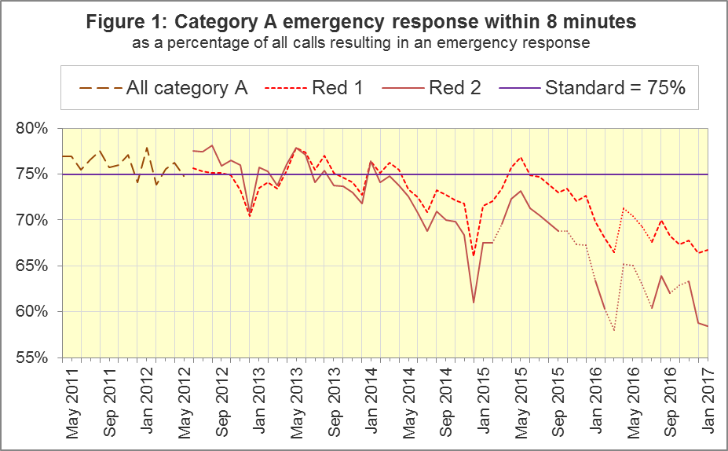

The standard for Ambulance Services is to send an emergency response, with a defibrillator, within 8 minutes to 75% of Category A calls. Figure 1 shows that for England[4], Red 1 performance in January 2017 was nearly as low as in December 2016.

For Red 1, out of the eight trusts where Category A still applied, only Isle of Wight Ambulance Service (IOW) met the 75% standard in January 2017. North West (NWAS) had the lowest proportion, 61.8%.

On 1 January 2017, at London Ambulance Service (LAS), between 00:30 and 08:00, calls were triaged and responded to appropriately, but recorded on paper, due to a Computer-Aided Dispatch system outage. LAS data from that time period relating to calls that were resolved by providing telephone advice and re-contact figures were therefore not captured and included in the AQI. Incidents that were triaged and responded to as either Red 1 or Red 2 were reported as Green 2 during the system outage and are also not included in the AQI.

### A2 Dispatch on Disposition

In January 2015, the Secretary of State for Health announced[5] the introduction of Dispatch on Disposition (DoD). This was the first change affecting the AQI due to the Ambulance Response Programme (ARP)[6]. It does not apply to Red 1 calls.

It meant that response data were still available across England, but for any affected Ambulance Service, Red 2 and Category A response data were no longer comparable before and after when DoD was introduced.

DoD increases the maximum time for triage, which means to identify the clinical situation and to take appropriate action. The change was based upon clinical advice that it would be likely to improve the overall outcomes for ambulance patients.

Until 10 February 2015, other than for Red 1 calls, the start time was the earliest of:

1. chief complaint or NHS Pathways initial disposition (Dx) code obtained;
2. first vehicle assigned;
3. 60 seconds after call connect.

From 10 February 2015, option 3 was increased from 60 seconds to 180 seconds for LAS and South Western (SWAS) Ambulance Services. From October 2015, further changes were tested in a variety of Ambulance Services on different dates, which are listed in full in the 8 December 2016 AQI Statistical Note. During October 2016, all Ambulance Services in England were aligned with a maximum start time of 240 seconds, except for IOW which aligned on 7 February 2017.

### A3 Clinical Coding Review

The second change affecting the AQI due to the ARP was the Clinical Coding Review (CCR). This was a clinically-led evidence based review of the call coding categorisations, to ensure patients receive the most appropriate response.

The existing Category A (Red 1 and Red 2), Green 1, Green 2, Green 3 and Green 4 categories were replaced with new categories that were not comparable with those used previously.

The new categorisations were piloted by SWAS, Yorkshire (YAS) and West Midlands (WMAS) Ambulance Services from 19 April, 21 April and 8 June 2016 respectively. Therefore, from these dates, Red 1, Red 2 and Category A no longer apply to these Trusts, and consequently data for these categories are no longer available for these Trusts.

### A4 Emergency Response in 8 minutes for Red 2 (Figure 2)

Figure 2 shows that in January 2017 the Red 2 measure for England[7] was 58.5%. Only March 2016 had a lower proportion. The 75% standard was last met in January 2014 and performance has been below 70% since August 2015.

NWAS, East Midlands (EMAS), East of England (EastAmb) and South East Coast (SECAmb) Ambulance Services have always used the same DoD maximum clock start time as each other. All other Ambulance Services implemented DoD according to a unique timetable. Figure 2 shows that, for the four Services where the Red 2 measure is always comparable, this measure follows a similar decline to England7 as a whole.

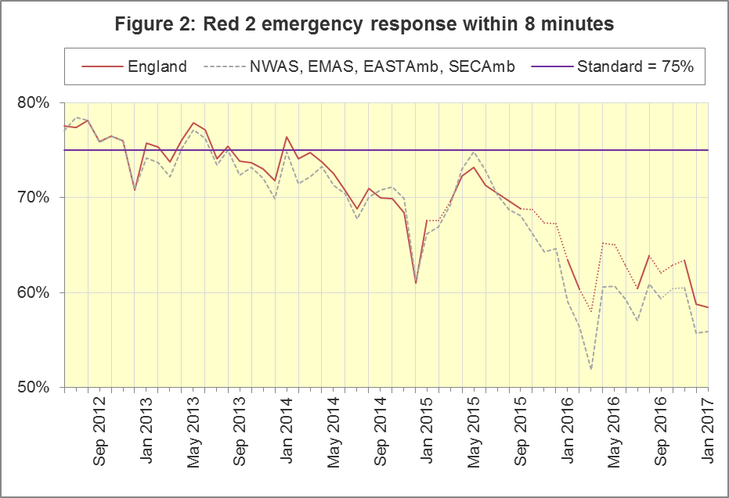

### A5 Category A Ambulance response in 19 minutes (Figure 3)

The second ambulance standard in the Handbook to the NHS Constitution is for trusts to send, within 19 minutes, a fully-equipped ambulance vehicle, able to transport the patient in a clinically safe manner, to 95% of Category A calls. For England8 in January 2017 performance was 87.6%, a significant decrease[8] and the lowest proportion recorded since the data collection began in June 2012. For the four trusts with the same DoD implementation timetable, this measure has followed the same trend as England[9] as a whole.

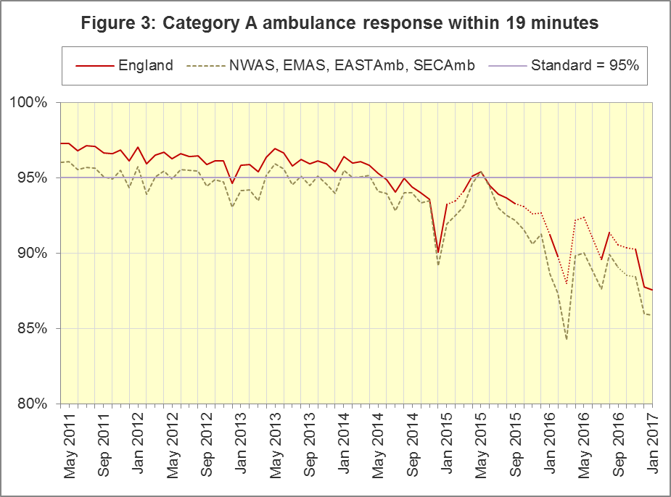

The numerators and denominators for Figures 2 and 3 are on the “DoD R2” and “DoD A19” tab respectively, in the Systems Indicators Time Series spreadsheet at <http://bit.ly/NHSAQI>.

In the trusts where Category A still applies, South Central (SCAS) had the highest proportion for both 8 minute Red 2 and 19 minute Category A, 71% and 94% respectively. SECAmb had the lowest proportion (48%) for Red 2, and EMAS had the lowest proportion (82%) for Category A.

For other Systems Indicators, DoD and the CCR do not affect comparability, but may lead to changes in levels. For example, a longer triage time may mean more calls are closed on the telephone, but the data for this measure remain comparable. Such changes may be difficult to detect within the habitual variation of the many AQI.

### A6 Systems Indicators: Ambulance volumes (Figure 4)

The number[10] of emergency telephone calls presented to the switchboard in January 2017 was 840,302, an average of 27.1 thousand per day, fewer than in December 2016 but similar to in October and November.

There were 603,886 emergency calls that received a face-to-face response from the ambulance service in January 2017, an average of 19.5 thousand per day, less than in December 2016 but more than in all other months.

There were 422,892 incidents with a patient transported to Type 1 or Type 2 A&E[11] in January 2017, an average of 13.6 thousand per day.

Figure 4 shows a general upward trend in all these measures, but also that each habitually reduce between December and January.

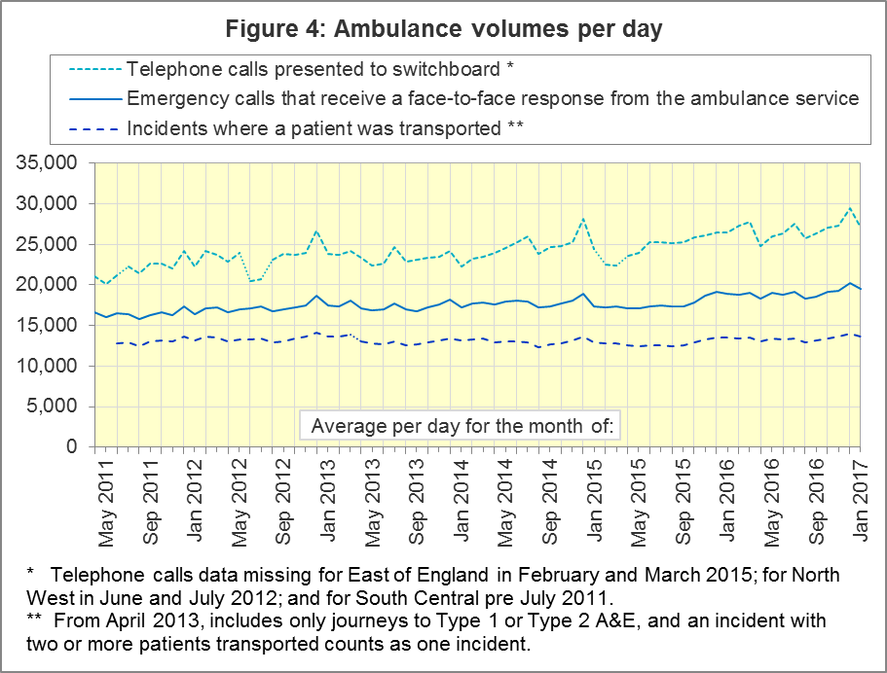

### A7 Latest monthly data for other Systems Indicators, January 2017

All other Systems Indicators in January 2017 were within their ranges from the previous twelve months.

| Indicator | England | Lowest Trust | | Highest Trust | |
| --- | --- | --- | --- | --- | --- |
| Calls abandoned before being answered | 1.3% | SCAS | 0.2% | SECAMB | 4.6% |
| Calls resolved through telephone assessment | 10.2% | WMAS | 5% | EMAS, SWAS | 15% |
| Calls resolved without transport to Type 1 or Type 2 A&E | 37.6% | EMAS | 23% | SWAS[12] | 50% |
| Recontact rate following discharge by telephone advice | 6.1% | EMAS | 1% | WMAS | 15% |
| Recontact rate following face-to-face treatment at scene | 5.6% | YAS | 1% | LAS | 9% |
| Incidents where a patient was transported | 422,892 | NEAS12 | 21,152 | LAS | 68,664 |

## B. Clinical Outcomes

No thresholds to denote “poor” care are set for Clinical Outcomes. Commissioners are expected to examine trends in these data, and work in collaboration with ambulance trusts to achieve sustained improvement in patient outcomes over time; but commissioners are not expected to use Clinical Outcomes to performance manage trusts, because there will be significant variations in the populations served.

### B1 Cardiac arrest: return of spontaneous circulation (ROSC)

Patients in cardiac arrest will typically have no pulse and will not be breathing. In October 2016, in England, resuscitation was commenced or continued by ambulance staff out-of-hospital for 2,652 such patients. Of these, 705 (27%) had ROSC, with a pulse, on arrival at hospital (Figure 5), similar to the proportion for the year ending September 2016, of 28%. The largest proportion in October 2016 was 36% for NWAS and the smallest12 proportion was 18% for SCAS and EMAS.

The Utstein group[13] comprises patients who had resuscitation commenced or continued by the Ambulance Services, following an out-of-hospital cardiac arrest of presumed cardiac origin, where the arrest was bystander witnessed, and the initial rhythm was Ventricular Fibrillation or Ventricular Tachycardia. The Utstein group therefore have a better chance of survival.

There were 359 such patients in England, in October 2016, of which 171 (48%) had ROSC on arrival at hospital (Figure 5), similar to the year ending September 2016, 51%. The largest proportion in the October 2016 was 65% for NEAS and the smallest was 28% for SCAS.

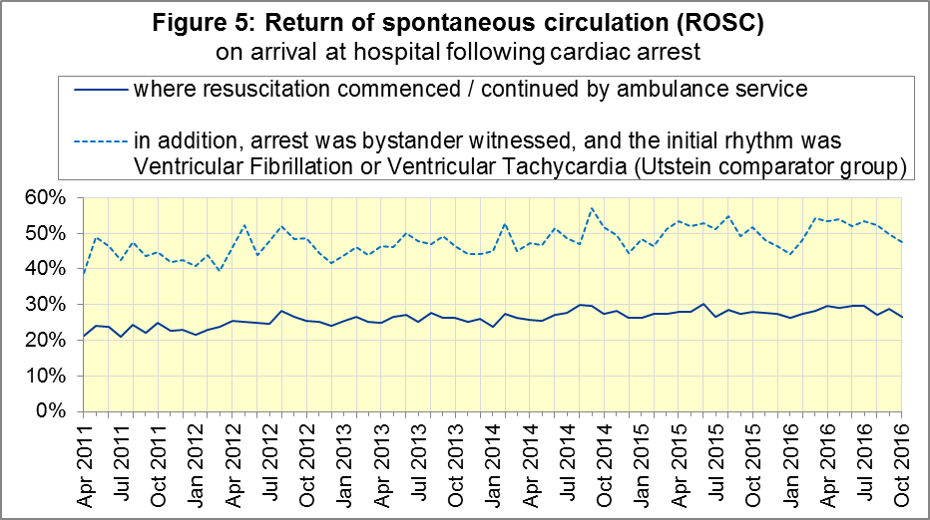

### B2 Cardiac arrest: survival to discharge

The proportion of cardiac arrest patients in England discharged from hospital alive was 8% in October 2016 (Figure 6), the same as in the year ending September. The largest proportion in October 2016 was 11% for YAS; the smallest[14] was 3% for EMAS.

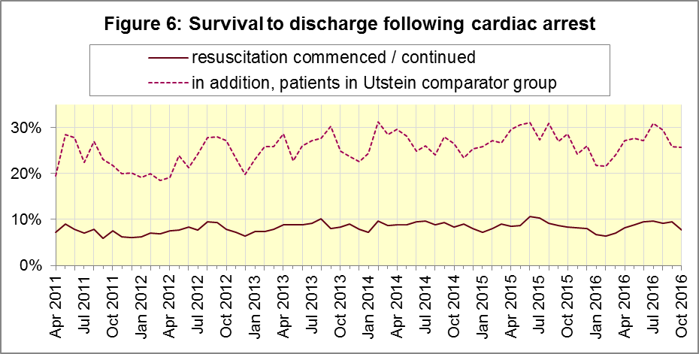

For the Utstein group, survival to discharge in October 2016 was 26%, the same as in the year ending September. The largest proportion was 36% for YAS; the smallest was 14% for NWAS.

### B3 ST-Elevation myocardial infarction

ST-segment elevation myocardial infarction (STEMI) is a type of heart attack, determined by an electrocardiogram (ECG) test. Early access to reperfusion, where blocked arteries are opened to re-establish blood flow, and other assessment and care interventions, are associated with reductions in STEMI mortality and morbidity.

859 STEMI patients received primary angioplasty in October 2016, in England. Of these patients, 742 (86%) of them received it within 150 minutes of the call being connected to the ambulance service (Figure 7), similar to the year ending September 2016 (87%). The largest proportion in October 2016 was 97% for SECAmb and the smallest was 76% for NEAS, NWAS and SWAS.

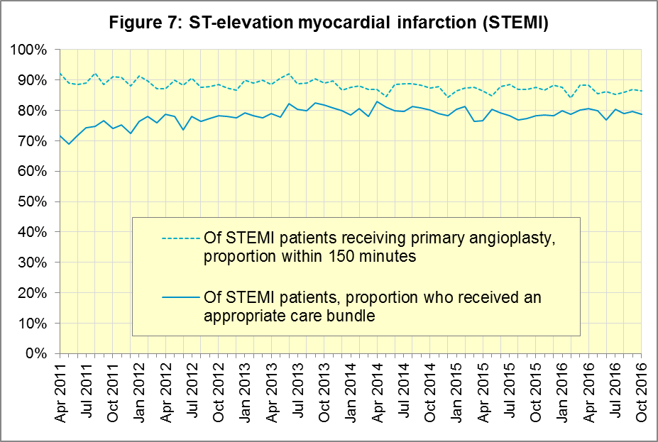

In October 2016, of 1,494 patients with an acute STEMI in England, 1,176 (79%) received the appropriate care bundle[15], the same as in the year ending September 2016. YAS had the largest proportion with 90% and the smallest[16] was SECAmb with 63%.

### B4 Stroke

The FAST procedure helps assess whether someone has suffered a stroke:

* **F**acial weakness: can the person smile? Has their mouth or eye drooped?
* **A**rm weakness: can the person raise both arms?
* **S**peech problems: can the person speak clearly and understand what you say?
* **T**ime to call 999 for an ambulance if you spot any one of these signs.

In October 2016, of 3,443 FAST positive patients in England, assessed face to face, and potentially eligible for stroke thrombolysis within agreed local guidelines, 1,780 (52%) arrived at hospitals with a hyperacute stroke unit within 60 minutes of an emergency call connecting to the ambulance service, less than in the year ending September 2016 (54%). The largest proportion for October 2016 was 63% for SECAmb and the smallest was 35% for SWAS.

There were 7,470 stroke patients assessed face to face in October 2016 in England, and 7,291 (98%) received the appropriate care bundle, similar to the year ending September 2016 (97%).

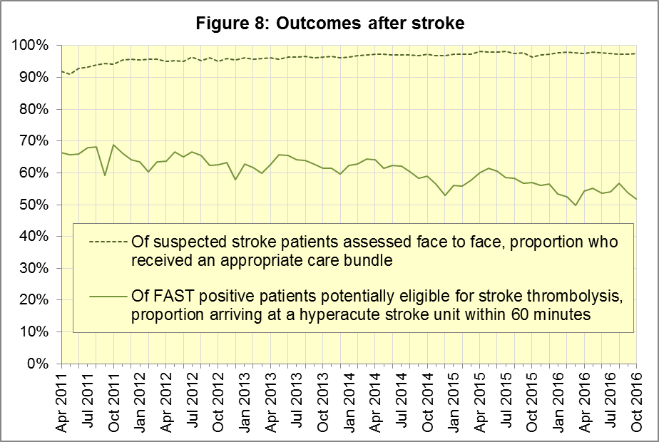

### B5 Revisions

Eight Trusts have taken the six-monthly opportunity to supply revisions to Clinical Outcomes for April to September 2016 data, which are used in the data in Section B above. Only NWAS, EastAmb and IOW have not. The largest revisions to proportions are survival after cardiac arrest (Utstein, Figure 12) and thrombolysis after stroke (Figure 15). SCAS in particular have made large changes to counts of thrombolysis after stroke (Figure 17).

#### Figure 9: Revisions to ROSC after cardiac arrest (all patients), England, 2016

#### Fig. 10: Revisions to ROSC after cardiac arrest (Utstein group), England, 2016

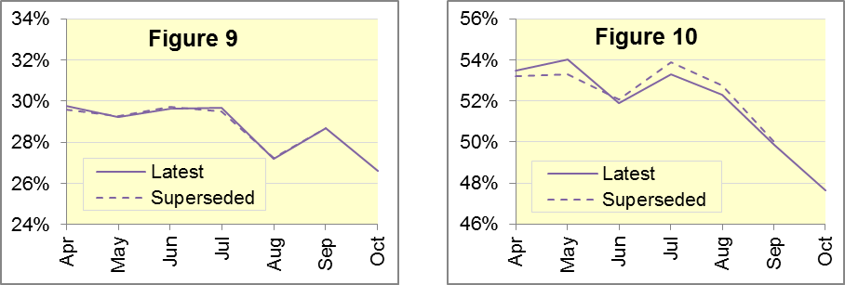

#### Figure 11: Revisions to Survival after cardiac arrest (all), England, 2016

#### Figure 12: Revisions to Survival after cardiac arrest (Utstein), England, 2016

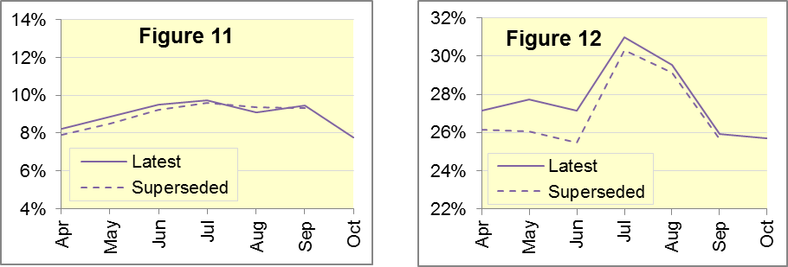

#### Figure 13: Revisions to angioplasty within 150 min. of STEMI, England, 2016

#### Figure 14: Revisions to STEMI patients given care bundle, England, 2016

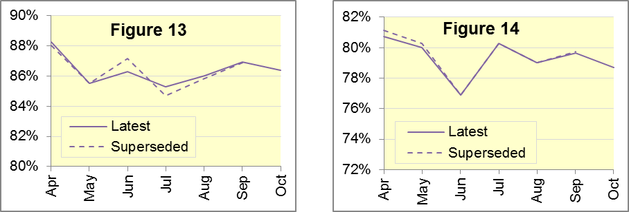

#### Figure 15: Revisions to Thrombolysis within 60 min. of stroke, England, 2016

#### Figure 16: Revisions to stroke patients given care bundle, England, 2016

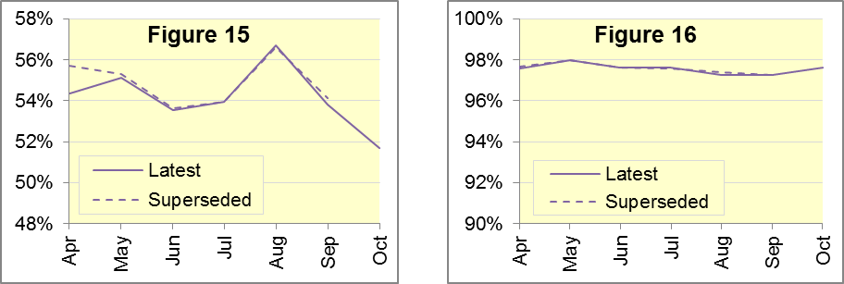

#### Figure 17: Revisions of more than 10% points to Trust-level monthly data, 2016

|  |  |  |  |  |  |  |  |
| --- | --- | --- | --- | --- | --- | --- | --- |
| Trust | Indicator | Month | From |  |  | To |  |
| NEAS | STEMI Angioplasty in 150 minutes | Apr | 45 / 56 | 80.4% |  | 45 / 47 | 95.7% |
| SECAmb | Stroke Unit in 60 min | Apr | 324 / 424 | 76.4% |  | 260 / 408 | 63.7% |
| SCAS | Stroke Unit in 60 min | Apr | 8 / 22 | 38.1% |  | 167 / 301 | 53.8% |
|  |  | Jun | 16 / 42 | 36.4% |  | 161 / 299 | 55.5% |
|  |  | Aug | 9 / 30 | 30.0% |  | 146 / 276 | 52.9% |

#### Figure 18: Revisions of more than 1% point to England monthly data, 2016

|  |  |  |  |  |  |  |  |
| --- | --- | --- | --- | --- | --- | --- | --- |
| Indicator | Month |  | From | |  | To | |
| Survival following cardiac arrest (Utstein) | Apr |  | 80 / 306 | 26.1% |  | 85 / 313 | 27.2% |
| May |  | 73 / 280 | 26.1% |  | 81 / 292 | 27.7% |
| Jun |  | 80 / 314 | 25.5% |  | 88 / 324 | 27.2% |
| Stroke Unit within 60 min | Apr |  | 1621 / 2910 | 55.7% |  | 1729 / 3182 | 54.3% |

## C. Further information on AQI

### C1 The AQI landing page and Quality Statement

[www.england.nhs.uk/statistics/statistical-work-areas/ambulance-quality-indicators](http://www.england.nhs.uk/statistics/statistical-work-areas/ambulance-quality-indicators), or <http://bit.ly/NHSAQI>, is the AQI landing page, and it holds:

* a Quality Statement for these statistics, which includes information on relevance, accuracy, timeliness, coherence, and user engagement;
* the specification guidance document for those who supply the data;
* timetables for data collection and publication;
* text files and time series spreadsheets containing all data from April 2011 up to the latest month;
* links to individual web pages for each financial year.

The web pages for each financial year hold:

* separate spreadsheets of each month’s data;
* this Statistical Note, and equivalent versions from previous months;
* the list of people with pre-release access to the data.

Publication dates are also at [www.gov.uk/government/statistics/announcements](http://www.gov.uk/government/statistics/announcements).

### C2 Revisions Timetable

Revisions usually follow a six-monthly cycle. The dates for past and future AQI Systems Indicators (SI) and Clinical Outcomes (CO) scheduled revisions are below. The AQI Quality Statement above contains a more detailed revisions policy.

| Publication |  | Data |  | Months affected |  |  | Publication |  | Data |  | Months affected |
| --- | --- | --- | --- | --- | --- | --- | --- | --- | --- | --- | --- |
| 11 May 2017 |  | SI |  | Apr ‘16 - Feb ‘17 |  |  | 6 Nov 2014 |  | SI |  | Apr ‘13 - Aug ‘14 |
| 9 Mar 2017 |  | CO |  | Apr ‘16 - Sep ‘16 |  |  | 5 Sep 2014 |  | CO |  | Apr ‘13 - Mar ‘14 |
| 10 Nov 2016 |  | SI |  | Apr ‘16 - Aug ‘16 |  |  | 2 May 2014 |  | SI |  | Apr ‘13 - Feb ‘14 |
| 8 Sep 2016 |  | CO |  | Apr ‘15 - Apr ‘16 |  |  | 7 Mar 2014 |  | CO |  | Apr ‘13 - Sep ‘13 |
| 12 May 2016 |  | SI |  | Apr ‘15 - Feb ‘16 |  |  | 1 Nov 2013 |  | SI |  | Apr ‘13 - Aug ‘13 |
| 10 Apr 2016 |  | CO |  | Apr ‘15 - Sep ‘15 |  |  | 2 Aug 2013 |  | CO |  | Apr ‘12 - Mar ‘13 |
| 10 Sep 2015 |  | CO |  | Apr ‘14 - Mar ‘15 |  |  | 3 May 2013 |  | SI |  | Apr ‘12 - Mar ‘13 |
| 4 Jun 2015 |  | SI |  | Apr ‘14 - Feb ‘15 |  |  | 1 Feb 2013 |  | CO |  | Apr ‘12 - Aug ‘12 |
| 30 Apr 2015 |  | SI |  | Apr ‘14 - Feb ‘15 |  |  | 11 Jan 2013 |  | SI |  | Apr ‘11 - Oct ‘12 |
| 5 Mar 2015 |  | CO |  | Apr ‘14 - Sep ‘14 |  |  | 31 Aug 2012 |  | CO |  | Apr ‘11 - Mar ‘12 |
|  |  |  |  |  |  |  | 4 May 2012 |  | SI & CO |  | Apr ‘11 - Mar ‘12 |

### C3 AQI Scope

The AQI include calls made by dialling either the usual UK-wide number 999 or its international equivalent 112.

As described in the specification guidance mentioned in section C1, calls made to NHS 111 are not included in the AQI measures for calls abandoned, re-contacts, frequent callers, time to answer calls, or calls resolved by telephone advice.

All other Systems Indicators involve the dispatch of an ambulance, and include ambulances dispatched as a result of a call to NHS 111, as well as 999 or 112.

### C4 Related statistics in England

The AQI appear in a Clinical Dashboard, available from the AQI landing page, which presents an alternative layout for the same data. Because of the Ambulance Response Programme, described in section A2, and consequent lack of comparability, NHS England no longer updates this dashboard.

The AQI were also used in the “Ambulance Services” publications[17] by NHS Digital, which included additional annual analysis and commentary, up to and including 2014-15 data. The Quality Statement described in section C1 has more information on this publication. It also contains details of weekly ambulance situation reports that NHS England collected for six months from November 2010.

Ambulance handover delays of over 30 minutes at each Emergency Department were collected and published by NHS England each winter until 2014-15: [www.england.nhs.uk/statistics/statistical-work-areas/winter-daily-sitreps](http://www.england.nhs.uk/statistics/statistical-work-areas/winter-daily-sitreps)

### C5 Rest of United Kingdom

Ambulance statistics for other countries of the UK can be found at the following websites. The AQI Quality Statement described in section C1 contains more information about the comparability of these statistics.

|  |  |
| --- | --- |
| Wales: | <http://wales.gov.uk/statistics-and-research/ambulance-services/?lang=en> |
| Scotland: | See Quality Improvement Indicators (QII) documents at [www.scottishambulance.com/TheService/BoardPapers.aspx](http://www.scottishambulance.com/TheService/BoardPapers.aspx) |
| Northern Ireland: | [www.health-ni.gov.uk/articles/emergency-care-and-ambulance-statistics](http://www.health-ni.gov.uk/articles/emergency-care-and-ambulance-statistics) |

### C6 Contact information

For press enquiries, please contact the NHS England press office on 0113 825 0958 or [nhsengland.media@nhs.net](mailto:nhsengland.media@nhs.net).

The person responsible for producing this publication is:

Ian Kay, Operational Information for Commissioning (Central), NHS England

Room 5E24, Quarry House, Leeds, LS2 7UE; 0113 825 4606; [i.kay@nhs.net](mailto:i.kay@nhs.net)

### C7 National Statistics

The UK Statistics Authority has designated these statistics as National Statistics, in accordance with the Statistics and Registration Service Act 2007 and signifying compliance with the Code of Practice for Official Statistics.

Designation can be broadly interpreted to mean that the statistics:

* meet identified user needs;
* are well explained and readily accessible;
* are produced according to sound methods; and
* are managed impartially and objectively in the public interest.

Once statistics have been designated as National Statistics it is a statutory requirement that the Code of Practice shall continue to be observed.

1. Page 34 of the July 2015 Handbook to the NHS Constitution has Ambulance response time standards, [www.gov.uk/government/publications/supplements-to-the-nhs-constitution-for-england](http://www.gov.uk/government/publications/supplements-to-the-nhs-constitution-for-england).
2. From February 2015, changes in operational practice meant that Red 2 response data are still available but not always comparable; see section A2 on Dispatch on Disposition. Also, after June 2016, Category A only applies to 8 of the 11 Ambulance Services in England, so Red 1 and Red 2 response data are not available for the other 3; see section A3 on the Clinical Coding Review.
3. On 1 June 2012, Category A (immediately life-threatening) calls was split into Red 1 and Red 2. Red 1 calls are the most time critical, and cover cardiac arrest patients who are not breathing and do not have a pulse, and other severe conditions such as airway obstruction. Red 2 calls are serious, but less immediately time critical, and cover conditions such as stroke and fits. [www.gov.uk/government/news/changes-to-ambulance-response-time-categories](http://www.gov.uk/government/news/changes-to-ambulance-response-time-categories)
4. England excludes YAS and SWAS after April 2016, and WMAS after June 2016. See section A3.
5. Dispatch on Disposition announcement: [www.parliament.uk/business/publications/written-questions-answers-statements/written-statement/Commons/2015-01-16/HCWS201](http://www.parliament.uk/business/publications/written-questions-answers-statements/written-statement/Commons/2015-01-16/HCWS201)
6. Ambulance Response Programme information: [www.england.nhs.uk/ourwork/qual-clin-lead/arp](http://www.england.nhs.uk/ourwork/qual-clin-lead/arp)
7. England excludes YAS and SWAS after April 2016, and WMAS after June 2016. See section A3.
8. Significance calculations in this document are Student’s t-test with 95% significance.
9. England excludes YAS and SWAS after April 2016, and WMAS after June 2016. See section A3.
10. The number of emergency calls presented to switchboard does not usually include calls made to NHS 111 requiring an ambulance. 111 calls requiring an ambulance are usually transferred electronically direct to ambulance dispatch and not routed via 999 call handlers. Occasionally, manual requests for ambulances are made between 111 and 999 call handlers and such calls are included in the numbers of emergency calls presented to switchboard.
11. Type 1 are consultant-led 24 hour emergency departments with full resuscitation facilities.

    Type 2 offer a consultant-led speciality A&E service such as ophthalmology or dental.

    Type 3 is A&E / minor injury activity that may be doctor-led or nurse-led.

    Type 4 are NHS walk-in centres. ([www.datadictionary.nhs.uk/data_dictionary/attributes/a/acc/](http://www.datadictionary.nhs.uk/data_dictionary/attributes/a/acc/accident_and_emergency_department_type_de.asp)  
    [accident_and_emergency_department_type_de.asp](http://www.datadictionary.nhs.uk/data_dictionary/attributes/a/acc/accident_and_emergency_department_type_de.asp))
12. Due to its small size, performance on Isle of Wight tends to vary more than other trusts. If it has the largest or smallest value, the Table in Section A7 shows the second largest or smallest value, but has a footnote marker to show that Isle of Wight is more extreme. The Clinical Outcomes in section B also use this system.
13. This definition was proposed at Utstein Abbey in Norway by an international group of cardiologists and other health professionals in 1990. <http://circ.ahajournals.org/content/110/21/3385>
14. Excluding Isle of Wight. See footnote 11 on page 6.
15. Pages 27 to 30 of the specification guidance for data suppliers on the AQI landing page at [www.england.nhs.uk/statistics/statistical-work-areas/ambulance-quality-indicators](http://www.england.nhs.uk/statistics/statistical-work-areas/ambulance-quality-indicators) describe the care bundles, and certain exclusions, for the STEMI and stroke indicators.
16. Excluding Isle of Wight. See footnote 11 on page 6.
17. NHS Digital *Ambulance Services*: <http://content.digital.nhs.uk/article/2021/Website-Search?q=ka34>