Statistical Note: Ambulance Quality Indicators (AQI)
The latest Systems Indicators for March 2017 for Ambulance Services in England showed the standards in the Handbook to the NHS constitution were not met.
The latest Clinical Outcomes data for STEMI patients transported by Ambulance Services in December 2016 show that an increased proportion received the appropriate care bundle; see page 13.

A. Systems Indicators

A1 Emergency response in 8 minutes (Figure 1)
In March 2017, of Category, A Red 1 calls in England, resulting in an emergency response, the proportion arriving within 8 minutes was 70.7%.
In March 2017, of Category^{2, 3} A Red 2 calls in England resulting in an emergency response, the proportion arriving within 8 minutes was 64.3%.
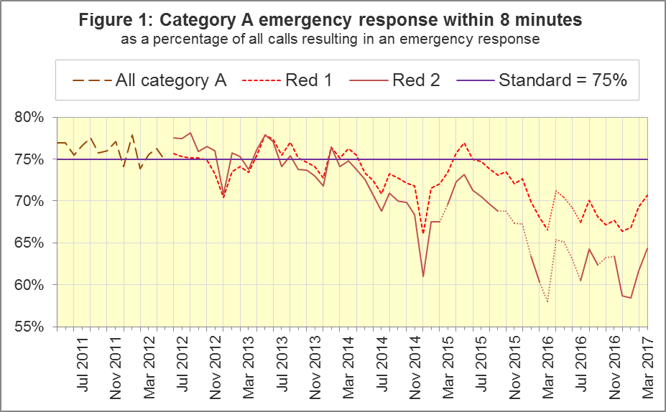
The standard for Ambulance Services is to send an emergency response, with a defibrillator, within 8 minutes to 75% of Category A calls. Figure 1 shows that for England,, Red 1 performance in March 2017 was the highest proportion since Red 1 became only applicable for eight Ambulance Services.
For Red 1, out of the eight trusts where Category A still applies, for the second month in a row, only South Central (SCAS, 75.0%) met the 75% standard in March 2017. North West (NWAS, 65.6%) and South East Coast (SECAmb, 67.3%) Ambulance Services had fewer than 70%.

A2 Dispatch on Disposition
In February 2015, the Secretary of State for Health announced the introduction of Dispatch on Disposition (DoD). This was the first change affecting the AQI due to the Ambulance Response Programme (ARP). It does not apply to Red 1 calls.
It meant that response data were still available across England, but for any affected Ambulance Service, Red 2 and Category A response data were no longer comparable before and after when DoD was introduced.
DoD increases the maximum time for triage, which means to identify the clinical situation and to take appropriate action. The change was based upon clinical advice that it would be likely to improve the overall outcomes for ambulance patients.
Until 10 February 2015, other than for Red 1 calls, the start time was the earliest of:
- chief complaint or NHS Pathways initial disposition (Dx) code obtained;
- first vehicle assigned;
- 60 seconds after call connect.
From 10 February 2015, option 3 was increased from 60 seconds to 180 seconds for London (LAS) and South Western (SWAS) Ambulance Services. From October 2015, further changes were tested in a variety of Ambulance Services on different dates, which are listed in full in the 8 December 2016 AQI Statistical Note. During October 2016, all Ambulance Services in England were aligned with a maximum start time of 240 seconds, except for Isle of Wight (IOW) which aligned on 7 February 2017.

A3 Clinical Coding Review
The second change affecting the AQI due to the ARP was the Clinical Coding Review (CCR). This was a clinically-led evidence based review of the call coding categorisations, to ensure patients receive the most appropriate response.
The existing Category A (Red 1 and Red 2) and Category C (Green 1, Green 2, Green 3, and Green 4) were replaced with new categories that were not comparable with those used previously.
The new categorisations were piloted by SWAS, Yorkshire (YAS) and West Midlands (WMAS) Ambulance Services from 19 April, 21 April and 8 June 2016 respectively. Therefore, from these dates, Red 1, Red 2, and Category A, no longer apply to these Trusts, and consequently data for these categories are no longer available for these Trusts.

A4 Emergency Response in 8 minutes for Red 2 (Figure 2)
Figure 2 shows that in March 2017 the Red 2 measure for England was 64.3%, an increase of more than 2 percentage points on February 2017 (61.7%). However, the 75% standard has not been met since January 2014 and performance has been below 70% since August 2015.
NWAS, SECAmb, East Midlands (EMAS), and East of England (EastAmb) Ambulance Services have always used the same DoD maximum clock start time as each other. All other Ambulance Services implemented DoD according to a unique timetable.
Figure 2 shows that from the trend for England⁸ is similar to the trend for the four Services where the Red 2 measure is always comparable, indicating that the trend for England is reliable despite its discontinuities.
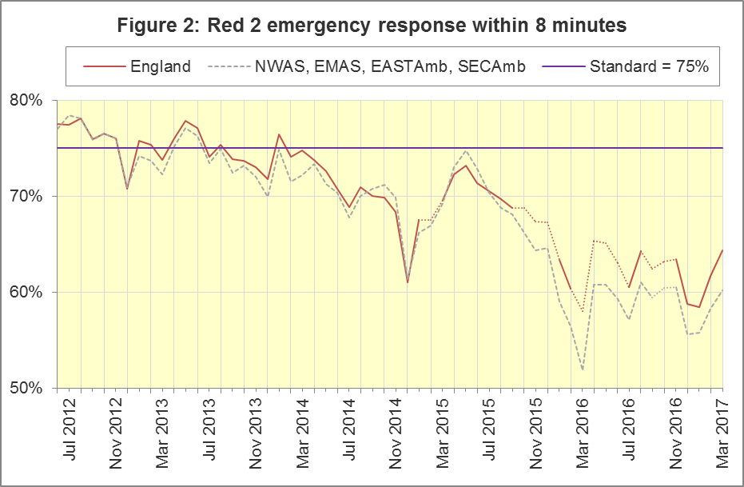

A5 Category A Ambulance response in 19 minutes (Figure 3)
The second ambulance standard in the Handbook to the NHS Constitution is for trusts to send, within 19 minutes, a fully-equipped ambulance vehicle, able to transport the patient in a clinically safe manner, to 95% of Category A calls. For England in March 2017, performance increased to 91.5%, continuing the improvement on January 2017, which was the lowest proportion recorded in the time series. Figure 3 shows that, as for the Red 2 measure, the trend for England is similar to that for the four trusts with the same DoD implementation timetable.
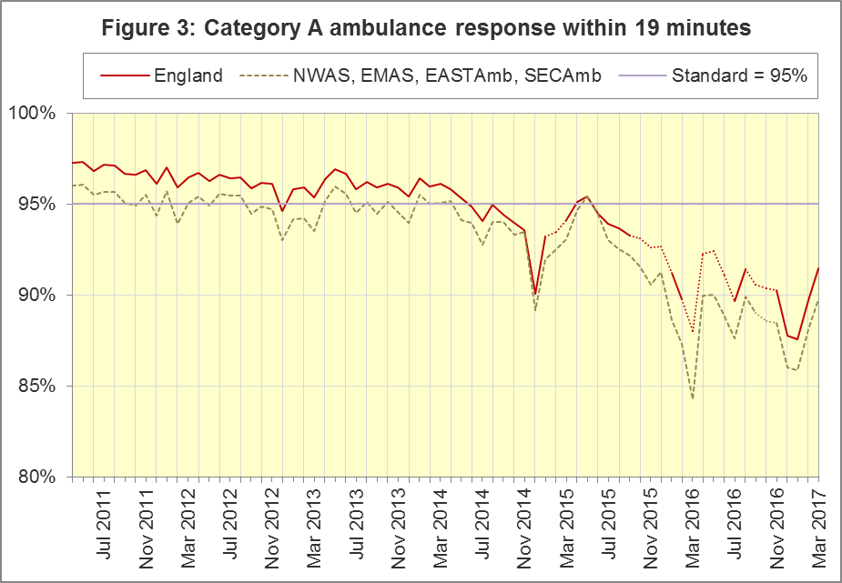
The numerators and denominators for Figures 2 and 3 are on the “DoD R2” and “DoD A19” tab respectively, in the Systems Indicators Time Series spreadsheet at http://bit.ly/NHSAQI.
In the trusts where Category A still applies, no trust met the 8 minute Red 2 standard of 75% in March, but LAS (95.4%) and South Central Ambulance Service (SCAS, 95.1%) met the 19 minute Category A standard of 95%. SECAmb (49.6%) had the lowest proportion for Red 2, and EMAS (86.5%) had the lowest proportion for Category A.
For other Systems Indicators, DoD and the CCR do not affect comparability, but may lead to changes in levels. For example, a longer triage time may mean more calls are closed on the telephone, but the data for this measure remain comparable. Such changes may be difficult to detect within the habitual variation of the many AQI.

A6 Systems Indicators: Ambulance volumes (Figure 4)
The number of emergency telephone calls presented to the switchboard in March 2017 was 812,897, an average of 26.2 thousand per day.
There were 582,062 emergency calls that received a face-to-face response from the ambulance service in March 2017, an average of 18.8 thousand per day, a small decrease on February 2017’s average of 19.0 thousand per day.
There were 417,524 incidents with a patient transported to Type 1 or Type 2 A&E in March 2017, a daily average of 13.5 thousand.
Figure 4 shows a general upward trend in calls and face-to-face responses, but also that each measure habitually reduces after the annual December peak.
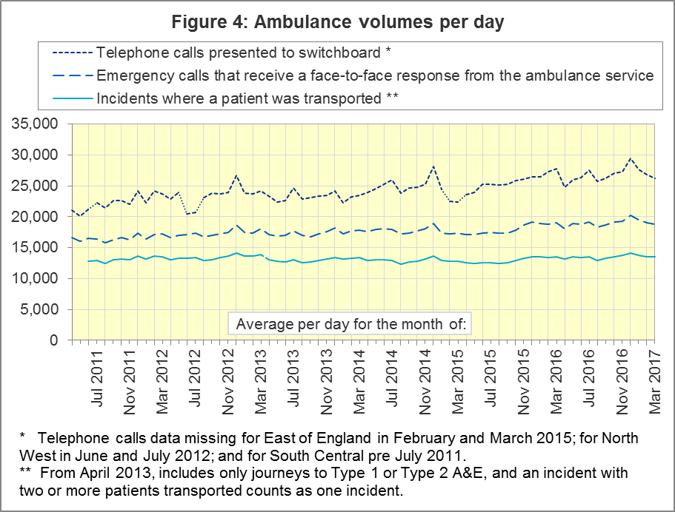

A7 Latest monthly data for other Systems Indicators, March 2017
Of calls that received a face-to-face response from the ambulance service, there was a significant decrease in the proportion that managed without need for transport to Type 1 and Type 2 A&E.
All other Systems Indicators in March 2017 were stable and within their ranges from the previous twelve months:
Indicator | England | Lowest Trust |  | Highest Trust
Calls abandoned before being answered | 0.8% | LAS, NEAS | 0.3% | NWAS | 1.8%
Calls resolved through telephone assessment | 9.7% | WMAS | 5.1% | EMAS | 18.8%
Calls resolved without transport to Type 1 or Type 2 A&E | 37.0% | EMAS | 22.3% | SWAS | 50.0%
Recontact rate following discharge by telephone advice | 6.2% | EMAS | 1.1% | WMAS | 15.4%
Recontact rate following face-to-face treatment at scene | 5.3% | YAS | 1.1% | LAS | 8.9%
Incidents where a patient was transported | 417,524 | NEAS | 20,273 | LAS | 69,413

A8 Revisions
All Ambulance Services except YAS and IOW have revised data for at least April 2016 to February 2017, which are included in the data in Section A above. EMAS and LAS also revised data for April 2015 to March 2016, as part of a one-off review over the inclusion of calls to NHS 111 in calls closed without transport data.
The largest revisions for 2016-17 data are for rates of calls resolved by telephone advice (‘Hear and Treat’) and calls receiving a face-to-face response where no patients were taken to Type 1 or Type 2 A&E (Figures 9 and 10 respectively, below).

Figures 5 and 6: Of Category A calls in England resulting in an emergency response, proportion arriving within 8 minutes, England, 2016-17
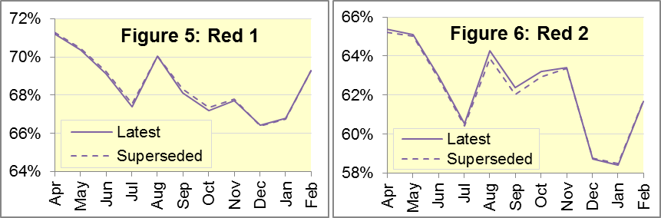

Figure 7: Of Category A calls in England resulting in an ambulance response, proportion arriving within 19 minutes, 2016-17

Figure 8: Proportion of calls abandoned before being answered, England, 2016-17
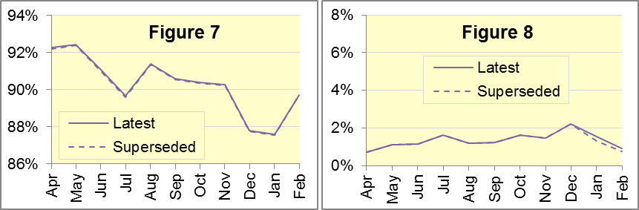

Figure 9: Of calls receiving a telephone or face-to-face response,
proportion resolved by telephone advice, England, 2016-17

Figure 10: Of calls receiving a face-to-face response, proportion managed without need for transport to Type 1 and Type 2 A&E, England, 2016-17
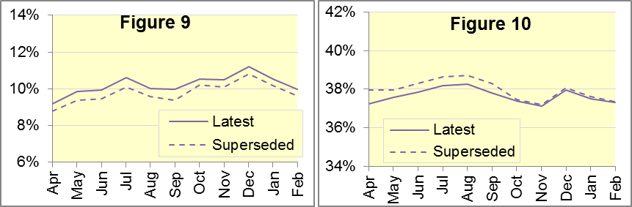

Figure 11: Re-contacts after discharge on scene, England, 2016-17

Figure 12: Re-contacts following calls closed with telephone advice, England, 2016-17
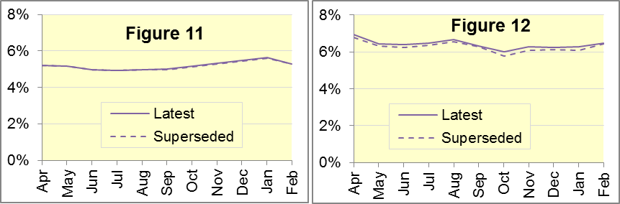

Figure 13: Incidents where a patient was transported, England, 2016-17
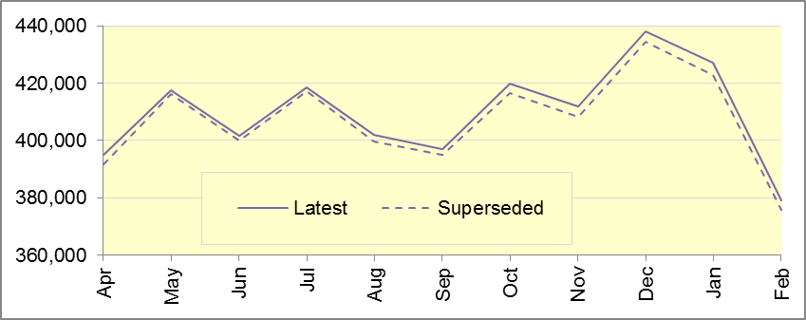

Figure 14: Revisions of more than 2% points to 2016-17 trust-level monthly data
Trust | Indicator | Month | From | To
NEAS | Emergency calls closed with telephone advice where re-contact occurs via 999 within 24 hours | Oct | 10.6% | 13.7%
 |  | Nov | 11.2% | 14.2%
 |  | Dec | 11.2% | 14.0%
 |  | Jan | 11.1% | 13.7%
EMAS | Proportion of calls closed with telephone advice (‘Hear and Treat’) | Apr | 13.2% | 16.8%
 |  | May | 15.0% | 19.0%
 |  | Jun | 16.2% | 20.2%
 |  | Jul | 17.8% | 21.7%
 |  | Aug | 16.5% | 19.9%
 |  | Sep | 14.9% | 19.8%
 |  | Oct | 16.2% | 21.7%
 |  | Nov | 16.0% | 21.9%
 |  | Dec | 17.2% | 22.7%
 |  | Jan | 14.8% | 19.7%
 |  | Feb | 14.4% | 19.1%
 | Proportion of calls receiving a face-to-face response that managed without need for transport to Type 1 and Type 2 A&E | Apr | 33.0% | 25.4%
 |  | May | 32.6% | 25.1%
 |  | Jun | 32.2% | 25.1%
 |  | Jul | 31.6% | 25.1%
 |  | Aug | 31.7% | 25.6%
 |  | Sep | 29.6% | 23.6%
SCAS | Emergency calls closed with telephone advice where re-contact occurs via 999 within 24 hours | Apr | 8.7% | 11.2%
 |  | May | 9.3% | 11.7%
 |  | Jun | 9.5% | 11.7%
SWAS | Proportion of calls receiving a face-to-face response that managed without need for transport to Type 1 and Type 2 A&E | May | 49.3% | 52.1%
 |  | Jun | 48.9% | 51.5%
 |  | Jul | 48.9% | 51.2%
 |  | Aug | 48.7% | 50.8%
 |  | Sep | 48.7% | 50.7%

Figure 15: Revisions of more than 0.5% points to England monthly data
Indicator | Month | From | To
Proportion of calls closed with telephone advice (‘Hear and Treat’) | Sep | 9.4% | 10.0%
Proportion of calls receiving a face-to-face response that managed without need for transport to Type 1 or Type 2 A&E | Apr | 38.0% | 37.2%

A9 Trust-level annual analysis: calls resolved without transport
Figure 16 shows, of all calls that receive a telephone or face-to-face response from the ambulance service, the proportion resolved by telephone advice, also referred to as ‘hear and treat’. For all England, this has increased from 5% in 2011-12 to 10% in 2016-17.
In 2016-17, EMAS had the largest proportion with 20%. SWAS had 15% and others had less than 12%.

Figure 16: Calls resolved by telephone advice
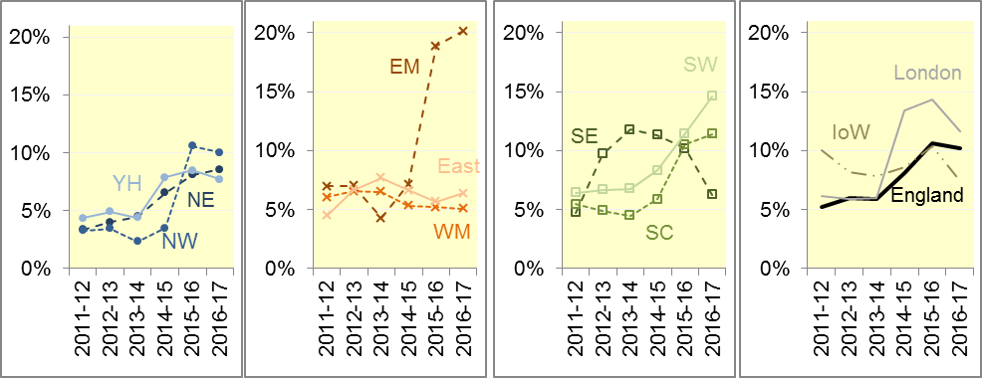

Figure 17: Calls where patients managed without need for transport to Type 1 or Type 2 A&E
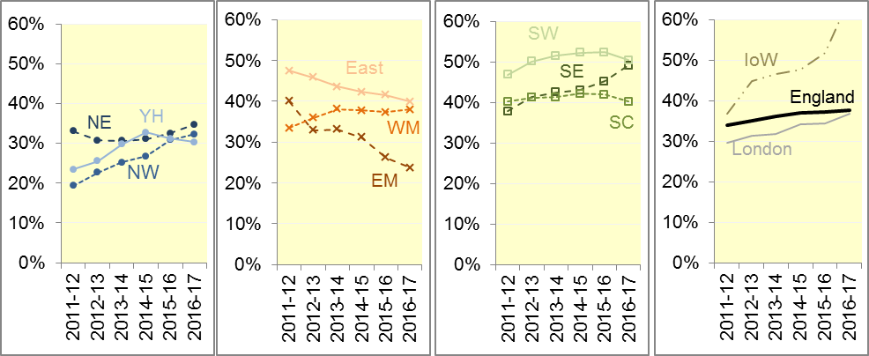
Figure 17 shows, of all calls that receive a face-to-face response from the ambulance service, the proportion managed without transport to a Type 1 or Type 2 A&E. Such patients are taken elsewhere (such as a minor injuries unit), or referred to an alternative care pathway, or discharged after treatment at the scene.
For all England, the proportion not taken to Type 1 or Type 2 A&E has seen a steady increase from 34% in 2011-12 to 38% in 2016-17.
In 2016-17, this proportion was about 50% for SECAmb and SWAS, 24% for EMAS, and between 30% and 40% elsewhere.

A10 Trust-level annual analysis: re-contacts
Figure 18 shows, of all emergency calls that are closed with telephone advice, the proportion with at least one re-contact from the same address within 24 hours. For all England, this has declined from 13% in 2011-12 and 2012-13 to 6% in 2015-16 and 2016-17.
After large changes around 2013, this measure changed little in 2016-17. It was 15% for WMAS, 14% for NEAS and less than 11% elsewhere.

Figure 18: Re-contact following calls closed with telephone advice
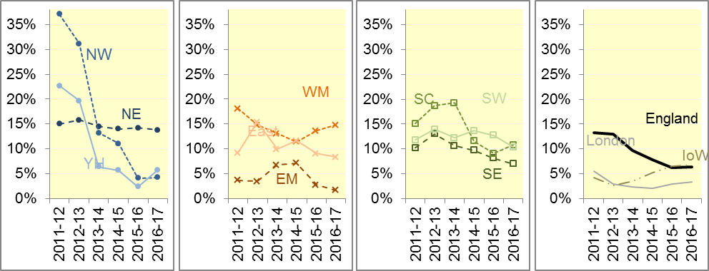

Figure 19: Re-contacts following discharge on scene
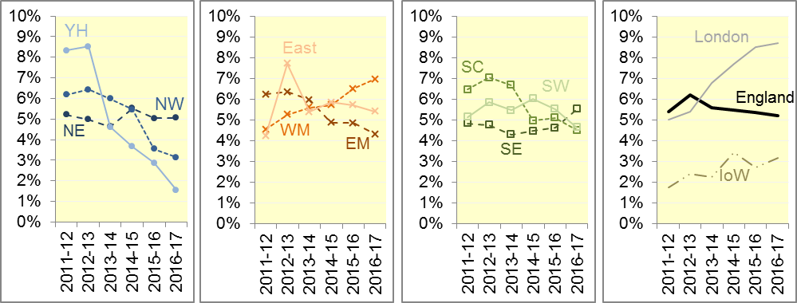
Figure 19 shows, of all patients treated and discharged on the scene, the proportion that re-contact on the telephone within 24 hours of the initial call. This has remained stable between 5% and 6% across England for each year 2011-12 to 2016-17.
This measure increased to 9% for LAS and decreased to 2% for YAS in 2016-17, whilst remaining between 3% and 7% elsewhere.

A11 Trust-level annual analysis: face-to-face responses
Figure 20 shows the number of calls per day that received a face-to-face response from the ambulance service.
Across England, this increased 15% between 2011-12 and 2016-17. The increase was about 30% for WMAS, SCAS and SWAS, about 20% for EMAS and SECAmb, and 10% or less elsewhere.

Figure 20: Calls that received a face-to-face response, per day
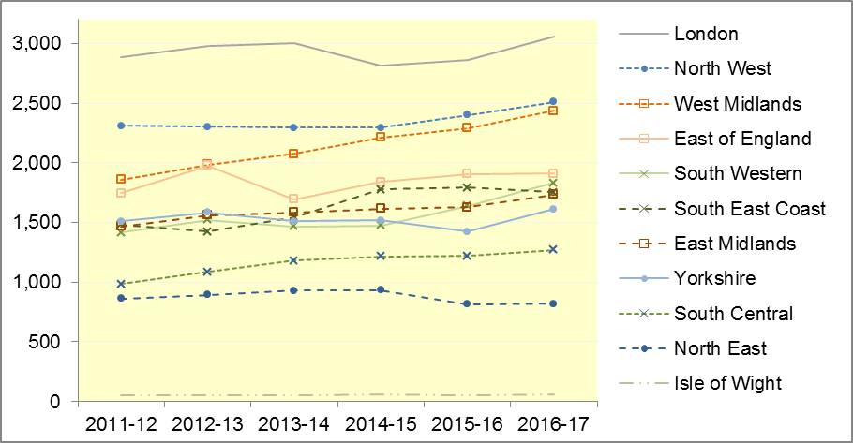

B. Clinical Outcomes
No thresholds to denote “poor” care are set for Clinical Outcomes. Commissioners are expected to examine trends in these data and work in collaboration with ambulance trusts to achieve sustained improvement in patient outcomes over time; but commissioners are not expected to use Clinical Outcomes to performance manage trusts, because there will be significant variations in the populations served.

B1 Cardiac arrest: return of spontaneous circulation (ROSC)
Patients in cardiac arrest will typically have no pulse and will not be breathing. In December 2016, in England, resuscitation was commenced or continued by ambulance staff out-of-hospital for 3,073 such patients. Of these, 836 (27%) had ROSC, with a pulse, on arrival at hospital (Figure 21), similar to the year ending September 2016 (28%). The largest proportion in December 2016 was 36% for NWAS and the smallest proportion was 23% for NEAS.
The Utstein group comprises patients who had resuscitation commenced or continued by the Ambulance Services, following an out-of-hospital cardiac arrest of presumed cardiac origin, where the arrest was bystander witnessed, and the initial rhythm was Ventricular Fibrillation or Ventricular Tachycardia. The Utstein group therefore have a better chance of survival.
There were 396 such patients in England in December 2016, of which 176 (44%) had ROSC on arrival at hospital (Figure 21), less than the year ending September 2016 (51%). The largest proportion in December 2016 was 50% for NEAS and the smallest was 38% for EastAmb.
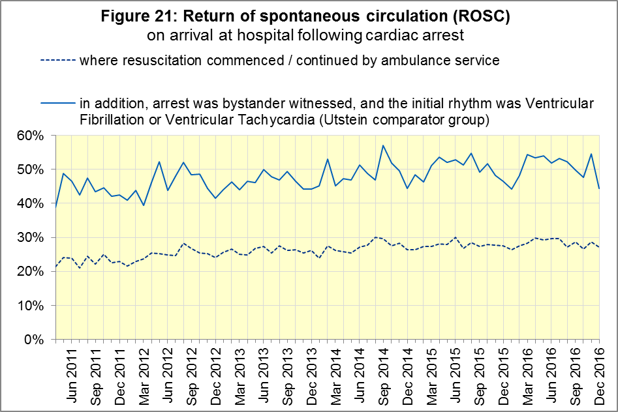

B2 Cardiac arrest: survival to discharge
The proportion of cardiac arrest patients in England discharged from hospital alive was 7% in December 2016 (Figure 22), less than for the year ending September 2016 (8%). The largest proportion in December was 12% for SCAS; the smallest was 4% for SECAmb.
For the Utstein group, survival to discharge in December 2016 was 22%, less than the year ending September 2016 (27%). The largest proportion was 34% for SWAS; the smallest was 9% for SECAmb.
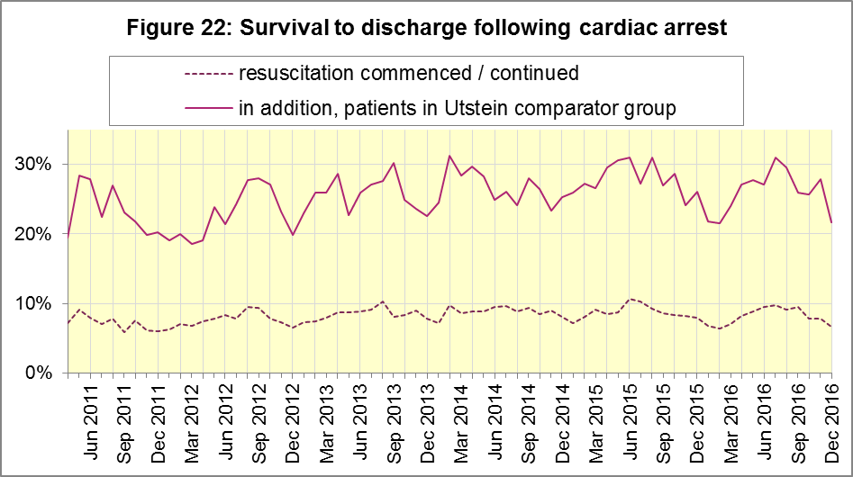

B3 ST-Elevation myocardial infarction
ST-segment elevation myocardial infarction (STEMI) is a type of heart attack, determined by an electrocardiogram (ECG) test. Early access to reperfusion, where blocked arteries are opened to re-establish blood flow, and other assessment and care interventions, are associated with reductions in STEMI mortality and morbidity.
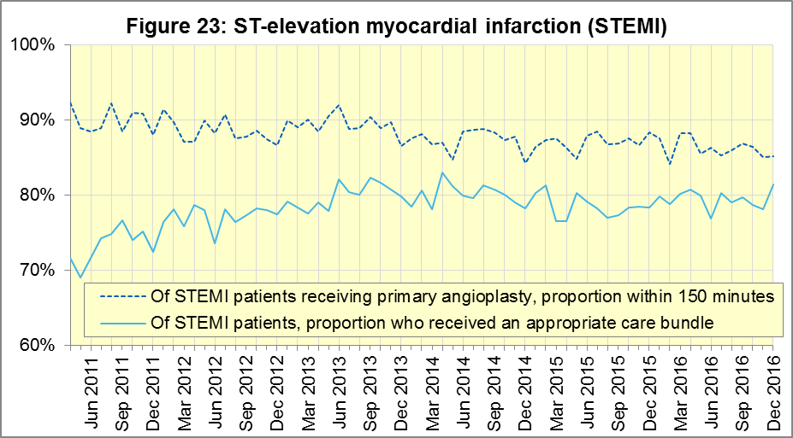
937 STEMI patients in England received primary angioplasty in December 2016. Of these patients, 798 (85%) of them received it within 150 minutes of the call being connected to the ambulance service (Figure 23), similar to the year ending September 2016 (87%). The largest proportion in December 2016 was 96% for EastAmb and the smallest was 68% for SWAS.
In December 2016, of 1,609 patients with an acute STEMI in England, 1,310 (81%) received the appropriate care bundle, a significant improvement on the previous twelve months. NWAS had the largest proportion with 91% and the smallest was SECAmb with 63%.

B4 Stroke
The FAST procedure helps assess whether someone has suffered a stroke:
- Facial weakness: can the person smile? Has their mouth or eye drooped?
- Arm weakness: can the person raise both arms?
- Speech problems: can the person speak clearly and understand what you say?
- Time to call 999 for an ambulance if you spot any one of these signs.
In December 2016, of 3,619 FAST positive patients in England, assessed face to face, and potentially eligible for stroke thrombolysis within agreed local guidelines, 1,834 (51%) arrived at hospitals with a hyperacute stroke unit within 60 minutes of an emergency call connecting to the ambulance service (Figure 24), less than the rate for the year ending September 2016 (57%). The largest proportion for December 2016 was 59% for SECAmb and the smallest was 35% for SWAS.
There were 7,678 stroke patients assessed face to face in December 2016 in England, of which 7,512 (98%) received the appropriate care bundle, identical to the year ending September 2016 (98%).
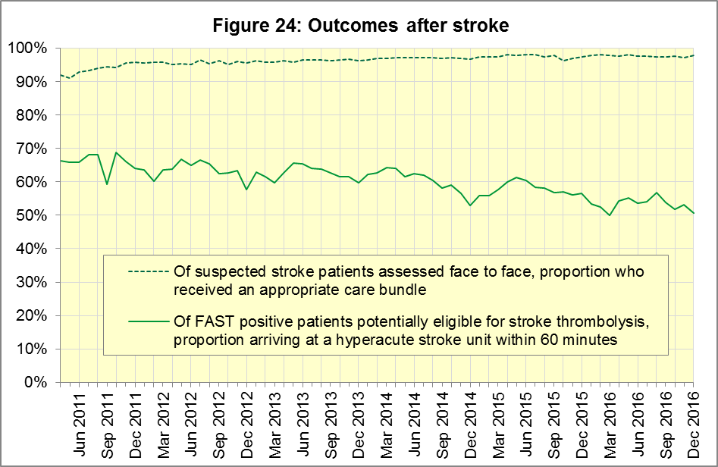

C. Further information on AQI

C1 The AQI landing page and Quality Statement
www.england.nhs.uk/statistics/statistical-work-areas/ambulance-quality-indicators, or http://bit.ly/NHSAQI, is the AQI landing page, and it holds:
- a Quality Statement for these statistics, which includes information on relevance, accuracy, timeliness, coherence, and user engagement;
- the specification guidance document for those who supply the data;
- timetables for data collection and publication;
- text files and time series spreadsheets containing all data from April 2011 up to the latest month;
- links to individual web pages for each financial year.
The web pages for each financial year hold:
- separate spreadsheets of each month’s data;
- this Statistical Note, and equivalent versions from previous months;
- the list of people with pre-release access to the data.
Publication dates are also at www.gov.uk/government/statistics/announcements.

C2 Revisions Timetable
Revisions usually follow a six-monthly cycle. The dates for past and future AQI Systems Indicators (SI) and Clinical Outcomes (CO) scheduled revisions are below. The AQI Quality Statement above contains a more detailed revisions policy.
Publication |  | Data |  | Months affected |  |  | Publication |  | Data |  | Months affected
11 May 2017 |  | SI |  | Apr ‘15 - Feb ‘17 |  |  | 6 Nov 2014 |  | SI |  | Apr ‘13 - Aug ‘14
9 Mar 2017 |  | CO |  | Apr ‘16 - Sep ‘16 |  |  | 5 Sep 2014 |  | CO |  | Apr ‘13 - Mar ‘14
10 Nov 2016 |  | SI |  | Apr ‘16 - Aug ‘16 |  |  | 2 May 2014 |  | SI |  | Apr ‘13 - Feb ‘14
8 Sep 2016 |  | CO |  | Apr ‘15 - Apr ‘16 |  |  | 7 Mar 2014 |  | CO |  | Apr ‘13 - Sep ‘13
12 May 2016 |  | SI |  | Apr ‘15 - Feb ‘16 |  |  | 1 Nov 2013 |  | SI |  | Apr ‘13 - Aug ‘13
10 Apr 2016 |  | CO |  | Apr ‘15 - Sep ‘15 |  |  | 2 Aug 2013 |  | CO |  | Apr ‘12 - Mar ‘13
10 Sep 2015 |  | CO |  | Apr ‘14 - Mar ‘15 |  |  | 3 May 2013 |  | SI |  | Apr ‘12 - Mar ‘13
4 Jun 2015 |  | SI |  | Apr ‘14 - Feb ‘15 |  |  | 1 Feb 2013 |  | CO |  | Apr ‘12 - Aug ‘12
30 Apr 2015 |  | SI |  | Apr ‘14 - Feb ‘15 |  |  | 11 Jan 2013 |  | SI |  | Apr ‘11 - Oct ‘12
5 Mar 2015 |  | CO |  | Apr ‘14 - Sep ‘14 |  |  | 31 Aug 2012 |  | CO |  | Apr ‘11 - Mar ‘12
 |  |  |  |  |  |  | 4 May 2012 |  | SI & CO |  | Apr ‘11 - Mar ‘12

C3 AQI Scope
The AQI include calls made by dialling either the usual UK-wide number 999 or its international equivalent 112.
As described in the specification guidance mentioned in section C1, calls made to NHS 111 are not included in the AQI measures for calls abandoned, re-contacts, frequent callers, time to answer calls, or calls resolved by telephone advice.
All other Systems Indicators involve the dispatch of an ambulance, and include ambulances dispatched as a result of a call to NHS 111, as well as 999 or 112.

C4 Related statistics in England
A Clinical Dashboard on the AQI landing page presents an alternative layout for the AQI data. Because of the lack of comparability due to the Ambulance Response Programme (section A2), NHS England last updated the dashboard in April 2016.
The AQI were also used in the “Ambulance Services” publications by NHS Digital, which included additional annual analysis and commentary, up to and including 2014-15 data. The Quality Statement described in section C1 has more information on this publication. It also contains details of weekly ambulance situation reports that NHS England collected for six months from November 2010.
Ambulance handover delays of over 30 minutes at each Emergency Department were collected and published by NHS England each winter until 2014-15: www.england.nhs.uk/statistics/statistical-work-areas/winter-daily-sitreps

C5 Rest of United Kingdom
Ambulance statistics for other countries of the UK can be found at the following websites. The AQI Quality Statement described in section C1 contains more information about the comparability of these statistics.
Wales: | http://wales.gov.uk/statistics-and-research/ambulance-services
Scotland: | See Quality Improvement Indicators (QII) documents at www.scottishambulance.com/TheService/BoardPapers.aspx
Northern Ireland: | www.health-ni.gov.uk/articles/emergency-care-and-ambulance-statistics

C6 Contact information
For press enquiries, please contact the NHS England press office on 0113 825 0958 or nhsengland.media@nhs.net.
The person responsible for producing this publication is:
Ian Kay, Operational Information for Commissioning (Central), NHS England
Room 5E24, Quarry House, Leeds, LS2 7UE; 0113 825 4606; i.kay@nhs.net

C7 National Statistics
The UK Statistics Authority has designated these statistics as National Statistics, in accordance with the Statistics and Registration Service Act 2007 and signifying compliance with the Code of Practice for Official Statistics.
Designation can be broadly interpreted to mean that the statistics:
- meet identified user needs;
- are well explained and readily accessible;
- are produced according to sound methods; and
- are managed impartially and objectively in the public interest.
Once statistics have been designated as National Statistics it is a statutory requirement that the Code of Practice shall continue to be observed.

Page 34 of the July 2015 Handbook to the NHS Constitution has Ambulance response time standards, www.gov.uk/government/publications/supplements-to-the-nhs-constitution-for-england.
After June 2016, Category A only applies to 8 of the 11 Ambulance Services in England, so Red 1 and Red 2 response data are not available for the other 3; see section A3 on the Clinical Coding Review. Also, from February 2015, changes in operational practice meant that Red 2 response data are still available but not always comparable; see section A2 on Dispatch on Disposition.
On 1 June 2012, Category A (immediately life-threatening) calls were split into Red 1 and Red 2. Red 1 calls are the most time critical, and cover cardiac arrest patients who are not breathing and do not have a pulse, and other severe conditions such as airway obstruction. Red 2 calls are serious, but less immediately time critical, and cover conditions such as stroke and fits. www.gov.uk/government/news/changes-to-ambulance-response-time-categories
England excludes YAS and SWAS after April 2016, and WMAS after June 2016. See section A3.
The Isle of Wight (IOW) contains 0.3% of the resident population of England. Its data vary more than other trusts because of its small size. Its data are all available in the accompanying spreadsheets, but in this document, if the IOW has the largest or smallest value, we report the second largest or smallest value instead.
Dispatch on Disposition announcement: www.parliament.uk/business/publications/written-questions-answers-statements/written-statement/Commons/2015-01-16/HCWS201
Ambulance Response Programme information: www.england.nhs.uk/ourwork/qual-clin-lead/arp
England excludes YAS and SWAS after April 2016, and WMAS after June 2016. See section A3.
England excludes YAS and SWAS after April 2016, and WMAS after June 2016. See section A3.
The number of emergency calls presented to switchboard does not usually include calls made to NHS 111 requiring an ambulance. 111 calls requiring an ambulance are usually transferred electronically direct to ambulance dispatch and not routed via 999 call handlers. Occasionally, manual requests for ambulances are made between 111 and 999 call handlers and such calls are included in the numbers of emergency calls presented to switchboard.
Type 1 are consultant-led 24 hour emergency departments with full resuscitation facilities. Type 2 offer a consultant-led speciality A&E service such as ophthalmology or dental. Type 3 is A&E / minor injury activity that may be doctor-led or nurse-led. Type 4 are NHS walk-in centres. (www.datadictionary.nhs.uk/data_dictionary/attributes/a/acc/ accident_and_emergency_department_type_de.asp)
Significance calculations in this document are Student’s t-test with 95% significance.
England excludes YAS and SWAS after April 2016, and WMAS after June 2016. See section A3.
England excludes YAS and SWAS after April 2016, and WMAS after June 2016. See section A3.
This definition was proposed at Utstein Abbey in Norway by an international group of cardiologists and other health professionals in 1990. http://circ.ahajournals.org/content/110/21/3385
Pages 27 to 30 of the specification guidance for data suppliers on the AQI landing page at www.england.nhs.uk/statistics/statistical-work-areas/ambulance-quality-indicators describe the care bundles, and certain exclusions, for the STEMI and stroke indicators.
NHS Digital Ambulance Services: http://content.digital.nhs.uk/article/2021/Website-Search?q=ka34

