# NHS 111 Minimum Data Set, England, February 2017

#### Summary

There were 1,157,994 calls offered to the NHS 111 service in February 2017, an average of 41,357 calls per day. This is a 2% decrease on the 42,013 average calls offered per day in February 2016.

Of calls offered to NHS 111 in February 2017, the proportion abandoned after waiting longer than 30 seconds was 2.2%, less than both the rates of 2.7% in January 2017 and of 5.0% in February 2016.

In February 2017, of calls answered by NHS 111, 89.4% were answered within 60 seconds, an improvement on 88.1% in January 2017 and 79.7% in February 2016.

Of calls answered, 13.8% were offered a call back in February 2017, compared with 13.3% offered a call back in January 2017.

Of call backs offered, 37% were within 10 minutes in February 2017, down slightly on the figure of 39% achieved in January 2017.

Of calls answered, 22.6% were transferred to or answered by a clinical advisor using NHS Pathways, up slightly on January 2017’s corresponding figure of 22.4%.

Of calls answered, the proportion that received any form of clinical input[1] was 25.2% in February 2017, up from 23.8% in January 2017.

The average length of calls was 17 minutes and 35 seconds in February 2017.

Of calls answered, 86% were triaged in February 2017, the same proportion as January 2017. Calls triaged are those where the NHS 111 call handler opens and uses the clinical assessment tool (NHS Pathways). Calls not triaged include, for example, follow-ups of previous calls, calls where the caller is unable or unwilling to give specific details about the patient’s condition or enquiries about contact details for pharmacists or other local care services.

Of calls triaged in February 2017, 13% had ambulances dispatched, 8% were recommended to A&E, 60% were recommended to primary care, 4% were recommended to another service and 14% were not recommended to attend another service. All these proportions were less than 1 percentage point different in January 2017.





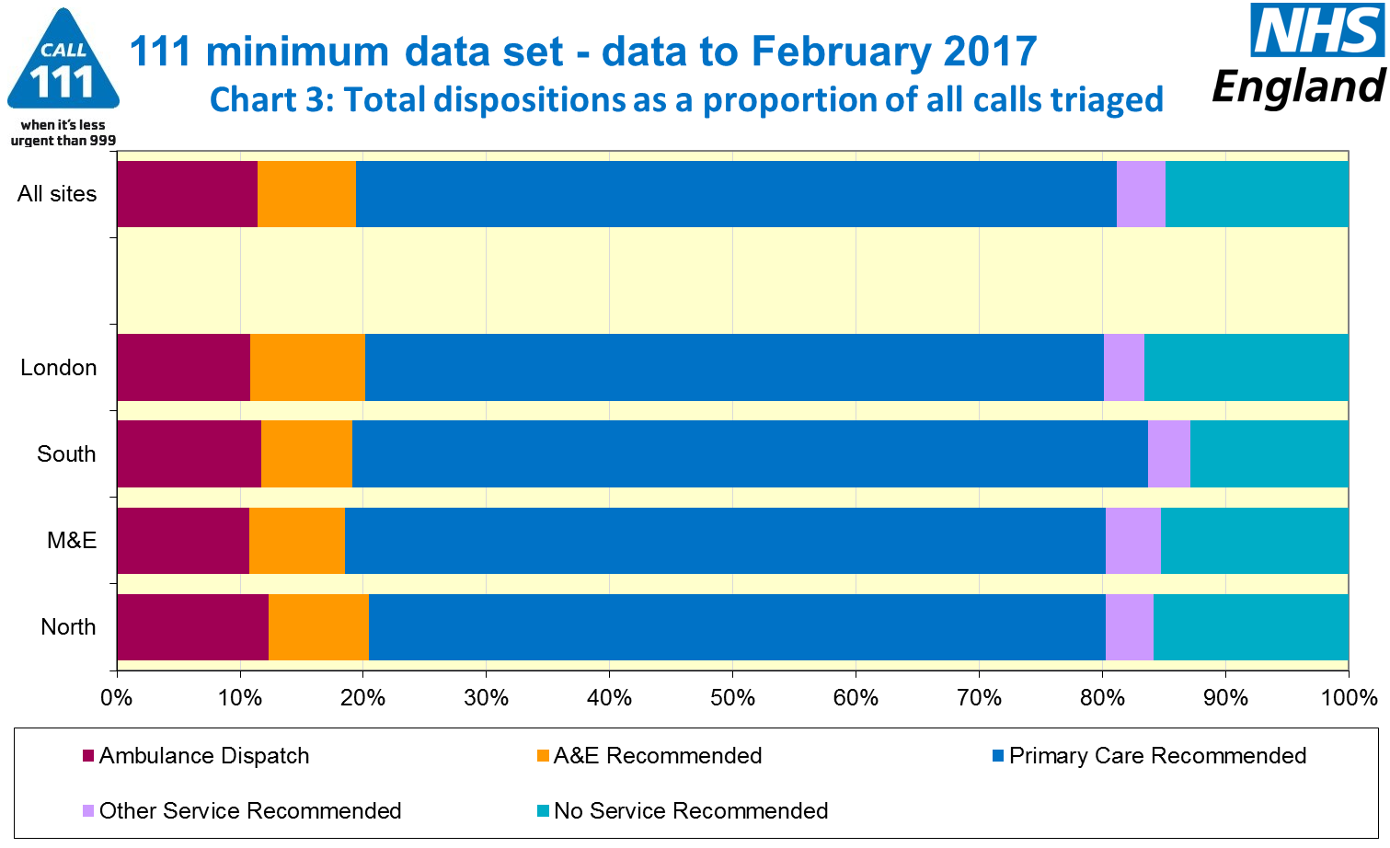





#### 

#### Additional Information:

All monthly data in the 111 Minimum Data Set (MDS) are available in spreadsheets at [www.england.nhs.uk/statistics/statistical-work-areas/nhs-111-minimum-data-set](http://www.england.nhs.uk/statistics/statistical-work-areas/nhs-111-minimum-data-set), along with all the previous accompanying statistical notes, the specification guidance document for those who produce the data, and the timetables for data collection and publication. Publication dates are also available from [www.gov.uk/government/statistics](http://www.gov.uk/government/statistics).

Material changes to the data or presentation of the NHS 111 MDS are listed in the 3 July 2015 Statistical Note and in earlier versions. Any further material changes will be described here in future Statistical Notes.

#### Contacts

For press enquiries, please contact the NHS England press office on 0113 825 0958 or [nhsengland.media@nhs.net](mailto:nhsengland.media@nhs.net).

The individual responsible for these data is:

Ian Kay

NHS England, Operational Information for Commissioning (Central)

Room 5E24, Quarry House, Leeds LS2 7UE

[i.kay@nhs.net](mailto:i.kay@nhs.net)

0113 825 4606

1. This data item is an experimental statistic and may change markedly as providers develop their calculation methods. The specification is in data item 5.22 on the guidance document v0.901 at the NHS 111 MDS landing page, [www.england.nhs.uk/statistics/statistical-work-areas/nhs-111-minimum-data-set](http://www.england.nhs.uk/statistics/statistical-work-areas/nhs-111-minimum-data-set).

   More information on experimental statistics is at: [www.ons.gov.uk/methodology/methodologytopicsandstatisticalconcepts/guidetoexperimentalstatistics](https://www.ons.gov.uk/methodology/methodologytopicsandstatisticalconcepts/guidetoexperimentalstatistics)