

# NHS 111 Minimum Data Set, England, July 2016

#### Summary

There were 1,238,972 calls offered to the NHS 111 service in England in July 2016, a 21.9% increase on the 1,016,249 in July 2015. The number of calls answered by the service was 1,141,770 in July 2016 a 17.3% increase on the July 2015 answered calls.

Of calls offered to NHS 111 in July 2016, the proportion abandoned after waiting longer than 30 seconds was 2.5%, an increase on the 1.8% recorded in June 2016.

In July 2016, of calls answered by NHS 111, 88.1% were answered within 60 seconds; a drop on the 90.6% in June 2016 and considerably lower than the 94.1% recorded in July 2015.

Of calls answered, 13.6% were offered a call back in July 2016, a small increase on the 13.4% recorded in June 2016.

Of call backs offered, 38.0% were within 10 minutes in July 2016, a drop on the 39.9% recorded in June 2016.

Of calls answered, 21.2% were transferred to a clinical advisor in July 2016, a slight drop on the 21.4% recorded in June 2016.

The average length of calls was 16 minutes and 15 seconds in July 2016.

Of calls answered, 85% were triaged in July 2016. This proportion has ranged between 85% and 87% for the last twenty two months. Calls triaged are those where the NHS 111 call handler opens and uses the clinical assessment tool (NHS Pathways). Calls not triaged include, for example, follow-ups of previous calls, calls where the caller is unable or unwilling to give specific details about the patient’s condition or enquiries about contact details for pharmacists or other local care services.

Of calls triaged in July 2016, 13% had ambulances dispatched, 9% were recommended to A&E, 60% were recommended to primary care, 4% were recommended to another service and 15% were not recommended to attend any other service.

Of calls resolved without triage in July 2016, calls where the caller terminated the call (55,984) and where the caller was referred to another service (23,223) were the highest figures recorded since the 111 service started in August 2010.

In July 2016, of calls which were not recommended to any service, the proportion recommended home care was 5.3%, this is the lowest proportion recorded since the 111 service started in August 2010.





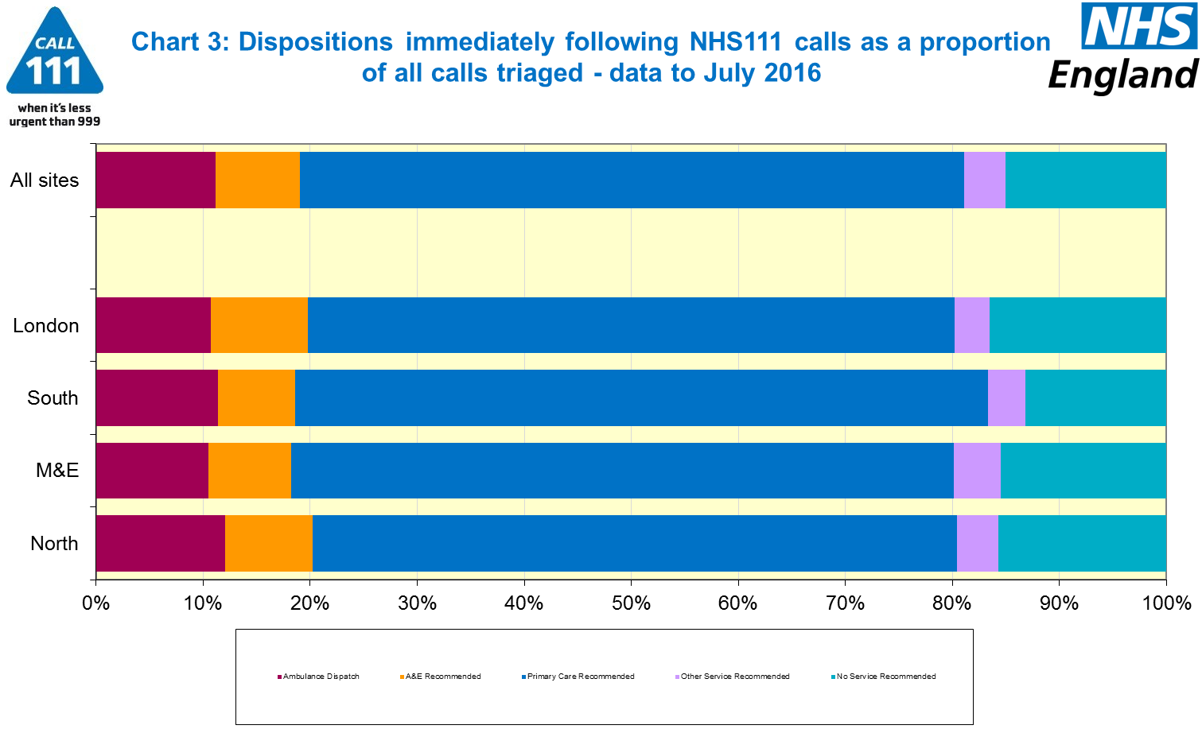







#### Additional Information:

All monthly data in the 111 Minimum Data Set (MDS) are available in spreadsheets at [www.england.nhs.uk/statistics/statistical-work-areas/nhs-111-minimum-data-set](http://www.england.nhs.uk/statistics/statistical-work-areas/nhs-111-minimum-data-set), along with all the previous accompanying statistical notes, the specification guidance document for those who produce the data, and the timetables for data collection and publication. Publication dates are also available from [www.gov.uk/government/statistics](http://www.gov.uk/government/statistics).

Material changes to the data or presentation of the NHS 111 MDS are listed in the 03 July 2015 Statistical Note and in earlier versions. Any further material changes will be described here in future Statistical Notes.

#### Contacts

For press enquiries, please contact the NHS England press office on 0113 825 0958 or [nhsengland.media@nhs.net](mailto:nhsengland.media@nhs.net).

The individual responsible for these data is:

James Thomas

NHS England, Operational Information for Commissioning (National)

Room 5E24, Quarry House, Leeds LS2 7UE

james.thomas5@nhs.net

0113 8250717

Published on Thursday 8th September 2016.