# NHS 111 Minimum Data Set, England, March 2017

#### Summary

There were 1,217,319 calls offered to the NHS 111 service in March 2017, an average of 39.3 thousand per day, and a considerable 20% decrease on the 48.9 thousand per day in March 2016. However, March 2016 included two bank holidays, and NHS 111 regularly receives more calls on a bank holiday, compared with a typical working day.

Of calls offered to NHS 111 in March 2017, the proportion abandoned after waiting longer than 30 seconds was 1.8%, less than both the rates of 2.2% in February 2017 and of 8.4% in March 2016.

In March 2017, of calls answered by NHS 111, 91.0% were answered within 60 seconds, an increase on 89.4% in February 2017 and 70.7% in March 2016.

Of calls answered in March 2017, 21.8% were transferred to or answered by a clinical advisor using NHS Pathways, a small decrease on February 2017 (22.6%).

The proportion of calls answered that received any form of clinical input[1] was 29.6% in March 2017, up from 25.2% in February 2017. This item has only been collected since November 2016, when it stood at 23.2% of calls answered.

13% of all calls answered in March 2017 were offered a call back, similar to February 2017 (14%).

Of those call backs, 38% were made within 10 minutes in March 2017, also similar to February 2017 (37%).

In March 2017, 86% of calls answered were triaged, the same as in February 2017. Calls triaged are those where the NHS 111 call handler opens and uses the clinical assessment tool (NHS Pathways). Calls not triaged include, for example, follow-ups of previous calls, calls where the caller is unable or unwilling to give specific details about the patient’s condition or enquiries about contact details for pharmacists or other local care services.

Of calls triaged in March 2017, 13% had ambulances dispatched, 9% were recommended to attend A&E, 60% were recommended to attend primary care, 5% were advised to attend another service and 14% were not recommended to attend another service. All these proportions were less than 1 percentage point different in each of January and February 2017.

**Annual Analysis of the NHS 111 Service in England**

The annual total of calls offered to the NHS 111 service in 2016-17 (April to March inclusive) was 14,700,691, or 40.3 thousand per day, an increase of 5% from 38.5 thousand per day in 2015-16. In 2015-16, the busiest month was March, which included Easter, and had 48.9 thousand calls offered per day. In 2016-17 the busiest month was December, which had 47.6 thousand calls offered per day.

The rate of calls abandoned after more than 30 seconds’ wait was 2.4% on average for 2016-17, compared with 3.1% in 2015-16. The lowest monthly rate in 2016-17 was 1.4% in August, while the lowest monthly rate in 2015-16 was 1.3% in each of June and July.

In the whole of 2016-17, 89.1% of all calls answered were answered within 60 seconds by the NHS 111 service, an increase from 87.8% in 2015-16. The highest monthly rate in 2016-17 was 92.9% in August, and the highest in 2015-16 was 94.1% in each of June and July, mirroring the trend for calls abandoned.

Of calls answered in 2016-17, 13.5% were offered a call back from an NHS Pathways-using clinical advisor, a small increase on 12.6% in 2015-16. The lowest rate in 2015-16 was 11.1% in April, and the lowest in 2016-17 was 12.7% in August.

In 2015-16, 41% of call backs offered were made within 10 minutes, and this figure decreased to 39% in 2016-17. In 2016-17, the highest rate for this service was 42.4% in August, compared with a high for 2015-16 of 47.6% in April.

Of calls answered, the proportion transferred to or answered by a clinical advisor using NHS Pathways in 2015-16 and 2016-17 were both 22%, with a rate between 21% and 23% in every month.

In 2015-16, the average mean length of all calls answered was 15 minutes and 58 seconds. This increased slightly to 16 minutes and 28 seconds in 2016-17.

In 2015-16, 11.3% of all calls triaged had ambulances dispatched, 8.2% were advised to attend A&E, 61.9% were recommended to attend primary care, 3.7% were advised to attend another service and 14.9% were not referred to another service. In 2016-17, ambulance dispatches increased 1.5 percentage points while recommendations to primary care decreased 1.7 percentage points.

The distribution of values for dispositions across the last two years is as follows:

|  |  |  |  |
| --- | --- | --- | --- |
| 2015-16 | Minimum | Average (Mean) | Maximum |
| Ambulance dispatched | 9.9% (May) | 11.3% | 12.2% (Feb) |
| Attend A&E | 7.5% (Dec) | 8.2% | 9.2% (Jul) |
| Attend Primary Care | 60.0% (Jul) | 61.9% | 63.4% (Apr) |
| Attend Another Service | 3.5% (Apr & Jun) | 3.7% | 3.9% (Dec & Jan) |
| Do Not Attend Another Service | 14.0% (Jan) | 14.9% | 16.0% (Jun & Jul) |
| 2016-17 |  |  |  |
| Ambulance dispatched | 11.8% (Apr & May) | 12.7% | 13.5% (Nov) |
| Attend A&E | 7.6% (Dec) | 8.6% | 9.2% (Sep) |
| Attend Primary Care | 59.3% (Sep) | 60.2% | 61.5% (Apr & May) |
| Attend Another Service | 3.6% (Apr & Jun) | 4.1% | 4.6% (Jan & Mar) |
| Do Not Attend Another Service | 13.8% (Jan) | 14.4% | 14.8% (Jun & Sep) |



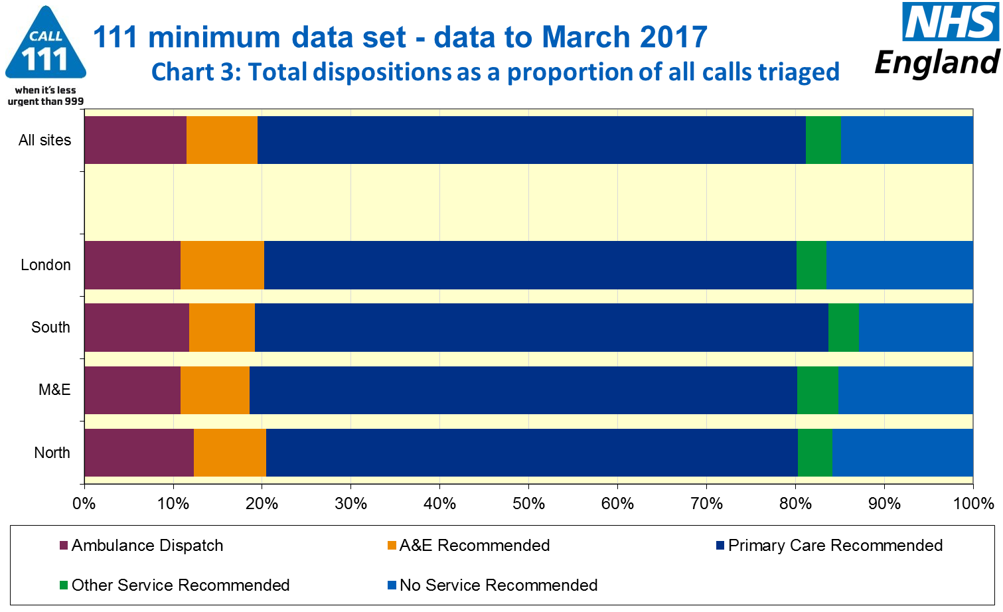





#### 

#### Additional Information:

All monthly data in the 111 Minimum Data Set (MDS) are available in spreadsheets at www.england.nhs.uk/statistics/statistical-work-areas/nhs-111-minimum-data-set, along with all the previous accompanying statistical notes, the specification guidance document for those who produce the data, and the timetables for data collection and publication. Publication dates are also available from [www.gov.uk/government/statistics](http://www.gov.uk/government/statistics).

Material changes to the data or presentation of the NHS 111 MDS are listed in the 3 July 2015 Statistical Note and in earlier versions. Any further material changes will be described here in future Statistical Notes.

#### Contacts

For press enquiries, please contact the NHS England press office on 0113 825 0958 or [nhsengland.media@nhs.net](mailto:nhsengland.media@nhs.net).

The individual responsible for these data is:

Ian Kay

NHS England, Operational Information for Commissioning (Central)

Room 5E24, Quarry House, Leeds LS2 7UE

[i.kay@nhs.net](mailto:i.kay@nhs.net)

0113 825 4606

1. This data item is an experimental statistic and may change markedly as providers develop their calculation methods. The specification is in data item 5.22 on the guidance document v0.901 at the NHS 111 MDS landing page, [www.england.nhs.uk/statistics/statistical-work-areas/nhs-111-minimum-data-set](http://www.england.nhs.uk/statistics/statistical-work-areas/nhs-111-minimum-data-set).

   More information on experimental statistics is at: [www.ons.gov.uk/methodology/methodologytopicsandstatisticalconcepts/guidetoexperimentalstatistics](https://www.ons.gov.uk/methodology/methodologytopicsandstatisticalconcepts/guidetoexperimentalstatistics)