**NHS Dental Commissioning Statistics for England – December 2016**

Published 2 February 2017 (Quarterly)

**About this release**

This release provides information about the amount of NHS dental activity that has been commissioned for the following year, measured in Units of Dental Activity (UDAs).

The UDAs commissioned are shown for each Local Office in England. There are now 14 Local Offices that commission NHS dental activity. Previously, there were 13, but Lancaster and Greater Manchester Local Office have now separated following devolution in Greater Manchester.

**88,470,000 UDAs were commissioned**

as of 31st December 2016, to be provided between 1st January 2017 and 31st December 2017

* This number has decreased slightly. It was a decrease of 361,600 UDAs compared to September 2016, equivalent to a 0.4% decrease.
* 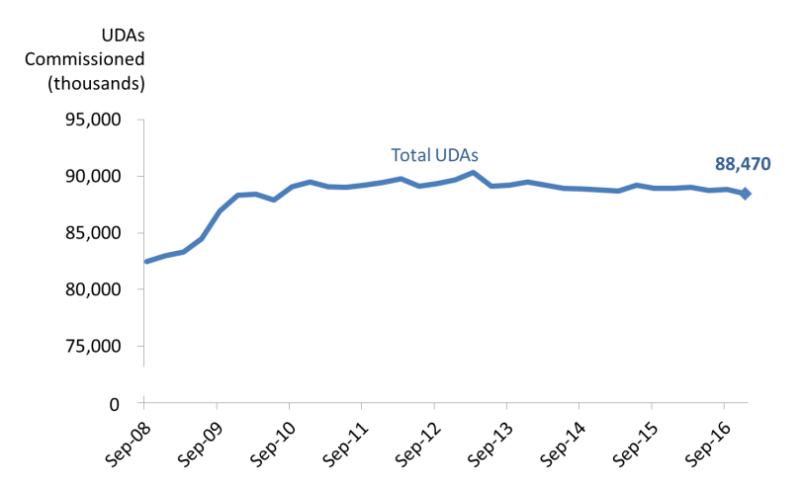It was 483,800 fewer UDAs, or -0.5%, compared to the number of UDAs commissioned at 31st December 2015 to be provided between 1st January 2016 and 31th December 2016.

**Key Definitions**

Units of Dental Activity (UDAs) are a measure of the amount of work done during dental treatment. More complex dental treatments count for more UDAs than simpler ones. For example, an examination is 1 UDA, fillings are 3 UDAs, and dentures are 12 UDAs.

‘Up and running UDAs’ refer to UDAs that are in contracts that are already delivering services.

Contracts which are not yet delivering services may be new contracts, where the contract has been signed but the dental activity has not yet started.

**6 of the 14 Local Offices increased the number of UDAs commissioned compared to a year ago**

* The largest percentage change since the last quarter (September 2016) at Local Office level was a decrease of 2.9%, or 198,000 UDAs, in the West Midlands.
* The largest percentage changes since last year (December 2015) at Local Office level was a decrease of 2.7% in the Central Midlands. This was a decrease of 192,400 UDAs.

**5,400 UDAs in contracts not yet delivering services**

* The number of UDAs commissioned in contracts which are not yet delivering services remains low. It was 5,400 in total (0.01%), all in London.



**Responsible Statistician:**

Joshua Bullock

**Feedback or queries:** ENGLAND.DEAT@nhs.net

**Next publication:**

4 May 2017

**Previous publications:** <https://www.england.nhs.uk/statistics/category/statistics/dental-commissioning/>

@NHSEnglandStats

**Changes at National and Commissioning Region level**

**Compared to the previous quarter (September 2016):**

* The total UDAs commissioned in England by the end of December 2016 was slightly lower (-0.4%, which was 361,600 fewer UDAs).
* The South had the largest percentage decrease (-0.8%) of all the regions. This was a decrease of 181,000 UDAs

Table 1 below summarises the changes from last quarter.

*Table 1: Units of Dental Activity Commissioned by* ***Quarterly*** *Change.*

England, Commissioning Regions



**Compared to the previous year (December 2016):**

* The total UDAs commissioned in England by the end of December 2016 was slightly lower (-0.5%, which was 483,800 fewer UDAs).
* The North has the largest percentage increase in the number of UDAs commissioned. It had an increase of 0.5% or 127,100 UDAs.
* London had the largest percentage decrease (-1.7%) of all the regions. This was a decrease of 219,100 UDAs.

Table 2 below summarises the changes from last year.

*Table 2: Units of Dental Activity Commissioned by* ***Annual*** *Change.*

England, Commissioning Regions



**Changes at Local Office level**

**Compared to the previous quarter (September 2016):**

* 3 out of the 14 Local Offices showed increases in the number of UDAs commissioned, and 10 showed decreases.
* The Central Midlands had the largest percentage increase (1.5%, or 102,600 more UDAs).
* London had the greatest percentage decrease (-2.9%). This was 198,000 fewer UDAs

**Compared to the previous year (December 2016):**

* 6 of the 14 Local Offices showed increases in the number of UDAs commissioned, whilst 8 showed decreases.
* Lancashire had the largest percentage increase (1.3%, or 32,600 more UDAs).
* The Central Midlands had the largest percentage decrease (-2.7%, or 192,400 fewer UDAs).

Table 3 below shows the annual and quarterly changes in UDAs commissioned, by Local Office.

*Table 3: Units of Dental Activity Commissioned, Quarterly and Annual Changes*

England, Local Offices



**Long-term quarterly trends (national)**

The data from September 2016 show that there has been a small decrease in the number of UDAs commissioned nationally (0.4%) compared to the previous quarter (September 2016). In September 2016, there had been a 0.1% increase.

**These are small fluctuations, and the long-term quarterly trend has generally been quite stable.** The total number of UDAs commissioned has remained within a narrow band (89.5 million ± 800,000) since September 2010. The largest quarterly increase was back in September 2009 (2.9%) and the largest decrease was in June 2013 (-1.3%).

As Figure 1 below shows, there have been seasonal variations affecting the quarter to quarter changes. Historically, the larger dips have been seen in the March and June quarters (for precise figures see Annex). This is most likely due to non-recurrent commissioning contracts coming to an end (end of the financial year) and new commissioning for the year not yet decided upon.

*Figure 1: Percentage change of Units of Dental Activity Commissioned quarter on quarter.*

England, June 2008 to June 2016.

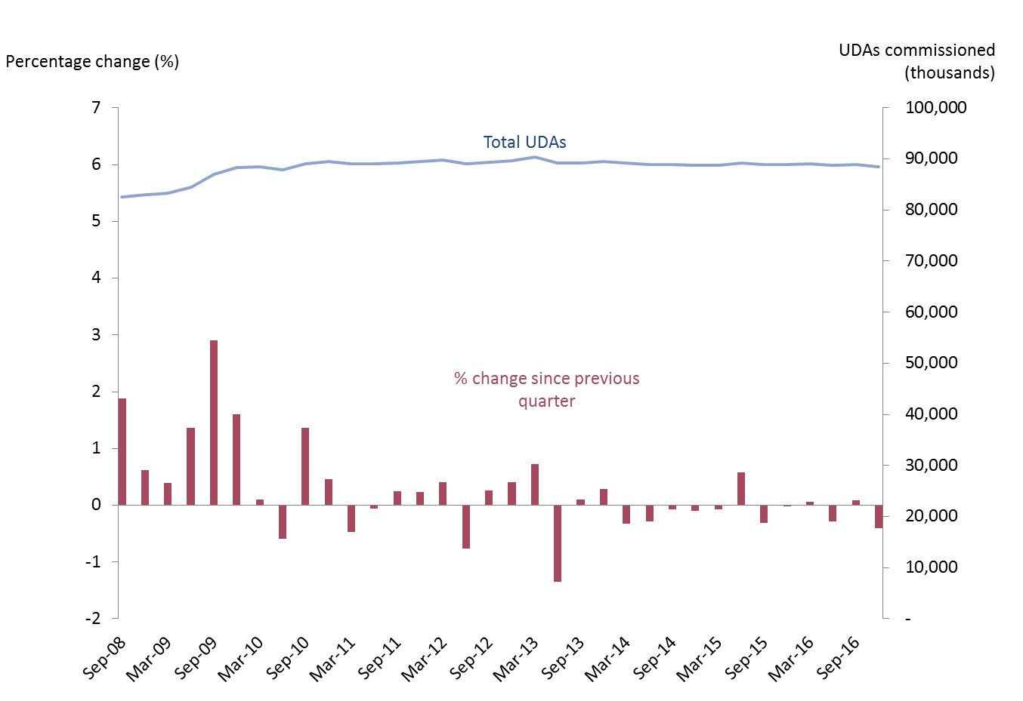

**Long term annual trends (national)**

Slightly fewer UDAs were commissioned nationally in total in December 2016 compared to a year ago (-0.5%). This was more negative than the annual change in September 2016 (-0.1%).

or each quarter between June 2008 and June 2010, the total number of UDAs commissioned was at least 3.0% higher than at the same time 12 months earlier. **The percentage increase declined to around 1.0% or below from December 2010 onwards.** March 2014 marked the most negative percentage change across the time period of -1.3%. See Figure 2 below.

*Figure 2: Percentage change of Units of Dental Activity Commissioned year on year.*

England, June 2008 to June 2016.

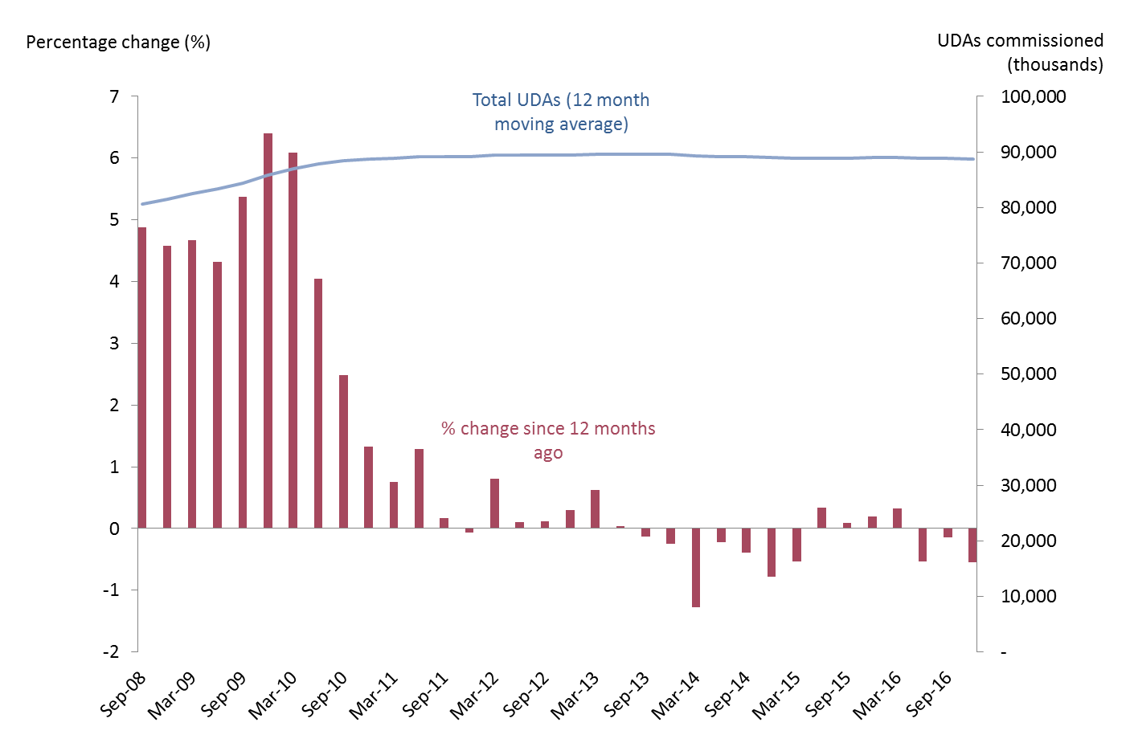**‘Up and running’ UDAs**

**Over time, the gap between the total number of UDAs commissioned and the ‘up and running’ UDAs has narrowed.** The number of UDAs commissioned in contracts which are not yet delivering services in December 2016 was 5,400 (0.01% of all UDAs commissioned). This is the same as September 2016, and a decrease from 38,100 in December 2015.

Since March 2011, UDAs commissioned in contracts which are not yet delivering services have represented 1.0% or less of the total UDAs commissioned. The data from June 2014 showed the smallest proportion seen over time of UDAs not yet delivering services (0.003%).

*Figure 3: Time Series of Units of Dental Activity Commissioned*

England, June 2008 to June 2016.

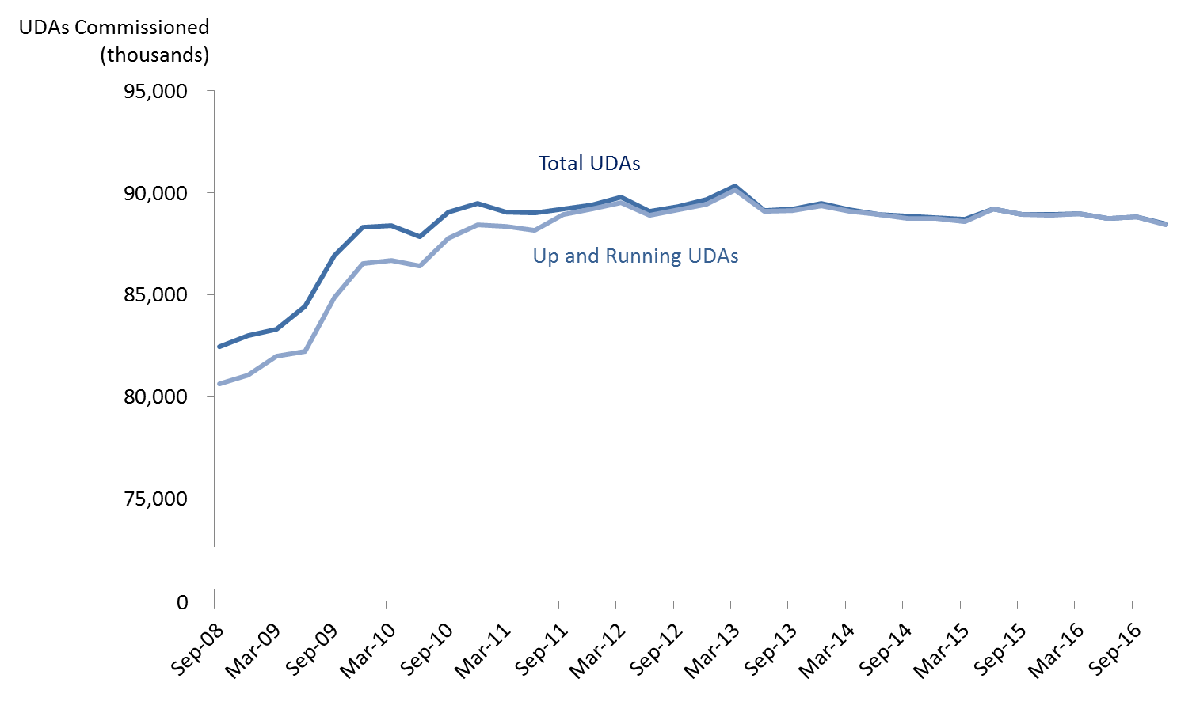**Annex**

*Table 4: Units of Dental Activity (UDAs) Commissioned*

England, September 2008 to December 2016



*Commissioned UDAs cover contracted UDAs in the next 12 months in GDS and PDS contracts and in VDP arrangements. *This excludes salaried services where there are no contracted UDAs*.