Statistical Note: Ambulance Quality Indicators (AQI)
The latest Systems Indicators for June 2017 for Ambulance Services in England showed the standards in the Handbook to the NHS constitution were not met.
The latest Clinical Outcomes data for March 2017 show, for stroke patients assessed face to face, a significantly higher proportion received an appropriate care bundle.

Systems Indicators

Emergency response in 8 minutes (Figure 1)
In June 2017, of Category A Red 1 calls in England, resulting in an emergency response, the proportion arriving within 8 minutes was 68.8%.
In June 2017, of Category A³ Red 2 calls in England, resulting in an emergency response, the proportion arriving within 8 minutes was 61.8%.
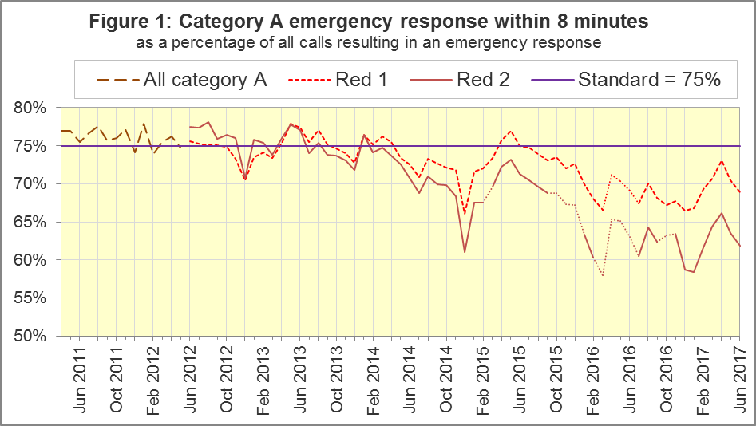
The standard for Ambulance Services is to send an emergency response, with a defibrillator, within 8 minutes to 75% of Category A calls. Figure 1 shows that for England, in June 2017, Red 1 performance decreased for the second month in a row, although at 68.8%, it was very close to the 2016-17 average of 68.7%.
For Red 1, out of the eight Services where Category A still applies, only North East (NEAS, 75.4%) met the 75% standard in June 2017. North West (NWAS, 62.5%), South East Coast (SECAmb, 63.9%), and Isle of Wight (IoW, 65.9%) Ambulance Services had fewer than 70%.

Dispatch on Disposition (DoD)
From February 2017, other than for Red 1 and Category 1 calls, the start time is the earliest of the following three possible trigger points:
- chief complaint or NHS Pathways initial disposition (Dx) code obtained;
- first vehicle assigned;
- 240 seconds after call connect.
Before February 2015, when DoD started, the third trigger point was 60 seconds after call connect. DoD tested alternatives of 180, 240 and 300 seconds in various Ambulance Services.
In October 2016, all Ambulance Services in England were aligned with a third trigger point of 240 seconds, except for Isle of Wight, which aligned in February 2017.
NWAS, SECAmb, East Midlands (EMAS), and East of England (EastAmb) Ambulance Services, always changed their clock start in the same months. Therefore, their response times remain comparable with each other.
However, all other Ambulance Services tested DoD according to a unique timetable, so each Service has a point between February 2015 and October 2016 when they become incomparable with other Services for Red 2 and Category A response times. All change dates are listed in the 8 December 2016 AQI Statistical Note.

Ambulance Response Programme (ARP)
DoD was Phase 1 of the ARP. Phase 2 of the ARP was the Clinical Coding Review (CCR). On 19 April, 21 April and 8 June 2016, in South Western (SWAS), Yorkshire (YAS), and West Midlands (WMAS) respectively, the existing Category A (Red 1 and Red 2) and Category C (Green 1, Green 2, Green 3, and Green 4) were replaced by new CCR categories, C1 to C4, that are not comparable with those used previously.
Therefore, from these dates, for these Trusts, data for Red 1, Red 2, and Category A are no longer available.
On 13 July 2017, NHS England published the University of Sheffield evaluation report of Phase 1 (DoD) and Phase 2 (CCR) of the Ambulance Response Programme (ARP), and announced standards for the new ambulance categories C1 to C4 at www.england.nhs.uk/urgent-emergency-care/arp.
Phase 3 of the ARP is a review of the AQI. We will phase out or redefine Systems Indicators (SIs) in section 1.5, and we will collect the new SIs listed in section 1.6.

Dates of collecting new SIs
Starting in August 2017, for publication on 12 October, we will collect the new SIs from the trusts who implemented the CCR in summer 2017: NWAS and EMAS.
Starting in September 2017, for publication on 9 November, we will collect the new SIs from the trusts that implemented the CCR in 2016: YAS, WMAS and SWAS.
We will collect the new SIs from the other six trusts in the month that they implement the CCR. This will be during 2017 for most of these, but not for IOW.
From the month when new SIs are collected, we will stop collecting existing SIs, except for SQU03_1_1_2, SQU03_10_2_1, and SQU03_10_2_2. We will collect these for three months to help measure the discontinuities due to the new definitions.
On 12 October, we will publish a separate spreadsheet with C1-C4 response time centiles for YAS, WMAS and SWAS, with data from October 2016, when they implemented CCR. We will annotate this file to describe differences in the way this monitoring data was collected to the new SIs.
We usually publish revisions to SIs in November, but we will delay collection of revisions for a few months, so that the last revisions to the existing SIs of 2017-18 will all be in the same publication.
Clinical Outcomes will also be reviewed in 2017, for collection from April 2018.

Systems Indicators to be phased out
HQU03_1_1_3 | Red 1 calls with emergency response on scene within 8 minutes
HQU03_1_1_4 | Red 1 calls with emergency response on scene
HQU03_1_1_5 | Red 1 time from Call Connect to emergency response on scene: 95th centile
HQU03_1_1_6 | Red 2 calls with emergency response on scene within 8 minutes
HQU03_1_1_7 | Red 2 calls with emergency response on scene
HQU03_1_2_1 | Category A calls with ambulance response on scene within 19 minutes
HQU03_1_2_2 | Category A calls with ambulance response on scene
SQU03_1_1_1 | Number of emergency and urgent calls abandoned before being answered
SQU03_1_1_2 | Total number of emergency and urgent calls presented to switchboard
SQU03_2_1_1 | Emergency calls closed with telephone advice with re-contact within 24 hours
SQU03_2_1_2 | Emergency calls closed with telephone advice
SQU03_2_2_1 | Patients treated and discharged on scene with re-contact within 24 hours
SQU03_2_2_2 | Patients treated and discharged on scene
SQU03_2_3_1 | Calls from patients for whom a locally agreed frequent caller procedure is in place
SQU03_2_3_2 | Total number of emergency and urgent calls presented to switchboard
SQU03_8_1_1 | Time to answer calls (emergency and urgent): median, 95th centile and 99th centile
SQU03_9_1_1 | Time to arrival on scene for Category A: median, 95th centile and 99th centile
SQU03_10_1_1 | Calls resolved by telephone advice
SQU03_10_1_2 | Calls that receive a telephone or face-to-face response from the ambulance service
SQU03_10_2_1 | Calls resolved without transport to Type 1 or Type 2 A&E
SQU03_10_2_2 | Calls that receive a face-to-face response from the ambulance service
SRS17_1_1_1 | Number of transported incidents
The Red 1, Red 2 and Category A data items that are longer applicable will be superseded by response times for the new Categories C1-C4.
Response times will be measured with means and centiles, replacing the previous binary measures of Red 1 and Red 2, where a response of 7 minutes 59 seconds was a success, and a response of 8 minutes 1 second was not.
We will redefine calls resolved on the telephone / on scene, and collect more detailed breakdowns. Other indicators will be replaced by indicators in section 1.6 to better reflect the clinical needs of patients, and any changes caused by the ARP.

New Systems Indicators
- Telephone call counts and answer times (mean, median, 95th, 99th centile);
- Incident counts, response times (mean and 90th centile), and resources allocated, for C1, C1 with transport (C1T), C2, C3, and C4 incidents;
- Count of C1 incidents identified by Nature of Call / Pre-Triage questions;
- Incidents with no face-to-face response referred to other services, or closed;
- Incidents with face-to-face response transported to ED, or elsewhere, or closed.
In August, we will put the specification document for the new Systems Indicators on www.england.nhs.uk/statistics/statistical-work-areas/ambulance-quality-indicators.

Emergency Response in 8 minutes for Red 2 (Figure 2)
Figure 2 shows that in June 2017, the Red 2 measure for England was 61.8%, less than in May 2017 (63.5%) and the 2016-17 average (62.5%). The 75% standard has not been met since January 2014 and this proportion has been below 70% since August 2015.
Figure 2 shows that the trend for England⁵ is similar to the trend for the four Services where the Red 2 measure is comparable, indicating that the trend for England is reliable, despite its discontinuities.
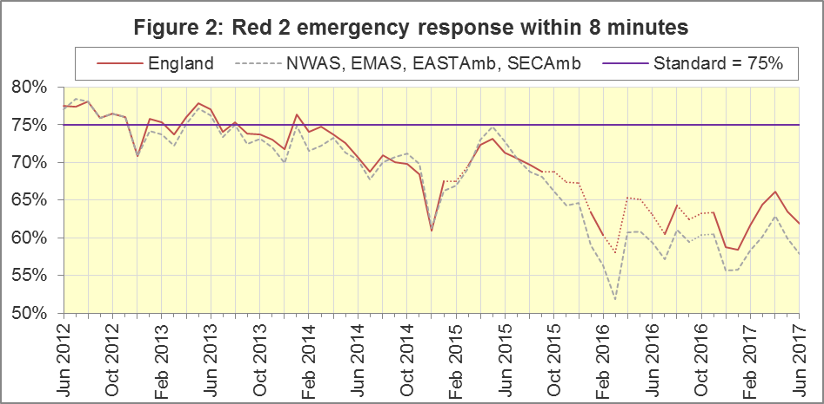
Out of the eight Services where Category A still applies, none met the Red 2 standard of 75% in June 2017. SECAmb had the lowest proportion at 46.4%.

Category A Ambulance response in 19 minutes (Figure 3)
The second ambulance standard in the Handbook to the NHS Constitution is for trusts to send, within 19 minutes, a fully-equipped ambulance vehicle, able to transport the patient in a clinically safe manner, to 95% of Category A calls. For England, in June 2017, performance was 90.0%, a little less than in May 2017 (90.8%) and the 2016-17 average (90.4%).
Figure 3 shows that, as with the Red 2 measure, the trend for England⁶ is similar to that for the four trusts with the same DoD implementation timetable.
The numerators and denominators for Figures 2 and 3 are on the “DoD R2” and “DoD A19” tab respectively, in the Systems Indicators Time Series spreadsheet at http://bit.ly/NHSAQI.
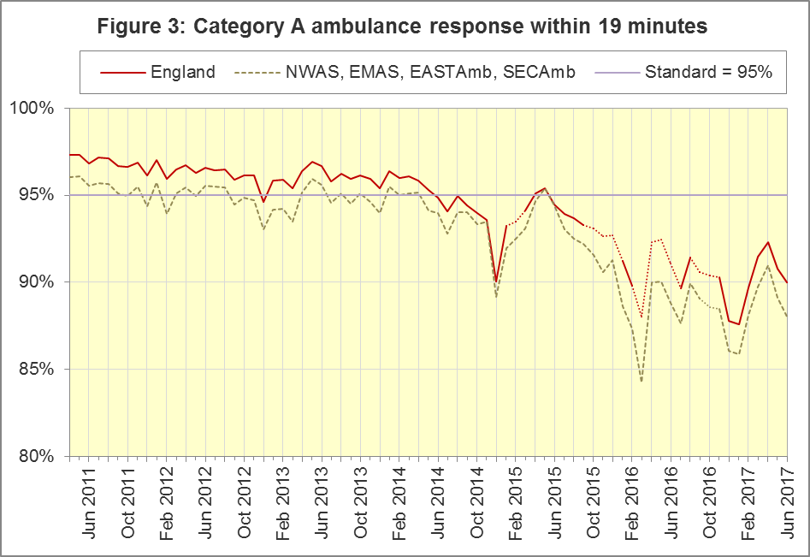
In the trusts where Category A still applies, no ambulance service met the 19 minute Category A standard of 95%. EMAS had the lowest proportion, 85.0%.
For other Systems Indicators, DoD and the CCR do not affect comparability, but may lead to changes in levels. For example, a longer triage time may mean more calls are closed on the telephone, but the data for this measure remain comparable. Such changes may be difficult to detect within the habitual variation of the many AQI.

Systems Indicators: Ambulance volumes (Figure 4)
The number of emergency telephone calls presented to the switchboard in June 2017 was 845,473, an average of 28.2 thousand per day.
There were 576,108 emergency calls that received a face-to-face response from the ambulance service in June 2017, an average of 19.2 thousand per day.
In June 2017, there were 400,759 incidents with a patient transported to Type 1 or Type 2 A&E, a average of 13.4 thousand per day.
Figure 4 shows that each measure habitually reduces after the annual December peak. Figure 4 also shows a gradual increase in telephone calls, and in face-to-face responses, but not so much for incidents where a patient was transported.
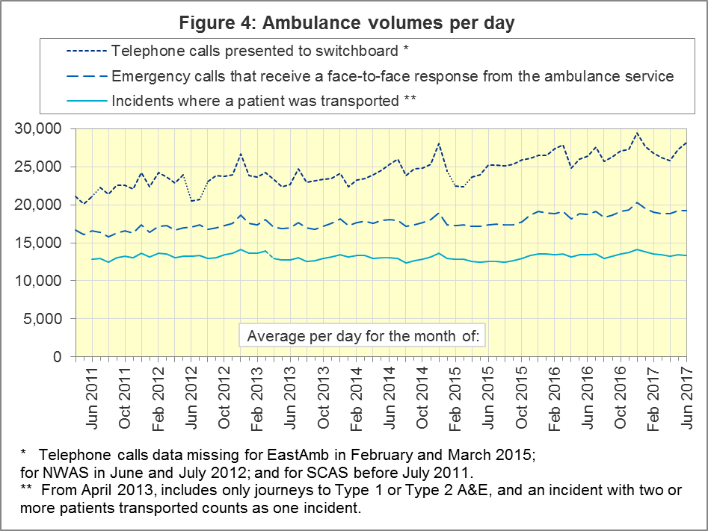

Latest monthly data for other Systems Indicators, June 2017
All other Systems Indicators, not already covered, were stable in June 2017 and within their ranges from the previous twelve months:
Indicator | England | Lowest Trust |  | Highest Trust⁹
Calls abandoned before being answered | 1.7% | YAS | 0.2% | NWAS | 4.5%
Calls resolved through telephone assessment | 10.4% | WMAS | 4.7% | EMAS | 18.4%
Calls resolved without transport to Type 1 or Type 2 A&E | 37.6% | EMAS | 23.6% | SWAS | 49.7%
Recontact rate following discharge by telephone advice | 6.1% | EMAS | 1.1% | WMAS | 14.5%
Recontact rate following face-to-face treatment at scene | 5.2% | YAS | 1.3% | LAS | 9.1%
Incidents where a patient was transported | 400,759 | NEAS | 19,318 | LAS | 66,258

Clinical Outcomes
This month’s publication contains Clinical Outcomes for March 2017, completing the data for 2016-17, and so we compare Clinical Outcomes for the latest year with those for earlier years.

Cardiac arrest: return of spontaneous circulation (ROSC)
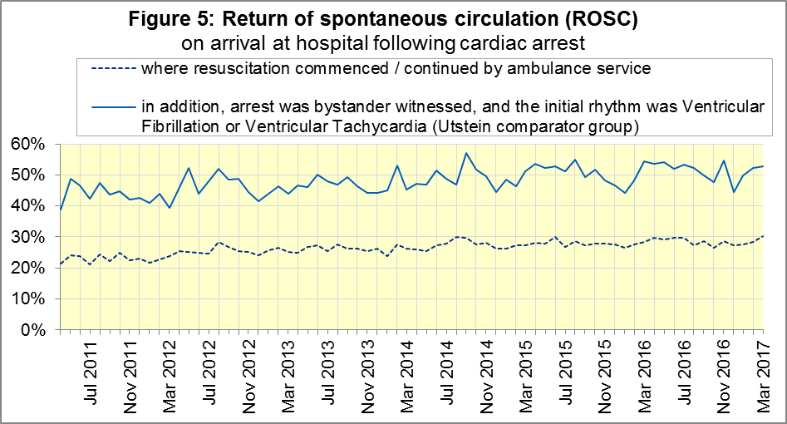
Patients in cardiac arrest will typically have no pulse and will not be breathing. In March 2017, in England, resuscitation was commenced or continued by ambulance staff out-of-hospital for 2,672 such patients. Of these, 808 (30%) had ROSC, with a pulse, on arrival at hospital (Figure 5), similar to the 2016-17 average (28%).
The Utstein group comprises patients who had resuscitation commenced or continued by the Ambulance Services, following an out-of-hospital cardiac arrest of presumed cardiac origin, where the arrest was bystander witnessed, and the initial rhythm was Ventricular Fibrillation or Ventricular Tachycardia. The Utstein group therefore have a better chance of survival.
There were 410 such patients in England in March 2017, of which 216 (53%) had ROSC on arrival at hospital (Figure 5), also similar to the 2016-17 average (51%).
Over recent years, Figure 6 shows that for all patients in England, ROSC has increased from 23% in 2011-12 to 28% in 2016-17. In 2016-17, NWAS had the largest proportion with 36%, and the lowest proportion was 25% for EMAS, NEAS and SWAS.

Figure 6: ROSC following cardiac arrest: annual trust-level data, all patients
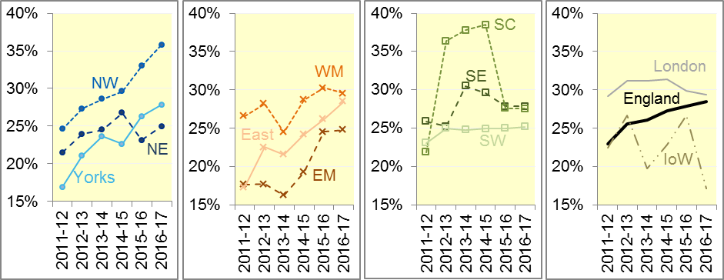

Figure 7: ROSC following cardiac arrest: annual trust-level data, Utstein group
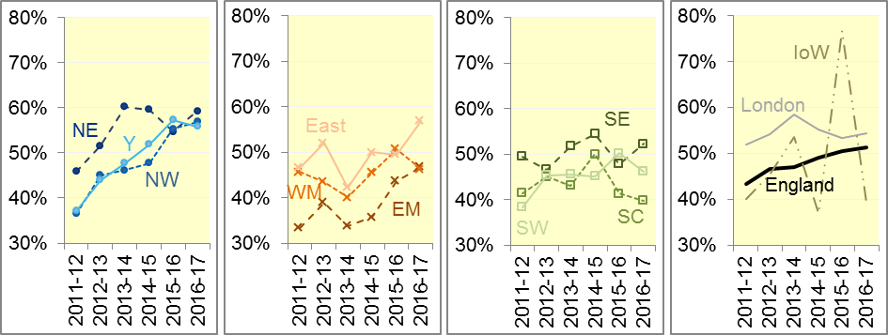
For the Utstein comparator group, Figure 7 shows that the England proportion increased gradually from 43% in 2011-12 to 51% in 2016-17. In 2016-17, NEAS had the largest proportion with 59%, and SCAS had the lowest proportion with 40%.

Cardiac arrest: survival to discharge
Figure 8 shows that the proportion of cardiac arrest patients in England discharged from hospital alive was 9% in March 2017, similar to the 2016-17 average (8%). For the Utstein group, survival to discharge in March 2017 was 29%, also similar to the 2016-17 average (27%).
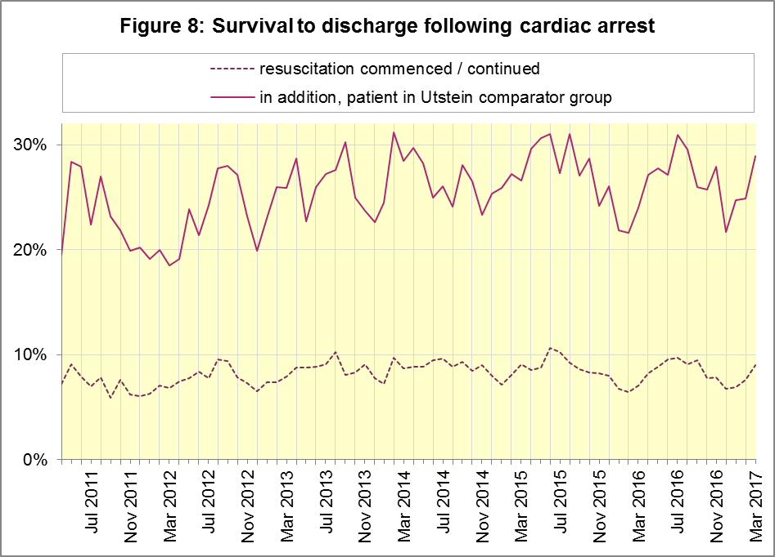

Figure 9: survival following cardiac arrest: annual trust-level data, all patients
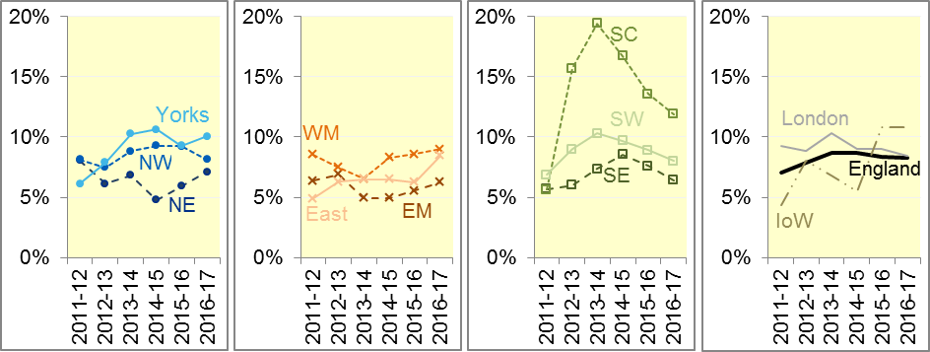
Figure 9 shows that for all patients in England, survival to discharge increased from 7% in 2011-12 to 8% in 2016-17. SCAS had the largest proportion in the last four years. The lowest proportion in 2016-17 was 6% in EMAS.
Figure 10 shows that for the Utstein group, survival across England increased from 22% in 2011-12 to 27% in 2016-17. In 2016-17, YAS had the largest proportion with 37%, and EMAS had the lowest proportion with 21%.

Figure 10: survival following cardiac arrest: trust-level data, Utstein group
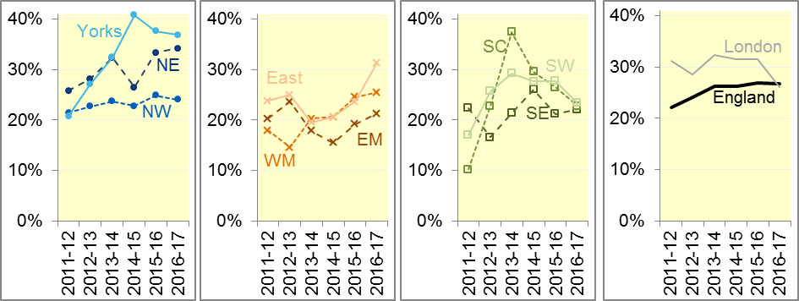

ST-Elevation myocardial infarction
ST-segment elevation myocardial infarction (STEMI) is a type of heart attack, determined by an electrocardiogram (ECG) test. Early access to reperfusion, where blocked arteries are opened to re-establish blood flow, and other assessment and care interventions, are associated with reductions in STEMI mortality and morbidity.
1,051 STEMI patients in England received primary angioplasty in March 2017. Of these patients, 906 (86%) of them received it within 150 minutes of the call being connected to the ambulance service (Figure 11), the same as the 2016-17 average.
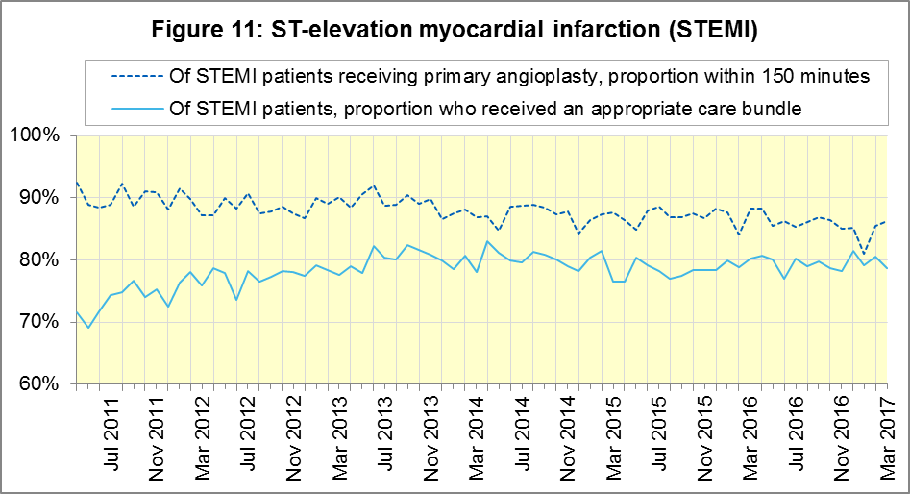
In March 2017, of 1,632 patients with an acute STEMI in England, 1,284 (79%) received the appropriate care bundle (Figure 11), also the same as the 2016-17 average.
Figure 12 shows the proportion of patients receiving primary angioplasty within 150 minutes decreased from 90% in 2011-12 to 86% in 2016-17 across England.
In 2016-17, NEAS had the largest proportion with 93%, and SWAS had the lowest proportion with 73%.

Figure 12: angioplasty within 150 minutes of STEMI: annual trust-level data
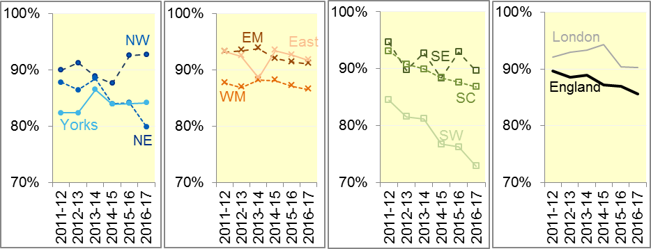
Figure 13 shows the proportion of STEMI patients in England who received an appropriate care bundle increased from 74% in 2011-12 to 80% in 2013-14, and was 79% in 2016-17.
In 2016-17, EastAmb had the largest proportion with 91%. SECAmb had the lowest proportion with 67% of those with ST-elevation myocardial infarction receiving an appropriate care bundle.

Figure 13: Care bundle after STEMI: annual trust-level data
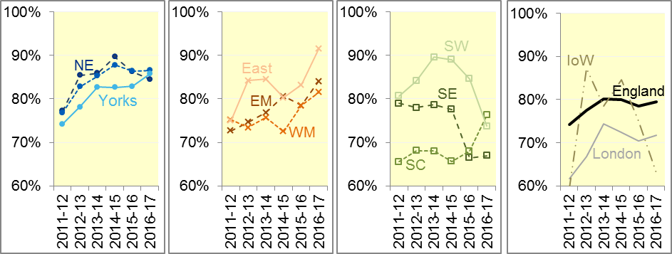

Stroke
The FAST procedure helps assess whether someone has suffered a stroke:
- Facial weakness: can the person smile? Has their mouth or eye drooped?
- Arm weakness: can the person raise both arms?
- Speech problems: can the person speak clearly and understand what you say?
- Time to call 999 for an ambulance if you spot any one of these signs.
In March 2017, of 3,966 FAST positive patients in England, assessed face to face, and potentially eligible for stroke thrombolysis within agreed local guidelines, 2,191 (55%) arrived at hospitals with a hyperacute stroke unit within 60 minutes of an emergency call connecting to the ambulance service (Figure 14), similar to the 2016-17 average (54%).
There were 7,932 stroke patients assessed face to face in March 2017 in England, of which 7,783 (98.1%) received the appropriate care bundle.
Although this was close to the 2016-17 average of 97.6%, the March 2017 proportion was actually a significant increase.
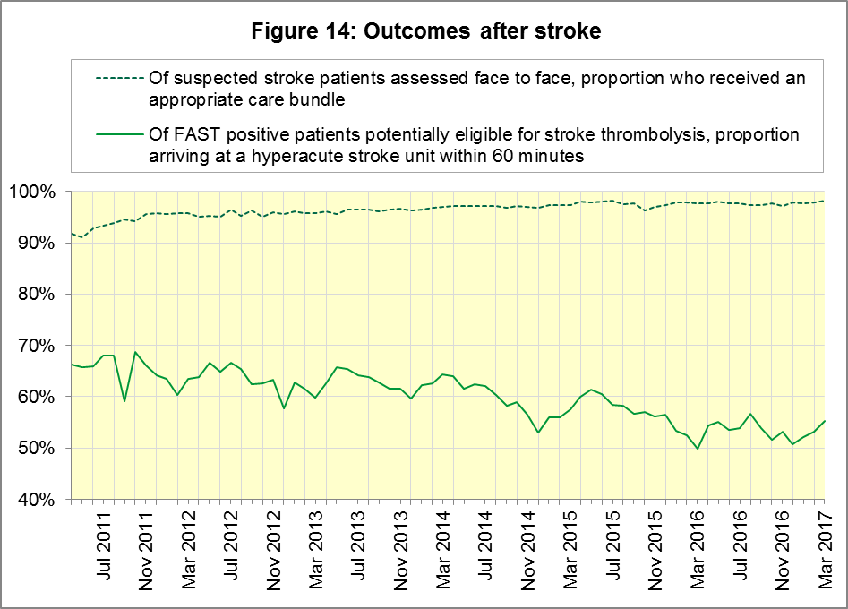

Figure 15 shows that in England, the proportion of patients arriving at a hyperacute stroke unit within 60 minutes decreased steadily from 65% in 2011-12 to 54% in 2016-17.
In 2016-17, SECAmb had the largest proportion (62%) arriving within 60 minutes, and SWAS had the lowest (37%).

Figure 15: thrombolysis within 60 minutes of stroke: annual trust-level data
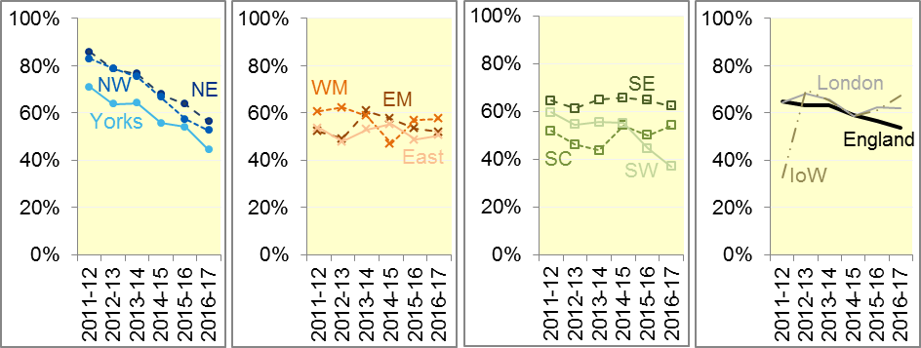
Figure 16 shows that in England, the proportion of patients who received an appropriate care bundle increased every year from 94% in 2011-12 to 98% in 2016-17. This proportion has the least variation of the Clinical Outcomes, with more than 95% in every Ambulance Service in the last two years.

Figure 16: Care bundle after stroke: annual trust-level data
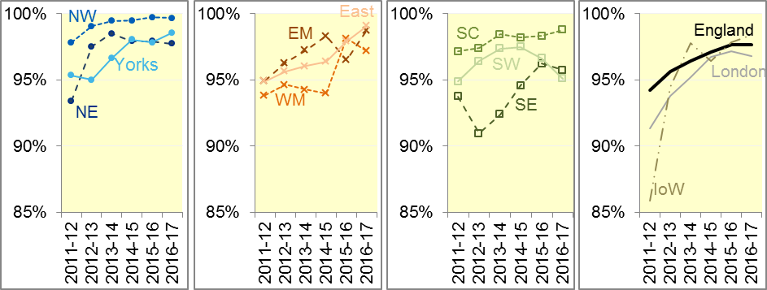

Further information on AQI

The AQI landing page and Quality Statement
www.england.nhs.uk/statistics/statistical-work-areas/ambulance-quality-indicators, or http://bit.ly/NHSAQI, is the AQI landing page, and it holds:
- a Quality Statement for these statistics, which includes information on relevance, accuracy, timeliness, coherence, and user engagement;
- the specification guidance document for those who supply the data;
- timetables for data collection and publication;
- time series spreadsheets and csv files from April 2011 up to the latest month;
- links to individual web pages for each financial year;
- contact details for the responsible statistician (also in 3.6 below).
The web pages for each financial year hold:
- separate spreadsheets of each month’s data;
- this Statistical Note, and equivalent versions from previous months;
- the list of people with pre-release access to the data.
Publication dates are also at www.gov.uk/government/statistics/announcements.

Revisions Timetable
Revisions usually follow a six-monthly cycle. The dates for past and future AQI Systems Indicators (SI) and Clinical Outcomes (CO) scheduled revisions are below. The AQI Quality Statement above contains a more detailed revisions policy.
Publication |  | Data |  | Months affected |  |  | Publication |  | Data |  | Months affected
14 Sep 2017 |  | CO |  | Apr ’16 - Mar ‘17 |  |  | 6 Nov 2014 |  | SI |  | Apr ‘13 - Aug ‘14
11 May 2017 |  | SI |  | Apr ‘15 - Feb ‘17 |  |  | 5 Sep 2014 |  | CO |  | Apr ‘13 - Mar ‘14
9 Mar 2017 |  | CO |  | Apr ‘16 - Sep ‘16 |  |  | 2 May 2014 |  | SI |  | Apr ‘13 - Feb ‘14
10 Nov 2016 |  | SI |  | Apr ‘16 - Aug ‘16 |  |  | 7 Mar 2014 |  | CO |  | Apr ‘13 - Sep ‘13
8 Sep 2016 |  | CO |  | Apr ‘15 - Apr ‘16 |  |  | 1 Nov 2013 |  | SI |  | Apr ‘13 - Aug ‘13
12 May 2016 |  | SI |  | Apr ‘15 - Feb ‘16 |  |  | 2 Aug 2013 |  | CO |  | Apr ‘12 - Mar ‘13
10 Apr 2016 |  | CO |  | Apr ‘15 - Sep ‘15 |  |  | 3 May 2013 |  | SI |  | Apr ‘12 - Mar ‘13
10 Sep 2015 |  | CO |  | Apr ‘14 - Mar ‘15 |  |  | 1 Feb 2013 |  | CO |  | Apr ‘12 - Aug ‘12
4 Jun 2015 |  | SI |  | Apr ‘14 - Feb ‘15 |  |  | 11 Jan 2013 |  | SI |  | Apr ‘11 - Oct ‘12
30 Apr 2015 |  | SI |  | Apr ‘14 - Feb ‘15 |  |  | 31 Aug 2012 |  | CO |  | Apr ‘11 - Mar ‘12
5 Mar 2015 |  | CO |  | Apr ‘14 - Sep ‘14 |  |  | 4 May 2012 |  | SI & CO |  | Apr ‘11 - Mar ‘12

AQI Scope
The AQI include calls made by dialling either the usual UK-wide number 999 or its international equivalent 112.
As described in the specification guidance mentioned in section 3.1, calls made to NHS 111 are not included in the AQI measures for calls abandoned, re-contacts, frequent callers, time to answer calls, or calls resolved by telephone advice.
All other Systems Indicators involve the dispatch of an ambulance, and include ambulances dispatched as a result of a call to NHS 111, as well as 999 or 112.

Related statistics in England
A dashboard on the AQI landing page presents an alternative layout for the AQI data. Because of the lack of comparability due to the Ambulance Response Programme (section 1.3), NHS England last updated the dashboard in April 2016.
The AQI were also used in the “Ambulance Services” publications by NHS Digital, which included additional annual analysis and commentary, up to and including 2014-15 data. The Quality Statement described in section 3.1 has more information on this publication. The Quality Statement also contains details of weekly ambulance situation reports that NHS England collected for six months from November 2010.
Ambulance handover delays of over 30 minutes at each Emergency Department were collected and published by NHS England for winter 2012-13, 2013-14 and 2014-15: www.england.nhs.uk/statistics/statistical-work-areas/winter-daily-sitreps.

Rest of United Kingdom
Ambulance statistics for other countries of the UK can be found at the following websites. The Quality Statement described in section 3.1 contains more information about the comparability of these statistics.
Wales: | http://wales.gov.uk/statistics-and-research/ambulance-services
Scotland: | See Quality Improvement Indicators (QII) documents at www.scottishambulance.com/TheService/BoardPapers.aspx
Northern Ireland: | www.health-ni.gov.uk/articles/emergency-care-and-ambulance-statistics

Contact information
Press: NHS England press office, nhsengland.media@nhs.net, 0113 825 0958.
The person responsible for producing this publication is:
Ian Kay, Operational Information for Commissioning (Central), NHS England
Room 5E24, Quarry House, Leeds, LS2 7UE; 0113 825 4606; i.kay@nhs.net

National Statistics
The UK Statistics Authority has designated these statistics as National Statistics, in accordance with the Statistics and Registration Service Act 2007 and signifying compliance with the Code of Practice for Official Statistics.
Designation can be broadly interpreted to mean that the statistics:
- meet identified user needs;
- are well explained and readily accessible;
- are produced according to sound methods; and
- are managed impartially and objectively in the public interest.
Once statistics have been designated as National Statistics it is a statutory requirement that the Code of Practice shall continue to be observed.

Page 34 of the July 2015 Handbook to the NHS Constitution has Ambulance response time standards, www.gov.uk/government/publications/supplements-to-the-nhs-constitution-for-england.
Significance calculations in this document are Student’s t-test with 95% significance, comparing the latest month with the latest financial year.
After June 2016, Category A only applies to 8 of the 11 Ambulance Services in England, so Red 1 and Red 2 response data are not available for the other 3; see section 1.3 on the Clinical Coding Review. Also, from February 2015, changes in operational practice meant that Red 2 response data are still available but not always comparable; see section 1.2 on Dispatch on Disposition. The Red 1 and Red 2 divisions of Category A (immediately life-threatening) calls were created on 1 June 2012. Red 1 calls are the most time critical, and cover cardiac arrest patients who are not breathing and do not have a pulse, and other severe conditions such as airway obstruction. Red 2 calls are serious, but less immediately time critical, and cover conditions such as stroke and fits. www.gov.uk/government/news/changes-to-ambulance-response-time-categories.
England excludes YAS and SWAS after April 2016, and WMAS after June 2016. See section 1.3.
England excludes YAS and SWAS after April 2016, and WMAS after June 2016. See section 1.3.
England excludes YAS and SWAS after April 2016, and WMAS after June 2016. See section 1.3.
The number of emergency calls presented to switchboard does not usually include calls made to NHS 111 requiring an ambulance. 111 calls requiring an ambulance are usually transferred electronically direct to ambulance dispatch and not routed via 999 call handlers. Occasionally, manual requests for ambulances are made between 111 and 999 call handlers and such calls are included in the numbers of emergency calls presented to switchboard.
Type 1 are consultant-led 24 hour emergency departments with full resuscitation facilities. Type 2 offer a consultant-led speciality A&E service such as ophthalmology or dental. Type 3 is A&E / minor injury activity that may be doctor-led or nurse-led. Type 4 are NHS walk-in centres. (www.datadictionary.nhs.uk/data_dictionary/attributes/a/acc/ accident_and_emergency_department_type_de.asp)
The Isle of Wight (IOW) contains 0.3% of the resident population of England. Its data, available in the accompanying spreadsheets, vary more than other trusts due to its small size. In this document, if IOW has the largest or smallest value, we report the second largest or smallest value instead.
This definition was proposed at Utstein Abbey in Norway by an international group of cardiologists and other health professionals in 1990. http://circ.ahajournals.org/content/110/21/3385
Pages 27 to 30 of the specification guidance for data suppliers on the AQI landing page at www.england.nhs.uk/statistics/statistical-work-areas/ambulance-quality-indicators describe the care bundles, and certain exclusions, for the STEMI and stroke indicators.
NHS Digital Ambulance Services: http://content.digital.nhs.uk/article/2021/Website-Search?q=ka34

