Statistical Note: Ambulance Quality Indicators (AQI)
The latest Systems Indicators for July 2017 for Ambulance Services in England showed the standards in the Handbook to the NHS constitution were not met.
The latest Clinical Outcomes data for April 2017 show fewer myocardial infarction patients received an appropriate care bundle, while more stroke patients arrived at hospital within 60 minutes.

Systems Indicators

Emergency response in 8 minutes (Figure 1)
In July 2017, of Category A Red 1 calls in England, resulting in an emergency response, the proportion arriving within 8 minutes was 67.9%.
In July 2017, of Category A² Red 2 calls in England, resulting in an emergency response, the proportion arriving within 8 minutes was 60.5%.
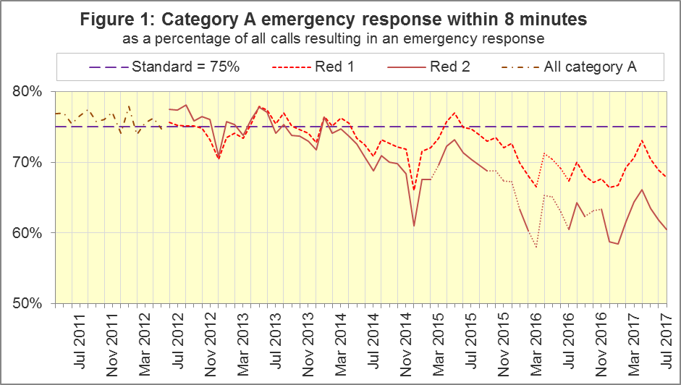
The standard for Ambulance Services is to send an emergency response, with a defibrillator, within 8 minutes to 75% of Category A calls. Figure 1 shows that for England, in July 2017, Red 1 performance decreased for the third month in a row, to 67.9%, a similar percentage to that for July 2016.
For Red 1, out of the eight Services where Category A still applies, in July 2017, only South Central Ambulance Service (SCAS, 75.5%) met the standard, and the lowest proportion was 57.5% for South East Coast Ambulance Service (SECAmb).

Dispatch on Disposition (DoD)
From February 2017, other than for Red 1 and Category 1 calls, the start time is the earliest of the following three possible trigger points:
- chief complaint or NHS Pathways initial disposition (Dx) code obtained;
- first vehicle assigned;
- 240 seconds after call connect.
Before February 2015, when DoD started, the third trigger point was 60 seconds. DoD tested alternatives of 180, 240 and 300 seconds in various Ambulance Services. In October 2016, all Ambulance Services in England were aligned with a third trigger point of 240 seconds, except for IoW, which aligned in February 2017.
North West (NWAS), SECAmb, East Midlands (EMAS), and East of England (EastAmb) Ambulance Services, always changed their clock start in the same months. Therefore, their response times remain comparable with each other.
However, all other Ambulance Services tested DoD according to a unique timetable, so each Service has a point between February 2015 and October 2016 when they become incomparable with other Services for Red 2 and Category A response times. All change dates are listed in the 8 December 2016 AQI Statistical Note.

Ambulance Response Programme (ARP)
DoD was Phase 1 of the ARP. Phase 2 of the ARP was the Clinical Coding Review (CCR), which meant that the existing Category A (Red 1 and Red 2) and Category C (Green 1, Green 2, Green 3, and Green 4) were replaced by Categories 1 to 4, which are not comparable with those used previously.
Therefore, for these Trusts, from these dates, data for Red 1, Red 2, and Category A are no longer available:
19th April 2016 | South Western Ambulance Service (SWAS)
21st April 2016 | Yorkshire Ambulance Service (YAS)
8th June 2016 | West Midlands Ambulance Service (WMAS)
19th July 2017 | East Midlands Ambulance Service (EMAS)

Phase 3 of the ARP is a review of the AQI. As described in more detail in the 10 August 2017 Statistical Note, we will phase out or redefine all existing Systems Indicators (SIs), and begin to collect the new set of SIs, starting in August 2017 with NWAS and EMAS, the trusts that implemented the CCR in summer 2017.
The definitions for the new SIs are in the 20170811 specification document at www.england.nhs.uk/statistics/statistical-work-areas/ambulance-quality-indicators, and an addendum to the Handbook to the NHS Constitution shows the standards that will apply to the new Categories.

Emergency Response in 8 minutes for Red 2 (Figure 2)
Figure 2 shows that in July 2017, the Red 2 measure for England was 60.5%, the same as for July 2016, but a decrease for the third month in a row. The 75% standard has not been met since January 2014 and this proportion has been below 70% since August 2015.
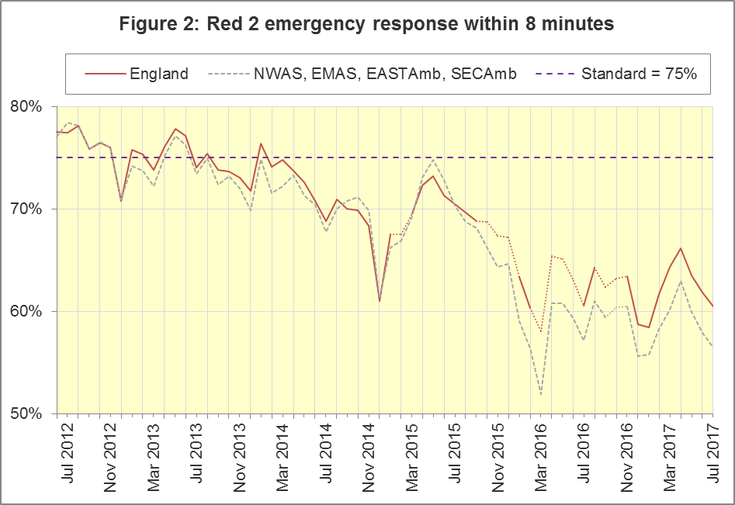
Figure 2 shows that the trend for England⁵ is similar to the trend for the four Services where the Red 2 measure is comparable, indicating that the trend for England is reliable, despite its discontinuities.
Out of the eight Services where Category A still applied in July 2017, the highest was 71.0% for SCAS. SECAmb had the lowest proportion, 45.7%.

Category A Ambulance response in 19 minutes (Figure 3)
The second ambulance standard in the Handbook to the NHS Constitution is for trusts to send, within 19 minutes, a fully-equipped ambulance vehicle, able to transport the patient in a clinically safe manner, to 95% of Category A calls. For England, in July 2017, performance was 89.7%. As with Red 2, this was a decrease for the third consecutive month, and yet also the same figure as in July 2016.
Figure 3 shows that, as with the Red 2 measure, the trend for England⁶ is similar to that for the four trusts with the same DoD implementation timetable.
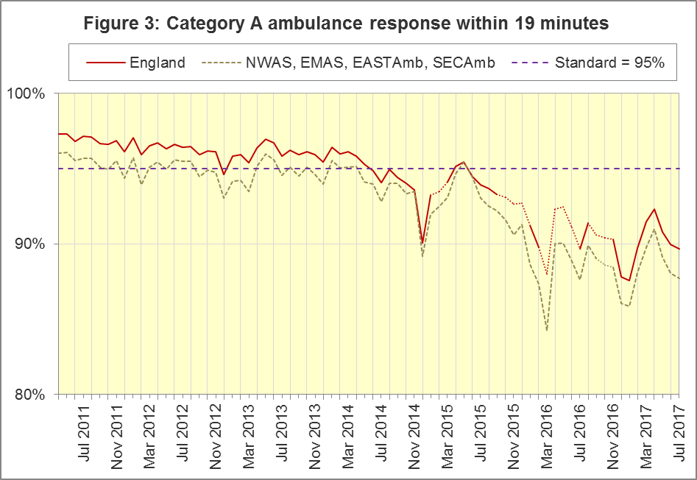
The numerators and denominators for Figures 2 and 3 are on the “DoD R2” and “DoD A19” tab respectively, in the Systems Indicators Time Series spreadsheet at http://bit.ly/NHSAQI.
In the trusts where Category A still applied in July 2017, the highest was 94.8% for SCAS, and the lowest was 82.7% in EMAS⁶.
For other Systems Indicators, DoD and the CCR do not affect comparability, but may lead to changes in levels. For example, a longer triage time may mean more calls are closed on the telephone, but the data for this measure remain comparable. Such changes may be difficult to detect within the habitual variation of the many AQI.

Systems Indicators: Ambulance volumes (Figure 4)
The number of emergency telephone calls presented to the switchboard in July 2017 was 856,262, an average of 28.7 thousand per day.
There were 574,909 emergency calls that received a face-to-face response from the ambulance service in July 2017, an average of 19.3 thousand per day.
In July 2017, there were 399,102 incidents with a patient transported to Type 1 or Type 2 A&E, an average of 13.4 thousand per day.
Figure 4 shows these measures usually revert to average after a high in December and a low in August. It also shows a gradual increase in telephone calls, and in face-to-face responses, but not so much for incidents where a patient was transported.
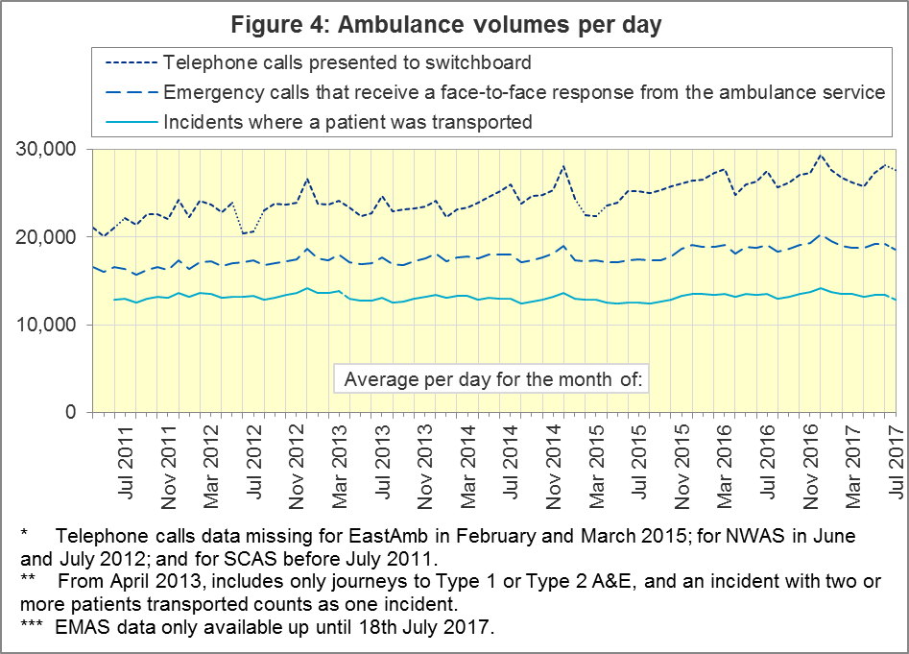

Latest monthly data for other Systems Indicators, July 2017
All other Systems Indicators, not already covered, were stable in July 2017 and within their ranges from the previous twelve months:
Indicator | England | Lowest Trust |  | Highest Trust¹¹
Calls abandoned before being answered | 1.8% | YAS | 0.2% | SECAmb | 8.2%
Calls resolved through telephone assessment | 10.2% | WMAS | 4.7% | EMAS | 20.3%
Calls resolved without transport to Type 1 or Type 2 A&E | 38.0% | EMAS | 23.3% | SWAS | 49.4%
Recontact rate following discharge by telephone advice | 6.7% | EMAS | 0.8% | WMAS | 15.0%
Recontact rate following face-to-face treatment at scene | 5.4% | YAS | 1.0% | LAS | 8.6%
Incidents where a patient was transported | 399,102 | NEAS | 19,838 | LAS | 68,006

Clinical Outcomes

Cardiac arrest: return of spontaneous circulation (ROSC)
Patients in cardiac arrest will typically have no pulse and will not be breathing. In April 2017, in England, resuscitation was commenced or continued by ambulance staff out-of-hospital for 2,564 such patients. Of these, 774 (30%) had ROSC, with a pulse, on arrival at hospital (Figure 5), similar to the 2016-17 average of 29% (revised from 28%, see section 2.5 below).
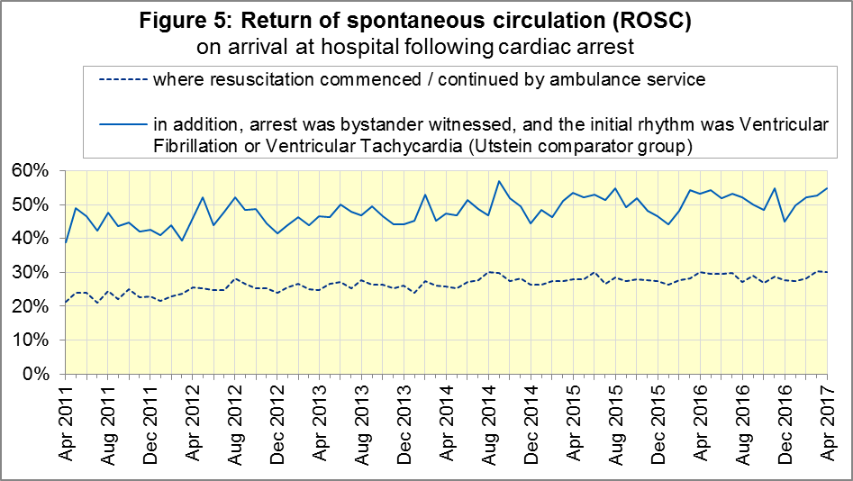
The trust with the largest proportion in April 2017 was NWAS (38%) and the smallest proportion was for NEAS (25%).
The Utstein group comprises patients who had resuscitation commenced or continued by the Ambulance Services, following an out-of-hospital cardiac arrest of presumed cardiac origin, where the arrest was bystander witnessed, and the initial rhythm was Ventricular Fibrillation or Ventricular Tachycardia. The Utstein group therefore have a better chance of survival.
There were 374 such patients in England in April 2017, of which 205 (55%) had ROSC on arrival at hospital (Figure 5). The small sample means that this measure often varies from month to month, and the latest figure is not significantly different to the 2016-17 average of 51%. The largest proportion in April 2017 was 64% for LAS and the smallest was 38% for SCAS.

Cardiac arrest: survival to discharge
Figure 6 shows that the proportion of cardiac arrest patients in England discharged from hospital alive was 9% in April 2017, the same as the 2016-17 average of 9% (revised from 8%). The trust with the largest proportion in April 2017 was SCAS (18%) and the smallest proportion was for SWAS (6%).
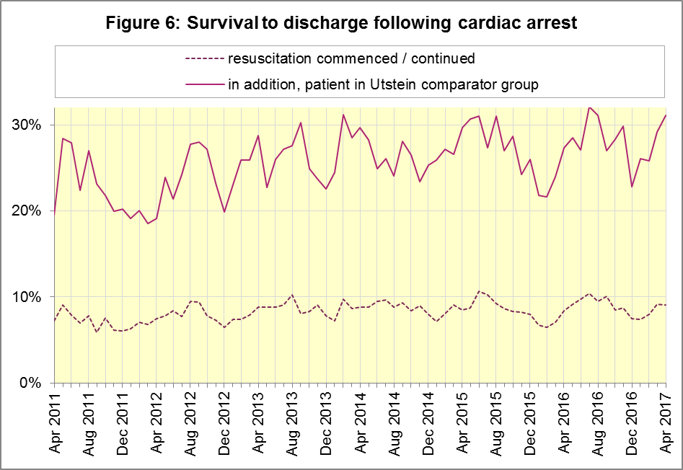
For the Utstein group, survival to discharge in April 2017 was 31%, similar to the 2016-17 average of 28% (revised from 27%). The trust with the largest proportion in April 2017 was LAS (38%) and the smallest proportion was for YAS (24%).

ST-Elevation myocardial infarction
ST-segment elevation myocardial infarction (STEMI) is a type of heart attack, determined by an electrocardiogram (ECG) test. Early access to reperfusion, where blocked arteries are opened to re-establish blood flow, and other assessment and care interventions, are associated with reductions in STEMI mortality and morbidity.
937 STEMI patients in England received primary angioplasty in April 2017. Of these patients, 821 (88%) of them received it within 150 minutes of the call being connected to the ambulance service (Figure 7), similar to the 2016-17 average (86%). The largest proportion in April 2017 was 97% for NEAS and the smallest was 76% for NWAS.
In April 2017, of 1,616 patients with an acute STEMI in England, 1,239 (77%) received the appropriate care bundle (Figure 7), significantly less than the 2016-17 average of 79%. The largest proportion in April 2017 was 93% for NEAS and the smallest was 60% for SECAmb.
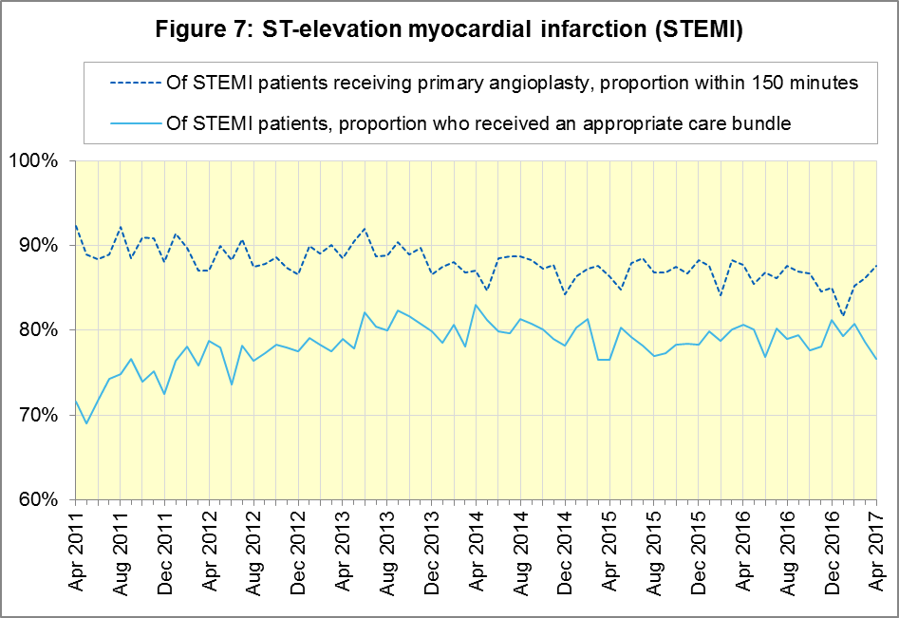

Stroke
The FAST procedure helps assess whether someone has suffered a stroke:
- Facial weakness: can the person smile? Has their mouth or eye drooped?
- Arm weakness: can the person raise both arms?
- Speech problems: can the person speak clearly and understand what you say?
- Time to call 999 for an ambulance if you spot any one of these signs.
In April 2017, of 3,702 FAST positive patients in England, assessed face to face, and potentially eligible for stroke thrombolysis within agreed local guidelines, 2,174 (59%) arrived at hospitals with a hyperacute stroke unit within 60 minutes of an emergency call connecting to the ambulance service (Figure 8), significantly more than the 2016-17 average (54%). The trust with the largest proportion in April 2017 was LAS (70%) and the smallest proportion was for SWAS (41%).
There were 7,411 stroke patients assessed face to face in April 2017 in England, of which 7,210 (97%) received the appropriate care bundle, similar to the 2016-17 average (98%). All trusts had at least 94% for April 2017 and for 2016-17.
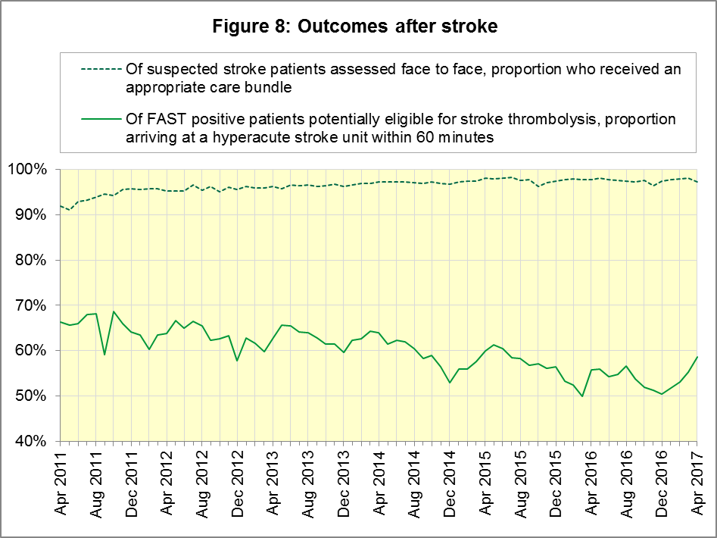

Revisions
Seven Trusts (NEAS, NWAS, EMAS, WMAS, LAS, SECAmb, and SWAS) have supplied us with revisions to data for April 2016 to March 2017, which are included in the data in Section 2 (above). The largest revisions are to the proportion of Utstein cardiac arrest patients who were discharged from hospital alive (Figure 12 below).

Figure 9: ROSC after cardiac arrest, 2016/17 (all)

Figure 10: ROSC after cardiac arrest, 2016/17 (Utstein comparator group)
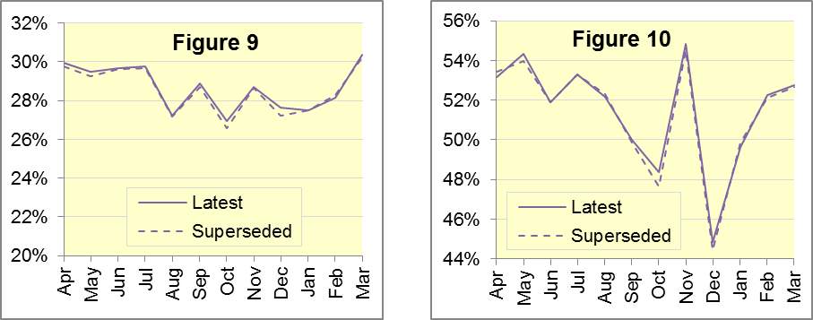

Figure 11: Survival to discharge after cardiac arrest, 2016/17 (all)

Figure 12: Survival to discharge after cardiac arrest, 2016/17 (Utstein)
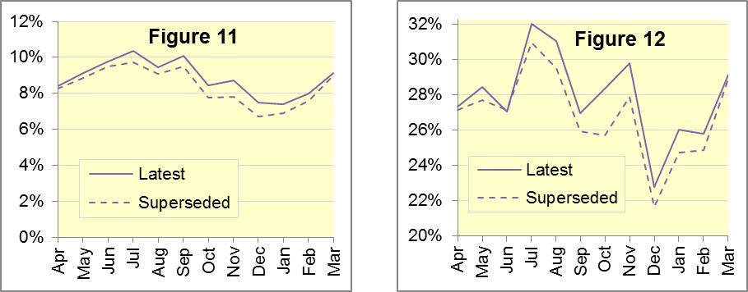

Figure 13: Angioplasty within 150 minutes of STEMI, 2016/17

Figure 14: STEMI patients receiving appropriate care bundle, 2016/17
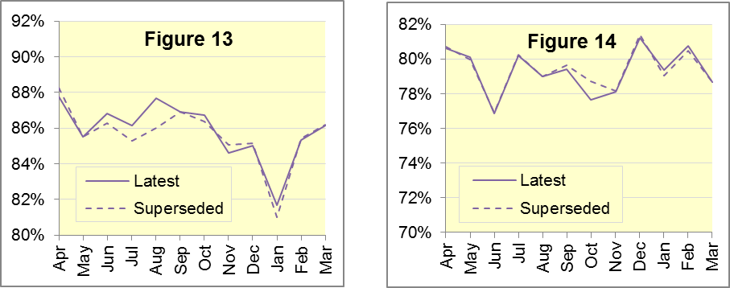

Figure 15: Thrombolysis within 60 minutes of stroke, 2016/17

Figure 16: Stroke patients receiving appropriate care bundle, 2016/17
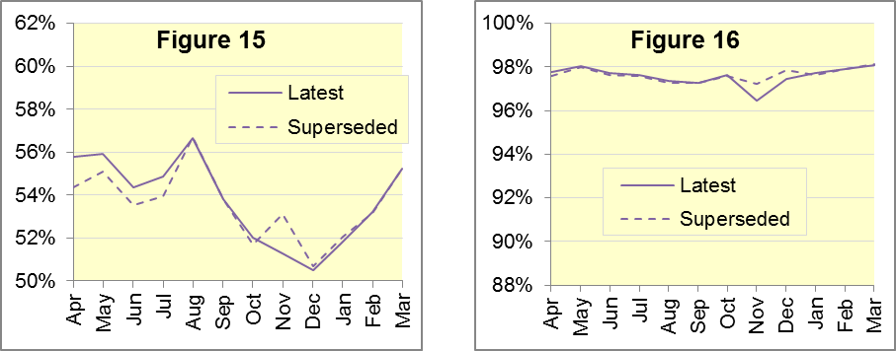

Figure 17: Revisions of more than 10% points to Trust-level monthly data
Trust |  | Indicator | Month | From | To
NWAS | Stroke Unit within 60 minutes |  | Apr | 47.2% | 59.9%
 | STEMI patients receiving angioplasty within 150 minutes |  | Aug | 77.6% | 89.3%
 | Survival following cardiac arrest (Utstein) |  | Oct | 13.8% | 27.0%
WMAS | Stroke Unit within 60 minutes |  | Nov | 69.1% | 49.7%
SECAmb | Survival following cardiac arrest (Utstein) |  | Nov | 4.8 | 26.7%

Figure 18: Revisions of more than 1 percentage point to England monthly data
Indicator | Month | From | To
Survival following cardiac arrest (Utstein) | Jul | 31.0% | 32.1%
 | Aug | 29.5% | 31.1%
 | Sep | 25.9% | 27.0%
 | Oct | 25.7% | 28.4%
 | Nov | 27.9% | 29.8%
 | Dec | 21.7% | 22.8%
 | Jan | 24.8% | 26.0%
Stroke Unit within 60 minutes | Apr | 27.6% | 28.7%
 | Nov | 20.6% | 21.8%
STEMI patients receiving angioplasty within 150 minutes | Aug | 86.0% | 87.7%
STEMI patients receiving care bundle | Oct | 78.7% | 77.7%

Further information on AQI

The AQI landing page and Quality Statement
www.england.nhs.uk/statistics/statistical-work-areas/ambulance-quality-indicators, or http://bit.ly/NHSAQI, is the AQI landing page, and it holds:
- a Quality Statement for these statistics, which includes information on relevance, accuracy, timeliness, coherence, and user engagement;
- the specification guidance document for those who supply the data;
- timetables for data collection and publication;
- time series spreadsheets and csv files from April 2011 up to the latest month;
- links to individual web pages for each financial year;
- contact details for the responsible statistician (also in 3.6 below).
The web pages for each financial year hold:
- separate spreadsheets of each month’s data;
- this Statistical Note, and equivalent versions from previous months;
- the list of people with pre-release access to the data.
Publication dates are also at www.gov.uk/government/statistics/announcements.

Revisions Timetable
Revisions usually follow a six-monthly cycle. The dates for past and future AQI Systems Indicators (SI) and Clinical Outcomes (CO) scheduled revisions are below. The AQI Quality Statement above contains a more detailed revisions policy.
Publication |  | Data |  | Months affected |  |  | Publication |  | Data |  | Months affected
8 Mar 2018 |  | CO |  | Apr ‘17 - Sep ‘17 |  |  | 5 Mar 2015 |  | CO |  | Apr ‘14 - Sep ‘14
9 Nov 2017 |  | SI |  | Apr ‘17 - Aug ‘17 |  |  | 6 Nov 2014 |  | SI |  | Apr ‘13 - Aug ‘14
14 Sep 2017 |  | CO |  | Apr ’16 - Mar ‘17 |  |  | 5 Sep 2014 |  | CO |  | Apr ‘13 - Mar ‘14
11 May 2017 |  | SI |  | Apr ‘15 - Feb ‘17 |  |  | 2 May 2014 |  | SI |  | Apr ‘13 - Feb ‘14
9 Mar 2017 |  | CO |  | Apr ‘16 - Sep ‘16 |  |  | 7 Mar 2014 |  | CO |  | Apr ‘13 - Sep ‘13
10 Nov 2016 |  | SI |  | Apr ‘16 - Aug ‘16 |  |  | 1 Nov 2013 |  | SI |  | Apr ‘13 - Aug ‘13
8 Sep 2016 |  | CO |  | Apr ‘15 - Apr ‘16 |  |  | 2 Aug 2013 |  | CO |  | Apr ‘12 - Mar ‘13
12 May 2016 |  | SI |  | Apr ‘15 - Feb ‘16 |  |  | 3 May 2013 |  | SI |  | Apr ‘12 - Mar ‘13
10 Apr 2016 |  | CO |  | Apr ‘15 - Sep ‘15 |  |  | 1 Feb 2013 |  | CO |  | Apr ‘12 - Aug ‘12
10 Sep 2015 |  | CO |  | Apr ‘14 - Mar ‘15 |  |  | 11 Jan 2013 |  | SI |  | Apr ‘11 - Oct ‘12
4 Jun 2015 |  | SI |  | Apr ‘14 - Feb ‘15 |  |  | 31 Aug 2012 |  | CO |  | Apr ‘11 - Mar ‘12
30 Apr 2015 |  | SI |  | Apr ‘14 - Feb ‘15 |  |  | 4 May 2012 |  | SI & CO |  | Apr ‘11 - Mar ‘12

AQI Scope
The AQI include calls made by dialling either the usual UK-wide number 999 or its international equivalent 112.
As described in the specification guidance mentioned in section 3.1, calls made to NHS 111 are not included in the AQI measures for calls abandoned, re-contacts, frequent callers, time to answer calls, or calls resolved by telephone advice.
All other Systems Indicators involve the dispatch of an ambulance, and include ambulances dispatched as a result of a call to NHS 111, as well as 999 or 112.

Related statistics in England
A dashboard on the AQI landing page presents an alternative layout for the AQI data. Because of the lack of comparability due to the Ambulance Response Programme (section 1.3), NHS England last updated the dashboard in April 2016.
The AQI were also used in the “Ambulance Services” publications by NHS Digital, which included additional annual analysis and commentary, up to and including 2014-15 data. The Quality Statement described in section 3.1 has more information on this publication. The Quality Statement also contains details of weekly ambulance situation reports that NHS England collected for six months from November 2010.
Ambulance handover delays of over 30 minutes at each Emergency Department were collected and published by NHS England for winter 2012-13, 2013-14 and 2014-15: www.england.nhs.uk/statistics/statistical-work-areas/winter-daily-sitreps.

Rest of United Kingdom
Ambulance statistics for other countries of the UK can be found at the following websites. The Quality Statement described in section 3.1 contains more information about the comparability of these statistics.
Wales: | http://wales.gov.uk/statistics-and-research/ambulance-services
Scotland: | See Quality Improvement Indicators (QII) documents at www.scottishambulance.com/TheService/BoardPapers.aspx
Northern Ireland: | www.health-ni.gov.uk/articles/emergency-care-and-ambulance-statistics

Contact information
Press: NHS England press office, nhsengland.media@nhs.net, 0113 825 0958.
The person responsible for producing this publication is:
Ian Kay, Operational Information for Commissioning (Central), NHS England
Room 5E24, Quarry House, Leeds, LS2 7UE; 0113 825 4606; i.kay@nhs.net

National Statistics
The UK Statistics Authority has designated these statistics as National Statistics, in accordance with the Statistics and Registration Service Act 2007 and signifying compliance with the Code of Practice for Official Statistics.
Designation can be broadly interpreted to mean that the statistics:
- meet identified user needs;
- are well explained and readily accessible;
- are produced according to sound methods; and
- are managed impartially and objectively in the public interest.
Once statistics have been designated as National Statistics it is a statutory requirement that the Code of Practice shall continue to be observed.

Page 34 of the July 2015 Handbook to the NHS Constitution has Ambulance response time standards, www.gov.uk/government/publications/supplements-to-the-nhs-constitution-for-england.
On 19 July 2017, East Midlands Ambulance Service (EMAS) became the fourth of the eleven Ambulance Services in England where Red 1 and Red 2 response data are no longer available; see section 1.3 on the Ambulance Response Programme. Also, after February 2015, changes in operational practice meant that Red 2 response data are still available but not always comparable; see section 1.2 on Dispatch on Disposition. The Red 1 and Red 2 divisions of Category A (immediately life-threatening) calls were created on 1 June 2012. Red 1 calls are the most time critical, and cover cardiac arrest patients who are not breathing and do not have a pulse, and other severe conditions such as airway obstruction. Red 2 calls are serious, but less immediately time critical, and cover conditions such as stroke and fits. www.gov.uk/government/news/changes-to-ambulance-response-time-categories.
England excludes YAS and SWAS after April 2016, WMAS after June 2016, and EMAS after 18 July 2017. See section 1.3.
The Isle of Wight (IOW) contains 0.3% of the resident population of England. Its data, available in the accompanying spreadsheets, vary more than other trusts due to its small size. In this document, if IOW has the largest or smallest value, we report the second largest or smallest value instead.
England excludes YAS and SWAS after April 2016, WMAS after June 2016, and EMAS after 18 July 2017. See section 1.3.
Excludes YAS and SWAS after April 2016, WMAS after June 2016, and EMAS after 18 July 2017. See section 1.3.
All EMAS data for July 2017 is unavailable from 19 July onwards, when they implemented CCR. Per day calculations in Section 1.6, but not Figure 4, scale up EMAS July data by 31/18 to compensate.
The number of calls presented to switchboard does not usually include calls to NHS 111 requiring an ambulance, which are usually transferred electronically direct to ambulance dispatch and not routed via 999 call handlers. Occasionally, manual requests for ambulances are made between 111 and 999 call handlers. Such calls are included in the numbers of emergency calls presented to switchboard.
Type 1 are consultant-led 24 hour emergency departments with full resuscitation facilities. Type 2 offer a consultant-led speciality A&E service such as ophthalmology or dental. Type 3 is A&E / minor injury activity that may be doctor-led or nurse-led. Type 4 are NHS walk-in centres. (www.datadictionary.nhs.uk/data_dictionary/attributes/a/acc/ accident_and_emergency_department_type_de.asp)
This definition was proposed at Utstein Abbey in Norway by an international group of cardiologists and other health professionals in 1990. http://circ.ahajournals.org/content/110/21/3385
Significance calculations in this document are Student’s t-test with 95% significance, comparing the latest month with the latest financial year.
Pages 27 to 30 of the specification guidance for data suppliers on the AQI landing page at www.england.nhs.uk/statistics/statistical-work-areas/ambulance-quality-indicators describe the care bundles, and certain exclusions, for the STEMI and stroke indicators.
NHS Digital Ambulance Services: http://content.digital.nhs.uk/article/2021/Website-Search?q=ka34

