Statistical Note: Ambulance Quality Indicators (AQI)
The latest Systems Indicators for August 2017 for Ambulance Services in England showed the standards in the Handbook to the NHS constitution were not met.
The latest Clinical Outcomes data for May 2017 show lower survival to discharge rates for cardiac arrest patients.

Systems Indicators

Emergency response in 8 minutes (Figure 1)
In August 2017, of Category A Red 1 calls in England, resulting in an emergency response, the proportion arriving within 8 minutes was 69.7%.
In August 2017, of Category A² Red 2 calls in England, resulting in an emergency response, the proportion arriving within 8 minutes was 61.8%.
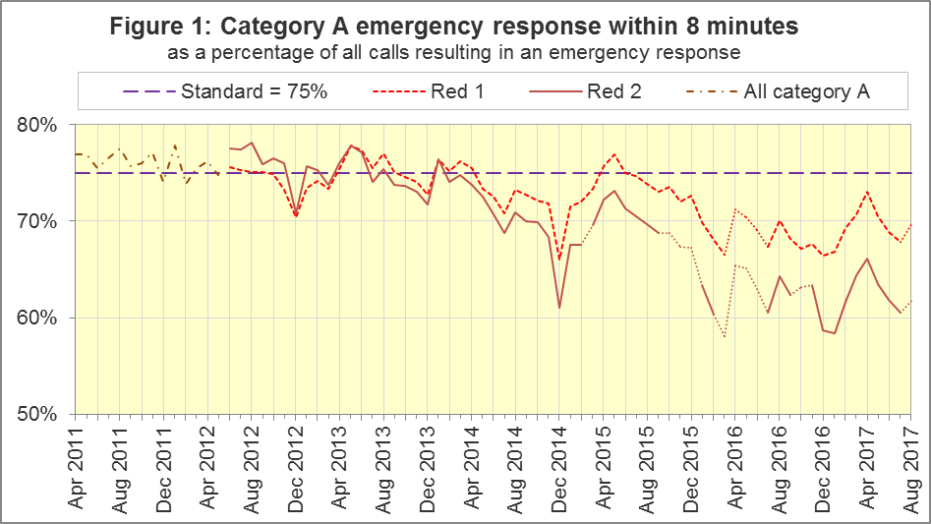
The standard for Ambulance Services is to send an emergency response, with a defibrillator, within 8 minutes to 75% of Category A calls. For the six Trusts still using Category A throughout August 2017, none met the standard, but Red 1 performance increased from 69.3% in July 2017 to 69.7% in August. The trust with the highest proportion was London Ambulance Service (LAS), with 74.5%, while the trust with the lowest proportion was South East Coast Ambulance Service (SECAmb), with 59.4%.

Ambulance Response Programme (ARP): Dispatch on Disposition
The ARP has altered the activities of Ambulance Services and, consequently, these statistics, in several ways.
In February 2015, Phase 1 or ARP started: Dispatch on Disposition (DoD). Prior to this, for Red 1 incidents, the start time was the earliest of the following three possible trigger points:
- chief complaint or NHS Pathways initial disposition (Dx) code obtained;
- first vehicle assigned;
- 60 seconds after call connect.
DoD tested alternatives to the third trigger point of 180, 240 and 300 seconds in various Ambulance Services. In October 2016, all Ambulance Services in England were aligned with a third trigger point of 240 seconds, except for IoW, which aligned in February 2017. All change dates are in the 8 December 2016 AQI Statistical Note.
NWAS, EMAS, East of England (EastAmb) and SECAmb always changed their clock start in the same months. Therefore, their response times remained comparable with each other until August 2017. Response Times averaged across these four Trusts are shown in Figures 2 and 3, as a comparison for England data series containing discontinuities.
All other Ambulance Services tested DoD according to a unique timetable, so each Service has a point between February 2015 and October 2016 when they become incomparable with other Services for Red 2 and Category A response times.

ARP Phase 2: Clinical Coding Review
The Clinical Coding Review (CCR) replaced the existing Category A (Red 1 and Red 2) and Category C (Green 1, Green 2, Green 3, and Green 4) with new Categories that are not comparable.
For these Trusts, from these dates, data for Red 1, Red 2, and Category A are no longer available:
SWAS | YAS | WMAS | EMAS | NWAS
19 April 2016 | 21 April 2016 | 8 June 2016 | 19 July 2017 | 1 August 2017

ARP Phase 3: Review of the AQI
As described in more detail in the 10 August 2017 Statistical Note, the ARP review of the AQI means we will phase out or redefine all existing Systems Indicators (SIs), and collect a new set. The definitions for the new SIs are in the 20170926 specification document at www.england.nhs.uk/statistics/statistical-work-areas/ambulance-quality-indicators or http://bit.ly/NHSAQI.
An addendum to the Handbook to the NHS Constitution (see page 1) shows the standards that will apply in future: mean and 90th centile response times for each of C1 and C2, and 90th centile response times for each of C3 and C4.
For the first time, this publication includes response times for the new Categories C1 to C4 described at www.england.nhs.uk/urgent-emergency-care/arp.

Response times for new Categories
In August 2017, NWAS response times were within the 90th centile C3 and C4 standards. EMAS response times were within the 90th centile C1 and C4 standards.
For C1, the mean response time was 10 minutes and 7 seconds for NWAS, and it was 8 minutes and 2 seconds for EMAS.
This publication includes response times for YAS, WMAS and SWAS reported from August 2017 back to October 2016, when these three Trusts started using the new C1 to C4. These times comprise the mean average and 50th, 75th, 95th and 99th centile response times, as defined in the specification v3.0 at http://bit.ly/NHSAQI. However, these times are based on different clock start and clock stop points, and are therefore not comparable with those for NWAS and EMAS, or the new standards in the Handbook to the NHS Constitution.
In August 2017, mean average Category 1 response times were 7 minutes 17 seconds for YAS, 7:30 for WMAS and 8:32 for SWAS. The latter two were the highest of the series back to October 2016, and for all three Trusts, their 95th centiles are the highest of this series. In most months of this series, WMAS has the lowest 95th centile, followed by YAS, and then SWAS.
Before the end of 2017, all Ambulance Services except the Isle of Wight will have switched to the new Categories C1 to C4 and started to provide data according to the 20170926 specification.

Emergency Response in 8 minutes for Red 2 (Figure 2)
Figure 2 shows that for the six Trusts still using Red 2 throughout August 2017, the proportion of Red 2 incidents receiving an emergency response in 8 minutes was 61.8%. For the same Trusts, the July 2017 proportion was 60.3%.
Out of the six Trusts where Red 2 still applied throughout August 2017, the highest was 72.0% for LAS. SECAmb had 46.5% and has had the lowest proportion for over a year.

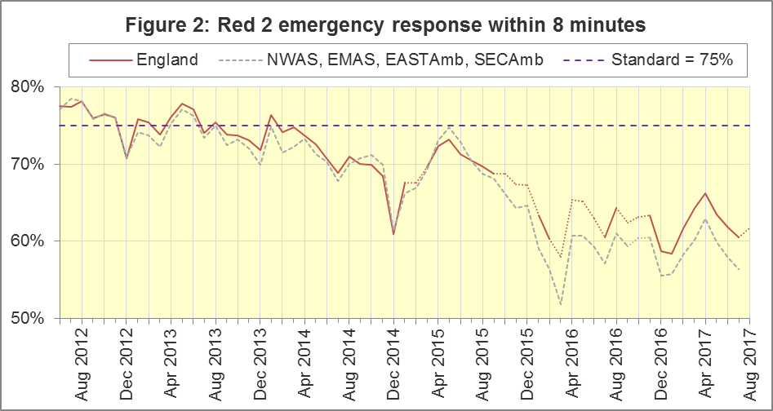
The numerators and denominators for Figures 2 and 3 are on the “DoD R2” and “DoD A19” tab respectively, in the Systems Indicators Time Series spreadsheet at http://bit.ly/NHSAQI. We are not updating the lines for NWAS, EMAS, EastAmb, and SECAmb, in Figures 2 and 3, now that NWAS and EMAS are no longer using Category A.

Category A Ambulance response in 19 minutes (Figure 3)
The second ambulance standard in the Handbook to the NHS Constitution is for Trusts to send, within 19 minutes, a fully-equipped ambulance vehicle, able to transport the patient in a clinically safe manner, to 95% of Category A calls. For the six Trusts still using Category A throughout August 2017, performance was 90.9% in August, and 90.4% in July. The highest of the six in August was 94.3% for LAS, and the lowest was 87.1% for NEAS.
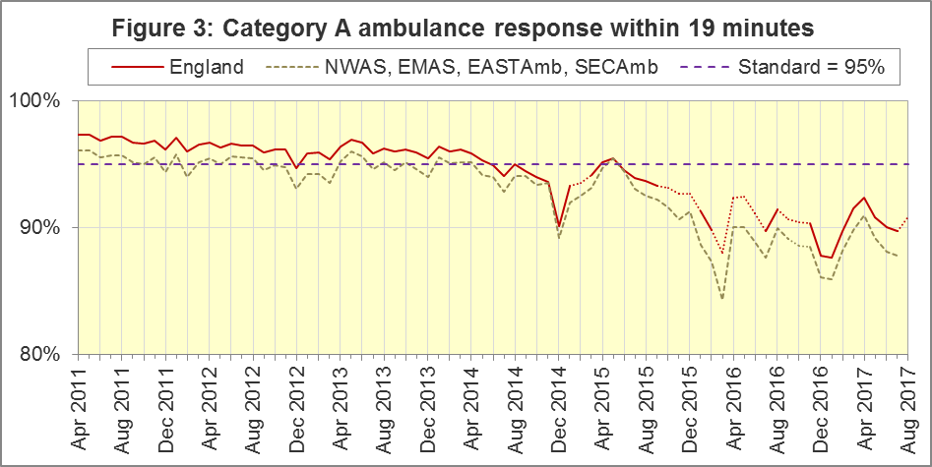
For other Systems Indicators, DoD and the CCR do not affect comparability, but may lead to changes in levels. For example, a longer triage time may mean more calls are closed on the telephone, but the data for this measure remain comparable. Such changes may be difficult to detect within the habitual variation of the many AQI.
As Trusts start to report the new indicators, we will continue to collect the numbers of calls receiving a face-to-face response, and the numbers of those not transported to Type 1 / Type 2 A&E, plus the numbers of telephone calls presented to switchboard. Those numbers therefore remain available for NWAS and EMAS in August 2017, but other Systems Indicators do not.

Systems Indicators: Ambulance volumes (Figure 4)
The number of emergency telephone calls presented to the switchboard in August 2017 was 852,798, an average of 27.5 thousand per day.
There were 578,839 emergency calls that received a face-to-face response from the ambulance service in August 2017, an average of 18.7 thousand per day.
Figure 4 shows these measures usually revert to average after a high in December and a low in August. It also shows a gradual increase in telephone calls, and in face-to-face responses, but not so much for incidents where a patient was transported.
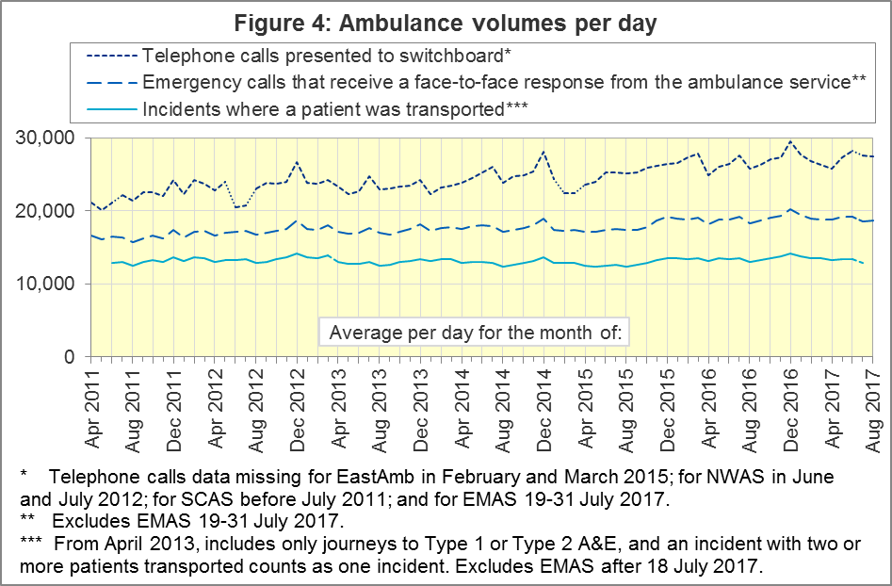

Latest monthly data for other Systems Indicators, August 2017
The August 2017 recontact proportion after treatment at scene was significantly higher than the average for 2016-17. All other Systems Indicators were stable in August 2017 and within their ranges from the previous twelve months:
Indicator | England | Lowest Trust |  | Highest Trust
Calls abandoned before being answered | 1.7% | YAS | 0.3% | SECAmb | 5.6%
Calls resolved through telephone assessment | 8.9% | WMAS | 4.8% | SWAS | 13.2%
Calls resolved without transport to Type 1 or Type 2 A&E | 37.6% | EMAS | 23.2% | SWAS | 49.4%
Recontact rate following discharge by telephone advice | 7.1% | YAS | 3.1% | WMAS | 16.2%
Recontact rate following face-to-face treatment at scene | 6.0% | YAS | 1.1% | LAS | 9.2%
Incidents where a patient was transported | 305,962 | NEAS | 19,373 | LAS | 66,070

Clinical Outcomes

Cardiac arrest: return of spontaneous circulation (ROSC)
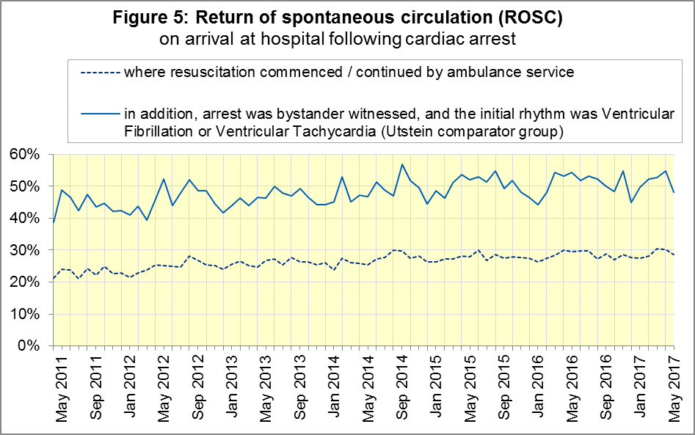
Patients in cardiac arrest will typically have no pulse and will not be breathing. In May 2017, in England, resuscitation was commenced or continued by ambulance staff out-of-hospital for 2,445 such patients. Of these, 702 (29%) had ROSC, with a pulse, on arrival at hospital (Figure 5), the same as the 2016-17 average of 29%.
The trust with the largest proportion in May 2017 was NWAS (36%) and the smallest was for SECAmb (23%).
The Utstein group comprises patients who had resuscitation commenced or continued by the Ambulance Services, following an out-of-hospital cardiac arrest of presumed cardiac origin, where the arrest was bystander witnessed, and the initial rhythm was Ventricular Fibrillation or Ventricular Tachycardia. The Utstein group therefore have a better chance of survival.
There were 343 such patients in England in May 2017, of which 165 (48%) had ROSC on arrival at hospital (Figure 5). The small sample means that this measure often varies from month to month, and the latest figure is not significantly different to the 2016-17 average of 51%. The largest proportion in May 2017 was 65% for NWAS and the smallest was 36% for SCAS.

Cardiac arrest: survival to discharge
Figure 6 shows that the proportion of cardiac arrest patients in England discharged from hospital alive was 9% in May 2017, the same as the 2016-17 average. In May 2017 the largest proportion was WMAS (12%) and the smallest was SECAmb (6%).
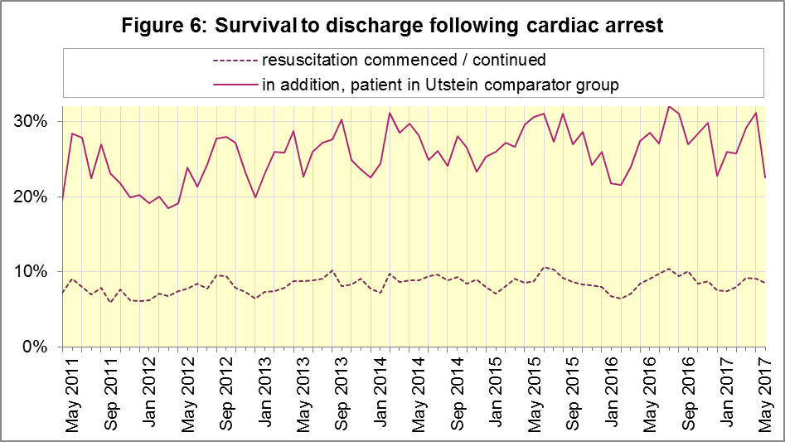
For the Utstein group, survival to discharge in May 2017 was 23%, significantly lower than the 2016-17 average of 28%. The trust with the largest proportion in May 2017 was EMAS (35%) and the smallest proportion was for SWAS (13%).

ST-Elevation myocardial infarction
ST-segment elevation myocardial infarction (STEMI) is a type of heart attack, determined by an electrocardiogram (ECG) test. Early access to reperfusion, where blocked arteries are opened to re-establish blood flow, and other assessment and care interventions, are associated with reductions in STEMI mortality and morbidity.
941 STEMI patients in England received primary angioplasty in May 2017. Of these patients, 813 (86%) of them received it within 150 minutes of the call being connected to the ambulance service (Figure 7), the same as the 2016-17 average. The largest proportion in May 2017 was 97% for EMAS and the smallest was 76% for SWAS.
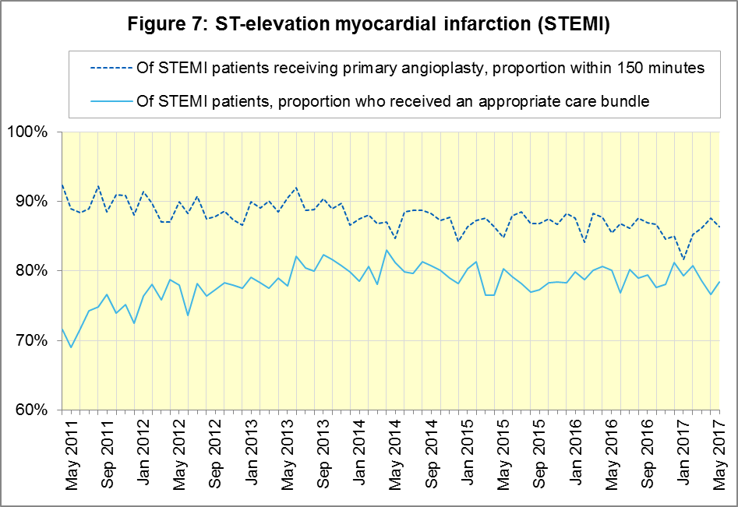
In May 2017, of 1,536 patients with an acute STEMI in England, 1,204 (78%) received the appropriate care bundle (Figure 7), similar to the 2016-17 average of 79%. The largest proportion in May 2017 was 93% for EastAmb and the smallest was 58% for SECAmb.

Stroke
The FAST procedure helps assess whether someone has suffered a stroke:
- Facial weakness: can the person smile? Has their mouth or eye drooped?
- Arm weakness: can the person raise both arms?
- Speech problems: can the person speak clearly and understand what you say?
- Time to call 999 for an ambulance if you spot any one of these signs.
In May 2017, of 3,863 FAST positive patients in England, assessed face to face, and potentially eligible for stroke thrombolysis within agreed local guidelines, 2,134 (55%) arrived at hospitals with a hyperacute stroke unit within 60 minutes of an emergency call connecting to the ambulance service (Figure 8), similar to the 2016-17 average (54%). The trust with the largest proportion in May 2017 was LAS (67%) and the smallest proportion was for SWAS (38%).
There were 7,803 stroke patients assessed face to face in May 2017 in England, of which 7,541 (97%) received the appropriate care bundle, similar to the 2016-17 average (98%). All trusts had at least 92% for May 2017 and for 2016-17.

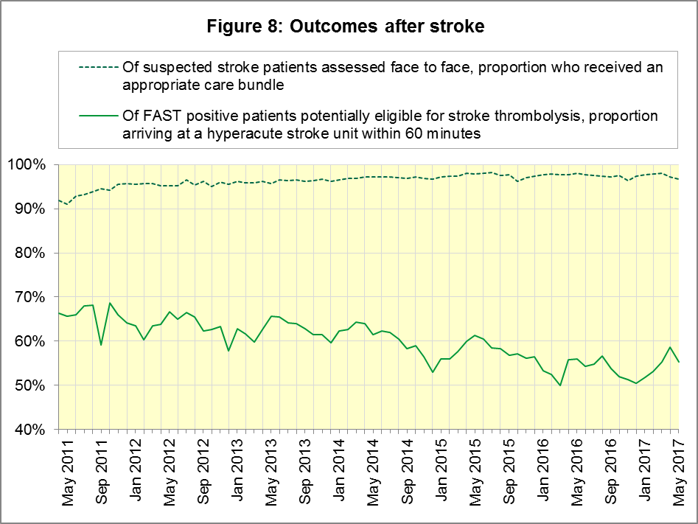

Further information on AQI

The AQI landing page and Quality Statement
www.england.nhs.uk/statistics/statistical-work-areas/ambulance-quality-indicators, or http://bit.ly/NHSAQI, is the AQI landing page, and it holds:
- a Quality Statement for these statistics, which includes information on relevance, accuracy, timeliness, coherence, and user engagement;
- the specification guidance document for those who supply the data;
- timetables for data collection and publication;
- time series spreadsheets and csv files from April 2011 up to the latest month;
- links to individual web pages for each financial year;
- contact details for the responsible statistician (also in 4.6 below).
The web pages for each financial year hold:
- separate spreadsheets of each month’s data;
- this Statistical Note, and equivalent versions from previous months;
- the list of people with pre-release access to the data.
Publication dates are also at www.gov.uk/government/statistics/announcements.

Revisions Timetable
Revisions usually follow a six-monthly cycle, but this will change in 2017-18 after the ARP review of indicators. The dates for past AQI Systems Indicators (SI) and Clinical Outcomes (CO) scheduled revisions are below. The AQI Quality Statement above contains a more detailed revisions policy.
Publication |  | Data |  | Months affected |  |  | Publication |  | Data |  | Months affected
14 Sep 2017 |  | CO |  | Apr ’16 - Mar ‘17 |  |  | 6 Nov 2014 |  | SI |  | Apr ‘13 - Aug ‘14
11 May 2017 |  | SI |  | Apr ‘15 - Feb ‘17 |  |  | 5 Sep 2014 |  | CO |  | Apr ‘13 - Mar ‘14
9 Mar 2017 |  | CO |  | Apr ‘16 - Sep ‘16 |  |  | 2 May 2014 |  | SI |  | Apr ‘13 - Feb ‘14
10 Nov 2016 |  | SI |  | Apr ‘16 - Aug ‘16 |  |  | 7 Mar 2014 |  | CO |  | Apr ‘13 - Sep ‘13
8 Sep 2016 |  | CO |  | Apr ‘15 - Apr ‘16 |  |  | 1 Nov 2013 |  | SI |  | Apr ‘13 - Aug ‘13
12 May 2016 |  | SI |  | Apr ‘15 - Feb ‘16 |  |  | 2 Aug 2013 |  | CO |  | Apr ‘12 - Mar ‘13
10 Apr 2016 |  | CO |  | Apr ‘15 - Sep ‘15 |  |  | 3 May 2013 |  | SI |  | Apr ‘12 - Mar ‘13
10 Sep 2015 |  | CO |  | Apr ‘14 - Mar ‘15 |  |  | 1 Feb 2013 |  | CO |  | Apr ‘12 - Aug ‘12
4 Jun 2015 |  | SI |  | Apr ‘14 - Feb ‘15 |  |  | 11 Jan 2013 |  | SI |  | Apr ‘11 - Oct ‘12
30 Apr 2015 |  | SI |  | Apr ‘14 - Feb ‘15 |  |  | 31 Aug 2012 |  | CO |  | Apr ‘11 - Mar ‘12
5 Mar 2015 |  | CO |  | Apr ‘14 - Sep ‘14 |  |  | 4 May 2012 |  | SI & CO |  | Apr ‘11 - Mar ‘12

AQI Scope
The AQI include calls made by dialling either the usual UK-wide number 999 or its international equivalent 112.
As described in the specification guidance mentioned in section 3.1, calls made to NHS 111 are not included in the AQI measures for calls abandoned, re-contacts, frequent callers, time to answer calls, or calls resolved by telephone advice.
All other Systems Indicators involve the dispatch of an ambulance, and include ambulances dispatched as a result of a call to NHS 111, as well as 999 or 112.

Related statistics in England
A dashboard on the AQI landing page presents an alternative layout for the AQI data. Because of the lack of comparability due to the Ambulance Response Programme (section 1.3), NHS England last updated the dashboard in April 2016.
The AQI were also used in the “Ambulance Services” publications by NHS Digital, which included additional annual analysis and commentary, up to and including 2014-15 data. The Quality Statement described in section 3.1 has more information on this publication. The Quality Statement also contains details of weekly ambulance situation reports that NHS England collected for six months from November 2010.
Ambulance handover delays of over 30 minutes at each Emergency Department were collected and published by NHS England for winter 2012-13, 2013-14 and 2014-15: www.england.nhs.uk/statistics/statistical-work-areas/winter-daily-sitreps.

Rest of United Kingdom
Ambulance statistics for other countries of the UK can be found at the following websites. The Quality Statement described in section 3.1 contains more information about the comparability of these statistics.
Wales: | http://wales.gov.uk/statistics-and-research/ambulance-services
Scotland: | See Quality Improvement Indicators (QII) documents at www.scottishambulance.com/TheService/BoardPapers.aspx
Northern Ireland: | www.health-ni.gov.uk/articles/emergency-care-and-ambulance-statistics

Contact information
Press: NHS England press office, nhsengland.media@nhs.net, 0113 825 0958.
The person responsible for producing this publication is:
Ian Kay, Operational Information for Commissioning (Central), NHS England
Room 5E24, Quarry House, Leeds, LS2 7UE; 0113 825 4606; i.kay@nhs.net

National Statistics
The UK Statistics Authority has designated these statistics as National Statistics, in accordance with the Statistics and Registration Service Act 2007 and signifying compliance with the Code of Practice for Official Statistics.
Designation can be broadly interpreted to mean that the statistics:
- meet identified user needs;
- are well explained and readily accessible;
- are produced according to sound methods; and
- are managed impartially and objectively in the public interest.
Once statistics have been designated as National Statistics it is a statutory requirement that the Code of Practice shall continue to be observed.

Page 34 of the July 2015 Handbook to the NHS Constitution has Ambulance response time standards, www.gov.uk/government/publications/supplements-to-the-nhs-constitution-for-england.
Category A no longer applies, and so data are unavailable, for South Western (SWAS) and Yorkshire (YAS) from April 2016, West Midlands (WMAS) from June 2016, and East Midlands (EMAS) and North West (NWAS) Ambulance Services after July 2017. See section 1.3 on the Clinical Coding Review. Also, after February 2015, changes in operational practice meant that Red 2 response data are still available but not always comparable; see section 1.2 on Dispatch on Disposition. The Red 1 and Red 2 divisions of Category A (immediately life-threatening) calls were created on 1 June 2012. Red 1 calls are the most time critical, and cover cardiac arrest patients who are not breathing and do not have a pulse, and other severe conditions such as airway obstruction. Red 2 calls are serious, but less immediately time critical, and cover conditions such as stroke and fits. www.gov.uk/government/news/changes-to-ambulance-response-time-categories.
The Isle of Wight (IOW) contains 0.3% of the resident population of England. Its data, available in the accompanying spreadsheets, vary more than other trusts due to its small size. In this document, if IOW has the largest or smallest value, we report the second largest or smallest value instead.
Dispatch on Disposition announcement: www.parliament.uk/business/publications/written-questions-answers-statements/written-statement/Commons/2015-01-16/HCWS201
All EMAS data for July 2017 is unavailable from 19 July onwards, when they implemented CCR. Per day calculations in Section 1.6, but not Figure 4, scale up EMAS July data by 31/18 to compensate.
The number of calls presented to switchboard does not usually include calls to NHS 111 requiring an ambulance, which are usually transferred electronically direct to ambulance dispatch and not routed via 999 call handlers. Occasionally, manual requests for ambulances are made between 111 and 999 call handlers. Such calls are included in the numbers of emergency calls presented to switchboard.
For all measures except for ‘Calls resolved without transport to Type 1 or Type 2 A&E’, this table excludes the trusts reporting new Systems Indicators (NWAS, EMAS).
This definition was proposed at Utstein Abbey in Norway by an international group of cardiologists and other health professionals in 1990. http://circ.ahajournals.org/content/110/21/3385
Significance calculations in this document are Student’s t-test with 95% significance, comparing the latest month with the latest financial year.
Pages 27 to 30 of the specification guidance for data suppliers on the AQI landing page at www.england.nhs.uk/statistics/statistical-work-areas/ambulance-quality-indicators describe the care bundles, and certain exclusions, for the STEMI and stroke indicators.
NHS Digital Ambulance Services: http://content.digital.nhs.uk/article/2021/Website-Search?q=ka34

