Statistical Note: Ambulance Quality Indicators (AQI)
The latest Systems Indicators for September 2017 for Ambulance Services in England showed the 8 and 19 minute measures were all at their lowest level for over a year, so the standards in the Handbook to the NHS constitution were not met.
The latest Clinical Outcomes data for June 2017 show increased return of circulation for patients in cardiac arrest, but fewer care bundles for patients with heart attacks.

Systems Indicators

Emergency response in 8 minutes (Figure 1)
In September 2017, of Category A Red 1 calls in England, resulting in an emergency response, the proportion arriving within 8 minutes was 66.3%.
In September 2017, of Category A² Red 2 calls in England, resulting in an emergency response, the proportion arriving within 8 minutes was 58.6%.
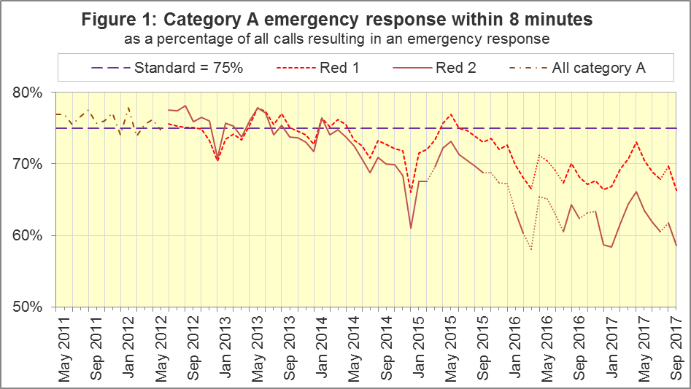
The standard for Ambulance Services is to send an emergency response, with a defibrillator, within 8 minutes to 75% of Category A calls. For the six Trusts still using Category A in September 2017, none met the standard, and Red 1 performance decreased from 69.7% in August 2017 to 66.3% in September 2017, the lowest average for these six Trusts since July 2016.
The Trust with the highest proportion was North East Ambulance Service (NEAS), with 73.3%, while the Trust with the lowest proportion was South East Coast Ambulance Service (SECAmb), with 50.8%.

Ambulance Response Programme (ARP): Dispatch on Disposition
The ARP has altered the activities of Ambulance Services and, consequently, these statistics, in several ways.
In February 2015, Phase 1 or ARP started: Dispatch on Disposition (DoD). Prior to this, for Red 1 incidents, the start time was the earliest of the following three possible trigger points:
- chief complaint or NHS Pathways initial disposition (Dx) code obtained;
- first vehicle assigned;
- 60 seconds after call connect.
DoD tested alternatives to the third trigger point of 180, 240 and 300 seconds in various Ambulance Services. In October 2016, all Ambulance Services in England were aligned with a third trigger point of 240 seconds, except for IoW, which aligned in February 2017. All change dates are in the 8 December 2016 AQI Statistical Note.
NWAS, EMAS, East of England (EastAmb) and SECAmb changed their clock starts in the same months, so their response times remained comparable with each other until August 2017. Response Times averaged across these four Trusts are shown in Figures 2 and 3, as a comparison for England data series containing discontinuities.
All other Ambulance Services tested DoD according to a unique timetable, so each Service has a point between February 2015 and October 2016 when they become incomparable with other Services for Red 2 and Category A response times.

ARP Phase 2: Clinical Coding Review
The Clinical Coding Review (CCR) replaced the existing Category A (Red 1 and Red 2) and Category C (Green 1, Green 2, Green 3, and Green 4) with new Categories that are not comparable.
For these Trusts, from these dates, data for Red 1, Red 2, and Category A are no longer available:
SWAS | YAS | WMAS | EMAS | NWAS
19 April 2016 | 21 April 2016 | 8 June 2016 | 19 July 2017 | 1 August 2017

ARP Phase 3: Review of the AQI
As described in more detail in the 10 August 2017 Statistical Note, the ARP review of the AQI means we will phase out or redefine all existing Systems Indicators (SIs), and collect a new set. The definitions for the new SIs are in the 20170926 specification document at www.england.nhs.uk/statistics/statistical-work-areas/ambulance-quality-indicators or http://bit.ly/NHSAQI.
Today’s publication includes data against this specification for the second time for NWAS and EMAS, and for the first time for YAS and WMAS.
We plan to publish data against the new specification only for these four Trusts again in our December publication, but for all Trusts except Isle of Wight in our January publication.
The new Categories C1 to C4 used in the new dataset are described at www.england.nhs.uk/urgent-emergency-care/arp, and an addendum to the Handbook to the NHS Constitution (see footnote 1) shows the standards that will apply in future: mean and 90th centile response times for each of C1 and C2, and 90th centile response times for each of C3 and C4.

Response times for new Categories
In September 2017, for C1, the mean response time was 6 minutes and 57 seconds for WMAS, 7:14 for YAS, 8:16 for EMAS, and 9:50 for NWAS, which meant an average of 8:07 across these Trusts.
WMAS met all standards. NWAS met those for C3 and C4, YAS met the 90th centiles for C1 and C3, and EMAS met the 90th centile standard for C1.
In September and October 2017, SWAS will still report the response times we have collected and published back to October 2016, as defined in the specification v3.0 at http://bit.ly/NHSAQI. It had a mean response time of 8:31 for September 2017. These times are based on different clock start and clock stop points, and are therefore not comparable with other Trusts or the new standards in the Handbook to the NHS Constitution.

Emergency Response in 8 minutes for Red 2 (Figure 2)
Figure 2 shows that for the six Trusts still using Red 2 in September 2017, the proportion of Red 2 incidents receiving an emergency response in 8 minutes was 58.6%. This was the lowest average for these six Trusts since March 2016. The highest proportion was 68.5% for London (LAS). SECAmb had 40.0%, and has had the lowest Red 2 proportion since April 2016.
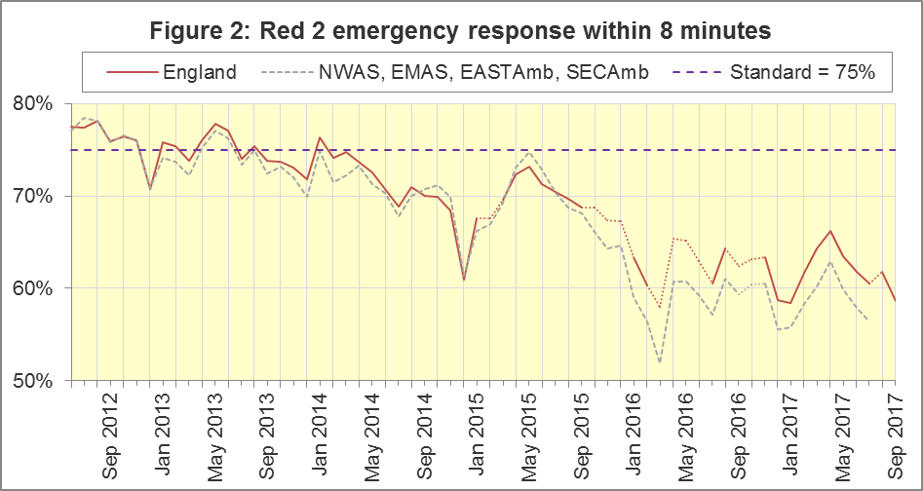
The numerators and denominators for Figures 2 and 3 are on the “DoD R2” and “DoD A19” tab respectively, in the Systems Indicators Time Series spreadsheet at http://bit.ly/NHSAQI. We are not updating the lines for NWAS, EMAS, EastAmb, and SECAmb, in Figures 2 and 3, now that NWAS and EMAS no longer use Category A.

Category A Ambulance response in 19 minutes (Figure 3)
The second ambulance standard in the Handbook to the NHS Constitution is for Trusts to send, within 19 minutes, a fully-equipped ambulance vehicle, able to transport the patient in a clinically safe manner, to 95% of Category A calls.
For the six Trusts still using Category A, performance was 87.9% in September, the lowest average ever across these six Trusts. The highest of the six in August was 93.9% for LAS, and the lowest was 80.3% for EastAmb.
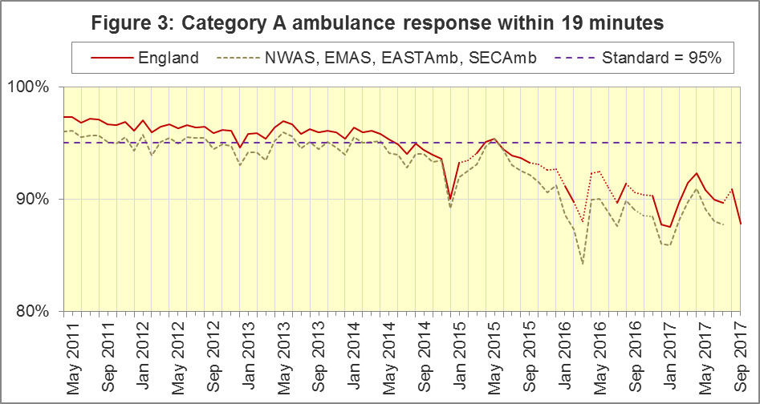
For other Systems Indicators, DoD and the CCR do not affect comparability, but may lead to changes in levels. For example, a longer triage time may mean more calls are closed on the telephone, but the data for this measure remain comparable. Such changes may be difficult to detect within the habitual variation of the many AQI.
When Trusts start to report the new indicators, we will continue to collect counts of incidents receiving a face-to-face response, and which of those were not transported to Type 1 / Type 2 A&E, plus the counts of telephone calls presented to switchboard, for a further three months. Therefore, in September 2017, those numbers remain available for all Trusts, but as stated in 1.4, YAS and WMAS have joined NWAS and EMAS in ceasing to provide all other Systems Indicators.

Systems Indicators: Ambulance volumes (Figure 4)
The number of emergency telephone calls presented to the switchboard in September 2017 was 876,723, an average of 29.2 thousand per day. Only in December 2016 (29.4 thousand) had this ever exceeded 28.2 thousand per day.
There were 570,827 emergency calls that received a face-to-face response from the ambulance service in September 2017, an average of 19.0 thousand per day. Figure 4 shows that this changed little from August 2017, unlike calls to switchboard.
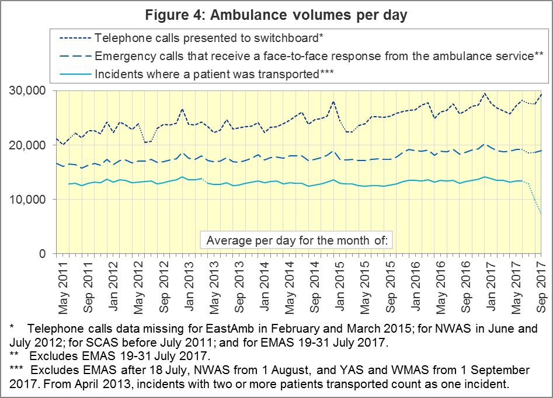

Latest monthly data for other Systems Indicators, September 2017
For the seven Trusts still reporting all the Systems Indicators in section 1.9, the September 2017 proportion for re-contacts after treatment at scene was the highest since these measures started in April 2011, and a significant increase on the average for the year ending September 2017; and the proportion for re-contacts after discharge by telephone advice was also a significant increase on that time.
The measure in section 1.9 which is still reported by all Trusts, calls resolved without transport to Type 1 or Type 2 A&E, was 36.9% in September 2017, the lowest figure since November 2015. The average for the year ending September 2017 was not a lot different, at 37.4%, but nevertheless, the figure for the month of September 2017 was a significant decrease.
Indicator | England | Lowest Trust |  | Highest Trust
Calls abandoned before being answered | 2.1% | NEAS | 0.4% | SECAmb | 3.6%
Calls resolved through telephone assessment | 10.3% | SECAmb | 5.8% | SWAS | 13.5%
Calls resolved without transport to Type 1 or Type 2 A&E | 36.9% | EMAS | 22.6% | SWAS | 48.5%
Recontact rate following discharge by telephone advice | 8.6% | LAS | 3.7% | SCAS | 13.4%
Recontact rate following face-to-face treatment at scene | 6.6% | NEAS | 4.5% | SECAmb | 9.1%
Incidents where a patient was transported | 218,736 | NEAS | 19,292 | LAS | 65,573

Clinical Outcomes
Clinical outcomes often vary considerably from month to month because they come from small populations; for some cardiac arrest measures, a change of five percentage points might not be a statistically significant change. Although we will continue to collect and publish Clinical Outcomes data in our spreadsheets each month, we will only summarise in this Statistical Note once every quarter in future.

Cardiac arrest: return of spontaneous circulation (ROSC)
Patients in cardiac arrest will typically have no pulse and will not be breathing. In June 2017, in England, resuscitation was commenced or continued by ambulance staff out-of-hospital for 2,400 such patients. Of these, 749 (31%) had ROSC, with a pulse, on arrival at hospital (Figure 5), significantly higher than the 2016-17 average of 29%.
The Trust with the largest proportion in June 2017 was SCAS (46%) and the smallest was for EastAmb (25%).
The Utstein group comprises patients who had resuscitation commenced or continued by the Ambulance Services, following an out-of-hospital cardiac arrest of presumed cardiac origin, where the arrest was bystander witnessed, and the initial rhythm was Ventricular Fibrillation or Ventricular Tachycardia. The Utstein group therefore have a better chance of survival.
There were 370 such patients in England in June 2017, of which 194 (52%) had ROSC on arrival at hospital (Figure 5), similar to the 2016-17 average of 51%. The largest proportion in June 2017 was 77% for NEAS and the smallest was 40% for NWAS.
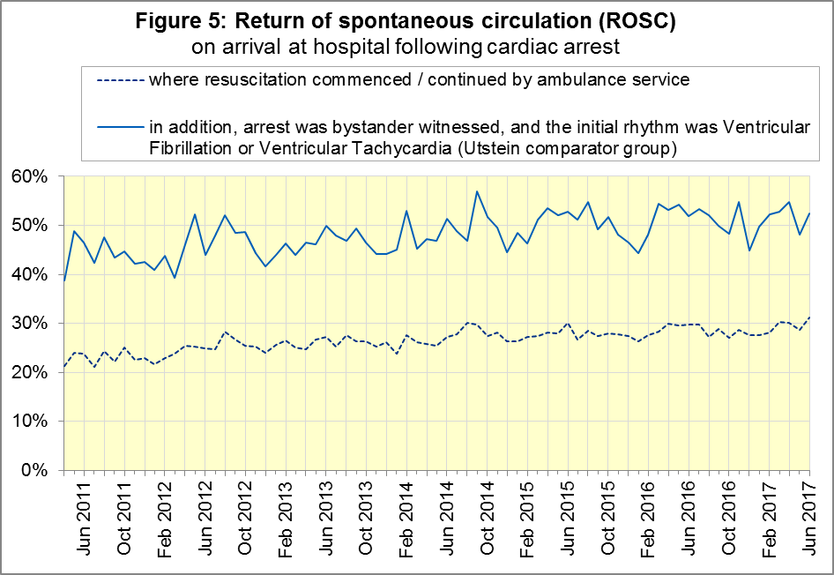

Cardiac arrest: survival to discharge
Figure 6 shows that the proportion of cardiac arrest patients in England discharged from hospital alive was 10% in June 2017, similar to the 2016-17 average of 9%. In June 2017 the largest proportion was SCAS (24%) and the smallest was SECAmb (6%).
For the Utstein group, survival to discharge in June 2017 was 28%, the same as the 2016-17 average. The Trust with the largest proportion in June 2017 was NEAS (53%) and the smallest proportion was for NWAS (15%).
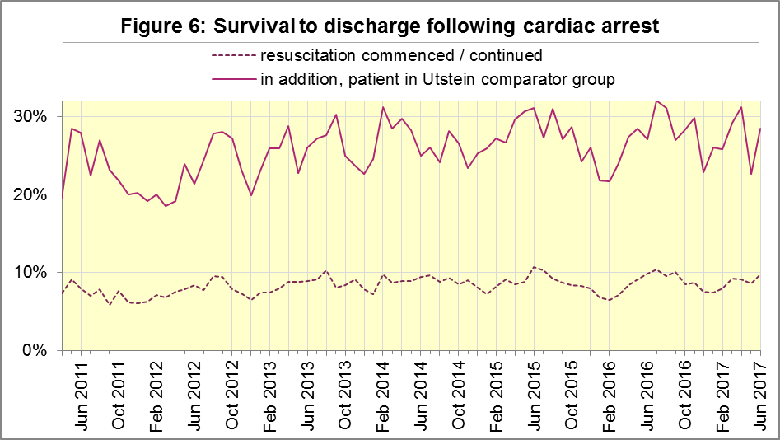

ST-Elevation myocardial infarction
ST-segment elevation myocardial infarction (STEMI) is a type of heart attack, determined by an electrocardiogram (ECG) test. Early access to reperfusion, where blocked arteries are opened to re-establish blood flow, and other assessment and care interventions, are associated with reductions in STEMI mortality and morbidity.
986 STEMI patients in England received primary angioplasty in June 2017. Of these patients, 843 (85%) of them received it within 150 minutes of the call being connected to the ambulance service (Figure 7), similar to the 2016-17 average of 86%. The largest proportion in June 2017 was 96% for EMAS and the smallest was 72% for SWAS.
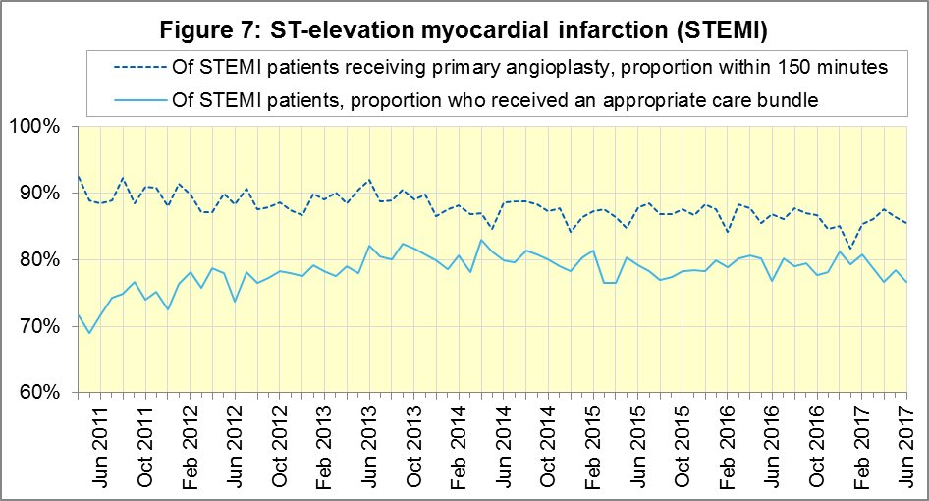
In June 2017, of 1,515 patients with an acute STEMI in England, 1,161 (77%) received the appropriate care bundle (Figure 7), lower than the 2016-17 average of 79%. The largest proportion in June 2017 was 96% for NEAS and the smallest was 66% for LAS.

Stroke
The FAST procedure helps assess whether someone has suffered a stroke:
- Facial weakness: can the person smile? Has their mouth or eye drooped?
- Arm weakness: can the person raise both arms?
- Speech problems: can the person speak clearly and understand what you say?
- Time to call 999 for an ambulance if you spot any one of these signs.
In June 2017, of 3,892 FAST positive patients in England, assessed face to face, and potentially eligible for stroke thrombolysis within agreed local guidelines, 2,219 (57%) arrived at hospitals with a hyperacute stroke unit within 60 minutes of an emergency call connecting to the ambulance service (Figure 8), similar to the 2016-17 average (54%). The Trust with the largest proportion in June 2017 was LAS (68%) and the smallest proportion was for SWAS (39%).
There were 7,798 stroke patients assessed face to face in June 2017 in England, of which 7,592 (97%) received the appropriate care bundle, similar to the 2016-17 average (98%). All Trusts had at least 94% for 2017-18 so far and 2016-17.
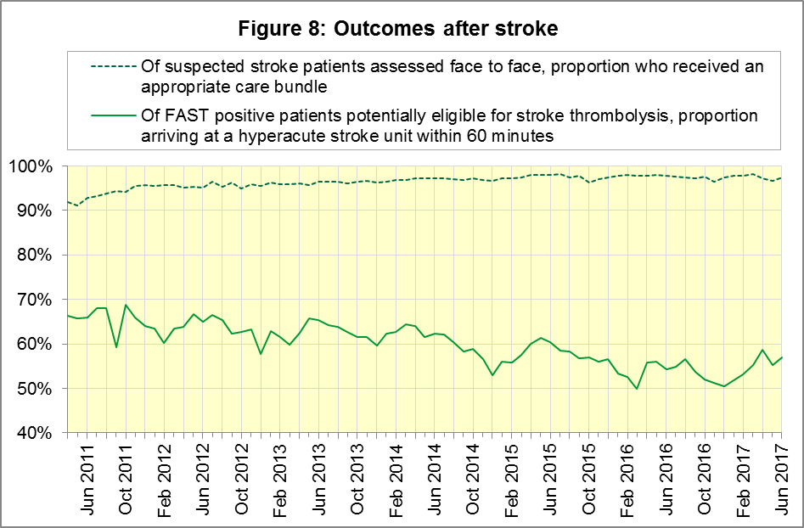

Further information on AQI

The AQI landing page and Quality Statement
www.england.nhs.uk/statistics/statistical-work-areas/ambulance-quality-indicators, or http://bit.ly/NHSAQI, is the AQI landing page, and it holds:
- a Quality Statement for these statistics, which includes information on relevance, accuracy, timeliness, coherence, and user engagement;
- the specification guidance document for those who supply the data;
- timetables for data collection and publication;
- time series spreadsheets and csv files from April 2011 up to the latest month;
- links to individual web pages for each financial year;
- contact details for the responsible statistician (also in 3.6 below).
The web pages for each financial year hold:
- separate spreadsheets of each month’s data;
- this Statistical Note, and equivalent versions from previous months;
- the list of people with pre-release access to the data.
Publication dates are also at www.gov.uk/government/statistics/announcements.

Revisions Timetable
Revisions usually follow a six-monthly cycle, but this will change in 2017-18 after the ARP review of indicators. The dates for past AQI Systems Indicators (SI) and Clinical Outcomes (CO) scheduled revisions are below. The AQI Quality Statement above contains a more detailed revisions policy.
Publication |  | Data |  | Months affected |  |  | Publication |  | Data |  | Months affected
14 Sep 2017 |  | CO |  | Apr ’16 - Mar ‘17 |  |  | 6 Nov 2014 |  | SI |  | Apr ‘13 - Aug ‘14
11 May 2017 |  | SI |  | Apr ‘15 - Feb ‘17 |  |  | 5 Sep 2014 |  | CO |  | Apr ‘13 - Mar ‘14
9 Mar 2017 |  | CO |  | Apr ‘16 - Sep ‘16 |  |  | 2 May 2014 |  | SI |  | Apr ‘13 - Feb ‘14
10 Nov 2016 |  | SI |  | Apr ‘16 - Aug ‘16 |  |  | 7 Mar 2014 |  | CO |  | Apr ‘13 - Sep ‘13
8 Sep 2016 |  | CO |  | Apr ‘15 - Apr ‘16 |  |  | 1 Nov 2013 |  | SI |  | Apr ‘13 - Aug ‘13
12 May 2016 |  | SI |  | Apr ‘15 - Feb ‘16 |  |  | 2 Aug 2013 |  | CO |  | Apr ‘12 - Mar ‘13
10 Apr 2016 |  | CO |  | Apr ‘15 - Sep ‘15 |  |  | 3 May 2013 |  | SI |  | Apr ‘12 - Mar ‘13
10 Sep 2015 |  | CO |  | Apr ‘14 - Mar ‘15 |  |  | 1 Feb 2013 |  | CO |  | Apr ‘12 - Aug ‘12
4 Jun 2015 |  | SI |  | Apr ‘14 - Feb ‘15 |  |  | 11 Jan 2013 |  | SI |  | Apr ‘11 - Oct ‘12
30 Apr 2015 |  | SI |  | Apr ‘14 - Feb ‘15 |  |  | 31 Aug 2012 |  | CO |  | Apr ‘11 - Mar ‘12
5 Mar 2015 |  | CO |  | Apr ‘14 - Sep ‘14 |  |  | 4 May 2012 |  | SI & CO |  | Apr ‘11 - Mar ‘12

AQI Scope
The AQI include calls made by dialling either the usual UK-wide number 999 or its international equivalent 112.
As described in the specification guidance mentioned in section 3.1, calls made to NHS 111 are not included in the AQI measures for calls abandoned, re-contacts, frequent callers, time to answer calls, or calls resolved by telephone advice.
All other Systems Indicators involve the dispatch of an ambulance, and include ambulances dispatched as a result of a call to NHS 111, as well as 999 or 112.

Related statistics in England
A dashboard on the AQI landing page presents an alternative layout for the AQI data. Because of the lack of comparability due to the Clinical Coding Review (section 1.3), NHS England last updated the dashboard in April 2016.
The AQI were also used in the “Ambulance Services” publications by NHS Digital, which included additional annual analysis and commentary, up to and including 2014-15 data. The Quality Statement described in section 3.1 has more information on this publication. The Quality Statement also contains details of weekly ambulance situation reports that NHS England collected for six months from November 2010.
Ambulance handover delays of over 30 minutes at each Emergency Department were collected and published by NHS England for winter 2012-13, 2013-14 and 2014-15: www.england.nhs.uk/statistics/statistical-work-areas/winter-daily-sitreps.

Rest of United Kingdom
Ambulance statistics for other countries of the UK can be found at the following websites. The Quality Statement described in section 3.1 contains more information about the comparability of these statistics.
Wales: | http://wales.gov.uk/statistics-and-research/ambulance-services
Scotland: | See Quality Improvement Indicators (QII) documents at www.scottishambulance.com/TheService/BoardPapers.aspx
Northern Ireland: | www.health-ni.gov.uk/articles/emergency-care-and-ambulance-statistics

Contact information
Press: NHS England press office, nhsengland.media@nhs.net, 0113 825 0958.
The person responsible for producing this publication is:
Ian Kay, Operational Information for Commissioning (Central), NHS England
Room 5E24, Quarry House, Leeds, LS2 7UE; 0113 825 4606; i.kay@nhs.net

National Statistics
The UK Statistics Authority has designated these statistics as National Statistics, in accordance with the Statistics and Registration Service Act 2007 and signifying compliance with the Code of Practice for Official Statistics.
Designation can be broadly interpreted to mean that the statistics:
- meet identified user needs;
- are well explained and readily accessible;
- are produced according to sound methods; and
- are managed impartially and objectively in the public interest.
Once statistics have been designated as National Statistics it is a statutory requirement that the Code of Practice shall continue to be observed.

Page 34 of the July 2015 Handbook to the NHS Constitution has Ambulance response time standards, www.gov.uk/government/publications/supplements-to-the-nhs-constitution-for-england.
Category A no longer applies, and so data are unavailable, for South Western (SWAS) and Yorkshire (YAS) from April 2016, West Midlands (WMAS) from June 2016, and East Midlands (EMAS) and North West (NWAS) Ambulance Services after July 2017. See section 1.3 on the Clinical Coding Review. Also, after February 2015, changes in operational practice meant that Red 2 response data are still available but not always comparable; see section 1.2 on Dispatch on Disposition. The Red 1 and Red 2 divisions of Category A (immediately life-threatening) calls were created on 1 June 2012. Red 1 calls are the most time critical, and cover cardiac arrest patients who are not breathing and do not have a pulse, and other severe conditions such as airway obstruction. Red 2 calls are serious, but less immediately time critical, and cover conditions such as stroke and fits. www.gov.uk/government/news/changes-to-ambulance-response-time-categories.
The Isle of Wight (IOW) contains 0.3% of the resident population of England. Its data, available in the accompanying spreadsheets, vary more than other Trusts due to its small size. In this document, if IOW has the largest or smallest value, we report the second largest or smallest value instead.
Dispatch on Disposition announcement: www.parliament.uk/business/publications/written-questions-answers-statements/written-statement/Commons/2015-01-16/HCWS201
The number of calls presented to switchboard does not usually include calls to NHS 111 requiring an ambulance, which are usually transferred electronically direct to ambulance dispatch and not routed via 999 call handlers. Occasionally, manual requests for ambulances are made between 111 and 999 call handlers. Such calls are included in the numbers of emergency calls presented to switchboard.
Significance calculations in this document are Student’s t-test with 95% significance, comparing the latest month with the latest financial year.
For all measures except for ‘Calls resolved without transport to Type 1 or Type 2 A&E’, this table excludes the Trusts reporting new Systems Indicators (NWAS, YAS, EMAS, WMAS).
This definition was proposed at Utstein Abbey in Norway by an international group of cardiologists and other health professionals in 1990. http://circ.ahajournals.org/content/110/21/3385
Pages 27 to 30 of the specification guidance for data suppliers on the AQI landing page at www.england.nhs.uk/statistics/statistical-work-areas/ambulance-quality-indicators describe the care bundles, and certain exclusions, for the STEMI and stroke indicators.
NHS Digital Ambulance Services: https://digital.nhs.uk/search?q=ambulance .

