# NHS 111 Minimum Data Set, England, April 2017

#### Summary

There were 1,379,041 calls offered to the NHS 111 service in April 2017, an average of 46.0 thousand per day, and a considerable 16% increase on 39.7 thousand per day in April 2016. This may be because April 2017 included two bank holidays and there were no bank holidays in April 2016; NHS 111 regularly receives more calls on a bank holiday compared with a typical working day.

Of calls offered to NHS 111 in April 2017, the proportion abandoned after waiting longer than 30 seconds was 1.9%, up slightly from the rate of 1.8% in March 2017, however less than the rate of 2.8% in April 2016.

In April 2017, of calls answered by NHS 111, 91.4% were answered within 60 seconds, an increase on both 91.0% in March 2017 and 87.1% in April 2016.

Of calls answered in April 2017, 22.0% were transferred to or answered by a clinical advisor using NHS Pathways, similar to March 2017 (21.8%).

The proportion of calls answered that received any form of clinical input[1] continues to increase and was 33.1% in April 2017, up from 29.6% in March 2017.

13% of all calls answered in April 2017 were offered a call back, the same as March 2017’s rate. Of those call backs, 41% were made within 10 minutes in April 2017, an increase on the previous month’s rate of 38%.

In April 2017, 86% of calls answered were triaged. Since the coverage of NHS 111 reached all of England in February 2014, this proportion has always been between 84% and 88%. Calls triaged are those where the NHS 111 call handler opens and uses the clinical assessment tool (NHS Pathways). Calls not triaged include, for example, follow-ups of previous calls, calls where the caller is unable or unwilling to give specific details about the patient’s condition or enquiries about contact details for pharmacists or other local care services.

Of calls triaged in April 2017, 12% had ambulances dispatched, 8% were recommended to attend A&E, 62% were recommended to attend primary care, 5% were advised to attend another service and 13% were not recommended to attend another service. This proportion of dispositions recommended to primary care was the highest since March 2016, and conversely, the March 2017 proportion of ambulance dispositions was the lowest in this time.

#### Revisions

This publication includes revisions to a small number of data items for Norfolk, Great Yarmouth & Waveney, North Essex and South Essex. The largest revisions change the January 2017 proportion of calls in England with clinical input from 23.8% to 24.3%. All of the revised data are marked ‘r’ in the published spreadsheets.





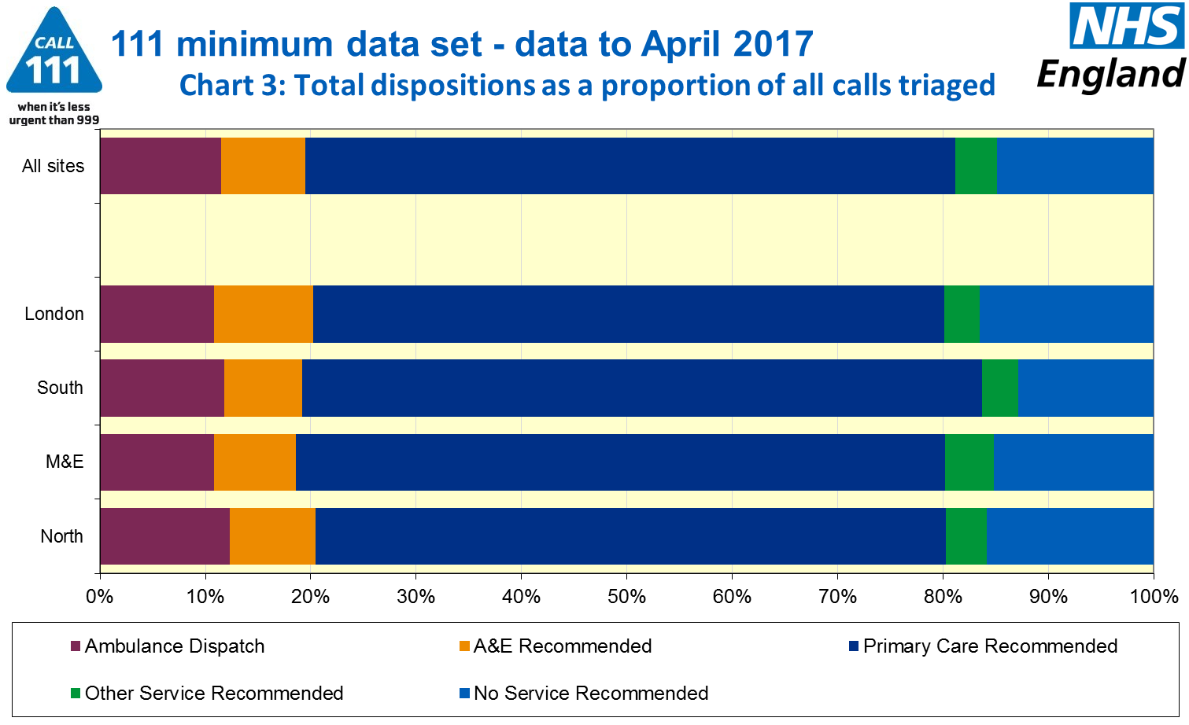



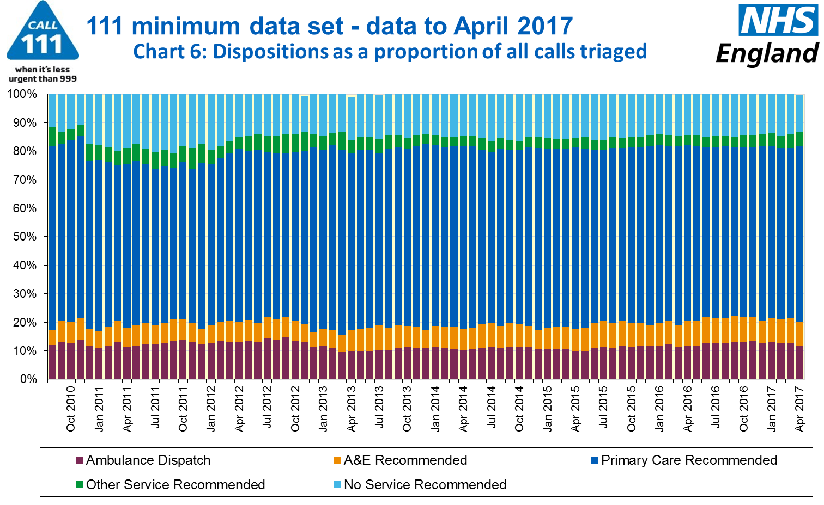

#### Additional Information:

All monthly data in the 111 Minimum Data Set (MDS) are available in spreadsheets at www.england.nhs.uk/statistics/statistical-work-areas/nhs-111-minimum-data-set, along with all the previous accompanying statistical notes, the specification guidance document for those who produce the data, and the timetables for data collection and publication. Publication dates are also available from [www.gov.uk/government/statistics](http://www.gov.uk/government/statistics).

Material changes to the data or presentation of the NHS 111 MDS are listed in the 3 July 2015 Statistical Note and in earlier versions. Any further material changes will be described here in future Statistical Notes.

#### Contacts

For press enquiries, please contact the NHS England press office on 0113 825 0958 or [nhsengland.media@nhs.net](mailto:nhsengland.media@nhs.net).

The individual responsible for these data is:

Ian Kay

NHS England, Operational Information for Commissioning (Central)

Room 5E24, Quarry House, Leeds LS2 7UE

[i.kay@nhs.net](mailto:i.kay@nhs.net)

0113 825 4606

1. This data item is an experimental statistic and may change markedly as providers develop their calculation methods. The specification is in data item 5.22 on the guidance document v0.901 at the NHS 111 MDS landing page, [www.england.nhs.uk/statistics/statistical-work-areas/nhs-111-minimum-data-set](http://www.england.nhs.uk/statistics/statistical-work-areas/nhs-111-minimum-data-set). More information on experimental statistics is at: [www.ons.gov.uk/methodology/methodologytopicsandstatisticalconcepts/guidetoexperimentalstatistics](https://www.ons.gov.uk/methodology/methodologytopicsandstatisticalconcepts/guidetoexperimentalstatistics)