# NHS 111 Minimum Data Set, England, June & July 2017

#### Latest data

There were 1,257,616 calls offered to the NHS 111 service in England[1] in July 2017 (40.6 thousand per day) and 1,165,074 in June 2017 (38.8 thousand per day). Both were small increases on the same months of 2016, and larger increases on the same months in 2014 and 2015.

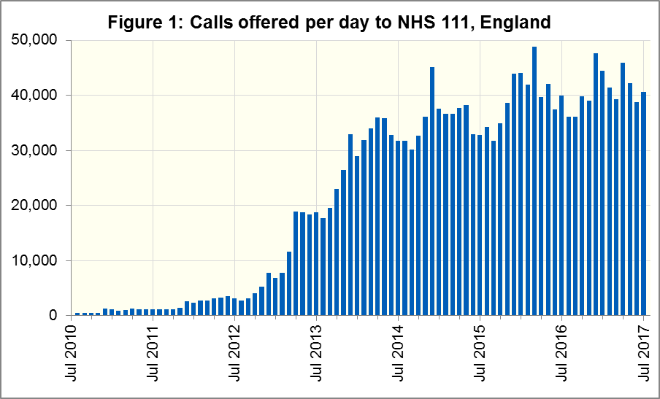

Of calls offered to NHS 111, the proportion abandoned[2] after waiting longer than 30 seconds was 1.8% in July 2017, less than in June 2017 (2.0%), and the lowest proportion since September 2016.

In July 2017, of calls answered by NHS 111, 89.7% were answered within 60 seconds, about average for 2017, and more than in June 2017 (89.1%).

The proportion of calls answered that received any form of clinical input[3] increased to 34.9% in June 2017 and to 35.8% in July 2017.

14% of all calls answered in July 2017 were offered a call back, the same as in June 2017. Of those call backs, 42% were made within 10 minutes in July 2017, an increase on the previous month’s proportion of 39%.

Of calls triaged, in July 2017, 12.9% had ambulances dispatched, 9.4% were recommended to attend A&E, 58.9% were recommended to attend primary care, 4.8% were advised to attend another service, and 14.1% were not recommended to attend another service.

These proportions all changed less than 0.5 percentage points between June and July 2017. However, the June 2017 proportion of 9.8% recommended to A&E was the largest since NHS 111 began in 2010.

#### Data availability

Today’s publication includes data for July 2017 as well as for June 2017. Subsequent publications will continue to contain data for the calendar month immediately prior to the publication date, unlike our previous publications which contained data for the month before that. This new timescale has reduced the amount of extra analysis in this Statistical Note.

At [www.england.nhs.uk/statistics/statistical-work-areas/nhs-111-minimum-data-set](http://www.england.nhs.uk/statistics/statistical-work-areas/nhs-111-minimum-data-set), the NHS 111 MDS landing page, we announced in late June 2017 that we will no longer collect the following data items after June 2017:

* 5.4, 5.5, 5.8, 5.9 (calls through 111 / other numbers)
* 5.12 to 5.15 (reasons for not triaging)
* 5.18, 5.21 (episode length, transfer time)
* 6.2, 6.3 (call handler and clinical advisor time)

The data in the 111 Minimum Data Set (MDS), including these bulleted items, will remain available via the landing page in national and regional time series spreadsheets, but only up to June 2017.

Starting from today, data excluding these bulleted items are available in a single spreadsheet for each month, via the landing page. From September, we will also make a new time series spreadsheet available for the data items that we continue to collect.

Previous statistical notes, the specification guidance document for those who produce the data, and the timetables for data collection and publication, also remain available via the landing page. Publication dates are also available from [www.gov.uk/government/statistics/announcements](http://www.gov.uk/government/statistics/announcements).

#### Contacts

For press enquiries, please contact the NHS England press office on 0113 825 0958 or [nhsengland.media@nhs.net](mailto:nhsengland.media@nhs.net).

The individual responsible for these data is:

Ian Kay

0113 825 4606

NHS England, Operational Information for Commissioning (Central)

Room 5E24, Quarry House, Leeds LS2 7UE

[i.kay@nhs.net](mailto:i.kay@nhs.net)

1. No data for the North West of England are available for Monday 31 July 2017. About 4000 calls are typically offered to NHS 111 in the North West of England on each working day.
2. Calls abandoned are not available for East Kent, so calls offered for East Kent are excluded in calculating the abandoned call proportion. However, this percentage would still round to 1.8% if they were not excluded.
3. This data item is an experimental statistic and may change markedly as providers develop their calculation methods. The specification is in data item 5.22 on the guidance document v0.901 at the NHS 111 MDS landing page. More information on experimental statistics is at: [www.ons.gov.uk/methodology/methodologytopicsandstatisticalconcepts/guidetoexperimentalstatistics](https://www.ons.gov.uk/methodology/methodologytopicsandstatisticalconcepts/guidetoexperimentalstatistics)