# NHS 111 Minimum Data Set, England, May 2017

#### Summary

There were 1,306,997 calls offered to the NHS 111 service in May 2017 (42.2 thousand per day), very similar to 1,306,199 in May 2016.

Of calls offered to NHS 111 in May 2017, the proportion abandoned after waiting longer than 30 seconds was 2.2%, more than 1.9% in April 2017, but less than 2.5% in May 2016.

In May 2017, of calls answered by NHS 111, 89.2% were answered within 60 seconds, less than 91.4% in April 2017, but more than 88.2% in May 2016.

Of calls answered in May 2017, 22.5% were transferred to or answered by a clinical advisor using NHS Pathways, similar to April 2017 (22.0%).

The proportion of calls answered that received any form of clinical input[1] increased to 34.1% in May 2017, from 33.1% in April 2017. Since November 2016, when this indicator was first collected, the proportion has increased each month.

14% of all calls answered in May 2017 were offered a call back, slightly more than April 2017 (13%). Of those call backs, 39% were made within 10 minutes in May 2017, a decrease on the previous month’s rate of 41%.

In May 2017, 86% of calls answered were triaged. Since the coverage of NHS 111 reached all of England in February 2014, this proportion has always been between 84% and 88%. Calls triaged are those where the NHS 111 call handler opens and uses the clinical assessment tool (NHS Pathways). Calls not triaged include, for example, follow-ups of previous calls, calls where the caller is unable or unwilling to give specific details about the patient’s condition, and enquiries about contact details for pharmacists or other local care services.

Of calls triaged in May 2017, 12% had ambulances dispatched, 9% were recommended to attend A&E, 60% were recommended to attend primary care, 5% were advised to attend another service, and 14% were not recommended to attend another service.

#### Survey data for October 2016 to March 2017

NHS 111 providers conduct surveys to compare patient experience between service areas. The latest six-monthly batch up to the end of March 2017 contained 15,066 responses. The number of responses varies by area, from 1,869 in the West Midlands to 52 in Luton. Results are not weighted according to the volume of callers or the resident population.

Between October 2016 and March 2017 inclusive, of those that responded to the relevant question:

* 87% were either very or fairly satisfied with the way the NHS 111 service handled the whole process;
* 88% followed all the advice given by the 111 service;
* seven days after their call, the problem they were calling about had improved or completely resolved for 77%;
* 90% found the advice they received from the 111 service was either very or quite helpful;
* If the 111 service had not been available:
* 17% would have contacted the 999 ambulance service;
* 28% would have contacted A&E;
* 35% would have contacted primary care;
* 13% would have contacted someone else;
* 6% would not have contacted anyone else.

For the full year April 2016 to March 2017, 17% of respondents wrote that they would have called for an ambulance, and 29% would have attended A&E, had 111 not been available.

Given that the actual dispositions for the 11.7 million calls triaged over this year were 13% ambulances and 9% A&E, this suggests that 0.4 million callers were directed away from the ambulance services, and a further 2.4 million were directed away from A&E.

#### Changes to data collection and publication schedule

The planned publication dates for the rest of 2017 will remain the second Thursday of each month. However, as announced in late June 2017 on the NHS 111 landing page [www.england.nhs.uk/statistics/statistical-work-areas/nhs-111-minimum-data-set](http://www.england.nhs.uk/statistics/statistical-work-areas/nhs-111-minimum-data-set), the 10 August 2017 publication will include not only data for June 2017, but also for July 2017. Subsequent publications will continue to include data for the calendar month immediately prior to the publication date.

Also, the following data items will be collected for the last time for the month of June 2017:

5.4 calls offered where 111 dialled

5.5 calls offered where other number dialled

5.8 calls answered where 111 dialled

5.9 calls answered where other number dialled

5.12 not triaged: caller terminated call

5.13 not triaged: caller referred, no triage

5.14 not triaged: given health info

5.15 not triaged: other reason

5.18 Mean average live transfer time

5.21 Mean average episode length

6.2 Call handler time

6.3 Clinical staff time





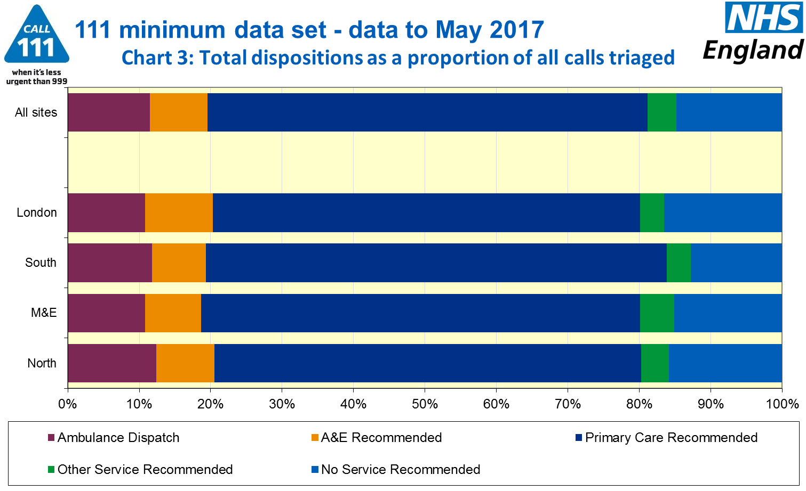



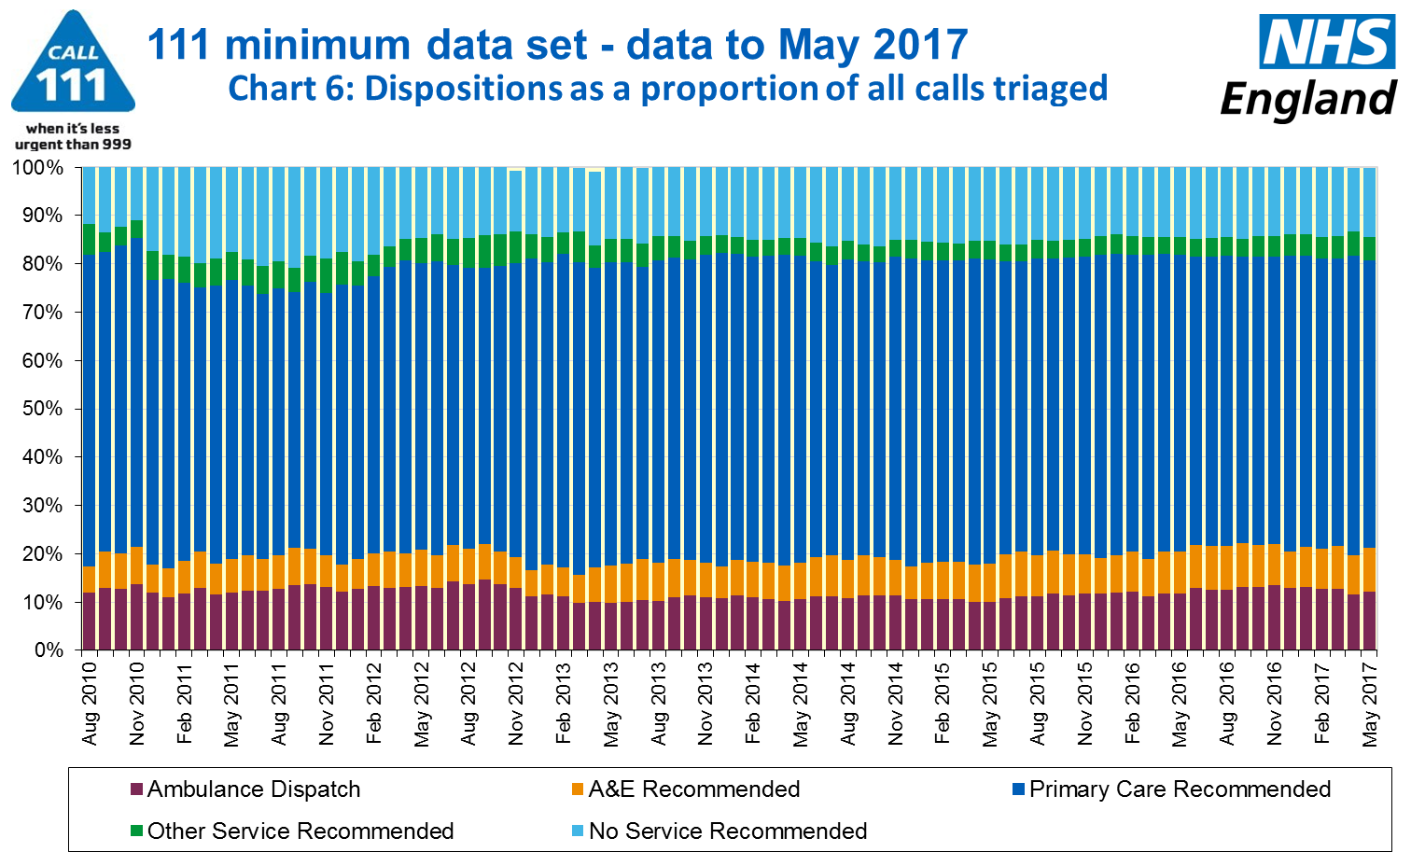

#### Additional Information:

All monthly data in the 111 Minimum Data Set (MDS) are available in spreadsheets at [www.england.nhs.uk/statistics/statistical-work-areas/nhs-111-minimum-data-set](http://www.england.nhs.uk/statistics/statistical-work-areas/nhs-111-minimum-data-set), along with all the previous accompanying statistical notes, the specification guidance document for those who produce the data, and the timetables for data collection and publication. Publication dates are also available from [www.gov.uk/government/statistics/announcements](http://www.gov.uk/government/statistics/announcements).

Material changes to the data or presentation of the NHS 111 MDS are listed in the 3 July 2015 Statistical Note and in earlier versions. Any further material changes will be described here in future Statistical Notes.

#### Contacts

For press enquiries, please contact the NHS England press office on 0113 825 0958 or [nhsengland.media@nhs.net](mailto:nhsengland.media@nhs.net).

The individual responsible for these data is:

Ian Kay

NHS England, Operational Information for Commissioning (Central)

Room 5E24, Quarry House, Leeds LS2 7UE

[i.kay@nhs.net](mailto:i.kay@nhs.net)

0113 825 4606

1. This data item is an experimental statistic and may change markedly as providers develop their calculation methods. The specification is in data item 5.22 on the guidance document v0.901 at the NHS 111 MDS landing page, [www.england.nhs.uk/statistics/statistical-work-areas/nhs-111-minimum-data-set](http://www.england.nhs.uk/statistics/statistical-work-areas/nhs-111-minimum-data-set). More information on experimental statistics is at: [www.ons.gov.uk/methodology/methodologytopicsandstatisticalconcepts/guidetoexperimentalstatistics](https://www.ons.gov.uk/methodology/methodologytopicsandstatisticalconcepts/guidetoexperimentalstatistics)