# NHS 111 Minimum Data Set, England, October 2017

#### Latest data

There were 1,243,759 calls offered to the NHS 111 service in England in October 2017 (40.1 thousand per day), an increase of 0.7% on the 1,235,035 calls offered in October 2016 (39.8 thousand per day).

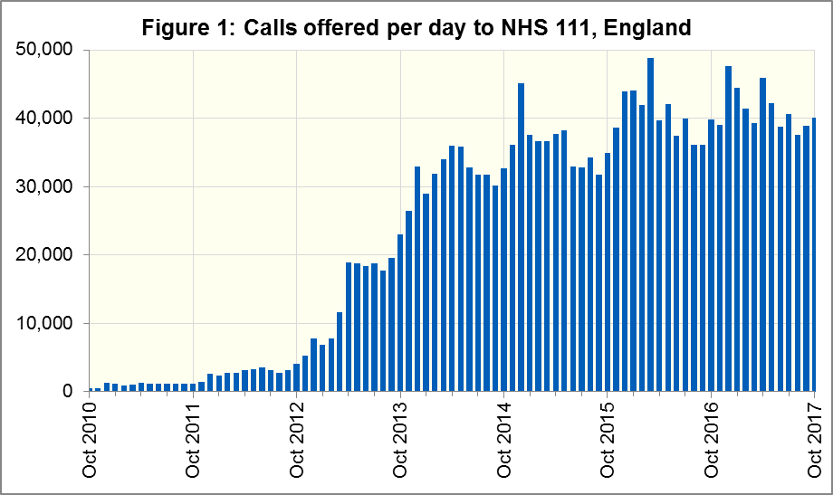

Of calls offered to NHS 111, the proportion abandoned after waiting longer than 30 seconds was 2.2% in October 2017, more than in October 2016 (2.4%).

In October 2017, of calls answered by NHS 111, 87.1% were answered within 60 seconds, less than in October 2016 (88.5%).

The proportion of calls answered that received any form of clinical input[1] increased in October 2017 to 37.1%, after two consecutive months at 36.4%.

13% of all calls answered in October 2017 were offered a call back, similar to the 14% recorded in October 2016. Of those call backs, 41% were made within 10 minutes.

Of calls triaged in October 2017, 14% had ambulances dispatched, 9% were recommended to attend A&E, 59% were recommended to attend primary care, 5% were advised to attend another service, and 14% were not recommended to attend another service, the same as in September 2017.

The NHS 111 time series spreadsheet to October 2016, available at the website below, contains revised population estimates for NHS 111 contract areas for all months of 2016, following the publication by ONS of new population estimates for CCGs in October.

#### Contacts

For press enquiries, please contact the NHS England press office on 0113 825 0958 or [nhsengland.media@nhs.net](mailto:nhsengland.media@nhs.net)

These statistics are available at

[www.england.nhs.uk/statistics/statistical-work-areas/nhs-111-minimum-data-set](http://www.england.nhs.uk/statistics/statistical-work-areas/nhs-111-minimum-data-set)

The person responsible for this publication is:

Ian Kay

0113 825 4606

NHS England, Operational Information for Commissioning (Central)

Room 5E24, Quarry House, Leeds LS2 7UE

[i.kay@nhs.net](mailto:i.kay@nhs.net)

1. This data item is an experimental statistic and may change markedly as providers develop their calculation methods. The specification is in data item 5.22 on the guidance document v0.901 at the NHS 111 MDS landing page. More information on experimental statistics is at: [www.ons.gov.uk/methodology/methodologytopicsandstatisticalconcepts/guidetoexperimentalstatistics](https://www.ons.gov.uk/methodology/methodologytopicsandstatisticalconcepts/guidetoexperimentalstatistics)