NHS 111 Minimum Data Set, England, September 2017

Latest data
There were 1,166,322 calls offered to the NHS 111 service in England in September 2017 (38.9 thousand per day), an increase of 8% on the 1,084,345 calls offered in September 2016 (36.1 thousand per day).

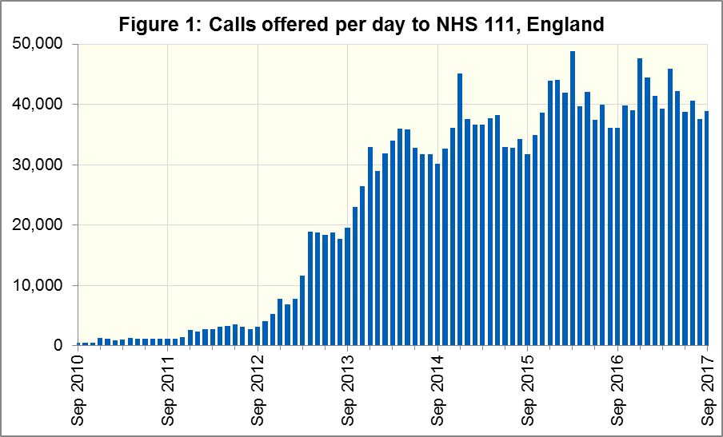

Of calls offered to NHS 111, the proportion abandoned, after waiting longer than 30 seconds was 2.0% in September 2017, more than in September 2016 (1.5%).
In September 2017, of calls answered by NHS 111, 88.4% were answered within 60 seconds, less than in September 2016 (92.0%).
The proportion of calls answered that received any form of clinical input stabilised in September 2017 at 36.4%, following nine consecutive months of increases.
13% of all calls answered in September 2017 were offered a call back, the same as in September 2016. Of those call backs, 42% were made within 10 minutes.
Of calls triaged in September 2017, 14% had ambulances dispatched, 9% were recommended to attend A&E, 59% were recommended to attend primary care, 5% were advised to attend another service and 14% were not recommended to attend another service. The proportion of triaged calls that had ambulances dispatched has increased slightly, but the other proportions remain unchanged from August 2017.

Contacts
For press enquiries, please contact the NHS England press office on 0113 825 0958 or nhsengland.media@nhs.net.
The individual responsible for these data is:
Ian Kay
0113 825 4606
NHS England, Operational Information for Commissioning (Central)
Room 5E24, Quarry House, Leeds LS2 7UE
i.kay@nhs.net

This data item is an experimental statistic and may change markedly as providers develop their calculation methods. The specification is in data item 5.22 on the guidance document v0.901 at the NHS 111 MDS landing page. More information on experimental statistics is at: www.ons.gov.uk/methodology/methodologytopicsandstatisticalconcepts/guidetoexperimentalstatistics

