Statistical Note: Ambulance Quality Indicators (AQI)
The latest Systems Indicators for October 2017 for Ambulance Services in England showed previous standards in the Handbook to the NHS constitution were not met.
As stated last month, we continue to publish spreadsheets with the latest Clinical Outcomes data, but because of the volatility due to small numbers, we will now only summarise them in this Note once every three months.

Systems Indicators

Emergency response in 8 minutes (Figure 1)
In October 2017, of Category A Red 1 calls in England, resulting in an emergency response, the proportion arriving within 8 minutes was 68.0%.
In October 2017, of Category A² Red 2 calls in England, resulting in an emergency response, the proportion arriving within 8 minutes was 58.9%.
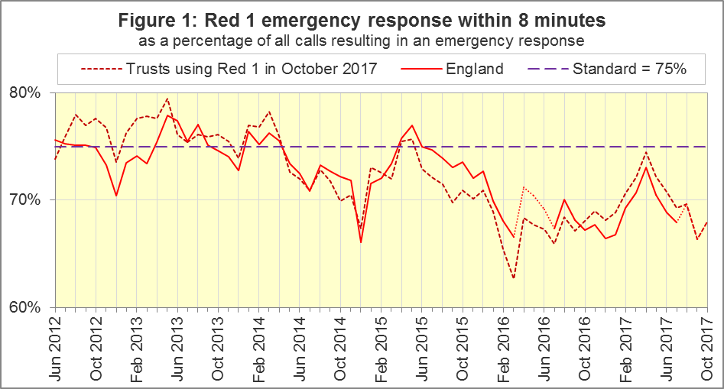
The standard for Ambulance Services was to send an emergency response, with a defibrillator, within 8 minutes to 75% of Category A calls. Figure 1 shows that for the six Trusts that used Red 1 in October 2017, combined performance was not as low as in early 2016. However, no Trusts met the standard in October 2017, ranging from 73% for London (LAS) and South Central (SCAS) Ambulance Services to 54% for East Coast Ambulance Service (SECAmb).

Publication contents
The 11 January 2018 publication will see a change to the reporting timetable as we will publish data for December 2017 as well as November 2017. After that we will continue to publish data for the last full month, rather than the penultimate full month.
This shortened timetable may result in fewer validation checks by Ambulance Services before they supply data to us. We will work with Ambulance Services to assess the quality of the data, and consider publishing revisions more frequently.
This is also the last Statistical Note in which we will describe the previous Handbook standards and Systems Indicators in specification v3.0 on our landing page www.england.nhs.uk/statistics/statistical-work-areas/ambulance-quality-indicators.
In 2018, we will continue to update the interactive Time Series spreadsheet on this website with all these data items in specification v3.0 for Isle of Wight (IOW), which is due to switch from that specification in spring 2018. We will also include data items SQU03_1_1_2 (calls received), SQU03_10_2_1 and SQU03_10_2_2 (face-to-face incidents not transported to A&E), to measure discontinuities between old and new data item definitions, for three months after Trusts start to report against the new specification.
However, the 11 January publication will contain new Systems Indicators from all Ambulance Services except IOW, for December 2017, and at least part of November 2017. The 11 January Statistical Note will only describe the data in the 20170926 specification document on the above landing page (also at http://bit.ly/NHSAQI), and the standards in the September 2017 Addendum of the Handbook to the NHS Constitution (see footnote 1 above), resulting from the Ambulance Response Programme.

Ambulance Response Programme (ARP)
The ARP has altered the activities of Ambulance Services and, consequently, these statistics, in several ways.
In February 2015, Phase 1 of ARP started: Dispatch on Disposition (DoD). Other than Red 1 incidents, the start time before DoD was the earliest of the following three possible trigger points:
- chief complaint or NHS Pathways initial disposition (Dx) code obtained;
- first vehicle assigned;
- 60 seconds after call connect.
DoD tested alternatives to the third trigger point of 180, 240 and 300 seconds in various Ambulance Services. In October 2016, all Ambulance Services in England were aligned with a third trigger point of 240 seconds, except for IoW, which aligned in February 2017. All change dates are in the 8 December 2016 AQI Statistical Note.
Phase 2 of ARP was the Clinical Coding Review (CCR), introducing new Categories C1 to C4, not comparable with the previous Category A (Red 1 and Red 2) and Category C (Green 1, Green 2, Green 3, and Green 4).
For these Trusts, from these dates, data for Red 1, Red 2, and Category A are no longer available:
SWAS | YAS | WMAS | EMAS | NWAS | EastAmb
19 Apr 2016 | 21 Apr 2016 | 8 Jun 2016 | 19 Jul 2017 | 1 Aug 2017 | 18 Oct 2017

Response times for new Categories
Comparable response times for October 2017 are available for YAS, WMAS, EMAS and NWAS.
The mean response time for the most acute Category, C1, ranged from 6 minutes and 41 seconds for WMAS to 9:29 for NWAS. The mean response time for Category C2 ranged from 11:38 for WMAS to 29:08 for EMAS.
All C1 to C4 mean and 90th centile response times for YAS and WMAS were shorter in October than in September, but those for EMAS nearly all increased.
For October and November 2017, SWAS still reports against specification v3.0 at http://bit.ly/NHSAQI. This includes C1 to C4 response times based on different clock start and clock stop points, which are therefore not comparable with other Trusts or the new standards in the Handbook to the NHS Constitution. The mean C1 response time for SWAS was 8:48 in October 2017.

Emergency Response in 8 minutes for Red 2 (Figure 2)
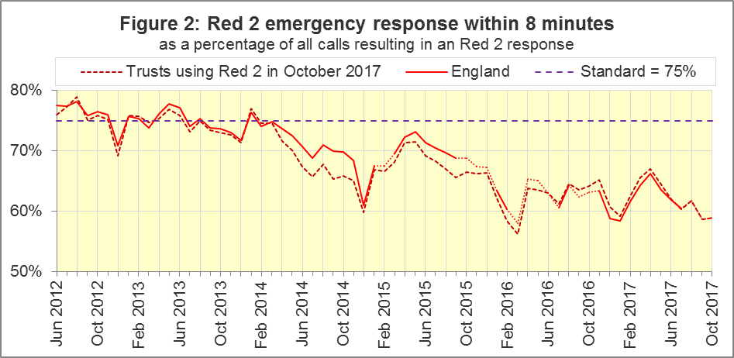
For the six Trusts still using Red 2 in October 2017, the proportion of Red 2 incidents receiving an emergency response in 8 minutes was 58.9%. As with Red 1, the largest proportion was for LAS and SCAS (69%), and the smallest was for SECAmb (41%).
Figure 2 shows the time series of this proportion for these six Trusts combined; October 2017 is only the sixth month in which it has been less than 60%.

Category A Ambulance response in 19 minutes (Figure 3)
The second ambulance standard in the Handbook to the NHS Constitution is for Trusts to send, within 19 minutes, a fully-equipped ambulance vehicle, able to transport the patient in a clinically safe manner, to 95% of Category A calls.
Figure 3 shows that for the six Trusts that used Category A in October 2017, the proportion of 90.3% in October was an increase on the series low of 87.9% in September.
Performance in October ranged from 94.9% for LAS to 84.8% for SECAmb.
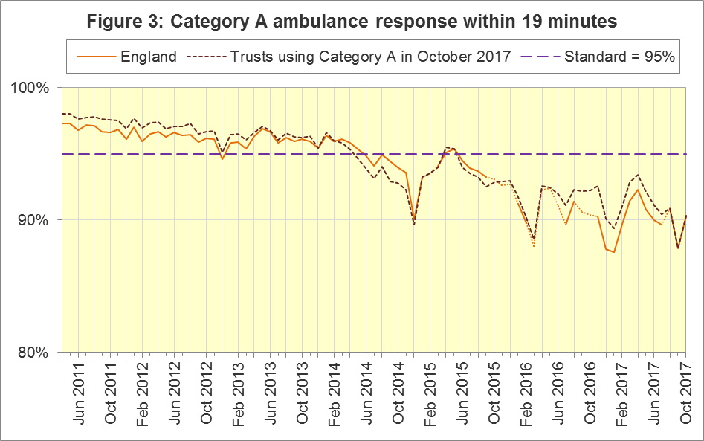
For other Systems Indicators, DoD and the CCR do not affect comparability, but may lead to changes in levels. For example, a longer triage time may mean more calls are closed on the telephone, but the data for this measure remain comparable. Such changes may be difficult to detect within the habitual variation of the many AQI.
NWAS, YAS, EMAS, and WMAS, no longer provide the previous Systems Indicators, except for the numbers of calls receiving a face-to-face response, and of those, not transported to Type 1 / Type 2 A&E; plus the numbers of telephone calls presented to switchboard.

Systems Indicators: Ambulance volumes (Figure 4)
The number of emergency telephone calls presented to the switchboard in October 2017 was 896,464, an average of 28.9 thousand per day.
There were 598,512 emergency calls that received a face-to-face response from the ambulance service in October 2017, an average of 19.3 thousand per day.
Figure 4 shows these measures usually revert to average after a high in December and a low in August. It also shows a gradual increase in telephone calls, and in face-to-face responses, but not so much for incidents where a patient was transported, although the latter is no longer supplied comprehensively after June 2017.
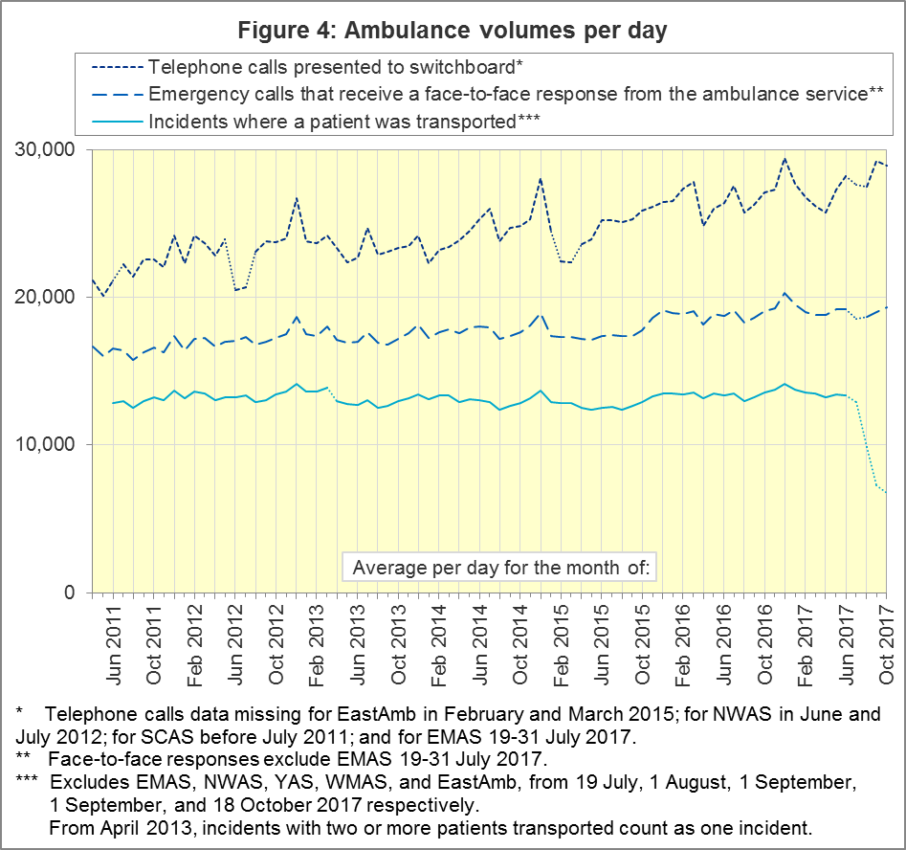

Latest monthly data for other Systems Indicators, October 2017
Indicator | England | Lowest Trust |  | Highest Trust
Calls abandoned before being answered | 2.1% | SCAS | 0.5% | SECAmb | 5.0%
Calls resolved through telephone assessment | 10.5% | SECAmb | 5.2% | SWAS | 13.0%
Calls resolved without transport to Type 1 or Type 2 A&E | 36.8% | EMAS | 20.3% | SWAS | 48.9%
Recontact rate following discharge by telephone advice | 7.8% | LAS | 3.5% | SECAmb | 13.3%
Recontact rate following face-to-face treatment at scene | 6.6% | SWAS | 4.7% | LAS | 9.0%
Incidents where a patient was transported | 184,819 | NEAS | 19,188 | LAS | 69,684

Further information on AQI

The AQI landing page and Quality Statement
www.england.nhs.uk/statistics/statistical-work-areas/ambulance-quality-indicators, or http://bit.ly/NHSAQI, is the AQI landing page, and it holds:
- a Quality Statement for these statistics, which includes information on relevance, accuracy, timeliness, coherence, and user engagement;
- the specification guidance document for those who supply the data;
- timetables for data collection and publication;
- time series spreadsheets and csv files from April 2011 up to the latest month;
- links to individual web pages for each financial year;
- contact details for the responsible statistician (also in 2.6 below).
The web pages for each financial year hold:
- separate spreadsheets of each month’s data;
- this Statistical Note, and equivalent versions from previous months;
- the list of people with pre-release access to the data.
Publication dates are also at www.gov.uk/government/statistics/announcements.

Revisions Timetable
Revisions usually follow a six-monthly cycle, but this will change in 2017-18 after the ARP review of indicators. The dates for past AQI Systems Indicators (SI) and Clinical Outcomes (CO) scheduled revisions are below. The AQI Quality Statement above contains a more detailed revisions policy.
Publication |  | Data |  | Months affected |  |  | Publication |  | Data |  | Months affected
14 Sep 2017 |  | CO |  | Apr ’16 - Mar ‘17 |  |  | 6 Nov 2014 |  | SI |  | Apr ‘13 - Aug ‘14
11 May 2017 |  | SI |  | Apr ‘15 - Feb ‘17 |  |  | 5 Sep 2014 |  | CO |  | Apr ‘13 - Mar ‘14
9 Mar 2017 |  | CO |  | Apr ‘16 - Sep ‘16 |  |  | 2 May 2014 |  | SI |  | Apr ‘13 - Feb ‘14
10 Nov 2016 |  | SI |  | Apr ‘16 - Aug ‘16 |  |  | 7 Mar 2014 |  | CO |  | Apr ‘13 - Sep ‘13
8 Sep 2016 |  | CO |  | Apr ‘15 - Apr ‘16 |  |  | 1 Nov 2013 |  | SI |  | Apr ‘13 - Aug ‘13
12 May 2016 |  | SI |  | Apr ‘15 - Feb ‘16 |  |  | 2 Aug 2013 |  | CO |  | Apr ‘12 - Mar ‘13
10 Apr 2016 |  | CO |  | Apr ‘15 - Sep ‘15 |  |  | 3 May 2013 |  | SI |  | Apr ‘12 - Mar ‘13
10 Sep 2015 |  | CO |  | Apr ‘14 - Mar ‘15 |  |  | 1 Feb 2013 |  | CO |  | Apr ‘12 - Aug ‘12
4 Jun 2015 |  | SI |  | Apr ‘14 - Feb ‘15 |  |  | 11 Jan 2013 |  | SI |  | Apr ‘11 - Oct ‘12
30 Apr 2015 |  | SI |  | Apr ‘14 - Feb ‘15 |  |  | 31 Aug 2012 |  | CO |  | Apr ‘11 - Mar ‘12
5 Mar 2015 |  | CO |  | Apr ‘14 - Sep ‘14 |  |  | 4 May 2012 |  | SI & CO |  | Apr ‘11 - Mar ‘12

AQI Scope
The AQI include calls made by dialling either the usual UK-wide number 999 or its international equivalent 112.
As described in the specification guidance mentioned in section 2.1, calls made to NHS 111 are not included in the AQI measures for calls abandoned, re-contacts, frequent callers, time to answer calls, or calls resolved by telephone advice.
All other Systems Indicators involve the dispatch of an ambulance, and include ambulances dispatched as a result of a call to NHS 111, as well as 999 or 112.

Related statistics in England
A dashboard on the AQI landing page presents an alternative layout for the AQI data. Because of the lack of comparability due to the Ambulance Response Programme (section 1.3), NHS England last updated the dashboard in April 2016.
The AQI were also used in the “Ambulance Services” publications by NHS Digital, which included additional annual analysis and commentary, up to and including 2014-15 data. The Quality Statement described in section 2.1 has more information on this publication. The Quality Statement also contains details of weekly ambulance situation reports that NHS England collected for six months from November 2010.
Ambulance handover delays of over 30 minutes at each Emergency Department were collected and published by NHS England for winter 2012-13, 2013-14 and 2014-15: www.england.nhs.uk/statistics/statistical-work-areas/winter-daily-sitreps.

Rest of United Kingdom
Ambulance statistics for other countries of the UK can be found at the following websites. The Quality Statement described in section 2.1 contains more information about the comparability of these statistics.
Wales: | http://wales.gov.uk/statistics-and-research/ambulance-services
Scotland: | See Quality Improvement Indicators (QII) documents at www.scottishambulance.com/TheService/BoardPapers.aspx
Northern Ireland: | www.health-ni.gov.uk/articles/emergency-care-and-ambulance-statistics

Contact information
Press: NHS England press office, nhsengland.media@nhs.net, 0113 825 0958.
The person responsible for producing this publication is:
Ian Kay, Operational Information for Commissioning (Central), NHS England
Room 5E24, Quarry House, Leeds, LS2 7UE; 0113 825 4606; i.kay@nhs.net

National Statistics
The UK Statistics Authority has designated these statistics as National Statistics, in accordance with the Statistics and Registration Service Act 2007 and signifying compliance with the Code of Practice for Official Statistics.
Designation can be broadly interpreted to mean that the statistics:
- meet identified user needs;
- are well explained and readily accessible;
- are produced according to sound methods; and
- are managed impartially and objectively in the public interest.
Once statistics have been designated as National Statistics it is a statutory requirement that the Code of Practice shall continue to be observed.

Page 34 of the July 2015 Handbook to the NHS Constitution has the previous Ambulance response standards, www.gov.uk/government/publications/supplements-to-the-nhs-constitution-for-england.
Category A no longer applies, and so data are unavailable, for South Western (SWAS) and Yorkshire (YAS) from April 2016, West Midlands (WMAS) from June 2016, and East Midlands (EMAS) and North West (NWAS) Ambulance Services after July 2017. See section 1.3 on the Clinical Coding Review. Also, after February 2015, changes in operational practice meant that Red 2 response data are still available but not always comparable; see section 1.2 on Dispatch on Disposition. The Red 1 and Red 2 divisions of Category A (immediately life-threatening) calls were created on 1 June 2012. Red 1 calls are the most time critical, and cover cardiac arrest patients who are not breathing and do not have a pulse, and other severe conditions such as airway obstruction. Red 2 calls are serious, but less immediately time critical, and cover conditions such as stroke and fits. www.gov.uk/government/news/changes-to-ambulance-response-time-categories.
The Isle of Wight (IOW) contains 0.3% of the resident population of England. Its data, available in the accompanying spreadsheets, vary more than other trusts due to its small size. In this document, if IOW has the largest or smallest value, we report the second largest or smallest value instead.
Dispatch on Disposition announcement: www.parliament.uk/business/publications/written-questions-answers-statements/written-statement/Commons/2015-01-16/HCWS201
All EMAS data for July 2017 is unavailable from 19 July onwards, when they implemented CCR. Per day calculations in Section 1.7, but not Figure 4, scale up EMAS July data by 31/18 to compensate.
The number of calls presented to switchboard does not usually include calls to NHS 111 requiring an ambulance, which are usually transferred electronically direct to ambulance dispatch and not routed via 999 call handlers. Occasionally, manual requests for ambulances are made between 111 and 999 call handlers. Such calls are included in the numbers of emergency calls presented to switchboard.
For all measures except for ‘Calls resolved without transport to Type 1 or Type 2 A&E’, this table excludes the trusts reporting new Systems Indicators (NWAS, EMAS, WMAS, YAS, EastAmb).
NHS Digital Ambulance Services: https://digital.nhs.uk/search?q=ambulance.

