NHS 111 Minimum Data Set, England, November 2017

Latest data
There were 1,205,670 calls offered to the NHS 111 service in England in November 2017 (40.2 thousand per day), an increase of 2.8% on the 1,172,821 calls offered in November 2016 (39.1 thousand per day).

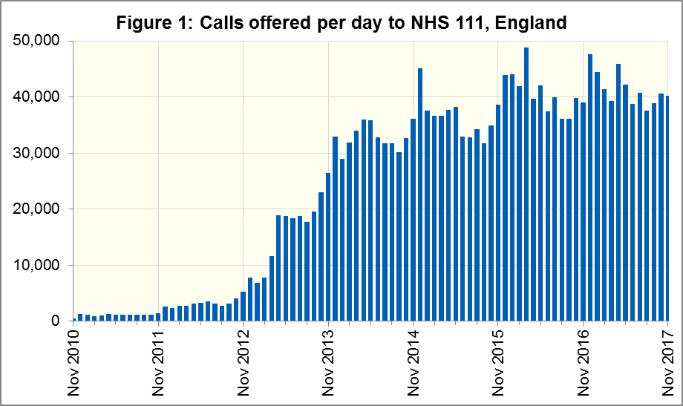

Of calls offered to NHS 111, the proportion abandoned after waiting longer than 30 seconds was 2.3% in November 2017, an improvement on November 2016 (2.5%).
In November 2017, of calls answered by NHS 111, 86.8% were answered within 60 seconds, less than in November 2016 (88.2%).
The proportion of calls answered that received any form of clinical input increased in November 2017 to a new high of 37.7%. This proportion has increased every month since it was first collected in November 2016.
13.8% of all calls answered in November 2017 were offered a call back, the same as the 13.8% recorded in November 2016. Of those call backs, 41.1% were made within 10 minutes.
Of calls triaged in November 2017, 13.7% had ambulances dispatched, 8.5% were recommended to attend A&E, 59.1% were recommended to attend primary care, 4.4% were advised to attend another service and 14.3% were not recommended to attend another service. These proportions remain largely unchanged from October 2017.

Revisions
Revisions to monthly data from July 2017 to October 2017 (inclusive) will be published alongside the November 2017 data. For July, August and October, all data items have been revised. The largest changes for each data item in each month are summarised in the table below.

Data Item | Largest change between revised and original submission
 | July 2017 | August 2017 | September 2017 | October 2017
Total calls offered | 4,081 | 758 |  | 15,891
Calls abandoned after at least 30 seconds | 88 | 12 | -25 | 667
Calls answered | 3,286 | 746 |  | 15,102
Calls answered within 60 secs | 2,964 | 357 |  | 12,135
Calls triaged | 2,783 | 562 | 42 | 12,346
Calls transferred to a clinical advisor | 639 | -4,750 | 13 | 3,044
Calls warm transferred to clinical advisor | 271 | -4,750 | 4 | 1,023
Calls where person offered call back | 368 | 80 | 9 | 2,021
Calls back within 10 min | 153 | 50 | -2 | 841
Calls to a clinician | -1,985 | -1,667 | -1,535 | 4,602
Ambulance dispatches | -2,506 | -3,038 | -2,927 | -301
Recommended to attend A&E | 307 | 85 | 4 | 794
Recommended to attend primary care | 2,506 | 3,041 | 2,938 | 8,446
Recommended to contact primary care | 1,098 | 241 | 147 | 4,456
Recommended to speak to primary care | 817 | 939 | 826 | 1,838
Recommended to dental | 115 | 34 | 38 | 924
Recommended to pharmacy | 1,512 | 1,884 | 1,927 | 1,228
Table 1: Largest changes at provider level between revised and original submissions. A negative value indicates a data item which has decreased in the revised submission. A blank cell indicates that no change occurred for that data item in that month.

Contacts
For press enquiries, please contact the NHS England press office on 0113 825 0958 or nhsengland.media@nhs.net.
The individual responsible for these data is:
Ian Kay
0113 825 4606
NHS England, Operational Information for Commissioning (Central)
Room 5E24, Quarry House, Leeds LS2 7UE
i.kay@nhs.net

This data item is an experimental statistic and may change markedly as providers develop their calculation methods. The specification is in data item 5.22 on the guidance document v0.901 at the NHS 111 MDS landing page. More information on experimental statistics is at: www.ons.gov.uk/methodology/methodologytopicsandstatisticalconcepts/guidetoexperimentalstatistics

