Statistical Note: Ambulance Quality Indicators (AQI)
As stated in the 14 December 2017 statistical note, today’s publication contains not only data for November 2017 but also for December 2017, bringing publication into line with NHS England’s statistics on A&E and NHS 111. This shortened timetable reduces the validation checks made by Ambulance Services before they supply data to us. We will work with Ambulance Services to assess the quality of the subsequent data, and consider publishing revisions more frequently.
The latest Systems Indicators for December 2017 for Ambulance Services in England showed that none of the six standards in the Handbook to the NHS constitution were met.

Systems Indicators

Response times
Figure 1 shows that reporting against the new standards started with North West (NWAS) and East Midlands (EMAS) Ambulance Services in August 2017. By December 2017, all Ambulance Services in England reported against the new standards, apart from Isle of Wight, which is missing from all data in this document.
For the following Ambulance Services and months, Systems Indicators cover only part of the month when reporting against the new standards started: NWAS 7-31 August; West Midlands (WMAS) 9-30 September; South Western (SWAS) 23-30 November inclusive.
For Category C1, the most life-threatening incidents, the average response time was 8 minutes 52 seconds in December 2017. Only WMAS and North East Ambulance Service (NEAS) met the mean standard of 7 minutes in November, and only NEAS met it in December.
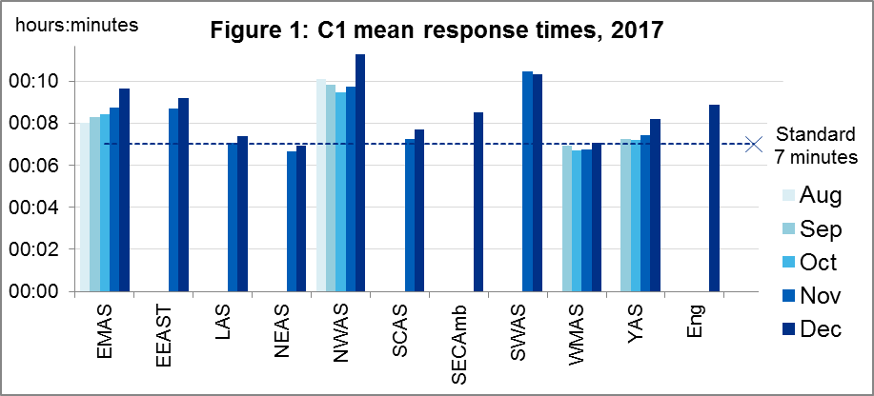
In the last six years, response times for all England against both the old 8 minute emergency response, and 19 minute transportation response, apart from Red 1 in 2016, increased between November and December. Figures 1 to 6 show that this was true again in 2017, for England as a whole, for all six of the new standards.
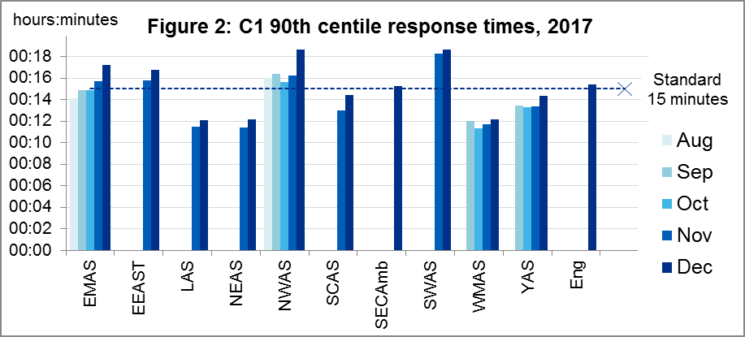
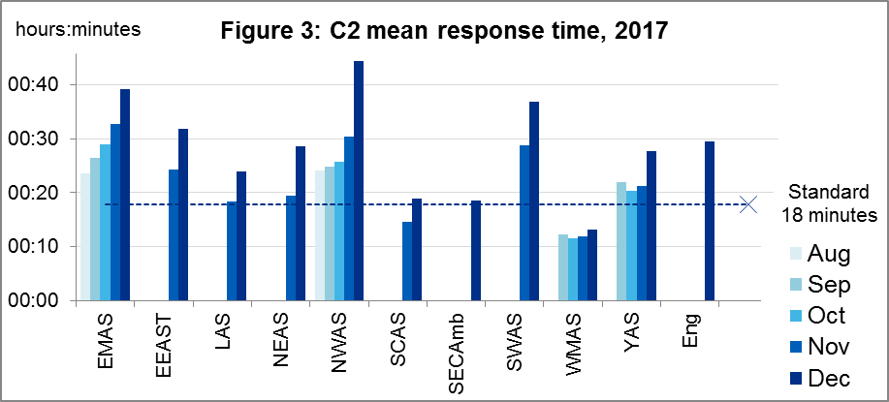
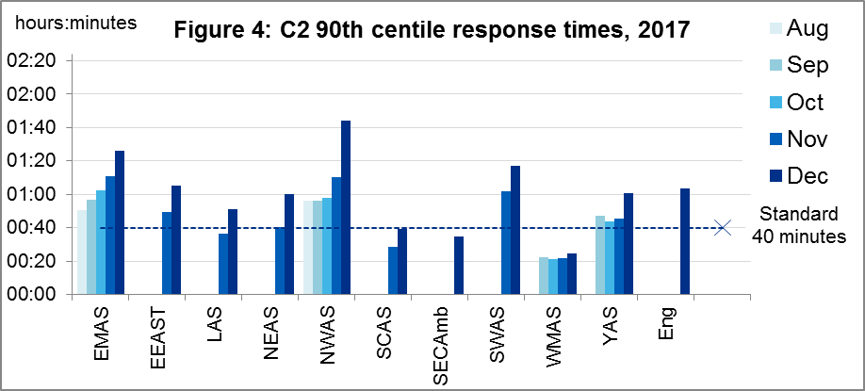
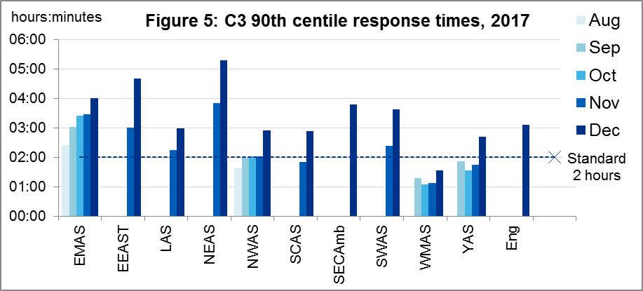
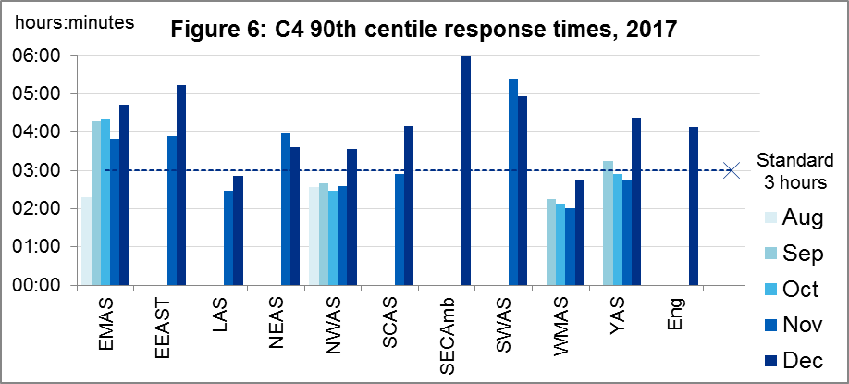

Other new Systems Indicators
There were 747,350 incidents in England in December 2017, 24.1 thousand per day. 93% had a face-to-face response, comprising 57% where a patient was transported to an Emergency Department, 6% where a patient was transported elsewhere, and 30% where no patients were transported. The other 7% were resolved on the telephone.
For the eight Ambulance Services in England that reported consistently throughout November and December 2017, which excludes SECAmb and SWAS:
- The average C1 response time increased 11% from 7:53 to 8:44;
- The average C2 response time increased 32% from 22:38 to 29:48;
- The count of incidents increased from 548,457 to 602,581 which, per day, was an increase of 6%;
- The proportion of incidents resolved on the telephone increased from 6% to 7%;
- The average call answer time increased from 9 to 10 seconds.

Previous Systems Indicators
In spring 2018, the Isle of Wight Ambulance Service plans to start reporting the new indicators in the 20170926 data specification agreed by the NHS England Ambulance Response Programme (ARP).
Isle of Wight data, and data for other Ambulance Services for the old data items SQU03_1_1_2 (calls received), SQU03_10_2_1 and SQU03_10_2_2 (face-to-face incidents not transported to A&E), to measure discontinuities between old and new data item definitions, will still be published in the interactive Time Series spreadsheet on the AQI landing page, alongside the data specifications.

Further information on AQI

The AQI landing page and Quality Statement
www.england.nhs.uk/statistics/statistical-work-areas/ambulance-quality-indicators, or http://bit.ly/NHSAQI, is the AQI landing page, and it holds:
- a Quality Statement for these statistics, which includes information on relevance, accuracy, timeliness, coherence, and user engagement;
- the specification guidance document for those who supply the data;
- timetables for data collection and publication;
- time series spreadsheets and csv files from April 2011 up to the latest month;
- links to individual web pages for each financial year;
- contact details for the responsible statistician (also in 2.6 below).
The web pages for each financial year hold:
- separate spreadsheets of each month’s data;
- this Statistical Note, and equivalent versions from previous months;
- the list of people with pre-release access to the data.
Publication dates are also at www.gov.uk/government/statistics/announcements.

Revisions
Revisions followed a six-monthly cycle until the ARP review of indicators in 2017, when revisions were delayed while Ambulance Services amended their systems to produce the new Indicators. The new indicator set allows Ambulance Services to report data more quickly, but only by reducing the validation checks before data supply. We will work with Ambulance Services to assess the quality of the subsequent data, and consider publishing revisions more frequently in future.

AQI Scope
The AQI include calls made by dialling either the usual UK-wide number 999 or its international equivalent 112.
As described in the specification guidance mentioned in section 2.1, calls made to NHS 111 are included in all Systems Indicators except data on contacts and calls, items A0 to A6.

Related statistics in England
A dashboard on the AQI landing page presents an alternative layout for the AQI data. Because of the lack of comparability due to the Ambulance Response Programme (see the 14 December 2017 AQI Statistical Note), NHS England last updated the dashboard in April 2016.
The AQI were also used in the “Ambulance Services” publications by NHS Digital, which included additional annual analysis and commentary, up to and including 2014-15 data. The Quality Statement described in section 2.1 has more information on this publication. The Quality Statement also contains details of weekly ambulance situation reports that NHS England collected for six months from November 2010.
Ambulance handover delays of over 30 minutes at each Emergency Department were published by NHS England for winter 2012-13, 2013-14, 2014-15 and 2017-18: www.england.nhs.uk/statistics/statistical-work-areas/winter-daily-sitreps.

Rest of United Kingdom
Ambulance statistics for other countries of the UK can be found at the following websites. The Quality Statement described in section 2.1 contains more information about the comparability of these statistics.
Wales: | http://wales.gov.uk/statistics-and-research/ambulance-services
Scotland: | See Quality Improvement Indicators (QII) documents at www.scottishambulance.com/TheService/BoardPapers.aspx
Northern Ireland: | www.health-ni.gov.uk/articles/emergency-care-and-ambulance-statistics

Contact information
Press: NHS England press office, nhsengland.media@nhs.net, 0113 825 0958.
The person responsible for producing this publication is:
Ian Kay, Operational Information for Commissioning (Central), NHS England
Room 5E24, Quarry House, Leeds, LS2 7UE; 0113 825 4606; i.kay@nhs.net

National Statistics
The UK Statistics Authority has designated these statistics as National Statistics, in accordance with the Statistics and Registration Service Act 2007 and signifying compliance with the Code of Practice for Official Statistics.
Designation can be broadly interpreted to mean that the statistics:
- meet identified user needs;
- are well explained and readily accessible;
- are produced according to sound methods; and
- are managed impartially and objectively in the public interest.
Once statistics have been designated as National Statistics it is a statutory requirement that the Code of Practice shall continue to be observed.

The September 2017 addendum to the Handbook to the NHS Constitution contains the Ambulance standards: www.gov.uk/government/publications/supplements-to-the-nhs-constitution-for-england.
Categories introduced nationwide in 2017: www.england.nhs.uk/urgent-emergency-care/arp
NHS Digital Ambulance Services: https://digital.nhs.uk/search?q=ka34&s=r

