# NHS 111 Minimum Data Set, England, December 2017

#### Latest data

There were 1,676,254 calls offered to the NHS 111 service in England in December 2017 (54.1 thousand per day), an increase of 13.5% on the 1,476,826 calls offered in December 2016 (47.6 thousand per day). This is the largest number of calls offered in a month since data collection began in August 2010. This is also the largest number of calls per day during the same timeframe.

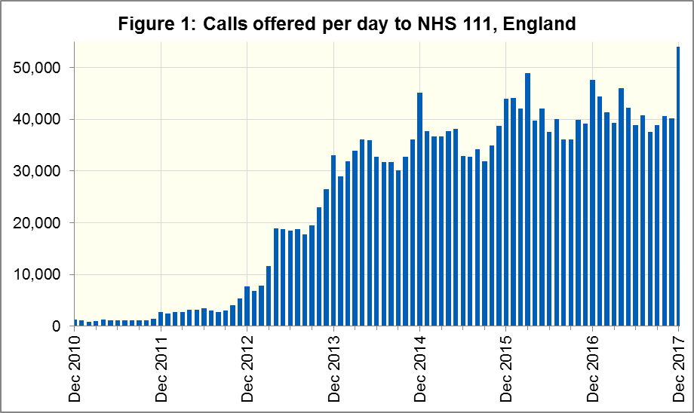

Of calls offered to NHS 111, the proportion abandoned after waiting longer than 30 seconds was 7.2% in December 2017, an increase on December 2016 (3.8%). This is the largest proportion of calls abandoned since March 2016.

In December 2017, of calls answered by NHS 111, 72.7% were answered within 60 seconds, less than in December 2016 (86.0%). This is the lowest proportion of calls answered in 60 seconds since March 2016.

The proportion of calls answered that received any form of clinical input[1] increased in December 2017 to a new high of 39.4%. This proportion has increased every month since it was first collected in November 2016.

14.3% of all calls answered in December 2017 were offered a call back, more than the 13.5% recorded in December 2016 and the largest proportion since August 2010. Of those call backs, 41.0% were made within 10 minutes.

Of calls triaged in December 2017, 12.7% had ambulances dispatched, 7.4% were recommended to attend A&E, 62.0% were recommended to attend primary care, 5.0% were advised to attend another service and 13.4% were not recommended to attend another service. These proportions are different to November 2017, with lower proportions of ambulance dispatches and recommendations to attend A&E but higher proportions of recommendations to attend primary care and other services. They are however, largely in line with trends seen in December 2016.

#### Survey data for April 2017 to September 2017

NHS 111 providers conduct surveys to compare patient experience between service areas. The latest six-monthly batch up to the end of September 2017 contained 15,195 responses. The number of responses varies by area, from 1,814 in the West Midlands to 52 in Somerset. Data for Luton & Bedfordshire was unavailable for this period at time of publication. Results are not weighted according to the volume of callers or the resident population.

Between April 2017 and September 2017 inclusive, of those that responded to the relevant question:

* 87% were either very or fairly satisfied with the way the NHS 111 service handled the whole process;
* 86% followed all the advice given by the 111 service;
* seven days after their call, the problem they were calling about had improved or completely resolved for 77%;
* 90% found the advice they received from the 111 service was either very or quite helpful;
* If the 111 service had not been available:
* 15% would have contacted the 999 ambulance service;
* 27% would have contacted A&E;
* 38% would have contacted primary care;
* 14% would have contacted someone else;
* 5% would not have contacted anyone else.

For the full year October 2016 to September 2017, 16% of respondents wrote that they would have called for an ambulance, and 28% would have attended A&E, had 111 not been available.

Given that the actual dispositions for the 12.1 million calls triaged over this year were 13% ambulances and 9% A&E, this suggests that 0.4 million callers were directed away from the ambulance services, and a further 2.3 million were directed away from A&E.

#### Contacts

For press enquiries, please contact the NHS England press office on 0113 825 0958 or [nhsengland.media@nhs.net](mailto:nhsengland.media@nhs.net).

The individual responsible for these data is:

Ian Kay

0113 825 4606

NHS England, Operational Information for Commissioning (Central)

Room 5E24, Quarry House, Leeds LS2 7UE

[i.kay@nhs.net](mailto:i.kay@nhs.net)

1. This data item is an experimental statistic and may change markedly as providers develop their calculation methods. The specification is in data item 5.22 on the guidance document v0.901 at the NHS 111 MDS landing page. More information on experimental statistics is at: [www.ons.gov.uk/methodology/methodologytopicsandstatisticalconcepts/guidetoexperimentalstatistics](https://www.ons.gov.uk/methodology/methodologytopicsandstatisticalconcepts/guidetoexperimentalstatistics)