Statistical Note: Ambulance Quality Indicators (AQI)
The latest Systems Indicators for January 2018 for Ambulance Services in England showed that one of the six standards in the Handbook to the NHS constitution was met.
The latest Clinical Outcomes showed fewer patients transported by Ambulance Services had the appropriate care bundle after a heart attack in August 2017. September 2017 showed fewer stroke patients conveyed within 60 minutes, but higher survival rates after cardiac arrest.

Systems Indicators

Response times
Figure 1 shows that January 2018 was the second month when all Ambulance Services in England, apart from Isle of Wight, reported against the new standards.
For Category C1, the most life-threatening incidents, the mean average response time was 8 minutes 19 seconds in January 2018, 33 seconds less than in December 2017. Only West Midlands (WMAS) and North East (NEAS) Ambulance Services met the mean standard of 7 minutes.
.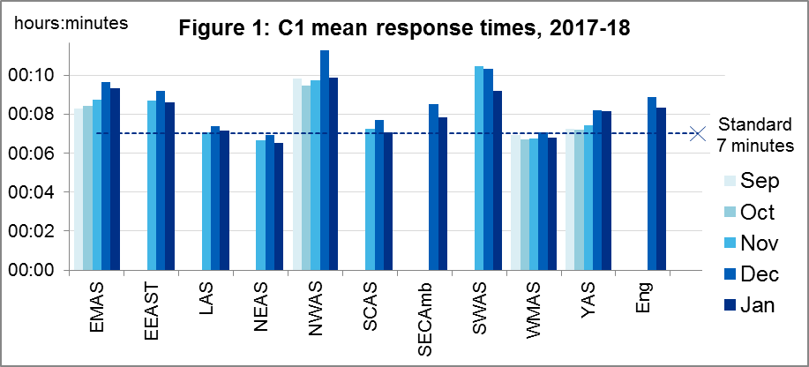
The 90th centile response time for Category C1 (Figure 2) was the only one of the six standards met across England as a whole.
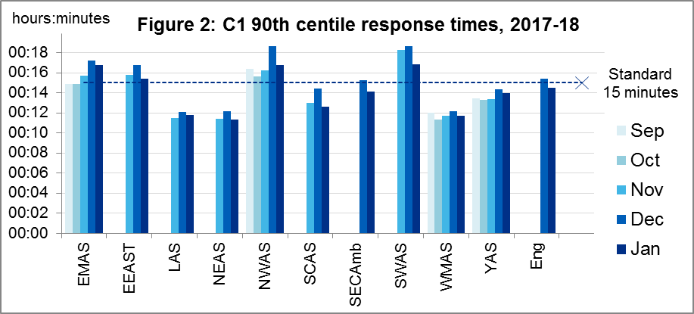
Only South Central (SCAS, 16:30), South East Coast (SECAmb, 16:13) and WMAS (12:22) met the Category C2 mean response time standard of 18 minutes. The same three Services met the 90th centile standard of 40 minutes for C2.
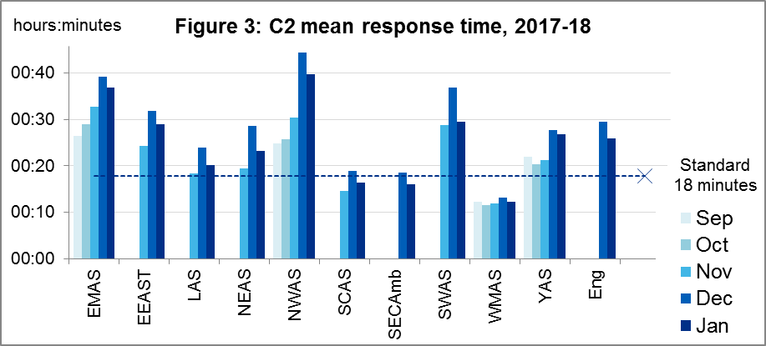
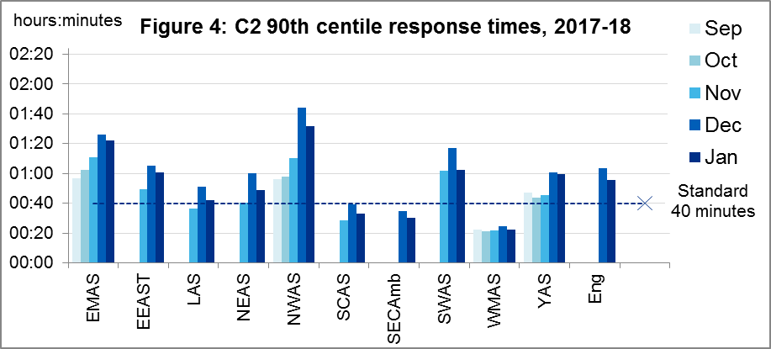
For C2 in January 2018, all ten Services had a response time shorter than in December 2017, but longer than in November 2017 (where available), both for the mean, and for the 90th centile.
For C3 in January 2018, the mean of the 90th centiles across England reduced by nearly 40 minutes from December 2017, yet still only WMAS met the C3 standard of 2 hours.
For C4, East Midlands (EMAS), London (LAS) and WMAS met the 3 hour standard.
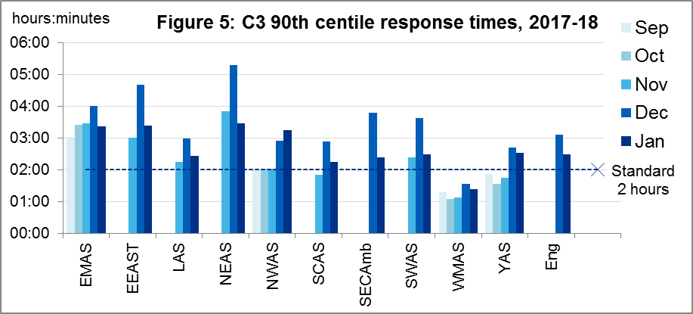
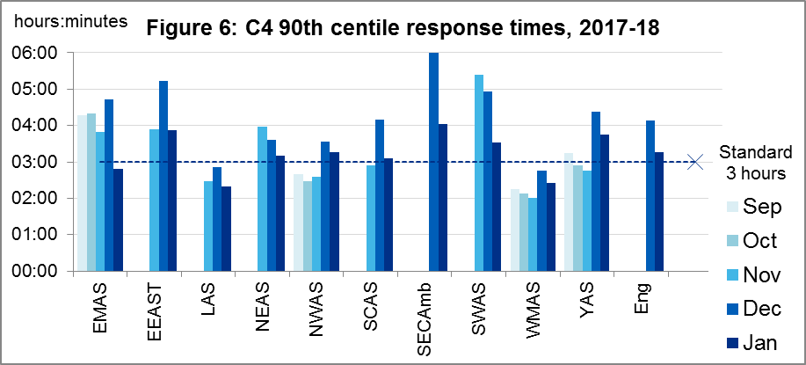

Other new Systems Indicators
In January 2018 there were 23.5 thousand calls to 999 answered per day. Comparing Services who provided data in both months, this was a decrease of 14% on December 2017.
In January 2018 there were 23.0 thousand incidents per day receiving a response from an Ambulance Service in January 2018, a decrease of 5% on December.
In January 2018 there were 13.5 thousand incidents per day where a patient was transported to an Emergency Department, a decrease of 1% on December.
That meant the proportion of incidents where a patient was transported to an Emergency Department increased 2 percentage points on December 2017, to 59%. Other incidents comprised 6% where a patient was transported elsewhere, 30% where patients were attended but not transported, and 6% resolved on the telephone.
The mean average call answer time, comparing Services who provided data in both months, was 46% less in January 2018 than in December 2017.

Clinical Outcomes
As stated in our 9 November 2017 Statistical Note, we continue to publish new Clinical Outcomes data in spreadsheets each month, but only describe them in this Statistical Note once a quarter.

Cardiac arrest: return of spontaneous circulation (ROSC)
Patients in cardiac arrest will typically have no pulse and will not be breathing. Figure 7 shows, of patients for whom resuscitation was commenced or continued by ambulance staff out-of-hospital, how many had ROSC, with a pulse, on arrival at hospital.
Figure 7 shows that during July and August 2017, the proportion of patients with ROSC (dotted line) was stable, with values similar to those in June. In September, 744 of 2,324 such patients had ROSC, or 32%, a significantly higher proportion than the average for the year ending September (29%), and the highest proportion of our time series back to April 2011.
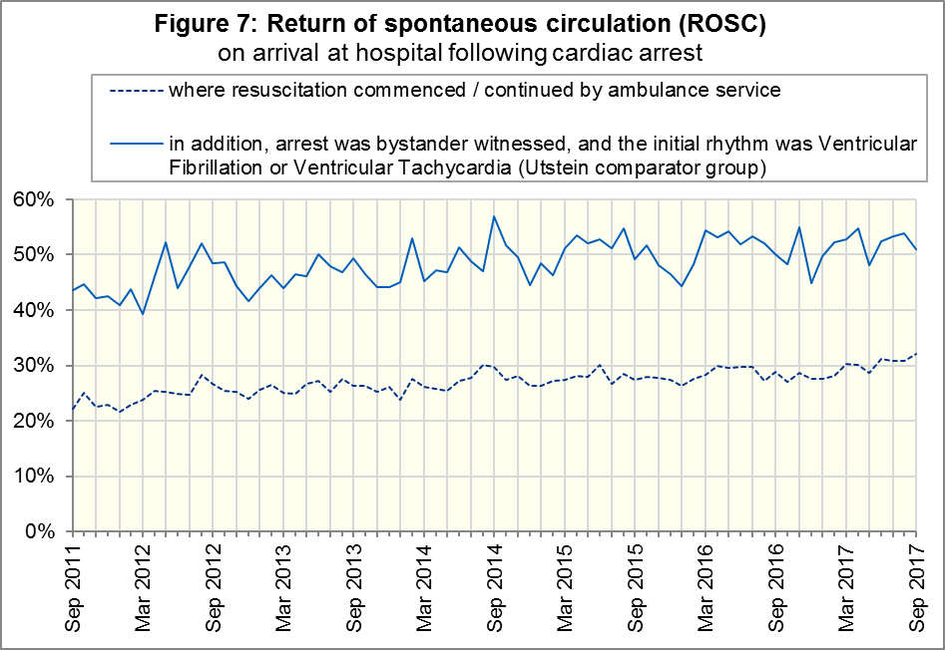
The Utstein comparator group comprises patients who had resuscitation commenced or continued by the Ambulance Services, following an out-of-hospital cardiac arrest of presumed cardiac origin, where the arrest was bystander witnessed, and the initial rhythm was Ventricular Fibrillation or Ventricular Tachycardia. This group therefore have a better chance of survival.
The proportion of these with ROSC was stable in July and August 2017 and, at 176 out of 345 patients (51%) in September, the same proportion as the average for the year ending September.

Cardiac arrest: survival to discharge
Figure 8 shows that the proportion of cardiac arrest patients in England discharged from hospital alive (dotted line) was 10% in July and August 2017. It rose to 11% in September, significantly higher the average proportion of 9% for the year ending September, and the highest proportion since June 2015.
For the Utstein comparator group (solid line), survival to discharge was also stable in July and August before increasing in September, to 33%. This is also the highest proportion of our time series back to April 2011, but due to the small count of patients (332), it is not quite a significant increase upon the average of 28% for the year ending September 2017.
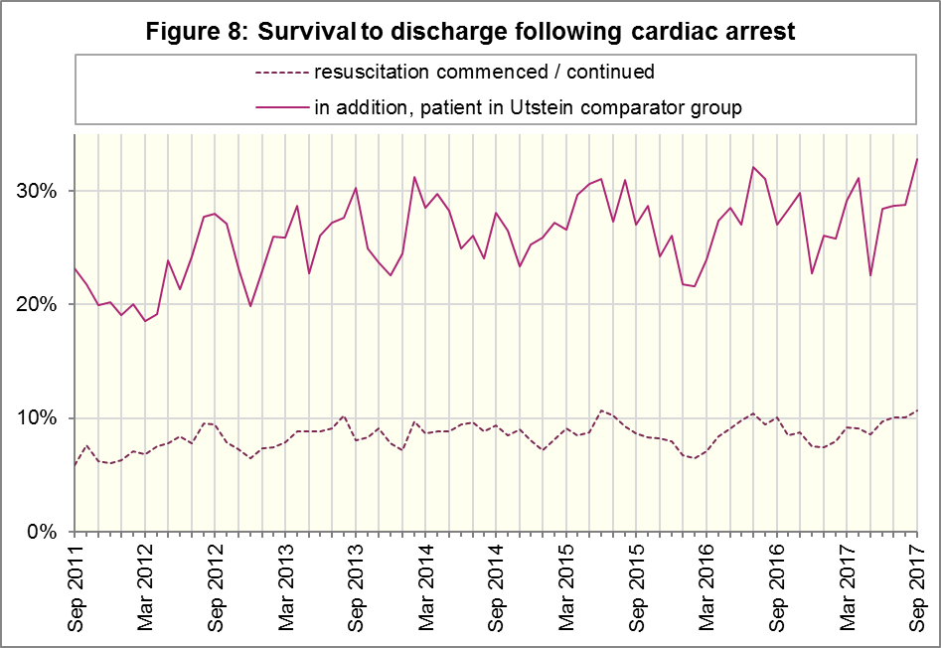

ST-segment elevation myocardial infarction (Figure 9)
ST-segment elevation myocardial infarction (STEMI) is a type of heart attack, determined by an electrocardiogram (ECG) test. Early access to reperfusion, where blocked arteries are opened to re-establish blood flow, and other assessment and care interventions, are associated with reductions in STEMI mortality and morbidity.
Of all patients receiving primary angioplasty, the proportion that received primary angioplasty within 150 minutes across July to September 2017 (dotted line) was similar to the average proportion for the year ending September, 85%.
The proportion of patients with acute STEMI that received an appropriate care bundle (solid line) reduced to 74% in August, the lowest proportion since June 2012, and significantly less than the average for 2016-17 of 79%, although this proportion increased back to 77% in September 2017.
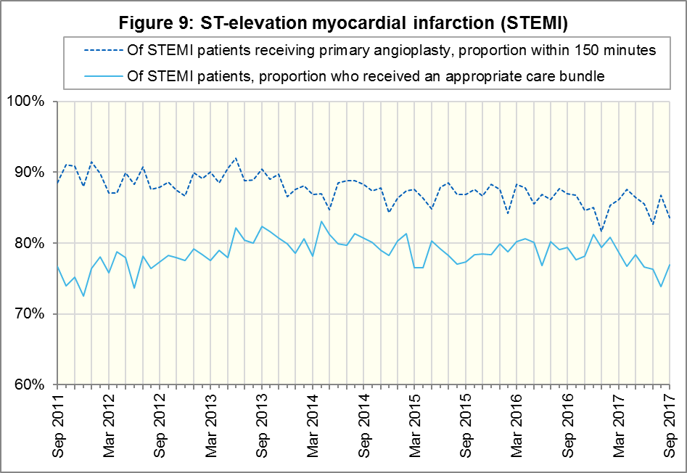

Stroke
The FAST procedure helps assess whether someone has suffered a stroke:
- Facial weakness: can the person smile? Has their mouth or eye drooped?
- Arm weakness: can the person raise both arms?
- Speech problems: can the person speak clearly and understand what you say?
- Time to call 999 for an ambulance if you spot any one of these signs.
Of FAST positive patients in England, assessed face to face, and potentially eligible for stroke thrombolysis within agreed local guidelines, the proportion of those patients that arrived at hospitals with a hyperacute stroke unit within 60 minutes of an emergency call connecting to the ambulance service (solid line) was stable in July and August 2017. However, it decreased to 50% (1877 out of 3757 patients) in September, significantly less than the average for the year ending September. In our time series back to April 2011, only March 2016 had a lower proportion.
Of stroke patients assessed face-to-face, the proportion that received an appropriate care bundle (dotted line) has stayed above 96% since May 2013.
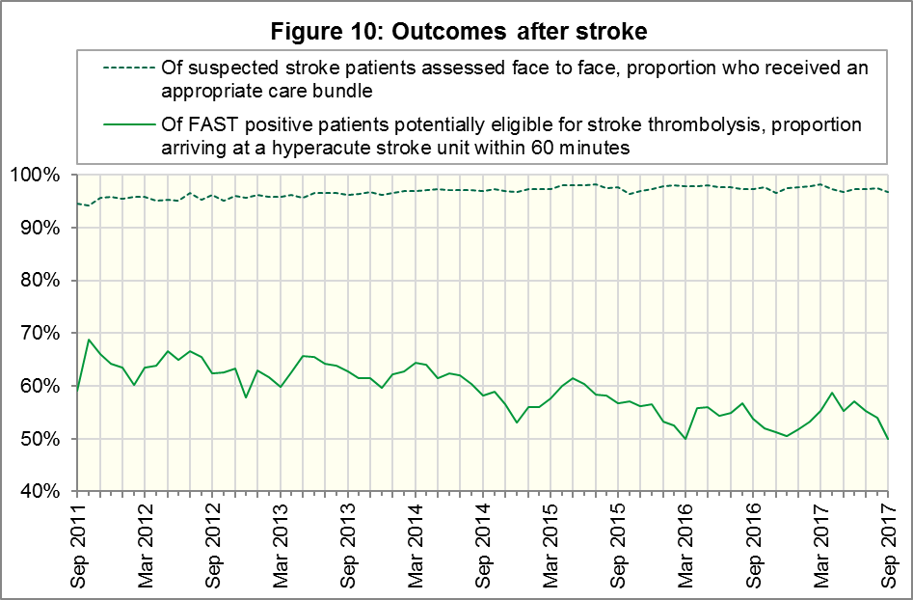

Further information on AQI

The AQI landing page and Quality Statement
www.england.nhs.uk/statistics/statistical-work-areas/ambulance-quality-indicators, or http://bit.ly/NHSAQI, is the AQI landing page, and it holds:
- a Quality Statement for these statistics, which includes information on relevance, accuracy, timeliness, coherence, and user engagement;
- the specification guidance document for those who supply the data;
- timetables for data collection and publication;
- time series spreadsheets and csv files from April 2011 up to the latest month;
- links to individual web pages for each financial year;
- contact details for the responsible statistician (also in 3.6 below).
The web pages for each financial year hold:
- separate spreadsheets of each month’s data;
- this Statistical Note, and equivalent versions from previous months;
- the list of people with pre-release access to the data.
Publication dates are also at www.gov.uk/government/statistics/announcements.

Revisions
We will publish revisions to Clinical Outcomes in March 2018 according to the usual six-monthly cycle.
For Systems Indicators, we published revisions according to a six-monthly cycle until the Ambulance Response Programme (ARP) review of indicators in 2017, when we delayed revisions while Ambulance Services amended their systems to produce the new Indicators. The new indicator set allows Ambulance Services to report data more quickly, but only by reducing the validation checks before data supply. We will work with Ambulance Services to assess the quality of the subsequent data, and plan to publish revisions in April 2018.

AQI Scope
The AQI include calls made by dialling either the usual UK-wide number 999 or its international equivalent 112.
As described in the specification guidance mentioned in section 3.1, calls made to NHS 111 are included in all Systems Indicators except data on contacts and calls, items A0 to A6.

Related statistics in England
A dashboard on the AQI landing page presents an alternative layout for the AQI data. Because of the lack of comparability due to the Ambulance Response Programme (see the 14 December 2017 AQI Statistical Note), NHS England last updated the dashboard in April 2016.
The AQI were also used in the “Ambulance Services” publications by NHS Digital, which included additional annual analysis and commentary, up to and including 2014-15 data. The Quality Statement described in section 3.1 has more information on this publication. The Quality Statement also contains details of weekly ambulance situation reports that NHS England collected for six months from November 2010.
Ambulance handover delays of over 30 minutes at each Emergency Department were published by NHS England for winter 2012-13, 2013-14, 2014-15 and 2017-18: www.england.nhs.uk/statistics/statistical-work-areas/winter-daily-sitreps.

Rest of United Kingdom
Ambulance statistics for other countries of the UK can be found at the following websites. The Quality Statement described in section 3.1 contains more information about the comparability of these statistics.
Wales: | http://wales.gov.uk/statistics-and-research/ambulance-services
Scotland: | See Quality Improvement Indicators (QII) documents at www.scottishambulance.com/TheService/BoardPapers.aspx
Northern Ireland: | www.health-ni.gov.uk/articles/emergency-care-and-ambulance-statistics

Contact information
Press: NHS England press office, nhsengland.media@nhs.net, 0113 825 0958.
The person responsible for producing this publication is:
Ian Kay, Operational Information for Commissioning (Central), NHS England
Room 5E24, Quarry House, Leeds, LS2 7UE; 0113 825 4606; i.kay@nhs.net

National Statistics
The UK Statistics Authority has designated these statistics as National Statistics, in accordance with the Statistics and Registration Service Act 2007 and signifying compliance with the Code of Practice for Official Statistics.
Designation can be broadly interpreted to mean that the statistics:
- meet identified user needs;
- are well explained and readily accessible;
- are produced according to sound methods; and
- are managed impartially and objectively in the public interest.
Once statistics have been designated as National Statistics it is a statutory requirement that the Code of Practice shall continue to be observed.

Ambulance standards are in the September 2017 addendum to the Handbook to the NHS Constitution: www.gov.uk/government/publications/supplements-to-the-nhs-constitution-for-england.
Throughout this publication, for the following Services and months, Systems Indicators are only available for part of the month: North West 7-31 August; West Midlands 9-30 September; South Western 23-30 November inclusive. Isle of Wight continues to use Categories A and C and is missing from all data in Section 1 of this document.
Categories introduced nationwide in 2017: www.england.nhs.uk/urgent-emergency-care/arp
This definition was proposed at Utstein Abbey in Norway by an international group of cardiologists and other health professionals in 1990. http://circ.ahajournals.org/content/110/21/3385
NHS Digital Ambulance Services: https://digital.nhs.uk/search?q=ka34&s=r

