NHS 111 Minimum Data Set, England, January 2018

Latest data
There were 1,481,342 calls offered to the NHS 111 service in England in January 2018 (47.8 thousand per day), an increase of 7.5% on the 1,378,117 calls offered in January 2017 (44.5 thousand per day).

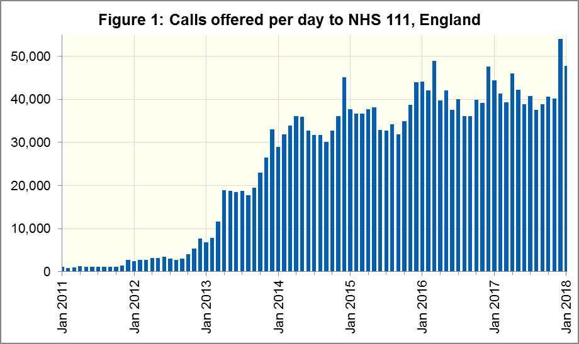

Of calls offered to NHS 111, the proportion abandoned after waiting longer than 30 seconds was 5.1% in January 2018, an increase on January 2017 (2.8%).
In January 2018, of calls answered by NHS 111, 75.5% were answered within 60 seconds, less than in January 2017 (88.1%).
The proportion of calls answered that received any form of clinical input increased in January 2018 to a new high of 39.5%. This proportion has increased every month since it was first collected in November 2016.
14.9% of all calls answered in January 2018 were offered a call back, more than the 13.3% recorded in January 2017 and the largest proportion since August 2010. Of those call backs, 42.0% were made within 10 minutes.
Of calls triaged in January 2018, 13.1% had ambulances dispatched, 8.1% were recommended to attend A&E, 60.2% were recommended to attend primary care, 4.7% were advised to attend another service and 13.8% were not recommended to attend another service. These proportions are different to December 2017, with higher proportions of ambulance dispatches and recommendations to attend A&E but lower proportions of recommendations to attend primary care and other services. They are however, largely in line with trends seen in January 2017.

Contacts
For press enquiries, please contact the NHS England press office on 0113 825 0958 or nhsengland.media@nhs.net.
The individual responsible for these data is:
Ian Kay
0113 825 4606
NHS England, Operational Information for Commissioning (Central)
Room 5E24, Quarry House, Leeds LS2 7UE
i.kay@nhs.net

This data item is an experimental statistic and may change markedly as providers develop their calculation methods. The specification is in data item 5.22 on the guidance document v0.901 at the NHS 111 MDS landing page. More information on experimental statistics is at: www.ons.gov.uk/methodology/methodologytopicsandstatisticalconcepts/guidetoexperimentalstatistics

