Statistical Note: Ambulance Quality Indicators (AQI)
The latest Systems Indicators for February 2018 for Ambulance Services in England showed that one of the six standards in the Handbook to the NHS constitution was met.

Systems Indicators

Response times
Figure 1 shows that February 2018 was the third month when all Ambulance Services in England, apart from Isle of Wight, reported against the new standards.
In February 2018 for Category C1, the most life-threatening incidents, the mean average response time was 8 minutes 16 seconds, 3 seconds less than in January.
However, only North East (NEAS) Ambulance Services met the mean standard of 7 minutes.
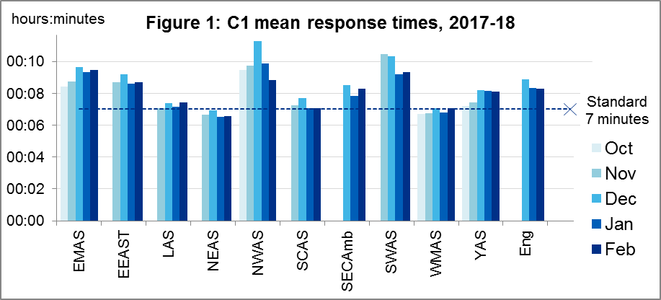
The 90th centile response time standard of 18 minutes for Category C1 (Figure 2) was the only one of the six standards met across England as a whole.
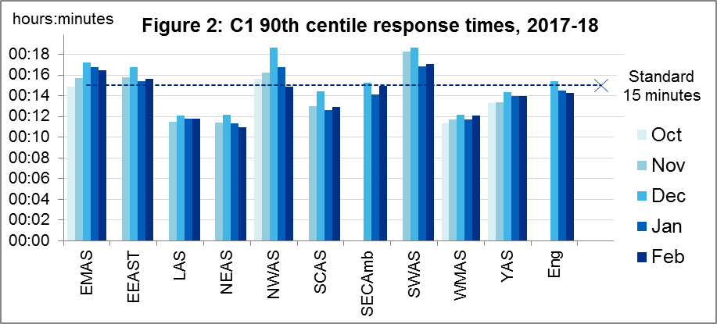
Only South Central (SCAS, 16:16), South East Coast (SECAmb, 17:04) and WMAS (13:14) met the Category C2 mean response time standard (Figure 3). The same three Services met the 90th centile standard of 40 minutes for C2 (Figure 4).
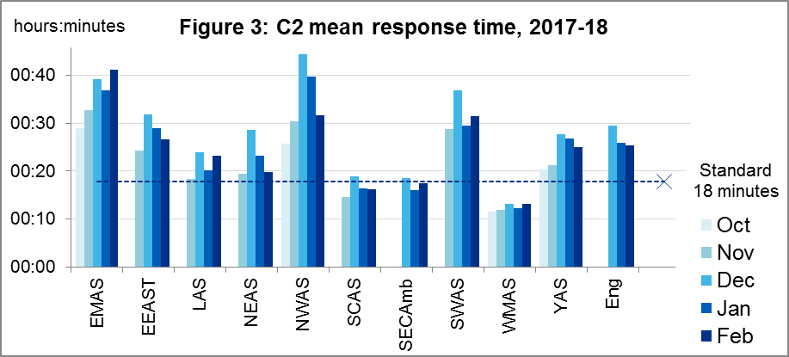
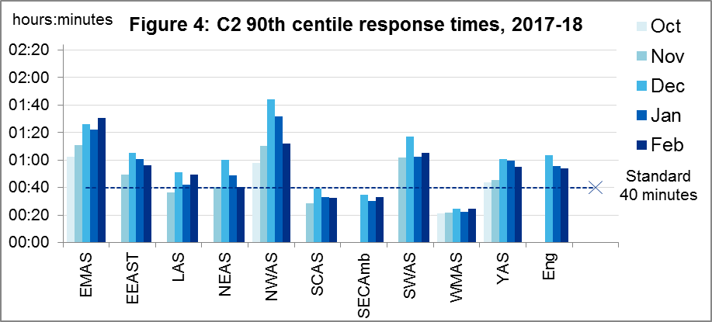
For England as a whole, the mean and 90th centile measures, both for C1 and C2, decreased between January and February 2018. However, for C3 and C4, the 90th centile measures both increased.
As in January, in February only WMAS met the C3 standard of 2 hours, and only East Midlands (EMAS), London (LAS) and WMAS met the C4 standard of 3 hours.
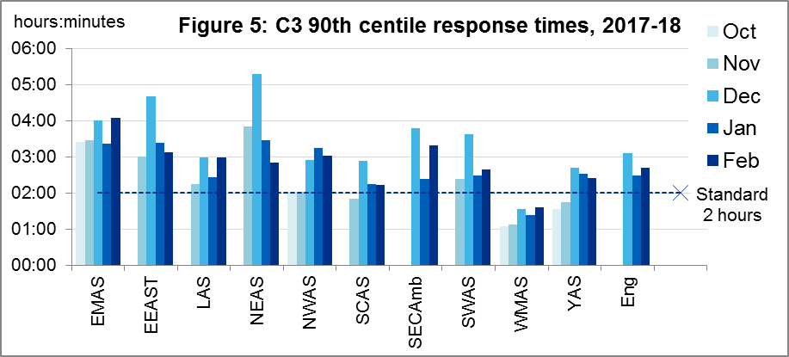
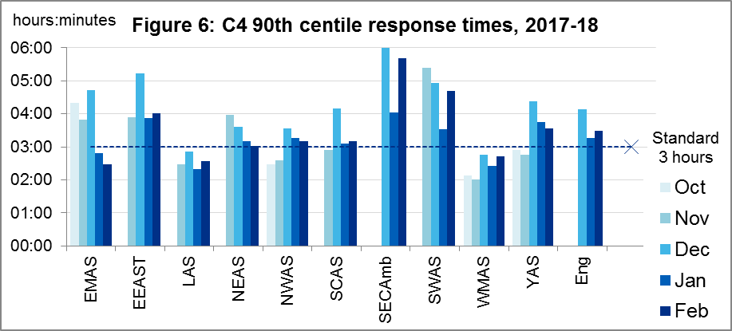

Other new Systems Indicators
In February 2018 there were 24.0 thousand calls to 999 answered per day, an increase of 2% on January. The mean average call answer time increased to 13 seconds from 11 seconds in January.
In February there were 22.5 thousand incidents per day receiving a response from an Ambulance Service, including 13.5 thousand per day where a patient was transported to an Emergency Department. These were decreases of 2% and 1% respectively on January.
The proportion of incidents where a patient was transported to an Emergency Department was therefore 59% in February. Other incidents comprised 6% where a patient was transported elsewhere, 30% where patients were attended but not transported, and 5% resolved on the telephone. These four proportions each changed less than 0.5 percentage points from January.

Clinical Outcomes
We continue to publish new Clinical Outcomes data in spreadsheets each month, but now only describe them in this Statistical Note once a quarter, as we did on 9 November 2017 and 8 February 2018.
However, this month is our scheduled six-monthly release of revisions, for Clinical Outcomes between April and September 2017. NWAS, WMAS and South Western Ambulance Service (SWAS) revised most of their indicators. EMAS revised survival to discharge and STEMI data, and LAS revised survival to discharge data. The largest revisions are listed in section 2.4.

Cardiac arrest
Patients in cardiac arrest will typically have no pulse and will not be breathing. Figure 7 shows, of patients for whom resuscitation was commenced or continued by ambulance staff out-of-hospital, how many had return of spontaneous circulation (ROSC), with a pulse, on arrival at hospital; and that the revisions to this data were very small.
The Utstein comparator group comprises patients who had resuscitation commenced or continued by the Ambulance Services, following an out-of-hospital cardiac arrest of presumed cardiac origin, where the arrest was bystander witnessed, and the initial rhythm was Ventricular Fibrillation or Ventricular Tachycardia. This group therefore have a better chance of survival.
Figure 8 shows these revisions were less than 1 percentage point at England level.

Figure 7: ROSC after cardiac arrest, 2017/18 (all)

Figure 8: ROSC after cardiac arrest, 2017/18 (Utstein comparator group)
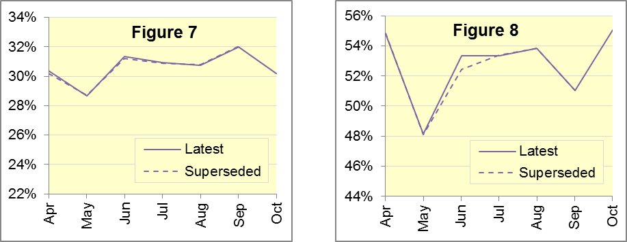

Survival to discharge data are shown in Figure 9, for all patients, and in Figure 10, for the Utstein sub-group. The revisions in Figure 10 for May, June and July are the only revisions at England level to any Clinical Outcomes in today’s publication that are more than one percentage point.

Figure 9: Survival to discharge after cardiac arrest, 2017/18 (all)

Figure 10: Survival to discharge after cardiac arrest, 2017/18 (Utstein)
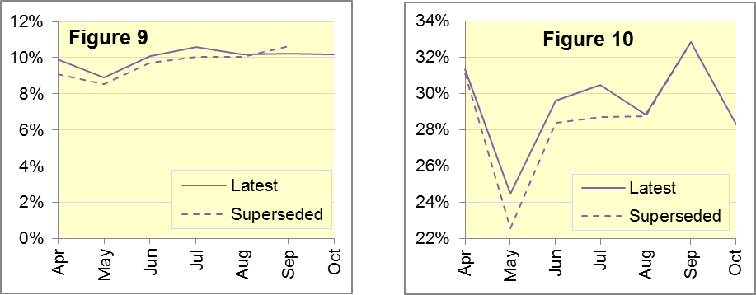

ST-segment elevation myocardial infarction
ST-segment elevation myocardial infarction (STEMI) is a type of heart attack, determined by an electrocardiogram (ECG) test. Early access to reperfusion, where blocked arteries are opened to re-establish blood flow, and other assessment and care interventions, are associated with reductions in STEMI mortality and morbidity.
Of all patients receiving primary angioplasty, the proportions that received primary angioplasty within 150 minutes are in Figure 11. Figure 12 shows the proportion of patients with acute STEMI that received an appropriate care bundle. At England level, all revisions to these are 0.2 percentage points or less.

Figure 11: Angioplasty within 150 minutes of STEMI, 2017/18

Figure 12: STEMI patients receiving appropriate care bundle, 2017/18
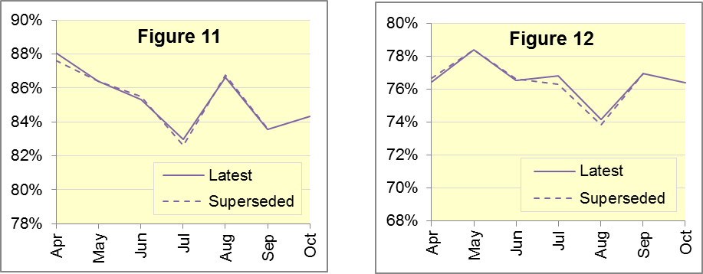

Stroke
The FAST procedure helps assess whether someone has suffered a stroke:
- Facial weakness: can the person smile? Has their mouth or eye drooped?
- Arm weakness: can the person raise both arms?
- Speech problems: can the person speak clearly and understand what you say?
- Time to call 999 for an ambulance if you spot any one of these signs.
Of FAST positive patients in England, assessed face to face, and potentially eligible for stroke thrombolysis within agreed local guidelines, the proportions of those patients that arrived at hospitals with a hyperacute stroke unit within 60 minutes of an emergency call connecting to the ambulance service are in Figure 13. Revisions are all less than 0.2 percentage points.
Figure 14 shows, of stroke patients assessed face-to-face, the proportion that received an appropriate care bundle. These revisions are even smaller.

Figure 13: Thrombolysis within 60 minutes of stroke, 2017/18

Figure 14: Stroke patients receiving appropriate care bundle, 2017/18
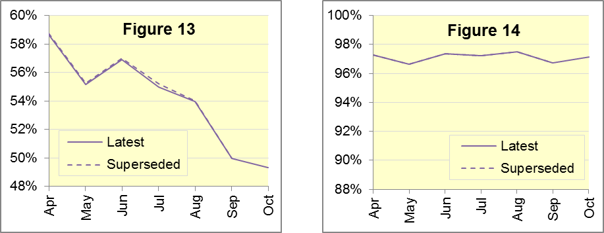

Revisions of more than 5 percentage points to Trust-level data

Figure 23: Revisions of at least one % point to England monthly data
Indicator | Month |  | From |  | To
Survival following cardiac arrest (Utstein) | May |  | 22.6% |  | 24.5%
 | June | 28.4% |  | 29.6%
 | July | 28.7% |  | 30.5%

Figure 24: Revisions of at least five % points to Trust-level monthly data
Trust | Indicator | Month | From | To
LAS | Survival following cardiac arrest (Utstein) | May | 20.0% | 25.0%
NWAS | Angioplasty within 150 minutes of STEMI | Apr | 76.5% | 84.3%
 | Survival following cardiac arrest (Utstein) | Jun | 15.0% | 20.0%
 |  | Jul | 11.1% | 21.2%
SWAS | Survival following cardiac arrest (Utstein) | May | 12.8% | 20.5%

Further information on AQI

The AQI landing page and Quality Statement
www.england.nhs.uk/statistics/statistical-work-areas/ambulance-quality-indicators, or http://bit.ly/NHSAQI, is the AQI landing page, and it holds:
- a Quality Statement for these statistics, which includes information on relevance, accuracy, timeliness, coherence, and user engagement;
- the specification guidance document for those who supply the data;
- timetables for data collection and publication;
- time series spreadsheets and csv files from April 2011 up to the latest month;
- links to individual web pages for each financial year;
- contact details for the responsible statistician (also in 3.6 below).
The web pages for each financial year hold:
- separate spreadsheets of each month’s data;
- this Statistical Note, and equivalent versions from previous months;
- the list of people with pre-release access to the data.
Publication dates are also at www.gov.uk/government/statistics/announcements.

Revisions
For Systems Indicators, we published revisions according to a six-monthly cycle until the Ambulance Response Programme (ARP) review of indicators in 2017, when we delayed revisions while Ambulance Services amended their systems to produce the new Indicators. The new indicator set allows Ambulance Services to report data more quickly, but only by reducing the validation checks before data supply. We will work with Ambulance Services to assess the quality of the subsequent data, and plan to publish revisions in April 2018.
A full history of AQI revisions was in the 14 December 2017 Statistical Note.

AQI Scope
The AQI include calls made by dialling either the usual UK-wide number 999 or its international equivalent 112.
As described in the specification guidance mentioned in section 3.1, calls made to NHS 111 are included in all Systems Indicators except data on contacts and calls, items A0 to A6.

Related statistics in England
A dashboard on the AQI landing page presents an alternative layout for the AQI data. Because of the lack of comparability due to the Ambulance Response Programme (see the 14 December 2017 AQI Statistical Note), NHS England last updated the dashboard in April 2016.

The AQI were also used in the “Ambulance Services” publications by NHS Digital, which included additional annual analysis and commentary, up to and including 2014-15 data. The Quality Statement described in section 3.1 has more information on this publication. The Quality Statement also contains details of weekly ambulance situation reports that NHS England collected for six months from November 2010.
Ambulance handover delays of over 30 minutes at each Emergency Department were published by NHS England for winter 2012-13, 2013-14, 2014-15 and 2017-18: www.england.nhs.uk/statistics/statistical-work-areas/winter-daily-sitreps.

Rest of United Kingdom
Ambulance statistics for other countries of the UK can be found at the following websites. The Quality Statement described in section 3.1 contains more information about the comparability of these statistics.
Wales: | http://wales.gov.uk/statistics-and-research/ambulance-services
Scotland: | See Quality Improvement Indicators (QII) documents at www.scottishambulance.com/TheService/BoardPapers.aspx
Northern Ireland: | www.health-ni.gov.uk/articles/emergency-care-and-ambulance-statistics

Contact information
Media: NHS England Media Relations, nhsengland.media@nhs.net, 0113 825 0958.
The person responsible for producing this publication is:
Ian Kay, Operational Information for Commissioning (Central), NHS England
Room 5E24, Quarry House, Leeds, LS2 7UE; 0113 825 4606; i.kay@nhs.net

National Statistics
The UK Statistics Authority has designated these statistics as National Statistics, in accordance with the Statistics and Registration Service Act 2007 and signifying compliance with the Code of Practice for Official Statistics.
Designation can be broadly interpreted to mean that the statistics:
- meet identified user needs;
- are well explained and readily accessible;
- are produced according to sound methods; and
- are managed impartially and objectively in the public interest.
Once statistics have been designated as National Statistics it is a statutory requirement that the Code of Practice shall continue to be observed.

Ambulance standards are in the September 2017 addendum to the Handbook to the NHS Constitution: www.gov.uk/government/publications/supplements-to-the-nhs-constitution-for-england.
Throughout this publication, for the following Services and months, Systems Indicators are only available for part of the month: North West 7-31 August; West Midlands 9-30 September; South Western 23-30 November inclusive. Isle of Wight continues to use Categories A and C and is excluded from all data in Section 1 of this document.
Categories introduced nationwide in 2017: www.england.nhs.uk/urgent-emergency-care/arp
This definition was proposed at Utstein Abbey in Norway by an international group of cardiologists and other health professionals in 1990. http://circ.ahajournals.org/content/110/21/3385
NHS Digital Ambulance Services: https://digital.nhs.uk/search?q=ka34&s=r

