**NHS Dental Commissioning Statistics for England – March 2018**

Published 1st May 2018 (Quarterly)

**About this release**

This release provides information about the amount of NHS dental activity that has been commissioned for the following year, measured in Units of Dental Activity (UDAs).

The UDAs commissioned are shown for each Local Office in England. There are now 14 Local Offices that commission NHS dental activity.

**87.6 million UDAs were commissioned**

As of 31st March 2018, to be provided between 1st April 2018 and 31st March 2019

* This is a decrease of 16,000 UDAs compared to December 2017, equivalent to a 0.02% decrease.
* It was 876,000 fewer UDAs, or -1.0%, compared to the number of UDAs commissioned at 30th March 2017 to be provided between 1st April 2017 and 30th March 2018.

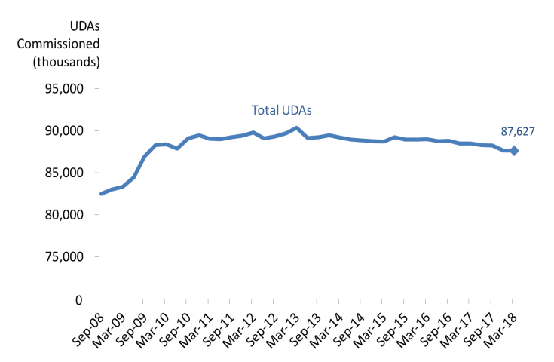

**Key Definitions**

Units of Dental Activity (UDAs) are a measure of the amount of work done during dental treatment. More complex dental treatments count for more UDAs than simpler ones. For example, an examination is 1 UDA, fillings are 3 UDAs, and dentures are 12 UDAs.

‘Up and running UDAs’ refer to UDAs that are in contracts that are already delivering services.

Contracts which are not yet delivering services may be new contracts, where the contract has been signed but the dental activity has not yet started.

**11 of the 14 Local Offices decreased the number of UDAs commissioned compared to a year ago**

* The largest percentage decreases – quarterly (-2.1%) and annually (-7.0%) – were both in Cumbria and North East, due mostly to recent boundary changes within the area.
* At a regional level, The North and Midlands and East regions saw quarterly decreases (-0.5% and -0.3%, respectively). London and South saw an increase in commissioned UDAs, quarterly. All regions saw an annual decrease in commissioned UDAs.

**43,328 UDAs in contracts not yet delivering services**

* The number of UDAs commissioned in contracts which are not yet delivering services increased from 0 in December 2017 to 43,300 in March 2018.



**Responsible Statistician:**

Raza Mohammed Quraishi

**Feedback or queries:** ENGLAND.DEAT@nhs.net

**Next publication:**

August 2018

**Previous publications:** <https://www.england.nhs.uk/statistics/category/statistics/dental-commissioning/>

@NHSEnglandStats

**Changes at National and Commissioning Region level**

**Compared to the previous quarter (December 2017):**

* The total UDAs commissioned in England by the end of March 2018 were lower (-0.02%, which was 16,000 less UDAs).
* London and South had an increase (+0.0% and +0.9%) at regional level. This was a total increase of 202,000 UDAs.
* North had the largest percentage decrease (-0.05%) of all the regions. This was a decrease of 146,000 UDAs.

Table 1 below summarises the changes since last quarter.

*Table 1: Units of Dental Activity Commissioned by* ***Quarterly*** *Change.*

England, Commissioning Regions



*\*The NHS England South region has recently been divided into two regions – the South West and the South East.  Figures are presented here for the old ‘South’ region as we await further clarification on the division of the region and new regional codes.*

**Compared to the previous year (March 2017):**

* The total UDAs commissioned in England by the end of March 2018 was slightly lower (-1.0%, which was 876,000 fewer UDAs).
* All four regions showed a decrease in the number of UDAs commissioned.
* The North had the largest percentage decrease (-1.6%) of all the regions. This was a decrease of 439,000 UDAs.

Table 2 below summarises the changes from last year.

*Table 2: Units of Dental Activity Commissioned by* ***Annual*** *Change.*

England, Commissioning Regions



**Changes at Local Office level**

**Compared to the previous quarter (December 2017):**

* 2 out of the 14 Local Offices showed increases in the number of UDAs commissioned, and 11 showed decreases. 1 Local Office, Lancashire and South Cumbria, showed no change.
* South Central had the greatest percentage increase (1.2%). This was 57,000 more UDAs.
* Cumbria and North East had the largest percentage decrease (-2.1%, or 122,000 fewer UDAs).

**Compared to the previous year (March 2017):**

* 3 of the 14 Local Offices showed increases in the number of UDAs commissioned, whilst 11 showed decreases.
* Lancashire and South Cumbria had the largest percentage increase (12.5%, or 314,000 more UDAs).
* Cumbria and North East had the largest percentage decrease (-7.0%, or 419,000 fewer UDAs).
* These movements, as with the quarterly changes, resulted largely from the boundary changes for Local Offices relating to South Cumbria.

*Table 3: Units of Dental Activity Commissioned, Quarterly and Annual Changes*

England, Local Offices



**Long term quarterly trends (national)**

The data from March 2018 shows that there has been a marginal decrease in the number of UDAs commissioned nationally (-0.02%) compared to the previous quarter (December 2017). In December 2017, there had been a -0.7% decrease.

The largest quarterly increase was back in September 2009 (2.9%) and the largest decrease was in June 2013 (-1.3%).

As Figure 1 below shows, the degree of change from quarter-to-quarter varies in magnitude, however the recent trend is predominantly negative.

*Figure 1: Total UDAs commissioned and percentage change of UDAs Commissioned quarter on quarter.* England, September 2008 to March 2018.

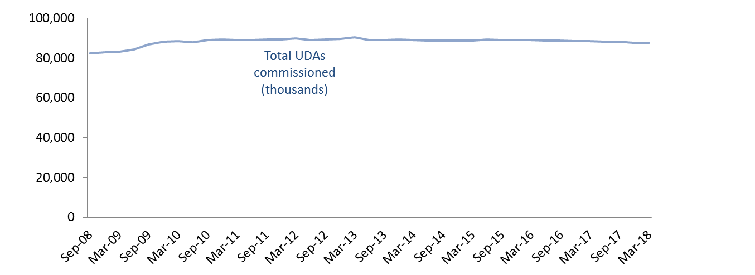

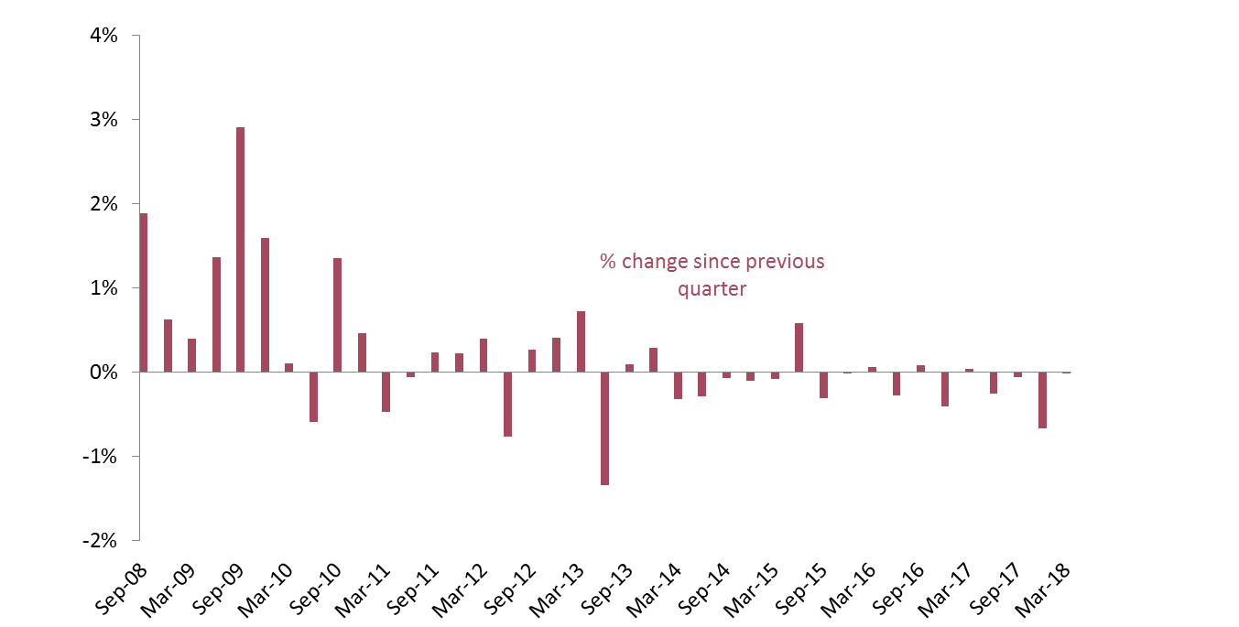

**Long term annual trends (national)**

Fewer UDAs were commissioned nationally from March 2018 compared to a year ago (-1.0%). This annual change was more than that registered in December 2017 (-0.02%).

For each quarter between June 2008 and June 2010, the total number of UDAs commissioned was at least 3.0% higher than at the same time 12 months earlier. The annual percentage change has been between a 1.3% increase and 1.3% decrease from December 2010 onwards.

The most recent data represent the eighth consecutive quarter seeing a year on year decrease. Against an increasing number of patients being seen, this emerging trend might indicate a decrease in treatment intensity based on improving oral health across the population.

*Figure 2: 12 month moving average for Total UDAs commissioned and percentage change of UDAs commissioned year on year.* England, September 2008 to March 2018.

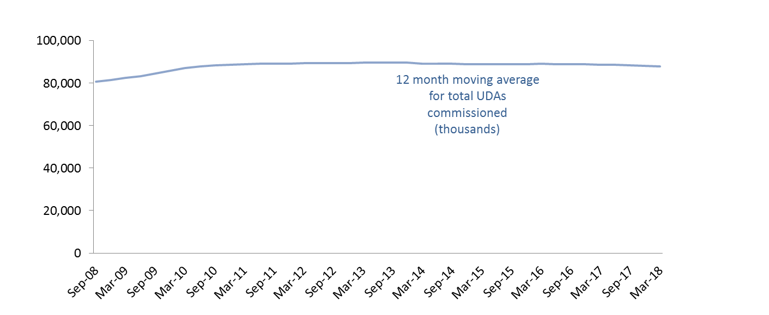

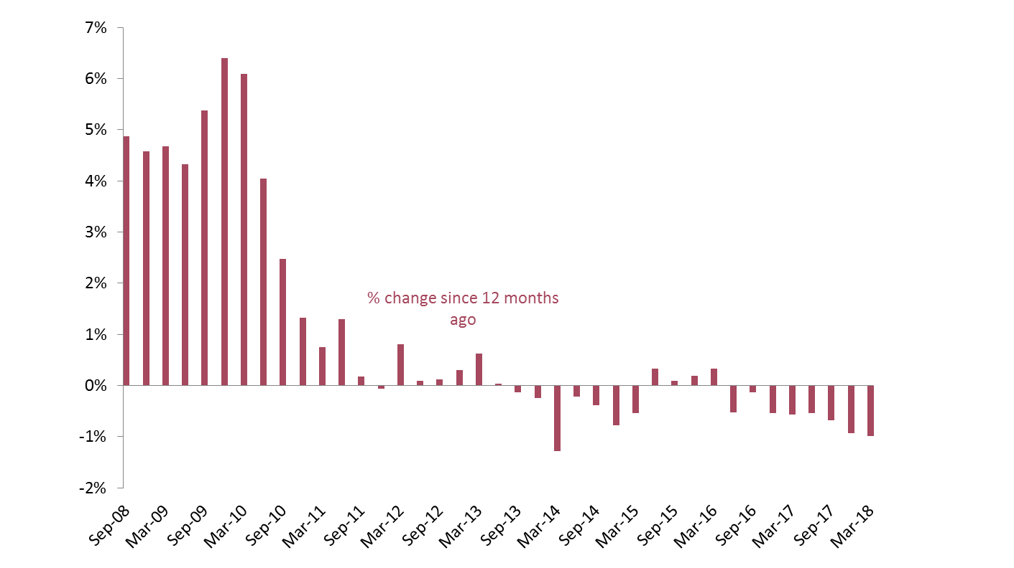

**‘Up and running’ UDAs**

**Over time, the gap between the total number of UDAs commissioned and the ‘up and running’ UDAs has narrowed.** The number of UDAs commissioned in contracts which are not yet delivering services in March 2018 was 43,300, an increase from both the previous quarter December 2017 (0) and from the previous year March 2017 (5,400).

Since March 2011, UDAs commissioned in contracts which are not yet delivering services have represented 1.0% or less of the total UDAs commissioned. The data from December 2017 showed 0 UDAs in contracts not yet providing services.

*Figure 3: Time Series of Units of Dental Activity Commissioned*

England, June 2008 to March 2018.

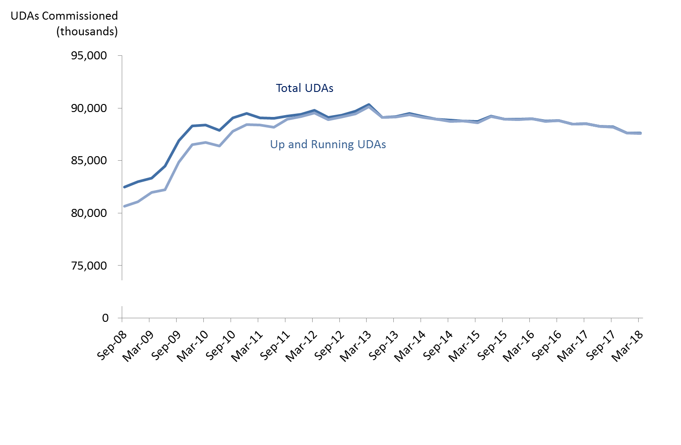**Changes to commissioning strategies**

**The approach to commissioning dental care is evolving.** The Dental Contract Reform programme is testing different models of remunerating dentists that do not rely on UDAs as currently measured. There are also commissioning innovations being trialled in areas where there have historically been issues with access to NHS dental care. This year two Smile4Life initiatives are being progressed to improve NHS dental access and care for young children.

Geographically – in response to political devolution and the Sustainability and Transformation Partnerships emerging in the wider NHS – there have been changes to the coverage of Local Offices and this may evolve further in the coming months and years. Therefore like-for-like comparisons at a regional and area level are becoming less meaningful.

In light of these changes, it is worth noting that ‘commissioned UDAs’ may become a less relevant indicator of commissioning intent across England.

**Annex**

*Table 4: Units of Dental Activity (UDAs) Commissioned*

England, September 2008 to March 2018



*Commissioned UDAs cover contracted UDAs in the next 12 months in GDS and PDS contracts and in VDP arrangements. *This excludes salaried services where there are no contracted UDAs*.