**NHS Dental Commissioning Statistics for England – December 2018**

Published 7th February 2018 (Quarterly)

**About this release**

This release provides information about the amount of NHS dental activity that has been commissioned for the following year, measured in Units of Dental Activity (UDAs).

The UDAs commissioned are shown for each Local Office in England. There are now 14 Local Offices that commission NHS dental activity.

**87.7 million UDAs were commissioned**

as of 31st December 2018, to be provided between 1st January 2019 and 31st December 2019.

* This is a decrease of 226,000 UDAs compared to September 2018, equivalent to a 0.3% decrease.
* It is 103,000 more UDAs, or 0.1% higher, compared to the number of UDAs commissioned at 31st December 2017 to be provided between 1st January 2018 and 31st December 2018.

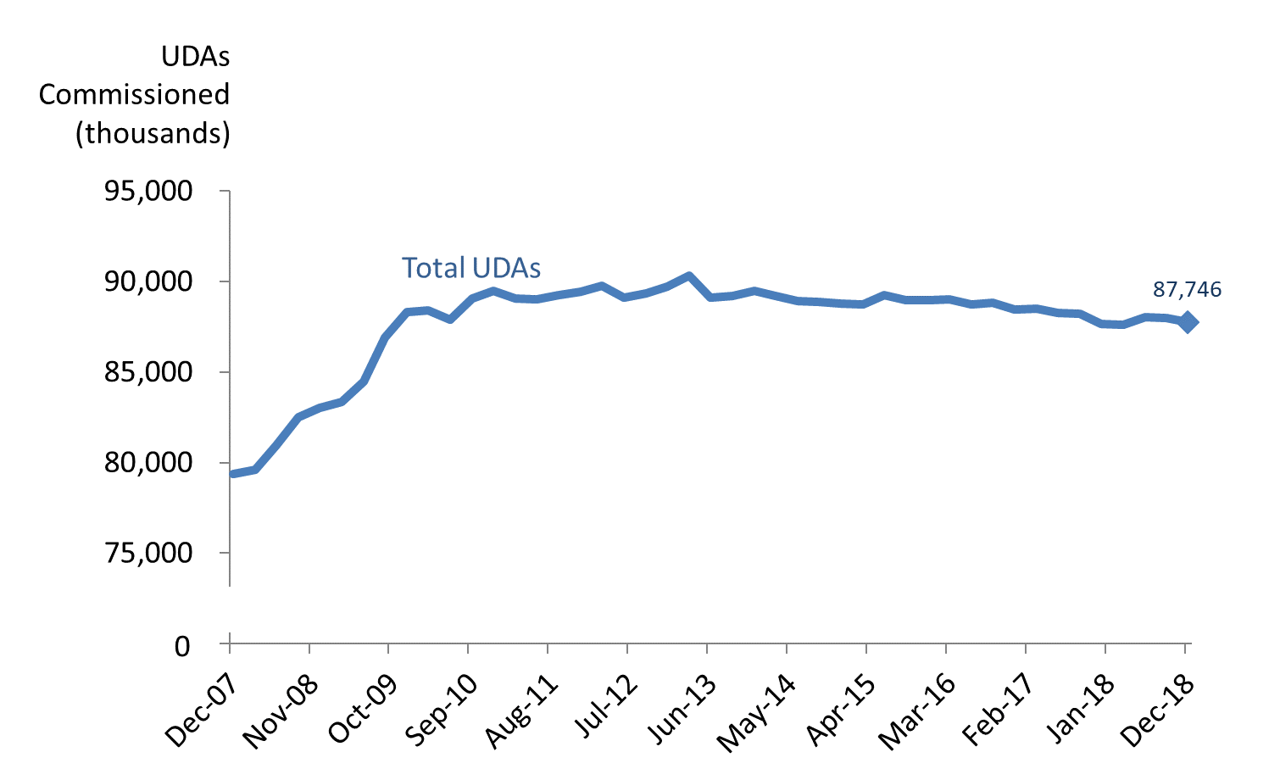

**Key Definitions**

Units of Dental Activity (UDAs) are a measure of the amount of work done during dental treatment. More complex dental treatments count for more UDAs than simpler ones. For example, an examination is 1 UDA, fillings are 3 UDAs, and dentures are 12 UDAs.

‘Up and running UDAs’ refer to UDAs that are in contracts that are already delivering services.

Contracts which are not yet delivering services may be new contracts, where the contract has been signed but the dental activity has not yet started.

**10 of the 14 Local Offices decreased the number of UDAs commissioned compared to a year ago**

* The largest quarterly percentage decreases (-6.7%) was in the South West. The largest annual percentage decrease (-7.4%) was in Cumbria and North East which is mostly due to recent boundary changes within the area.
* At a regional level, the North (0.2%) and Middle and East (0.1%) saw quarterly increases. London saw no change whereas The South saw a quarterly decrease (1.4%) in commissioned UDAs. All regions except South (-1.9%) saw an annual increase in commissioned UDAs.

**180,000 UDAs in contracts not yet delivering services**

* The number of UDAs commissioned in contracts which are not yet delivering services increased from 125,000 in September 2018 to 180,000 in December 2018.



**Responsible Statistician:**

Dominic Woodfine

**Feedback or queries:** ENGLAND.DEAT@nhs.net

**Next publication:**

April 2019

**Previous publications:** <https://www.england.nhs.uk/statistics/category/statistics/dental-commissioning/>

@NHSEnglandStats

**Changes at National and Commissioning Region level**

**Compared to the previous quarter (September 2018):**

* The total UDAs commissioned in England by the end of December 2018 were lower (-0.3%, which was 226,000 fewer UDAs).
* The South had a decrease (-1.4%) at a regional level. This was a total decrease of 297,000 UDAs.
* London remained stable, with a decrease of only 5,000 UDAs.
* The North and Midlands and East had percentage increases (+0.2% and +0.1%) with an increase of 47,000 and 30,000 UDAs, respectively.

*Table 1: Units of Dental Activity Commissioned by* ***Quarterly*** *Change.*

England, Commissioning Regions



**Compared to the previous year (December 2017):**

* The total UDAs commissioned in England by the end of December 2018 was slightly higher (+0.1%, which was 103,000 more UDAs).
* The North, Midlands and East and London regions had an increase (+0.7%, +0.9% and +0.5%) in the number of commissioned UDAs which was an increase of 185,000, 243,000 and 65,000 UDAs, respectively.
* The South had the only percentage decrease (-1.9%) of all the regions. This was a decrease of 389,000 UDAs.

*Table 2: Units of Dental Activity Commissioned by* ***Annual*** *Change.*

England, Commissioning Regions



*\*The former NHS England South region has recently been divided into two regions – the South West and the South East.  Figures are presented here for the old ‘South’ region as commissioners do not currently have access to reporting based on the new division.*

**Changes at Local Office level**

Aligned to the changes to Regional hierarchies within NHS England, there have been corresponding changes to the Local Offices. Commissioners are not currently able to report commissioned activity against the newly defined Local Offices, hence results here are shown for the old definitions of Local Offices.

**Compared to the previous quarter (September 2018):**

* 5 out of the 14 Local Offices showed increases in the number of UDAs commissioned, and 8 showed decreases. Lancashire and South Cumbria showed no change.
* North Midlands had the greatest percentage increase (+3.9%). This was 231,000 more UDAs.
* South West had the largest percentage decrease (-6.7%) which is equivalent to 378,000 fewer UDAs.

**Compared to the previous year (December 2017):**

* 4 of the 14 Local Offices showed increases in the number of UDAs commissioned, whilst 10 showed decreases.
* Lancashire and South Cumbria had the largest percentage increase (+12.5%, or 314,000 more UDAs).
* Cumbria and North East had the largest percentage decrease (-7.4%, or 442,000 fewer UDAs).
* These movements resulted largely from the boundary changes for Local Offices relating to South Cumbria.

*Table 3: Units of Dental Activity Commissioned, Quarterly and Annual Changes*

England, Local Offices



**Long term quarterly trends (national)**

The data from December 2018 shows that there has been a decrease in the number of UDAs commissioned nationally (-0.3%) compared to the previous quarter (September 2018). In September 2018, there had been a decrease of -0.1%.

The largest quarterly increase was back in September 2009 (2.9%) and the largest decrease was in June 2013 (-1.3%).

As Figure 1 below shows, the degree of change from quarter-to-quarter varies in magnitude; however, the recent trend is predominantly negative.

*Figure 1: Total UDAs commissioned and percentage change of UDAs Commissioned quarter on quarter.* England, September 2008 to September 2018.

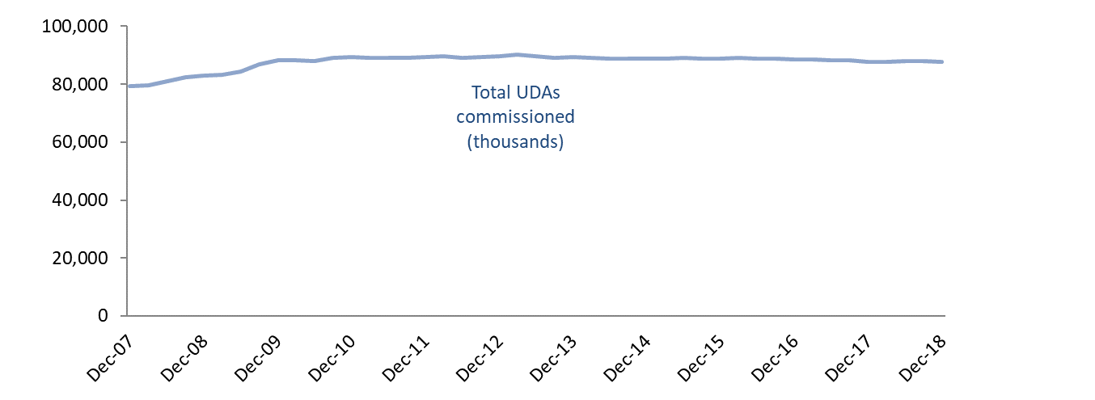

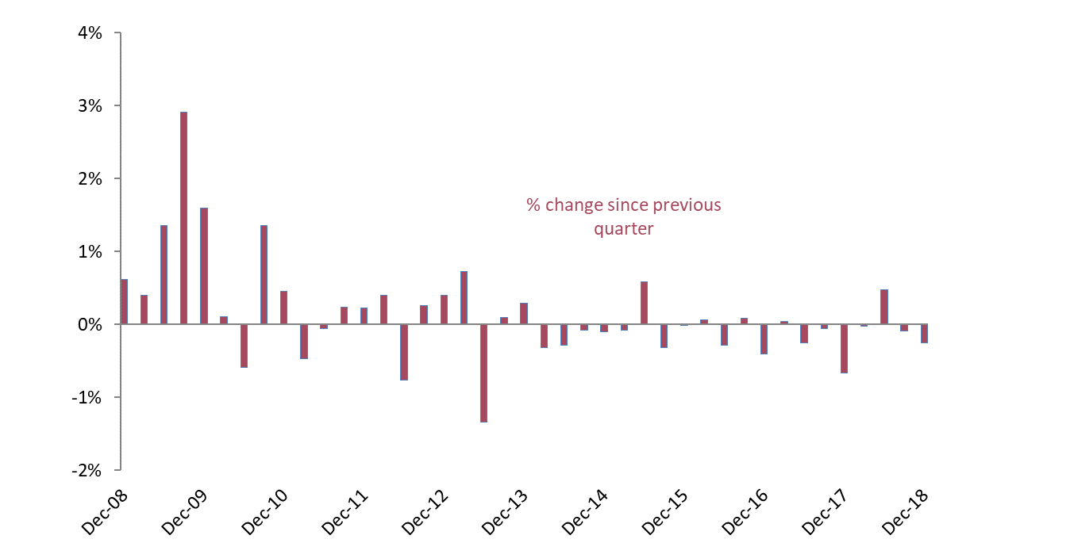

**Long term annual trends (national)**

More UDAs have been commissioned nationally from December 2018 compared to a year ago (+0.1%).

For each quarter between June 2008 and June 2010, the total number of UDAs commissioned was at least 3.0% higher than at the same time 12 months earlier. The annual percentage change has been between a 1.3% increase and 1.3% decrease from December 2010 onwards.

The most recent data represents the first quarter seeing a year on year increase since June 2016. With the number of adult patients being seen plateauing while the number of child patients seen continues to increase, the prevailing trend in commissioned activity might be indicative of changing patterns of delivery. The reducing intensity of treatment is a factor, however financial pressures might also be having an effect in the number of UDAs being commissioned.

*Figure 2: 12 month moving average for Total UDAs commissioned and percentage change of UDAs commissioned year on year.* England, September 2008 to September 2018.

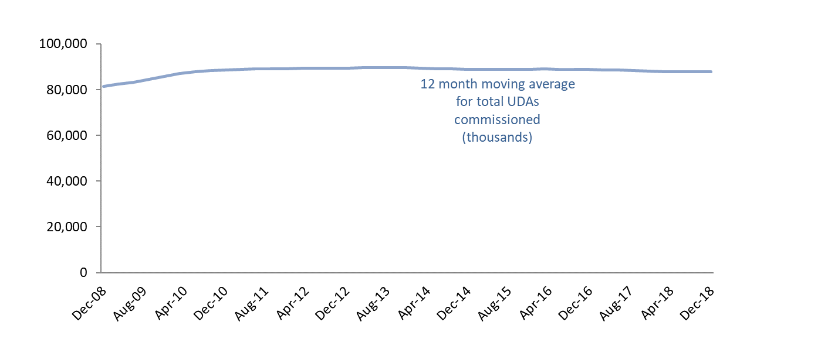

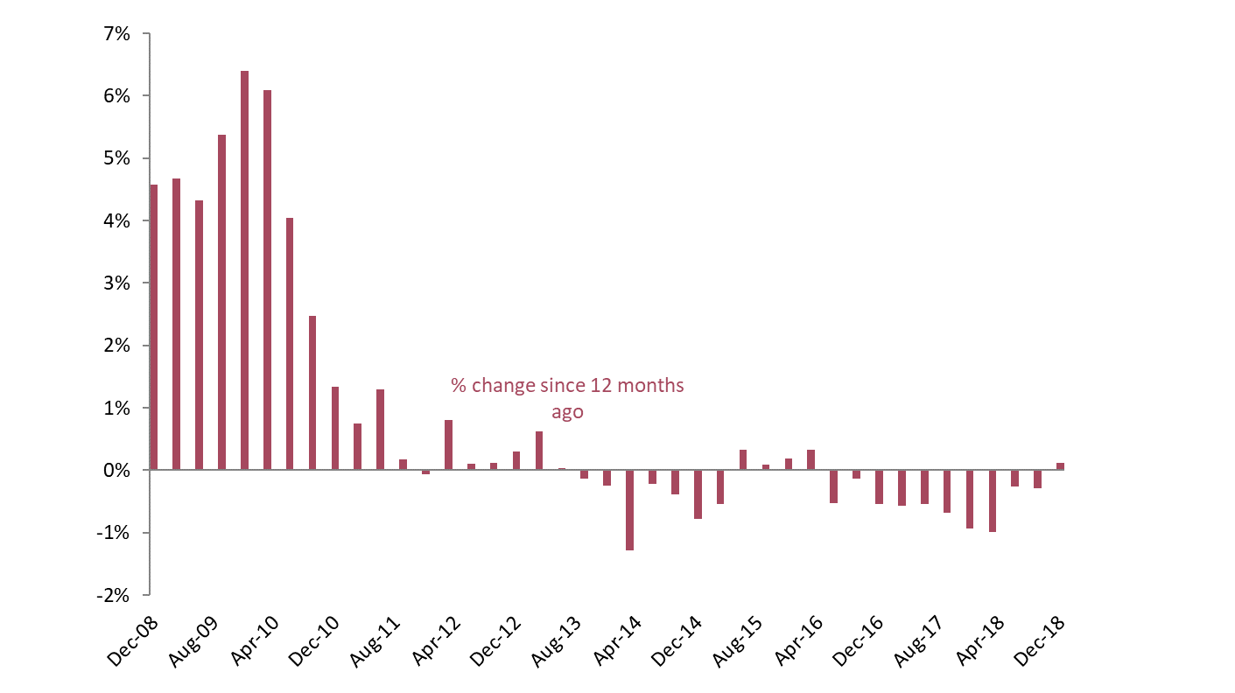

**‘Up and running’ UDAs**

**Over time, the gap between the total number of UDAs commissioned and the ‘up and running’ UDAs has narrowed.** The number of UDAs commissioned in contracts which are not yet delivering services in December 2018 was 180,000, an increase from the previous quarter September 2018 (125,000) as well as from December 2017 which had none.

Since March 2011, UDAs commissioned in contracts which are not yet delivering services have represented 1.0% or less of the total UDAs commissioned.

*Figure 3: Time Series of Units of Dental Activity Commissioned*

England, December 2007 to December 2018.

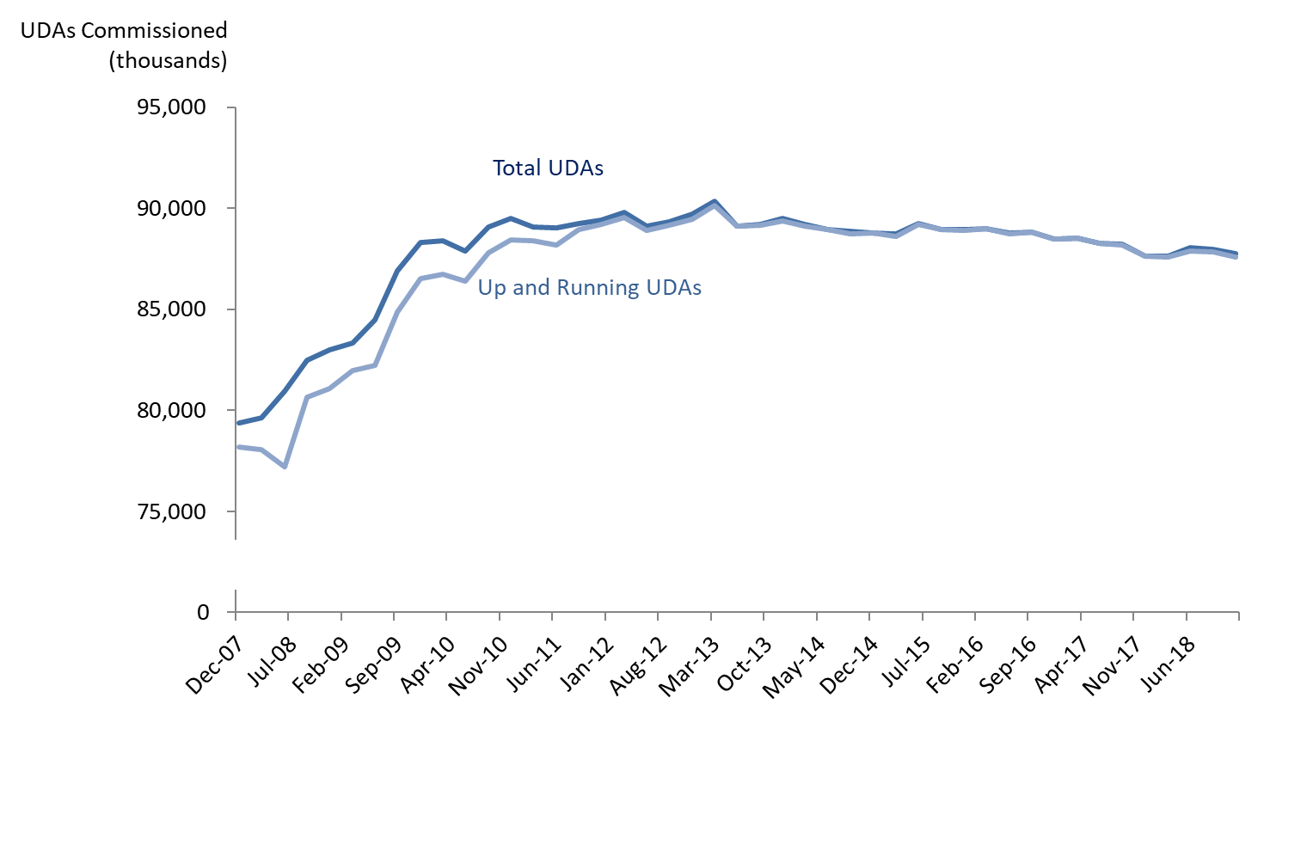**Changes to commissioning strategies**

**The approach to commissioning dental care is evolving.** The Dental Contract Reform programme is testing different models for remunerating dentists that do not rely on UDAs as currently measured. There are also commissioning innovations being trialled in areas where there have historically been issues with access to NHS dental care. This year two Smile4Life initiatives are being progressed to improve NHS dental access and care for young children.

Geographically – in response to political devolution and the Sustainability and Transformation Partnerships emerging in the wider NHS – there have been changes to the coverage of Local Offices and this may evolve further in the coming months and years. Therefore like-for-like comparisons at a regional and area level are becoming less meaningful.

In light of these changes, it is worth noting that ‘commissioned UDAs’ may become a less relevant indicator of commissioning intent across England.

**Annex**

*Table 4: Units of Dental Activity (UDAs) Commissioned*

England, December 2008 to December 2018



*Commissioned UDAs cover contracted UDAs in the next 12 months in GDS and PDS contracts and in VDP arrangements. *This excludes salaried services where there are no contracted UDAs*.