**NHS Dental Commissioning Statistics for England – June 2019**

Published 1st July 2019 (Quarterly)

**About this release**

This release provides information about the amount of NHS dental activity that has been commissioned for the following year, measured in Units of Dental Activity (UDAs).

The UDAs commissioned are shown for each Local Office in England. There are now 14 Local Offices that commission NHS dental activity.

**87.3 million UDAs were commissioned**

as of 30th June 2019, to be provided between 1st July 2019 and 30th June 2020.

* This is a decrease of 306,000 UDAs compared to March 2019, equivalent to a 0.3% decrease.
* It is 804,000 fewer UDAs, or 0.8% lower, compared to the number of UDAs commissioned at 30th June 2018 to be provided between 1st July 2018 and 30th June 2019.

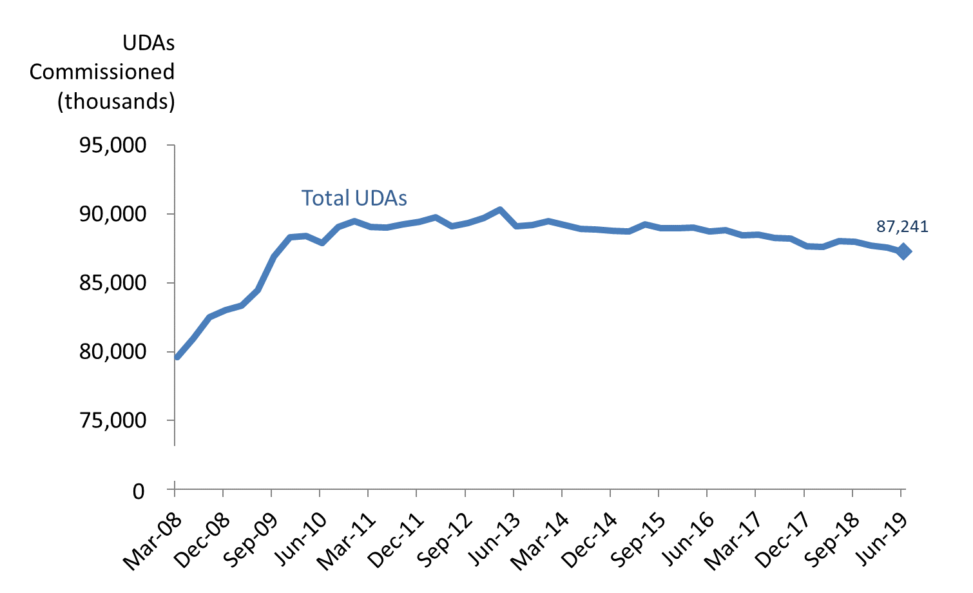

**Key Definitions**

Units of Dental Activity (UDAs) are a measure of the amount of work done during dental treatment. More complex dental treatments count for more UDAs than simpler ones. For example, an examination is 1 UDA, fillings are 3 UDAs, and dentures are 12 UDAs.

‘Up and running UDAs’ refer to UDAs that are in contracts that are already delivering services.

Contracts which are not yet delivering services may be new contracts, where the contract has been signed but the dental activity has not yet started.

**11 of the 14 Local Offices decreased the number of UDAs commissioned compared to a year ago**

* The largest quarterly percentage decrease (-2.9%) was in the North Midlands. The largest annual percentage decrease (-3.4%) was also in the North Midlands.
* At a regional level, the North (-0.2%), Midlands and East (-0.9%) and London (-0.6%) saw a quarterly decrease. The South saw a quarterly increase (+0.6%) in commissioned UDAs.

**192,000 UDAs in contracts not yet delivering services**

* The number of UDAs commissioned in contracts which are not yet delivering services was at 180,000 between December 2018 to March 2019 and rose to 192,000 at June 2019.



**Responsible Statistician:**

Raza Quraishi

**Feedback or queries:** [raza.quraishi@nhs.net](mailto:dominic.woodfine@nhs.net)

**Next publication:**

October 2019

**Previous publications:** <https://www.england.nhs.uk/statistics/category/statistics/dental-commissioning/>

@NHSEnglandStats

**Changes at National and Commissioning Region level**

**Compared to the previous quarter (March 2019):**

* The total UDAs commissioned in England by the end of June 2019 were lower (-0.3%, which was 247,000 fewer UDAs).
* The South had an increase (+0.6%) at a regional level. This was a total increase of 120,000 UDAs.
* The North, Midlands and East and London, had percentage decreases (-0.2%, -0.9% and -0.6%) with a decrease of 42,000, 244,000 and 80,000 UDAs, respectively.

*Table 1: Units of Dental Activity Commissioned by* ***Quarterly*** *Change.*

England, Commissioning Regions*



**Compared to the previous year (June 2019):**

* The total UDAs commissioned in England by the end of June 2018 was lower (-0.8%, which was 745,000 fewer UDAs).
* The North region had an increase (+0.1%) in the number of commissioned UDAs which was an increase of 26,000.
* Midlands and East, London and South regions had a percentage decrease (-1.5%, -0.7% and -1.3%). This was a decrease of 409,000, 86,000 and 277,00 UDAs, respectively.

*Table 2: Units of Dental Activity Commissioned by* ***Annual*** *Change.*

England, Commissioning Regions*



*\*The former NHS England South region has recently been divided into two regions – the South West and the South East.  Figures are presented here for the old ‘South’ region as commissioners do not currently have access to reporting based on the new division.*

**Changes at Local Office level**

Aligned to the changes to Regional hierarchies within NHS England, there have been corresponding changes to the Local Offices. Commissioners are not currently able to report commissioned activity against the newly defined Local Offices, hence results here are shown for the old definitions of Local Offices.

**Compared to the previous quarter (March 2019):**

* 5 out of the 14 Local Offices showed increases in the number of UDAs commissioned, and 8 showed decreases.
* South West had the greatest percentage increase (+2.7%). This was 143,000 more UDAs.
* North Midlands had the largest percentage decrease (-2.9%) which is equivalent to 178,000 fewer UDAs.

**Compared to the previous year (June 2018):**

* 3 of the 14 Local Offices showed increases in the number of UDAs commissioned, whilst 11 showed decreases.
* Greater Manchester had the largest percentage increase (+1.1%, or 56,000 more UDAs).
* North Midlands had the largest percentage decrease (-3.4%, or 210,000 fewer UDAs).

*Table 3: Units of Dental Activity Commissioned, Quarterly and Annual Changes*

England, Local Offices*



**Long term quarterly trends (national)**

The data from June 2019 shows that there has been a decrease in the number of UDAs commissioned nationally (-0.3%) compared to the previous quarter (March 2019). In March 2019, there had been a decrease of -0.2%.

The largest quarterly increase was back in September 2009 (2.9%) and the largest decrease was in June 2013 (-1.3%).

As Figure 1 below shows, the degree of change from quarter-to-quarter varies in magnitude; however, the recent trend is predominantly negative.

*Figure 1: Total UDAs commissioned and percentage change of UDAs Commissioned quarter on quarter.* England, March 2008 to June 2019.*

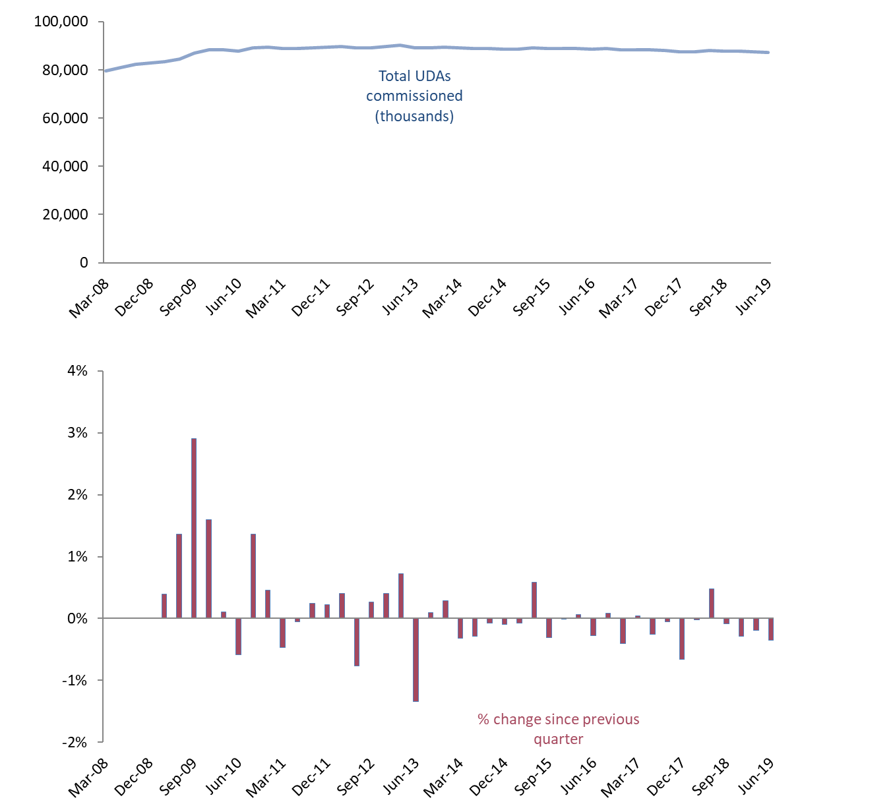

**Long term annual trends (national)**

Fewer UDAs have been commissioned nationally from June 2019 compared to a year ago (-0.8%).

For each quarter between June 2008 and June 2010, the total number of UDAs commissioned was at least 3.0% higher than at the same time 12 months earlier. The annual percentage change has been between a 1.3% increase and 1.3% decrease from December 2010 onwards.

With the number of adult patients being seen plateauing while the number of child patients seen continues to increase, the prevailing trends in commissioned activity might be indicative of changing patterns of delivery. The reducing intensity of treatment is a factor, however financial pressures might also be having an effect in the number of UDAs being commissioned.

*Figure 2: 12 month moving average for Total UDAs commissioned and percentage change of UDAs commissioned year on year.* England, March 2008 to June 2019.*

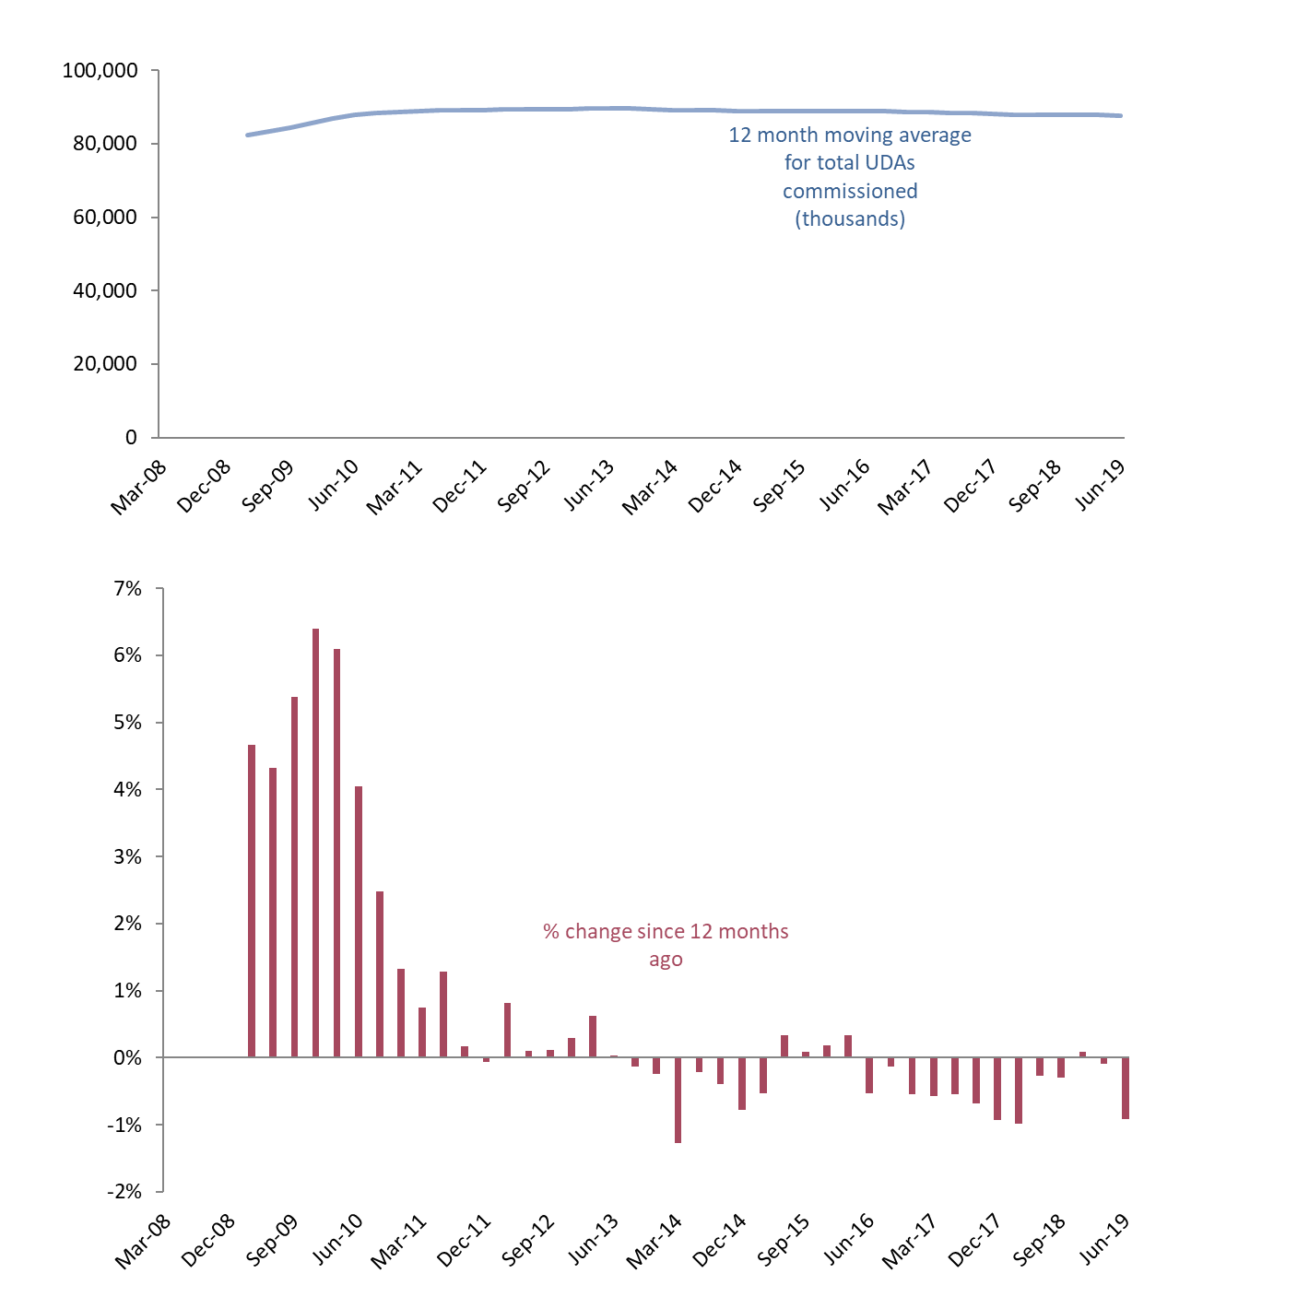

**‘Up and running’ UDAs**

**Over time, the gap between the total number of UDAs commissioned and the ‘up and running’ UDAs has narrowed.** The number of UDAs commissioned in contracts which are not yet delivering services in June 2019 was 192,000, an increase on the previous quarter March 2019 (180,000) and June 2018 (155,000).

Since March 2011, UDAs commissioned in contracts which are not yet delivering services have represented 1.0% or less of the total UDAs commissioned.

*Figure 3: Time Series of Units of Dental Activity Commissioned*

England, March 2008 to June 2019.*

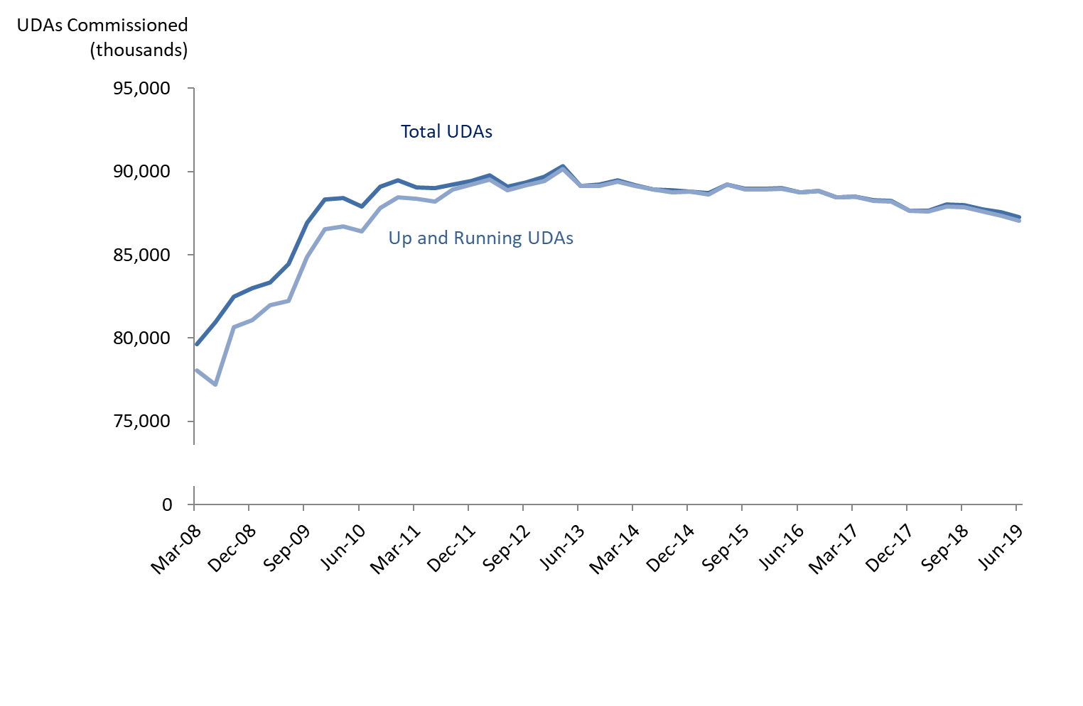**Changes to commissioning strategies**

**The approach to commissioning dental care is evolving.** The Dental Contract Reform programme is testing different models for remunerating dentists that do not rely on UDAs as currently measured. There are also commissioning innovations being trialled in areas where there have historically been issues with access to NHS dental care. This year two Smile4Life initiatives are being progressed to improve NHS dental access and care for young children.

Geographically – in response to political devolution and the Sustainability and Transformation Partnerships emerging in the wider NHS – there have been changes to the coverage of Local Offices and this may evolve further in the coming months and years. Therefore like-for-like comparisons at a regional and area level are becoming less meaningful.

In light of these changes, it is worth noting that ‘commissioned UDAs’ may become a less relevant indicator of commissioning intent across England.

**Annex**

*Table 4: Units of Dental Activity (UDAs) Commissioned*

England, December 2008 to March 2019*



*Commissioned UDAs cover contracted UDAs in the next 12 months in GDS and PDS contracts and in VDP arrangements. *This excludes salaried services where there are no contracted UDAs*.