STATISTICAL PRESS NOTICE
MIXED-SEX ACCOMMODATION BREACH DATA
February 2025

Main Points

- This notice presents data on all breaches of the Mixed-Sex Accommodation (MSA) guidance (i.e. occurrences of unjustified mixing) relating to English NHS-funded providers of healthcare hospital sleeping accommodation during February 2025.
- In February 2025, providers of NHS-funded healthcare reported 4,371 breaches of the MSA guidance in relation to NHS patients in sleeping accommodation in England. This compares to 4,929 in February 2020 (the same month pre-Covid-19).
- An MSA breach rate is published alongside counts of breaches to enable comparison between provider organisations, over time and to the national rate. This is the number of MSA breaches of sleeping accommodation per 1,000 finished consultant episodes (FCEs).
- The corresponding breach rate in February 2025 is 2.4 per 1,000 FCEs compared to 3.0 in February 2020.
- Of the 133 acute Trusts that submitted data for February 2025, 54 (40.6%) reported zero sleeping breaches.
- 4,317 (98.8%) of all breaches occurred in acute Trusts in February 2025.
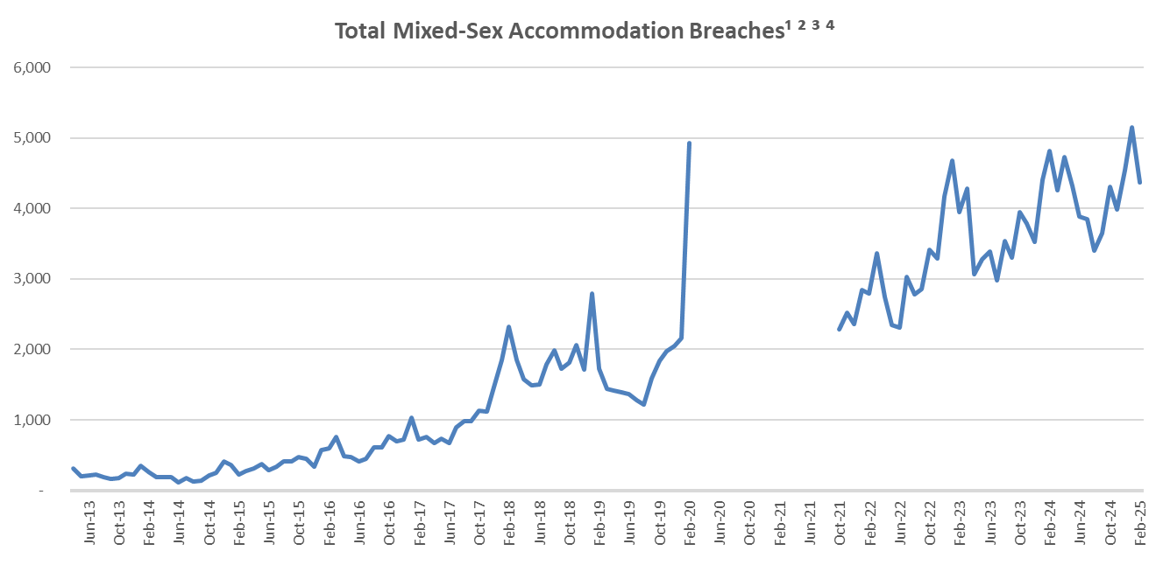
Table notes:
1. Unjustified breaches of mixed sleeping accommodation.
2. Jan-19 includes 1,123 breaches reported by Sandwell and West Birmingham Hospitals NHS Trust. The Trust previously reported data to the national collection incorrectly. The Trust rectified this following advice from NHS Improvement that national policy and guidance should be followed.
3. Feb-20 includes 2,637 breaches reported by Epsom and St Helier University Hospitals NHS Trust. The Trust previously reported data to the national collection incorrectly. The Trust rectified this following an internal review of processes.
4. March 2020 to September 2021 data not available - the collection was suspended during this period due to COVID-19 and the need to release capacity across the NHS.

Provider and commissioner tables as well as hospital site level data can be found at:
http://www.england.nhs.uk/statistics/mixed-sex-accommodation/msa-data/
Statistical Notes

- MSA Data Collection

National reporting of unjustified mixing (i.e. breaches) in relation to sleeping accommodation commenced on 1 February 2010. MSA breach data is a mandatory monthly collection from all NHS providers and other organisations that provide NHS-funded care (including Independent and Voluntary Sector organisations). Data are collected, validated and published in accordance with the Code of Practice for Official Statistics.

As well as monitoring and reporting all unjustified mixing of sleeping accommodation, the NHS is also required to monitor all justified mixing in sleeping accommodation, all mixed-sex sharing of bathroom / toilet facilities (including passing through accommodation or toilet/bathroom facilities used by the opposite gender), and all mixed provision of day space in mental health units at a local level. For practical reasons, central reporting has been mandated for MSA breaches in respect of sleeping accommodation only.

“Sleeping accommodation” includes areas where patients are admitted and cared for on beds or trolleys, even where they do not stay overnight. Further information on what constitutes a nationally reportable breach can be found in the national policy, “Delivering same-sex accommodation”.

- Provider and Commissioner based data

MSA data is published both on a provider and commissioner basis.

Provider-based reflects data at organisation level for those organisations that provide NHS funded treatment or care, for example NHS Acute Trusts, NHS Mental Health Trusts, Independent Sector and Voluntary Sector organisations.

Commissioner-based reflects data on a responsible population basis, i.e. Clinical Commissioning Groups (CCGs) that are responsible for commissioning a patient’s treatment.

- Data availability

Data is published on the NHS England statistics website around 6 to 7 weeks after the reference period, this is usually on the second Thursday of the month.

The MSA collection was suspended between March 2020 and September 2021 (inclusive) due to Covid-19 and the need to release capacity across the NHS.

- Revisions to published figures
Revisions were last published alongside the November 2023 data in January 2024 covering the period October 2022 to September 2023. All 12 months were impacted by revisions. Revisions were made by two organisations and had a minimal impact at national level.

- MSA breach rate indicator

The MSA breach rate is the number of breaches of mixed-sex sleeping accommodation per 1,000 Finished Consultant Episodes.

An MSA breach rate indicator was developed because a simple count of the number of MSA breaches does not provide a fair comparison across healthcare providers. Raw numbers alone do not take into account the size of an organisation and it would be unfair to classify large acute providers as “worst performing” compared to other, smaller providers, as they handle larger volumes of admitted patients and therefore the possibility of mixing patients is greater. The MSA breach rate indicator gives us the ability to compare healthcare providers with others, or to compare change over time. It can tell us how a provider is “performing” in relation to other similar organisations, or the national average, and whether they are improving or getting worse.

Changes to October 2021 to March 2022 breach rate calculations

On reintroduction of the MSA collection in October 2021, if the established methodology was used, the October 2020 FCE data (i.e. the same month of the previous year) would normally be used to calculate the rate. However, this data was impacted by Covid-19 and is likely to distort the breach rate figures.

Therefore, to account for this the following amendments outside the usual methodology applied to the data period of FCE data used to calculate the breach rates:
October 2021 to March 2022 data (2021/22) | Use the last 12 months of pre-pandemic FCE data (March 2019 to February 2020) as the denominator for the breach rate i.e.  - October 2021 to February 2022 rates will use October 2019 to February 2020 FCE data respectively (i.e. 2019/20)  - March 2022 rates will use March 2019 FCE data (i.e. 2018/19)
April 22 data onwards (2022/23) | Revert back to the established method using FCE data from the same period of the previous year (2021/22) i.e. April 2022 rate will use April 2021 FCE data.

From April 2022 data onwards, as outlined above, the FCE periods used to calculate the rate reverted to the established methodology. For more information, see the MSA Breach Rate methodology paper at: http://www.england.nhs.uk/statistics/mixed-sex-accommodation/

- Data Quality

MSA breach data was first collected in December 2010. Figures published from December 2010 to March 2011 should be treated with caution as providers were implementing and embedding new data collection procedures.

From April 2011, MSA data became mandatory for all NHS providers and data collection processes were fully embedded in the NHS, therefore, data submitted from April 2011 onwards is of a higher quality than in previous months.

January 2019 data includes 1,123 breaches reported by Sandwell and West Birmingham Hospitals NHS Trust. The Trust previously reported data to the national collection incorrectly. The Trust rectified this following advice from NHS England that national policy and guidance should be followed.
In September 2019, a revised policy, "Delivering same-sex accommodation" was published. Data providers were asked to ensure reporting of MSA breaches for the purposes of this collection were in line with the revised policy by January 2020. The transition period allowed providers to make appropriate changes to enable them to report on this basis. As such this may have impacted on data quality for September to December 2019 data. Providers should be reporting consistently and as per the updated guidance from January 2020 onwards.
From January 2020 publication (November 2019 data) onwards, breaches for Non-English commissioned patients are excluded. These numbers are small and excluding them has a minimal impact on the timeseries data.
February 2020 includes 2,637 breaches reported by Epsom and St Helier University Hospitals NHS Trust. The Trust previously reported data to the national collection incorrectly. The Trust rectified this following an internal review of processes.
After a significant gap in collection following the suspension of the collection due to Covid-19, data for October 2021 when the collection first resumed should be viewed with caution.
- Feedback welcomed

We welcome feedback on the content and presentation of MSA statistics within this Statistical Press Notice and those published on the NHS England website. Please email any comments on this, or any other issues regarding the MSA data and statistics, to: england.electivepublications@nhs.net

- Additional Information

Details of MSA data for individual organisations are available at:

http://www.england.nhs.uk/statistics/mixed-sex-accommodation/msa-data/

For further information, please e-mail the NHS England media team at nhscb.media@nhs.net or call 07768 901293
The analyst responsible for producing these data is:
Elective Analysis,
NHS England
Wellington Place, Leeds, LS1 4AP
Email: england.electivepublications@nhs.net

The MSA collection resumed in October 2021 data following a period of suspension (March 2020 to September 2021) due to Covid-19 and the need to release capacity across the NHS.

