Derived unreported removals

Summary
        - The term unreported removal describes any flow on or off the waiting list not captured in the submitted clock starts (new RTT periods) and completed pathways numbers. It is calculated as the balancing item between the waiting list at the start of a period, the additions onto the list during the period (new RTT periods), those taken off the list during the period (completed pathways) and the size of the waiting list at the end of the period:
Unreported removals = waiting list at start of period + clock starts during period – completed pathways during period – waiting list at end of period.
        - The unreported removals figure represents the difference between the expected waiting list figure (given the reported clock start and completed pathway figures) and the reported waiting list.
        - Use of the term “removals” is therefore imperfect, as differences can also arise from incorrectly reported clock starts, but it is used to simplify the language.
        - Unreported removals are not the same thing as cases removed from the list through validation work. Validation refers to administrative and clinical action undertaken to ensure that the waiting list is as accurate as possible. Records removed through validation may increase the level of unreported removals but may also be reported as completed pathways if they are recorded in advance of data submission. Records removed through validation will be for one of the reasons stated below (eg because the patient had started treatment).
        - Unreported removals have occurred throughout the history of the statistics, averaging 17% of total removals prior to the pandemic and 14% since 2021. They are similar in nature to reported completed pathways in terms of the reasons for removal and the percentage involving activity.

Background
        - Most removals from the RTT waiting list should be reported as either completed admitted or non-admitted pathways, in line with the RTT rules and recording and reporting guidance. Completed admitted pathways are cases where patients started treatment and the treatment involved admission to hospital. Completed non-admitted pathways are cases where patients completed their RTT pathway during the month for reasons other than an inpatient or day case admission to hospital for treatment. This includes any of the following reasons:
- Start of first definitive treatment, where that treatment was delivered in outpatients
- Clinically appropriate to return the patient to primary care
- Start of active monitoring, initiated by either the patient or the care professional
- Patient declined offered treatment
- Clinical decision made not to treat made or that no further contact is required
- Patient does not attend an appointment and is discharged back to the care of their GP
- Patient died before treatment
        - Unreported removals will occur if any of these completed pathways are not recorded in time for data submission deadlines (monthly data must be submitted by the 13th working day after the end of the month). In their submissions, providers are required to submit only removals that happened within the reporting month. If they identify removals that happened in previous months, they won’t be counted in the latest month’s figure, but will be taken into account in their latest waiting list number. So, those ‘historic’ removals are ‘lost’ to reporting. This will include (but not be limited to) instances where providers undertake work to validate their waiting list and identify cases where a pathway was completed in a previous month. As a result, unreported removals can be for any of the reasons included in completed RTT pathways, including cases where the patient has started treatment.
        - A lack of triangulation between the waiting list numbers, clock starts and reported completed pathways also occurs when a provider does not submit data for a period of time due to data quality issues (typically associated with the implementation of a new IT system). Any change in the waiting list between pausing and resuming submission would be unexplained because no starts and stops would be recorded for the intervening period. This affects the national, regional and commissioner series, as well as those for the provider concerned. This is mitigated to some extent in the published national series that include estimates for non-submitting providers.
        - Unreported removals can also be generated legitimately by cases where a patient’s waiting time clock is nullified (in other words, removed from the waiting list without an associated completed pathway), for example where:
- A patient does not attend their first appointment following the initial referral that started their waiting time clock.
- An RTT clock has already been started but the provider cannot accept the referral because it is not clinically appropriate (for example, where a referral is made to a trust that doesn’t carry out the relevant procedure).
        - Where the clock nullification is identified prior to data being submitted these pathways should not be included in the submitted clock starts or waiting list figures and hence would not generate an unreported removal. However, where the nullification is generated later in the patient’s pathway, after a clock start has been reported and the patient has been recorded as a case on the waiting list, these cases may appear as unreported removals.
        - Routine validation of waiting lists may also identify cases of duplicate pathways on waiting lists and removal of the duplicates will appear as unreported removals.
        - At an individual organisation level, recording of RTT waiting times in line with the guidance will also cause valid differences between the expected and reported waiting list where patients are transferred between providers. In this case, the patient’s pathway will be added to the waiting list in the receiving provider without an associated clock start and removed from the originating provider’s waiting list without an associated completed pathway, as the clock started at the originating provider and continues to tick as the patient is transferred. However, the combined effect of such transfers on unreported removals at England level should be neutral.

Trends and characteristics
        - We can derive figures for unreported removals back to October 2015. Up until the pandemic, they averaged 281 thousand per month, which equated to 17% of total removals. Since 2021, they have equated to 14% of removals.
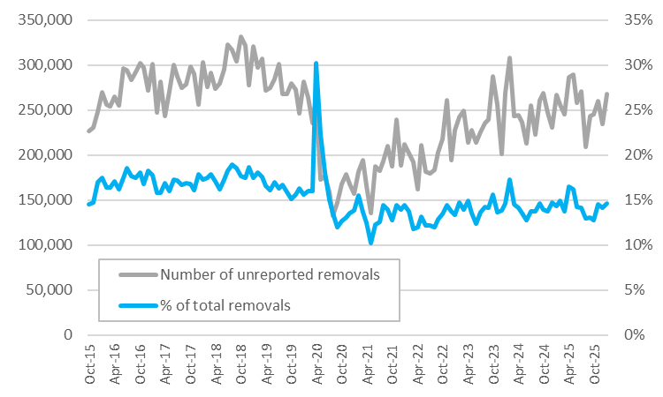
        - We can gain some insight about the characteristics of unreported removals through the record level management information from the Waiting List Minimum Data Set (WLMDS). In the WLMDS, providers submit information about new RTT pathways, cases still on the waiting list, and removals from the list. The WLMDS data are submitted more rapidly than the monthly statistics and the reporting of completed pathways is less complete. The WLMDS is therefore affected by the issue of unreported removals to a slightly greater degree. We can identify unreported removals in the WLMDS by looking for cases that stop being reported on the waiting list, despite not being reported as a completed pathway in the data set.
        - We can obtain information about the reason for the removal for a small subset of unreported removals where a valid code was recorded in the waiting list section of the data set (amounting to 113 thousand records in 2025). This suggests that the reasons are broadly similar to those for reported completed pathways. In 2025, 49% of the unreported removals where a reason was given were due to the patient starting treatment, compared with 50% for reported completed pathways. 23% were the result of a decision not to treat, compared with 29% for reported completed pathways.
        - In contrast, 11% were the result of the patient not attending their first appointment, compared to only 1% for reported completed pathways. This links to the point made in paragraph 7 that an unreported removal can be generated legitimately under such circumstances. In the published WLMDS figures for completed pathways, we exclude records with this status code (#33 = the RTT period ended because the patient did not attend the first care activity after the referral). Providers have recently been asked to submit all such removals in the WLMDS, but some are not yet doing so. So, it is likely that this percentage is an underestimate.
        - We can gain additional insight into unreported removals by linking the WLMDS data with information on outpatient attendances and admitted spells from the Commissioning Data Sets to understand what activity happened before and after the removal. Through that data linkage, we can also derive an estimate for the percentage of unreported removals that involved some outpatient or inpatient activity before and after removal. Note: this will be an underestimate and so should be viewed as a minimum, because:
- It is not possible to attribute some activity to a pathway.
- The analysis excludes events involving diagnostic tests such as CTs, MRIs and ultrasound; and so some ‘Straight to Test’ pathways will falsely appear as involving no activity.
        - The figures for recent periods will also be understated because of lags in activity being recorded. In 2025, at least 73% of unreported removals involved some outpatient or admitted activity, compared with at least 87% of reported completed pathways. This percentage is similar to preceding years, especially when the lag effect is taken into account: 75% in both 2024 and 2023.
        - Around one-third (32%) of unreported removals involve some activity after the clock stop, which in many cases will indicate the patient started treatment and went on to receive further care. This proportion is similar for reported completed pathways (36%), again suggesting that unreported removals are very similar in nature to reported completed pathways.

Improving the data on completed pathways
        - A number of mechanisms exist to improve the quality of data on completed pathways, including:
- The requirement under the NHS Standard Contract to supply data that are of good quality.
- The provision of digital tools for providers to support waiting list validation (including through the Federated Data Platform and the LUNA data quality product).
- The option for providers to update their completed pathway figures on a six-monthly basis in line with our published revisions policy.
- The supply of funding to undertake additional waiting list validation.
        - Further developments are being taken forward to strengthen these provisions:
- The inclusion within the published official statistics of figures for unreported removals.
- The sharing of figures on unreported removal rates with NHS providers and their inclusion in the elective data quality programme, through which NHS England regional teams support providers to improve the quality of their submissions.
- The introduction of ‘patient-not-present’ payments for providers, which supports the timely capture and reporting of completed pathways.
        - It should be noted that actions to improve the accuracy of waiting list information can result in an increase in the level of unreported removals in the short term.

Feedback
        - We would welcome any feedback you might have on this document, which should be sent to england.RTT@nhs.net.

Provided the appointment was clearly communicated to the patient and discharging the patient is not contrary to their best clinical interests

