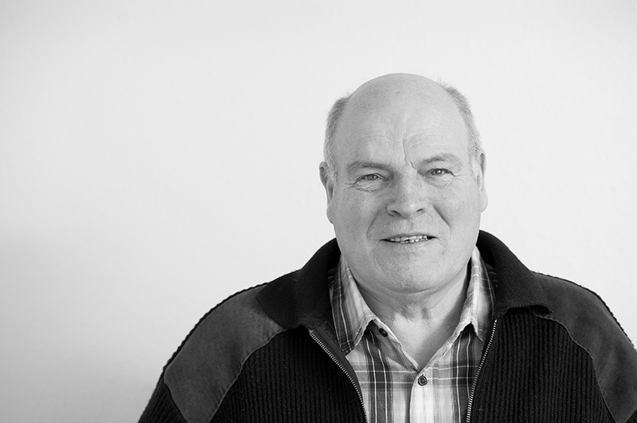

Open and Honest Care in your local NHS Trust

Community Open and Honest Report Template



**Open and Honest Care report for Enter Trust name**

**Enter Month, Year**

Version number: 1.0

First published: June 2015

Updated: N/A

Prepared by: NHS England (North)

Classification: OFFICIAL

The National Health Service Commissioning Board was established on 1 October 2012 as an executive non-departmental public body. Since 1 April 2013, the National Health Service Commissioning Board has used the name NHS England for operational purposes*.*

# Contents

Contents 4

1 Safety 5

1.1 Safety Thermometer 5

1.2 Health Care Associated infections (HCAIs) 5

1.3 Pressure Ulcers 5

2 Experience 6

2.1 Patient Experience 6

2.1.1 The Friends and Family Test 6

2.1.2 A patient's story 7

2.2 Staff Experience 7

2.2.1 The Friends and Family Test 7

3 Improvement 8

3.1 Improvement Story: we are listening to our patients and making changes 8

3.2 Supporting Information 8

# Safety

## Safety Thermometer

On one day each month we check to see how many of our patients suffered certain types of harm whilst in our care. We call this the NHS Safety Thermometer. The safety thermometer looks at four harms: pressure ulcers, falls, blood clots and urine infections for those patients who have a urinary catheter in place. This helps us to understand where we need to make improvements. The score below shows the percentage of patients who did not experience any harms.

XX% of patients did not experience any of the four harms in this community trust

For more information, including a breakdown by category, please visit: <http://www.safetythermometer.nhs.uk/>

## Health Care Associated infections (HCAIs)

HCAIs are infections acquired as a result of healthcare interventions. Clostridium difficile (C.difficile) and methicillin-resistant staphylococcus aureus (MRSA) bacteremia are nationally monitored as we are trying to reduce the incidence of these infections. C.difficile is a type of bacterial infection that can affect the digestive system, causing diarrhoea, fever and painful abdominal cramps - and sometimes more serious complications. This bacteria does not normally affect healthy people, but because some antibiotics remove the 'good bacteria' in the gut that protect against C.difficile, people on these antibiotics are at greater risk.

The MRSA bacteria is often carried on the skin and inside the nose and throat. It is a particular problem in hospitals because if it gets into a break in the skin it can cause serious infections and blood poisoning. It is also more difficult to treat than other bacterial infections as it is resistant to a number of widely-used antibiotics.

We have a zero tolerance policy to infections and are working towards eradicating them. Although community providers do not have targets for reduction in numbers of infections, planned programmes for infection prevention and control are in place.

Examples of this can be found on our website: Insert Infection Control website link here

## Pressure Ulcers

Pressure ulcers are localised injuries to the skin and/or underlying tissue as a result of pressure. They are sometimes known as bedsores. They can be classified into four categories, with one being the least severe and four being the most severe. The pressure ulcers reported include all validated avoidable/unavoidable pressure ulcers that were identified at any time whilst the patient is on a nursing caseload that were not present on initial assessment.

This month X Category 2 - Category 4 pressure ulcers were acquired on community caseloads

| **Number of Pressure Ulcers** | **Category 2** | **Category 3** | **Category 4** | **Total** |
| --- | --- | --- | --- | --- |
| Site/Service 1 | X | X | X | X |
| Site/Service 2 | X | X | X | X |
| Site/Service 3 | X | X | X | X |

In the community setting we also calculate an average called 'rate per 10,000 CCG population'. This allows us to compare our improvement over time, but cannot be used to compare us with other community services as staff may report pressure ulcers in different ways, and patients may be more or less vulnerable to developing pressure ulcers than our patients. For example, our community may have younger or older patient populations, who are more or less mobile, or are undergoing treatment for different illnesses.

| **Rate per 10,000 Population** |  |
| --- | --- |
| Site/Service 1 | XX |
| Site/Service 2 | XX |
| Site/Service 3 | XX |

# Experience

To measure patient and staff experience we ask a number of questions. The idea is simple: if you like using a certain product or doing business with a particular company you like to share this experience with others.

The answers given are used to give a score which is the percentage of patients who responded that they would recommend our service to their friends and family.

## Patient Experience

### The Friends and Family Test

The Friends and Family Test (FFT) requires all patients to be asked, **‘**How likely are you to recommend our service to friends and family if they needed similar care or treatment?’

Community FFT percentage recommended* XX% recommended

This is based on XX responses

*This result may have changed since publication, for the latest score please visit:

<http://www.england.nhs.uk/statistics/statistical-work-areas/friends-and-family-test/friends-and-family-test-data/>

We also asked X patients the following questions about their care in the community setting

|  | **Site/Service 1** | **Site/Service 2** | **Site/Service 3** | **Trust Overall** |
| --- | --- | --- | --- | --- |
| Were the staff respectful of your home and belongings? |  |  |  |  |
| Did the health professional you saw listen fully to what you had to say? |  |  |  |  |
| Did you agree your plan of care together? |  |  |  |  |
| Were you/your carer or family member involved in decisions about your care and treatment as much as you wanted them to be? |  |  |  |  |
| Did you feel supported during the visit? |  |  |  |  |
| Do you feel staff treated you with kindness and empathy? |  |  |  |  |
| How likely are you to recommend this service to friends and family if they needed similar care or treatment? |  |  |  |  |

* + 1. **A patient's story**

This section should include a brief summary of the story being told. It should be clear, concise and jargon free. Try to avoid long, dense paragraphs of text.

Paste your story over this text. Expand the text box by increasing the line depth or adding new lines

## Staff Experience

### The Friends and Family Test

The Friends and Family Test (FFT) requires staff to be asked, at periodic points: How likely are you to recommend our organisation to friends and family if they needed care or treatment?’ and ‘How likely are you to recommend our organisation to friends and family as a place to work?’

FFT percentage recommended care* XX% recommended

This is based on XX responses

FFT percentage recommended work* XX% recommended

This is based on XX responses

*This result may have changed since publication, for the latest score please visit:

<http://www.england.nhs.uk/statistics/statistical-work-areas/friends-and-family-test/friends-and-family-test-data/>

We asked X staff working in the community setting the following questions

|  | **% Recommended** |
| --- | --- |
| Would you recommend this service as a place to work? | XX |
| Would you recommend the standard of care in this service to a friend or relative if they needed treatment? | XX |
| Are you satisfied with the quality of care you give to the patients, carers and their families? | XX |

1. **Improvement**
   1. **Improvement Story: we are listening to our patients and making changes**

This can be a short story, video or blog etc. It should be presented in plain language that emphasises clarity, brevity and the avoidance of technical language – particularly in relation to medical or analytical terms.

It should be dynamic and build a story each month of what is happening. It should be truthful but not alarmist. Paste your story over this text.

Expand the text box by increasing the line depth or adding new lines.

* 1. **Supporting Information**

You can add any supporting information in this section or links directly to your Trust website to signpost further information on patient safety, harms or improvement.

This could include improvement work through other programmes such as sign up to safety.

Paste your information over this text. Expand the text by increasing the line depth or adding new lines.