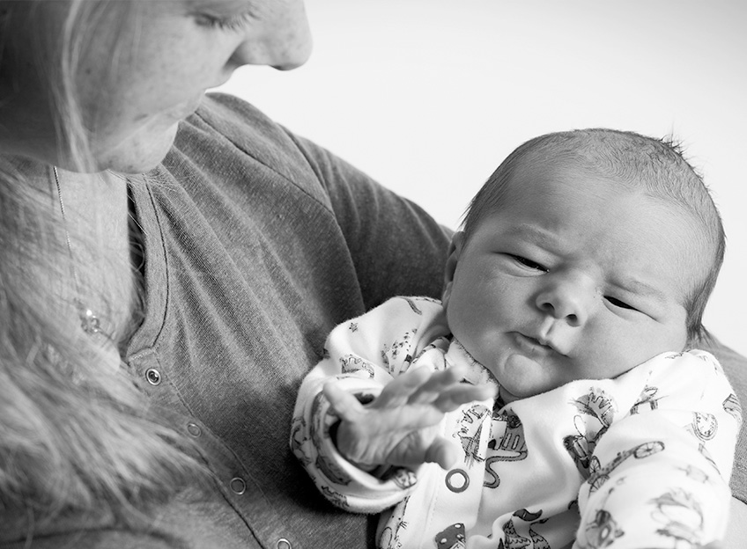

Open and Honest Care in your local Hospital

Maternity Open and Honest Care Report Template

**Open and Honest Care in Enter Trust Name**

**Month, Year**

Version number: 1.0

First published: June 2015

Updated: N/A

Prepared by: NHS England (North)

Classification: Official

The National Health Service Commissioning Board was established on 1 October 2012 as an executive non-departmental public body. Since 1 April 2013, the National Health Service Commissioning Board has used the name NHS England for operational purposes*.*

# Contents

Contents 4

1 Safety 5

1.1 Maternity Safety Thermometer 5

1.2 Outcomes in our maternity service 6

1.3 Safe Staffing 6

2 Experience 7

2.1 Women and Family Experience 7

2.1.1 The Friends and Family Test 7

2.1.2 Women’s’ or family story 8

2.2 Staff Experience 8

2.2.1 The Friends and Family Test 8

3 Improvement 9

3.1 Improvement story: we are listening to women and their families and are making changes to improve the maternity service. 9

3.2 Supporting Information 9

# Safety

## Maternity Safety Thermometer

On one day each month we use the maternity safety thermometer, which is a nationally agreed tool to monitor care in maternity services. We use it to check to see how many women and babies experienced certain types of harm whilst in our care. It is called a safety 'thermometer' because it is a tool designed to take a sample of information available and so acts similarly to a 'temperature' check of safety, experience and improvement. This helps us to understand where we need to make improvements.

When we are using the term ‘harm’ in the context of maternity care it is important to understand that for many women these ‘harms’ are known complications of labour and birth and can not necessarily be avoided.

The maternity safety thermometer records whether any of four physical 'harms' occurred and asks three questions about women's experiences of maternity care. The four physical ‘harms’ we record information on in the maternity safety thermometer are;

* Severe tears in the skin and muscle around the vagina (also known as perineal tears or 3rd and 4th degree tears)
* Heavy blood loss following birth more than 1000mls (also known as post partum haemorrhage)
* Apgar score less than 7 at 5 minutes which is an indication of how well your baby was at birth (this is a score out of 10 where 2 points are given for each of the following: heart rate, breathing, colour, muscle tone and response to touch - 10 being the best score)
* Women who report having a maternal infection starting between the onset of labour and 10 days of giving birth.

The term ‘harm free care’ (HFC) is the percentage of women who do not experience any of these ‘harms’ during their labour and birth as recorded in the maternity safety thermometer. The score below shows the percentage of women who did not experience any of these harms measured in the Maternity Safety Thermometer and is known as harm free care. Please note the Safety Thermometer harms identify data collected from women on one day per month and are a snap shot of the 'harms'. The breakdown of these results, are shown below alongside the actual incidence of harms.

XX% of women did not experience any of the four physical harms in this Trust

XX% of women did not express concern over their perception of safety

XX% of women did not experience any of the combined harms in this Trust

For more information, including a breakdown by category, please visit:  [http://www.safetythermometer.nhs.uk/index.php?option=com_content&view=article&id=11&Itemid=285](http://www.safetythermometer.nhs.uk/)

## Outcomes in our maternity service

Most women have a normal birth but some women need to have some help to give birth to their baby and have an operative birth. Operative birth could be a caesarean section, vacuum or forceps birth. Whilst having an operative birth can be potentially life-saving there is great variation across the country. It is important to note that the need for an operative birth is dependent on risk factors and can vary in different populations so this information should not be used in isolation.

| **Total number of births** | **Spontaneous vaginal birth** | **Planned Caesarean** | **Emergency Caesarean** | **Forceps Ventouse or Vacuum** | **Vaginal Breach** |
| --- | --- | --- | --- | --- | --- |
| This month | X | X | X | X | X |
| Actual cumulative numbers to date since Month, Year | X | X | X | X | X |

The 'Actual' harms represent the total number of those harms identified occurring for all women giving birth this month.

Of the XXX women who gave birth this month the following 'actual' harms occurred:

|  | **Actual Incidence of Harms** | **Total percentage harms of all women** | **Safety Thermometer Prevalence of Harm** |
| --- | --- | --- | --- |
| Severe perineal tears (3rd and 4th degree) | X | X% | X% |
| Post Partum Haemorrhage (more than 1000mls) | X | X% | X% |
| Maternal Infection | X | X% | X% |
| Apgar score less than 7 at 5 minutes | X | X% | X% |

The number of stillbirths is recorded each quarter. The number of stillbirths which occurred in our Trust for the last quarter (Month, Year – Month, Year)

Actual Stillbirths X% Stillbirths of total births XX%

Of the X Stillbirths XX were expected due to congenital abnormalities or other unavoidable complications

## Safe Staffing

Guidelines recently produced by the National Institute for Health & Care Excellence (NICE) make recommendations that focus on safe nursing for adult wards in acute hospitals and maternity settings. As part of the guidance we are required to publish monthly reports showing the registered nurses/midwives and unregistered nurses we have working in each area. The information included in the report shows the monthly planned staffing hours in comparison with the monthly actual staffing hours worked on each ward and/or the percentage of shifts meeting the safe staffing guidelines.

In order to view our reports please visit: Insert safe staffing website link here

# Experience

To measure patient and staff experience we ask a number of questions. The idea is simple: if you like using a certain product or doing business with a particular company you like to share this experience with others.

The answers given are used to give a score which is the percentage of patients who responded that they would recommend our service to their friends and family.

## Women and Family Experience

### The Friends and Family Test

The Friends and Family Test requires all women, at 36 weeks, (ante natal), after the birth, (Labour/Birth), prior to transfer from hospital (Post natal in hospital) and on discharge from the midwife, (post natal at home) to be asked: How likely are you to recommend the maternity service to friends and family? We are now calculating and presenting the FFT results as a percentage of respondents who would/would not recommend the service to their friends and family. The maternity services had the following scores:

Antenatal * XX % recommended

This is based on XX responses

Labour/Birth* XX% recommended

This is based on XX responses

Post Natal in Hospital* XX% recommended

This is based on XX responses

Post Natal at home* XX% recommended

This is based on XX responses

*This result may have changed since publication, for the latest score please visit:

<http://www.england.nhs.uk/statistics/statistical-work-areas/friends-and-family-test/friends-and-family-test-data/>

We also ask women questions about their experiences in relation to feeling safe during labour. The responses are below and have been taken from the NHS Safety Thermometer

|  | **Yes** | **No** |
| --- | --- | --- |
| Were you left alone by midwives or doctors at a time when it worried you during labour or birth? | XX% | XX% |
| If you raised a concern about safety during labour or birth did you feel that it was taken seriously? | XX% | XX% |
| Were you ever separated from your baby? | XX% | XX% |

### Women’s’ or family story

This section should include a brief summary of the story being told. It should be clear, concise and jargon free. Try to avoid long, dense paragraphs of text.

Paste your story over this text. Expand the text box by increasing the line depth or adding new lines

## Staff Experience

### The Friends and Family Test

The Friends and Family Test (FFT) requires staff to be asked, at periodic points: How likely are you to recommend our organisation to friends and family if they needed care or treatment?’ and ‘How likely are you to recommend our organisation to friends and family as a place to work?’

FFT percentage recommended care* XX% recommended

This is based on XX responses

FFT percentage recommended work* XX% recommended

This is based on XX responses

*This result may have changed since publication, for the latest score please visit:

<http://www.england.nhs.uk/statistics/statistical-work-areas/friends-and-family-test/friends-and-family-test-data/>

We also asked XX staff the following questions

|  | **% Recommended** |
| --- | --- |
| Would you recommend this maternity service as a place to work? | XX |
| Would you recommend the standard of care from this maternity service to a friend or relative if they needed treatment? | XX |
| Are you satisfied with the quality of care you give to the patients, carers and their families? | XX |

# Improvement

## Improvement story: we are listening to women and their families and are making changes to improve the maternity service.

This can be a short story, video or blog etc. It should be presented in plain language that emphasises clarity, brevity and the avoidance of technical language - particularly in relation to nursing, medical or analytical terms.

It should be dynamic and build a story each month of what is happening. It should be truthful but not alarmist. Paste your story over this text.

Expand the text box by increasing the line depth or adding new lines

NB You can also use RCA from incidents if you wish i.e. story lessons learnt and recommendations and actions taken if you prefer.

## Supporting Information

You can add any supporting information in this section or links directly to your Trust website to signpost further information on patient safety, harms or improvement.

This could include improvement work through other programmes such as sign up to safety.

As per Standard Operating Procedure v1.5 please include your Supervisors of Midwives to Midwife ratio. The National recommendation is 1:15.

Paste your information over this text. Expand the text box by increasing the line depth or adding new lines.