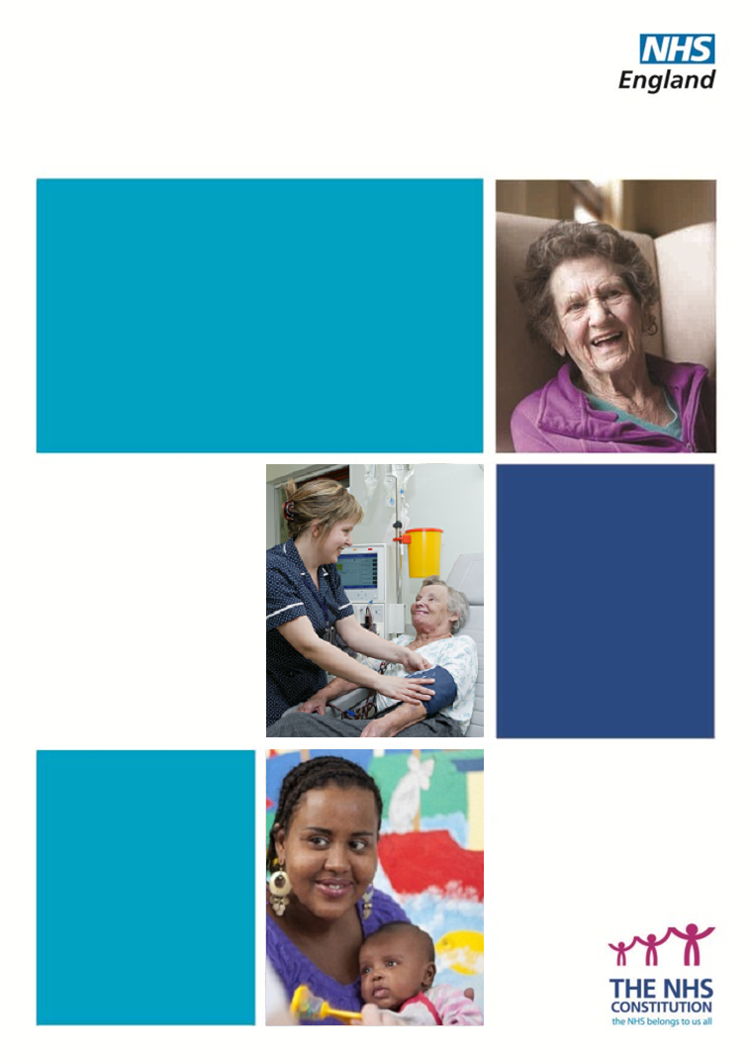

NHS Standard Contract

National Variation Agreement template 2014/15

NHS Standard Contract National Variation Agreement Template 2014/15

First published: February 2014

Prepared by NHS Standard Contract Team

Publications Gateway Approval Number: 01170
NATIONAL VARIATION AGREEMENT

Contract/Variation Reference:

Proposed by: Co-ordinating Commissioner on behalf of NHS England [and on behalf of Commissioners]*

Date of Proposal:

Date of Variation Agreement:

Capitalised words and phrases in this Variation Agreement have the meanings given to them in the Contract referred to above.

- The Parties have agreed the Variation summarised below:

National Variation to adopt NHS Standard Contract 2014/15 terms and conditions.

[Summarise additional Local Variation as appropriate]*

- The Variation is reflected in the revised Particulars and Service Conditions bearing the contract reference and variation number set out above and the NHS Standard Contract 2014/15 General Conditions published December 2014 and the Parties agree that the Contract is varied accordingly.

- The Variation takes effect on 1 April 2014.

IN WITNESS OF WHICH the Parties have signed this Variation Agreement on the date(s) shown below

SIGNED by | ……………………………………………..  Signature
[INSERT AUTHORISED  SIGNATORY’S NAME]  for and on behalf of  [INSERT COMMISSIONER] | ………………………………………………  Title  ………………………………………………  Date
[INSERT AS ABOVE FOR EACH COMMISSIONER]
SIGNED by  [INSERT AUTHORISED  SIGNATORY’S NAME]  for and on behalf of  [INSERT PROVIDER NAME] | ……………………………………………..  Signature  ……………………………………………..  Title  ………………………………………………  Date

*Delete if only effecting National Variation/add further details in box if also effecting locally-agreed Variation

