PATIENT-LED ASSESSMENTS OF THE CARE ENVIRONMENT PREPARATION FOR
PATIENT ASSESSORS

Contents
Who should attend training/preparation? 3
How long should the training/preparation be? 3
Who should deliver the training/preparation? 4
Any tips or hints? 4
Checking that training/preparation has been effective 4
After the training/preparation 4
Conclusion 4
Suggested training/preparation plan – two hours 5
Suggested training/preparation plan – three hours 5
Suggested training/preparation plan – whole day 6

The quality of local training/preparation is fundamental to the success of patient-led assessments of the care environment (PLACE). Good training/preparation not only ensures good assessors, it also demonstrates that you value your volunteers and intend to take their views seriously.

Who should attend training/preparation?

This depends very much on your patient assessors and their previous experience. All assessors (staff and patients) will need some preparation, but people who were previously involved in PLACE may require a different approach from those who are assessing for the first time.
You may wish to deliver joint training/preparation with staff – this has the advantage of building strong relationships before the assessment, though it can be repetitive for some team members. Even if you don’t include staff assessors in the full training/preparation, it can be helpful to invite them for coffee to meet their team-mates.

How long should the training/ preparation be?

The time needed will vary locally. You will need to take into account:
- who your patient assessors are, including:
  - any previous experience;
  - any particular skills or knowledge gaps;
  - any special training/preparation needs (eg disabilities);
- the amount of time patient assessors can reasonably be expected to give:
  - at home (reading the documentation plus any local guidance you produce);
  - in advance of the assessment (in a training/preparation session at the site);
  - on the day of the assessment (before or during the assessment);
- any particular features of the site being assessed:
  - infection prevention and control;
  - what to do in an emergency;
  - patient population and how to interact with them;
  - specific areas for assessment;
  - who will be delivering the training/ preparation the organisation or with other bodies such as local Healthwatch).

Remember that many patient assessors may be older or frail, and that a long session can be counter-productive. Build in plenty of breaks and discussion time and make sure you give enough attention to introductions.
For multi-site organisations, you will need to decide how to cover general, trust/organisation wide issues and specific, site-related ones. You may wish to hold a single training/preparation session in advance for all the general issues, with short, site-specific information on the day of the assessment.
On pages five and six are some suggested running orders for a two-hour, three-hour and full-day training/preparation programme. These are suggestions only – it is important that what you do meets the needs of your assessors.

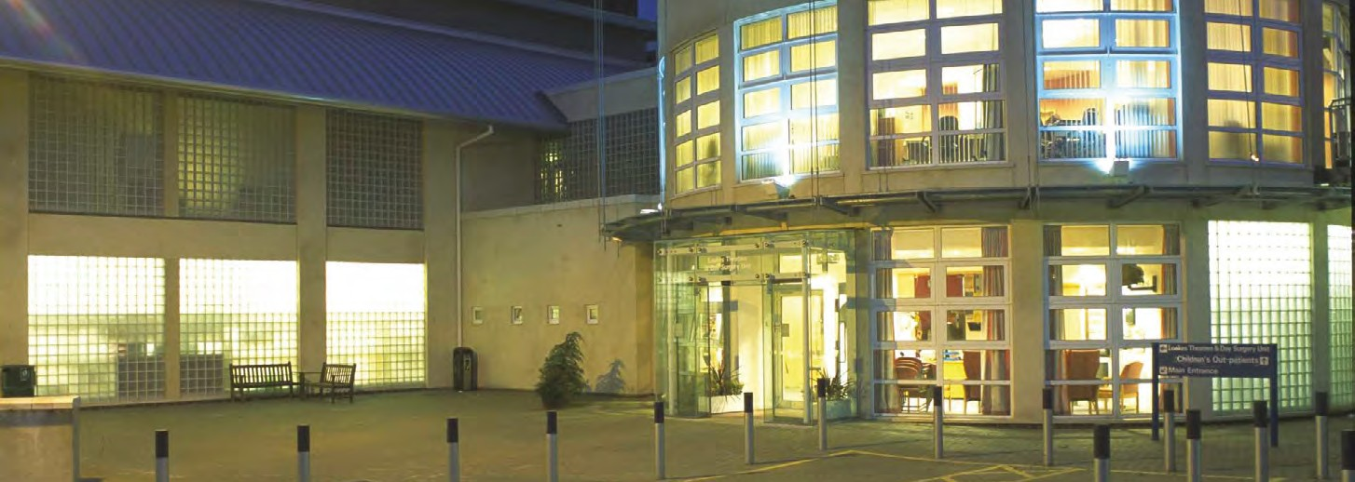

Who should deliver the training/preparation?

Again, it’s up to you. Arranging joint training/ preparation with local Healthwatch can be a good way of developing strong relationships, but others can also contribute, eg trust volunteer
co-ordinator, infection prevention staff, local patient representative organisations. Arranging for an executive or non-executive director to call in for a few minutes to open the session and thank patients for attending is an excellent way of demonstrating how much your organisation values their input.

Any tips or hints?

Many patient assessors are not in full-time work and may be unaccustomed to spending long periods of time in a classroom. Training/ preparation can be very tiring – the following tips may help:
Conclusion
Good training/preparation is essential for a smooth assessment. Use the national packages where they are helpful, but don’t be afraid to put your own local stamp on the training. Patient assessment will be most successful where the whole team feels that they are working together to a common purpose, so feel free to develop the training in a way that suits your organisation.
- don’t spend more than 30 minutes on any single ‘chalk-and-talk’ session;
- don’t run two ‘chalk-and-talk’ sessions together – split them up with questions or an activity;
- the longer the event, the more interactive work you should include (eg table discussions, mock assessments etc);
- build in plenty of breaks;
- make sure no-one is isolated – consider inviting other staff to join in at lunch to meet patient assessors and introduce them to others;
- provide handouts or notes to back up the sessions.

Checking that training/ preparation has been effective

It’s important to ensure that patient assessors have fully understood the training/preparation and are aware of their roles. Formal testing is inappropriate, but try to build in enough question and answer sessions to clear up any areas of confusion. It can be helpful to ‘buddy-up’ new assessors with some of your existing PLACE assessors for support.
Many people are reluctant to ask questions in a large group, for fear of looking foolish. Make sure you offer plenty of opportunity for one-to- one discussions with experienced assessors (staff or patient), eg over coffee breaks or during table discussions. Alternatively, ask participants to jot down on paper the things that are worrying them and drop them in a box. These can then be addressed anonymously with the whole group – the chances are that more than one person has the same concern.

After the training/preparation

Sending out further information after the event helps people feel fully involved and offers an opportunity for them to refresh what they have learned. Some handouts need to be given out on the day, but think about whether there is anything you can send separately, between the training/preparation and the assessment visit.

Suggested training/preparation plan – two hours

Item | Time (min)
Arrival and coffee – networking 1
Welcome and introduction | 10
PowerPoint presentation – There’s a PLACE for us | 30
Questions | 15
Break | 10
Understanding the forms | 15
Questions | 10
Information about the site/organisation, (layout, what to do in emergency etc) | 20
Final questions | 10
Thanks and close – reimbursement of expenses
- Arrival (with refreshments) should be planned for up to half an hour before the training/preparation starts, to allow everyone to get a drink and get to know each other. It can be helpful to use a ‘buddy’ system between staff and patient assessors so that everyone feels fully involved right from the start. It’s also useful to have several staff available after the session for half an hour or so to answer specific queries.

Suggested training/preparation plan – three hours

Item | Time (min)
Arrival and coffee – networking 2
Welcome and introduction | 10
Ice-breaker exercise | 15
PowerPoint presentation – There’s a PLACE for us | 30
Questions | 15
Information about the site/organisation, (layout, what to do in emergency etc) | 20
Break | 15
Understanding the forms | 15
Questions | 10
Mock assessment (may be in a patient area or in the training/preparation room) | 30
Feedback from mock assessment | 10
Final questions and planning for assessment | 10
Thanks and close – reimbursement of expenses
- Arrival (with refreshments) should be planned for up to half an hour before the training/preparation starts, to allow everyone to get a drink and get to know each other. It can be helpful to use a ‘buddy’ system between staff and patient assessors so that everyone feels fully involved right from the start. It’s also useful to have several staff available after the session for half an hour or so to answer specific queries.

Suggested training/preparation plan – whole day

Item | Time (min)
Arrival and coffee – networking 3
Welcome and introduction – the national picture | 10
Ice-breaker exercise | 15
The local environment | 30
Questions and discussion | 20
Break | 15
PowerPoint presentation – There’s a PLACE for us | 30
Table discussion, followed by general questions | 30
Lunch and networking | 60
Information about the site/organisation, (layout, what to do in emergency etc) | 20
Understanding the forms | 15
Questions | 10
Mock assessment (may be in a patient area or in the training/preparation room) | 30
Break | 15
Feedback from mock assessment | 20
Final questions and planning for assessment | 10
Thanks and close – reimbursement of expenses
- Arrival (with refreshments) should be planned for up to half an hour before the training/preparation starts, to allow everyone to get a drink and get to know each other. It can be helpful to use a ‘buddy’ system between staff and patient assessors so that everyone feels fully involved right from the start. It’s also useful to have several staff available for half an hour or so after the session to answer specific queries.

