PATIENT-LED ASSESSMENTS OF THE CARE ENVIRONMENT
GUIDANCE ON THE ORGANISATION AND CONDUCT OF ASSESSMENTS

Contents
Introduction 3
General principles 4
Timetable 2015 5
Site types 5
Mental health and learning disabilities – special considerations 6
The assessing team 6
Patient representation 7
Patient assessor numbers 7
Responsibilities 8
Conducting the assessment 8
Talking to patients 8
Independent review 8
Disputes 8
The assessment 9
Scope of the assessment 9
Sampling 10
Scoring 11
Completing the assessment forms 12
Food and hydration assessment 13

Introduction
This guide covers the arrangements for organising and undertaking patient-led assessments of the care environment (PLACE), including guidance on the allocation of scores. The aim is to promote consistency across all organisations, thereby improving the data quality and supporting benchmarking. It should be read in conjunction with the detailed assessment forms and separate guidance issued on the recruitment and preparation of patient assessors.
The purpose of the PLACE assessments is to assess organisations across a range of environmental aspects against common guidelines. It is recognised that sites/ organisations vary in age and design; sometimes this will limit their ability to meet the higher criteria. Whilst there may be nothing that the organisation can do about some of these things, it is important that the assessment be based on standard criteria and no allowances should be made for such factors. The scores awarded must reflect what was seen on the day.
The PLACE programme offers a non-technical view of the buildings and non-clinical services provided across all hospitals, hospices and independent treatment centres providing NHS- funded care. It is based on a visual assessment, not relying on the application of any technical or scientific tools (for example adenosine triphosphate). Assessors will therefore, in some instances, need to exercise a degree of judgement.
All PLACE assessors should familiarise themselves with this guidance. However, each section of the assessment forms contains the detailed guidance necessary to allow the assessment to be undertaken.

General principles
Scores should be based on the conditions seen at the time of the assessment. It is the sites/ organisations’ responsibility to provide a clean environment at all times, and therefore no allowance should be made for such things as the weather, building works or the next scheduled cleaning, except for those items that are subject to scheduled but infrequent cleaning/maintenance.
The assessment should not be made against how well a site/organisation is doing with what it has, but how well it is doing against the defined criteria and guidance. No allowance should be made for shortcomings that are the product of infrastructural obstacles – age/design etc.
Something being ‘as good as it can be in the circumstances’ is not sufficient reason to award a high score. If there are investment or management implications for the organisation as a result, this is a matter for the trust/ organisation to address.
The PLACE assessment form applies to all types of hospitals, hospices and independent treatment centres. Where there are recognised differences/special considerations that should
be taken into account, these are reflected in the detailed guidance. Other than this, no allowances should be made for the particular challenges that may face specific units. Such difficulties are not an excuse for less-than- acceptable standards, even if this means that the highest scores cannot be achieved.
Over- or under-scoring benefits no-one as it presents a false picture of the standards being provided. If organisations are to be able to continuously improve, they need to understand their current position.
The results of the assessments are shared with the Care Quality Commission, who use the information in their monitoring of provider compliance with the essential standards of quality and safety, and to inform inspection of relevant standards. Other organisations (for example NHS England, or the National Institute for Health and Clinical Excellence (NICE)) may also use the data in support of their own objectives.
The PLACE process requires organisations to respond formally to their assessments and develop a plan for improvement.

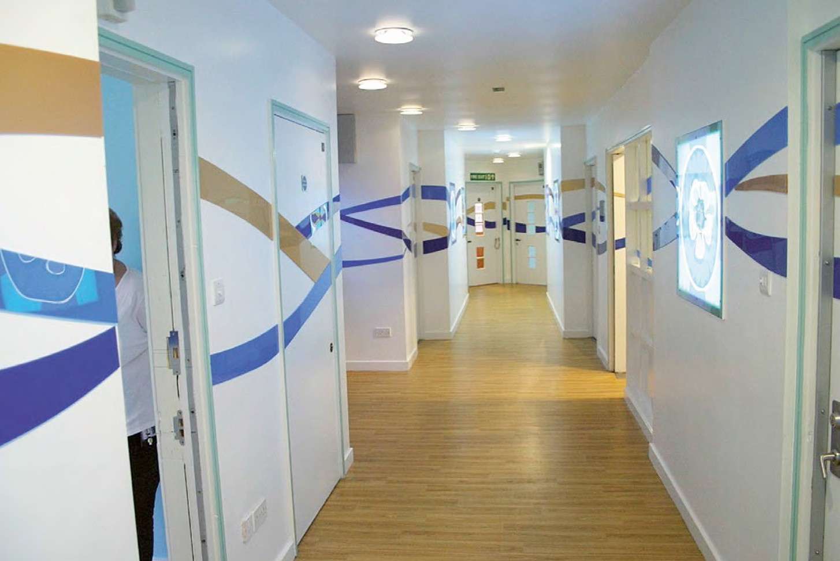

Timetable 2015
All assessments will be delivered through self- assessment. The commencement and closing dates will be 9 March and 12 June 2015.
Organisations will be allocated a six week period in which to undertake their assessment(s), and a final date by which any assessment(s) should be completed and data submitted. It is for the trust/ organisation to decide how, and when within the six week period they organise/undertake their assessment(s).
In the event that an assessment cannot proceed in the time period identified, the organisation must contact the HSCIC as soon as possible and an alternative will be identified. However, organisations are urged to make every attempt to undertake assessments at the first opportunity.
All reports will be submitted through the EFM website at http://efm.hscic.gov.uk

Site types
The list of site types to select from is:
- acute
- specialist
- general mental health/learning disabilities provided by the same healthcare organisation
- community
- mental health only including wards in sites shared with another organisation
- learning disabilities only including wards in sites shared with another organisation
- both mental health and learning disabilities provided from the same site
- treatment centre - with inpatient facilities
- non NHS organisations only
- treatment centre - without inpatient facilities
- non NHS organisations only
- hospice.
All sites/organisations are eligible for inclusion in the programme regardless of size or bed numbers. However, the intention is to restrict inclusion of very small units which clearly do not meet the definition of a hospital. Therefore, where a unit has fewer than ten beds, organisations will need to determine, based on their knowledge of the unit and the services provided, whether it could reasonably be classed as a hospital. For example, a nine- bedded unit called ‘XXX Regional Eye Hospital’ would meet the definition of a hospital, but a community-based home where assessment and treatment are not carried out would not. Any unit with ten or more beds should be included in the assessment programme.

Mental health and learning disabilities – special considerations
The assessment form applies equally to all healthcare premises and providers. However, in some care environments special considerations need to be applied to reflect the very different way in which care is organised and delivered.
This is particularly the case in mental health and learning disabilities.
Some people stay in mental health or learning disabilities units for long periods, and the unit effectively becomes their home for that time.
The surroundings should reflect this, and the
unit should aim to provide an environment that is appropriate to their care but in which individuals feel comfortable and that supports their therapeutic and personal wellbeing. In such instances, it is particularly important to seek the views of users, since their perception of their environment may differ from those of the staff.
Patient assessors should, as far as possible,
reflect the patient population.
Maintaining the environment for care in such settings can also deliver additional challenges, including in some cases the age and design of buildings and the need to care for people with challenging behaviours. PLACE teams should be particularly careful about not making too many concessions based on these challenges in their assessments. If standards are not good enough, they are not good enough, regardless of the cause or origin. Where there are specific circumstances that require different guidelines, this is reflected in the assessment and accompanying guidance.

The assessing team
The precise membership of any assessment team is for local determination, subject to certain requirements (see ‘Patient representation’ below).
PLACE teams will consist of patient and staff assessors. Either before or at the commencement of the assessment, one person should be identified to act as the team leader – this may
be either a staff or a patient assessor. Whoever is nominated for this role, it should be an agreed decision by all members of the team, as it is crucial that the leader have the full support of other team members as they have a vital role in managing the process and resolving any disputes or disagreements. Where the team splits into smaller sub-teams, each sub-team should also agree a person to stand in for the team leader who, clearly, cannot be present everywhere at all times. Additionally, a member of the staff should be appointed as the assessment manager with responsibility for all administrative matters before, during and after the assessment, and for submitting the results to the HSCIC.
Organisations should consider including representation from the following (an individual staff assessor may cover several roles):
- an executive director (for example of estates,
nursing, Director of Infection Prevention and Control);
- a representative of the trust estates function;
- a hotel services manager/domestic manager;
- a catering manager/nutritional lead for the organisation;
- a senior nurse;
- a member of the infection prevention and control team.

Mental health and learning disabilities units/ hospitals need to tread a fine line between a homely environment and one that meets high standards of cleanliness, tidiness, privacy and maintenance. They also have to care for patients whose clinical condition may lead them to undervalue, neglect or even damage their environment. These challenges increase the need for sound assessment to ensure that high standards are delivered even in difficult circumstances.

Patient representation
A crucial component of the assessment process is the involvement of patient assessors. This term covers all people whose experience of the site/organisation is as a user rather than as a provider, and so encompasses relatives, carers, friends, patient advocates, volunteers, trust membership and trust governors. However, the entire patient representation should not be drawn from the board of governors. Additional guidance is available on the recruitment and preparation of patient assessors, but the following principles should be applied:
- the number of patients should always be at least equal to the number of staff;
- local Healthwatch should always be the first point of contact to identify patient representation;
- where local Healthwatch declines to undertake this role, or cannot meet the requirement in full (see below re numbers), organisations should use their existing patient involvement mechanisms;
- existing or recent staff members (that is, who have left the trust/organisation within the previous 2 years) or anyone otherwise connected to the trust in an official capacity should not be asked to act as patient assessors, even where they may otherwise meet the definition of ‘patient’. However, they may act
as a patient assessor for another organisation.

Patient assessor numbers
There is no maximum number of patients in a PLACE team. As a minimum, patient assessors should make up 50 per cent of the team (including any sub-teams). There should always be at least two patient assessors, even in smaller sub-teams, so in practice this is likely to mean that more than 50 per cent of the overall team will be patient assessors.
The exact number you need depends on how you want to organise your assessment – for example if you want several smaller teams or one large one. This also allows the use of a wider range of patient assessors, including those who might not be physically fit enough to assess a whole site.
Where an additional member of staff – for example a ward sister – joins the assessing team for their ward or area only, this should not be seen to disturb the 50:50 ratio, but the additional staff member should not participate in the scoring unless the patient numbers will still equal or exceed the total number of staff.
On rare occasions, if a patient assessor is unavailable at short notice and a replacement cannot be found, it is acceptable to proceed with fewer than 50 per cent patient assessors as long as:
- the minimum number of patient assessors (two) is still met;
- all patient assessors are happy to proceed;
- the staff-to-patient assessor ratio is not more
than one extra staff assessor.
NB – under no circumstances should an assessment be carried out with only a single patient assessor. If, on the day of the assessment, only one (or none) is available, the assessment must not go ahead. To avoid postponements, it is prudent for the trust/ organisation to recruit more than the minimum number of patient assessors.

Responsibilities
For some questions, responsibility for providing information lies solely with the organisation.
These are issues of fact that cannot, or do not need to be, observed, for example the length of the menu cycle. Similarly, there are areas of the assessment that only patient assessors are required to respond to. Other than these, the assessment is a collaboration between staff and patient assessors.
Within the assessment format, there is a patient assessment summary sheet, which is for completion solely by patient assessors. It will be a matter for the patient assessors to decide whether they wish staff to be present at this time.
Patient assessors may choose to complete more than one patient assessment summary sheet, for example, if the assessment has taken place over more than one day, with different assessing teams, both teams may wish to complete a form based on the areas they assessed.

Conducting the assessment Organisations should be as flexible as possible in their arrangements so that as many people, from as many backgrounds as possible, are
provided with the opportunity to be involved. Other than the requirements around numbers, organisations have the flexibility of precisely how their assessments are undertaken, including:
- undertaking the assessment on more than one day. Larger sites/organisations may particularly find this useful as it would mean a less intensive process. Additionally it may allow more patient assessors to be involved over the period of the assessment;
- splitting assessing teams into several teams. This would allow more of the site/organisation to be seen whilst at the same time reducing the burden on any particular individual(s) as well as being less disruptive;
- considering inviting particular patient assessors to join the assessment team for specific purposes, without their needing to attend for the entire day or length of the assessment. For example, a sight-impaired person may feel more comfortable helping to assess the signage than they would
cleanliness; or a child/young person may be particularly interested in helping to assess ward environments or food for their age group;
- undertaking the assessment during the evening or at weekends (it is reasonable for assessments to continue up to 7pm at night).

Talking to patients
PLACE is not a patient survey. PLACE assessors are required, as a team, to reach joint decisions based on what they see on the day of the assessment, taking into account the guidance provided. In certain circumstances (for example ascertaining whether an individual received the meal they ordered) it will be necessary to talk directly to patients, and team members may also wish to talk to patients on other matters. However, assessors should avoid allowing their judgements on, for example, cleanliness matters to be unduly influenced by individuals’ comments since these will be subjective and personal. In any event, care should be exercised when approaching patients, and the advice of ward or other staff sought before doing so.

Independent review
Independent review in the context of PLACE assessments, means that an individual with experience of the patient assessment process attends a PLACE assessment at another organisation to observe the process and ensure that it is conducted in accordance with the published advice, guidelines and recommendations. Such individuals do not normally take part in the assessment and would not count as a patient assessor for the purpose of ensuring a minimum of 50 per cent of assessors were from outside the organisation being assessed.

Disputes
Any team member who has concerns about the conduct of an assessment and who is not able to resolve such concerns with the lead assessor may contact the HSCIC to express these concerns. In such cases, the HSCIC reserves the right to undertake a fresh assessment with an independently appointed assessment team.

The assessment
The assessment falls into five broad categories:
- cleanliness;
- condition, appearance and maintenance
- food and hydration;
- privacy, dignity and wellbeing; and
- dementia
There are a number of questions which are for the organisation to answer, since these are factual. These questions should be answered before the assessment and copies provided to patient assessors.

Scope of the assessment
For large sites/organisations, a minimum of 25 per cent of wards (or ten, whichever is the greater) and a similar number of non-ward areas should be included in the assessment. For smaller sites/organisations with ten wards or fewer, all should be included. In all cases the area assessed should:
Where wards and areas to be assessed are decided in advance, this information should be restricted to as small a group of people as possible, and should not normally include anyone outside the assessment team. On no account should staff within the areas to be assessed be forewarned, and nor should special actions (for example extra cleaning) be carried out.
- be sufficient to allow the PLACE team to make informed judgements about those parts of the site/organisation it does not visit;
- where possible, focus on areas of the site/ organisation not included in recent PLACE assessments so that over a period of time all areas will be assessed;
- the team may also want to consider visiting areas of failure from the previous assessment to check for improvement);
- include all buildings/wings of different ages and conditions. Final decisions on which wards or areas of the site/organisation to be assessed should not be made until the day of the assessment, and should be a joint decision by all members of the team, although the staff will have an important role to play in ensuring that the wards or areas chosen are reflective of the range of services and, where appropriate, the buildings and wings that make up the site/organisation.

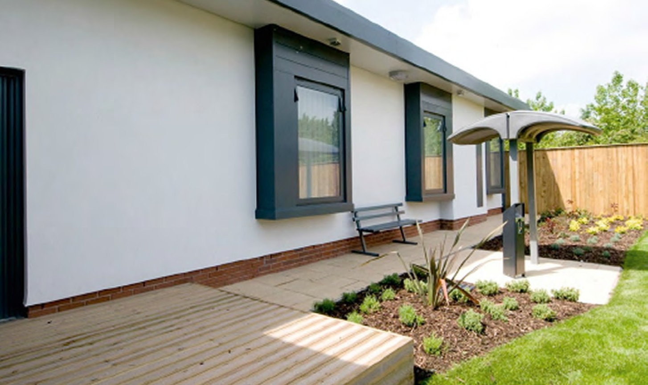

Sampling
All items included in the assessment framework and present in the area being assessed must be included.
However, the notion of sampling is well established, and it is not necessary to look at every item in every area in order to determine the score to be awarded.
Where there is only one of a specific item – for example a floor – it should assessed in full.
However, where there are multiples of the same item (for example beds or over-bed tables), assessing teams should assess sufficient of
each to be able to reach a reasonable judgement on the likely condition of all those items not seen. This should be determined by the assessors at the time, and should follow the simple rule ‘Have we seen enough to be sure it’s clean enough?’
Where the items present a mix of pass, qualified pass and fail, the team will need to assess as many items as necessary until such time as assessors feel they have seen sufficient to
judge between a qualified pass and a fail.

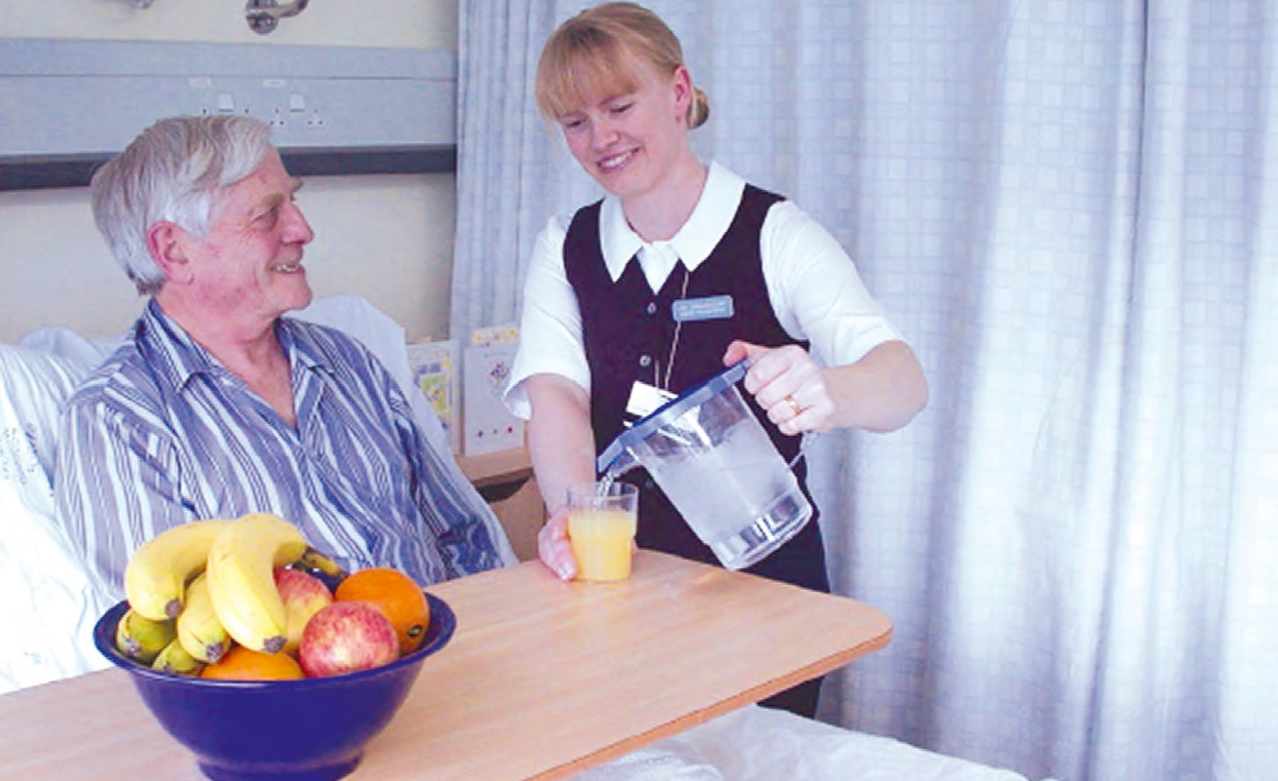

Scoring
To achieve a pass, all aspects of all items must meet the definition/guidance as set out in the assessment form. There is no margin whereby an item can fail to meet the required standard
There are a range of scoring approaches depending on the area and aspect being assessed. They are:
Cleanliness PASS/QUALIFIED PASS/FAIL
Y/N

and still achieve a pass.
It is not possible to set out the point at which a qualified pass becomes a fail. Those undertaking the assessment need to exercise judgement.
Teams will therefore need, through discussion, to agree which score to apply where it is obvious that a pass is not appropriate. For example, a
Buildings and facilities

Privacy, dignity and wellbeing
PASS/QUALIFIED PASS/FAIL

Y/N
AN ANSWER TO BE SELECTED FROM A PREDETERMINED LIST OF OPTIONS

small amount of fluff on a floor should not be
deemed as a fail, but fluff under every bed and/ or in every corner would be a fail. Similarly, a small amount of spilled liquid would not be a fail, but any bodily substances – blood, faeces, urine etc – on any surface would constitute a fail regardless of the quantity or frequency.
Where separate teams assess different areas of the site/organisation, the scores should be agreed by each team. It is recommended that:
- each team score as they go – final scores for each ward or area should be agreed at the conclusion of the assessment of that ward/ area before moving to the next. (NB: this does not apply to internal areas, where a single score reflecting all similar areas seen is still required – see below);
- no member of the team should assess any area alone, so that any faults or shortfalls are agreed by at least two people. NB – patient assessors should never be allowed to undertake assessments, or parts of an assessment, unaccompanied.
Other areas – for example corridors, lifts, public toilets – can be aggregated for the purpose of agreeing a final score. The score awarded should reflect the standards found across all those seen – this will inevitably require teams to exercise a degree of judgement.
Dementia Y/N
Food Y/N
AN ANSWER TO BE SELECTED FROM A PREDETERMINED LIST OF OPTIONS
GOOD, ACCEPTABLE OR POOR (THE FOOD QUALITY ASSESSMENT ONLY)

More guidance on scoring is included in the assessment forms.
The scoring guidance should be applied consistently across all areas.

Completing the assessment forms There is no single assessment form; rather, there are a series of separate assessment forms specific to each area (see list below). A separate
assessment form should be completed for each ward/area, out-patient area (except where all out-patient areas are served by a single
reception/waiting area, where a single form may be completed) and emergency department or minor injuries unit. A single assessment form for internal and external areas should be completed, with the scores being agreed by the assessors to reflect the totality of areas seen
(for example corridors).
- organisation and assessment details;
- organisational questions – food;
- organisational questions – facilities;
- organisational questions – food and drink - treatment centres
- ward assessment acute/community, hospices and treatment centres;
- ward assessment mental health/learning disabilities;
- emergency departments/minor injuries units;
- out-patients areas;
- external areas;
- communal areas;
- ward food – assessment;
- patient assessment summary sheet.
The forms may be completed by exception during the assessment (i.e. only enter a mark on the form where a qualified pass, fail or no response needs to be recorded).
Sites/organisations should consider the need to provide the assessment forms and supporting guidance documents in large print/other formats, and alternative languages, as appropriate to the local population using the service.

Food and hydration assessment
Each organisation must decide for itself the levels of service (for example choice) it wishes to provide, but these decisions will inevitably be reflected in the outcome of the assessment.
Clear criteria allow organisations to plan service developments, but do not compel them to do so.
Those questions which are for answer by the assessing team can only be answered through observation, tasting, and occasionally asking patients (for example, finding out whether a patient received the meal they ordered). Teams should base their scoring on what is observed and said rather than relying on statements of policy or assertions of what usually happens. If something does not happen on the day of the assessment, this must be reflected in the assessment regardless of what policies or practices may be in place. This means that the assessors should ideally:
- undertake the assessment on the ward, from the same food as provided to patients. The practice of sampling food in a separate area with food specifically provided to assessors is not acceptable;
- if possible, assess both the lunchtime and evening meal services to obtain a rounded view and to improve the accuracy of the assessment. It is recognised that this may not be feasible in small units; however, in large hospitals or trusts where there are multiple sites it should be possible to ensure that different mealtimes are assessed in different units;
- taste food at the end of the patient meal service to ensure that temperatures have been maintained at an acceptable level for the last patient to be served;
- wherever possible taste all meals on offer rather than only a selection – not everyone in the team has to try everything, but at least two people should taste any single item so the score is not based one a single individual’s view;
- in the meantime, watch how food is served to check for the care taken in presentation; and
- observe how staff are involved in the meal service and how they provide help for those patients who require it.
At no stage of the food assessment should team members watch patients eat or in any other way disturb them whilst they are eating. Any questions, such as whether they received the meal they ordered, should not be asked until their meal
is finished.
It is also important that assessors, as far as possible, overcome their own likes and dislikes and remain objective. Where an individual has a particular dislike for specific foods, they should avoid assessing them. This can be a particular issue with spicy foods, where personal tolerance for example, levels of heat can widely vary. In these instances it may be helpful to seek the views of patients.
The food assessment should also, where appropriate, be undertaken on more than one ward/area, and the organisation of the assessment day should take this into account. The total number of wards/areas where food is assessed is for organisations to determine, but should follow the following minima:
- up to 6 wards – one
- 7–12 wards – two
- 13–18 wards – three
- 19–24 wards – four
- 25 or more wards – five
Where for any reason the food delivery model varies between wards/areas, assessing teams should try to ensure that each kind is assessed, though this may not always be practical/possible.
A separate assessment sheet should be completed in respect of each ward/area on which a food assessment is undertaken (however, the ‘Organisational questions relating to food service’ need be completed only once).
NB – where patient food is bought or cooked by the patients, there will be no need to undertake an assessment of food service, and in this situation organisations should select the ‘self- catering’ option. However, this option should only be selected where all patients are provided with food through this means, and where there is a mix of self-catering and other within an organisation, assessment should be undertaken in respect of those services provided by the site/ organisation.

The operation of Protected Mealtimes is part of the assessment, not a barrier to it. Since part of the assessment involves observation of compliance with Protected Mealtimes and staff involvement in food service, it is important that the assessment of food and service should take place at the time of the meal service. However, teams should be careful not to disturb patients during the meal. It should be possible to answer any questions either before or after the meal service.

