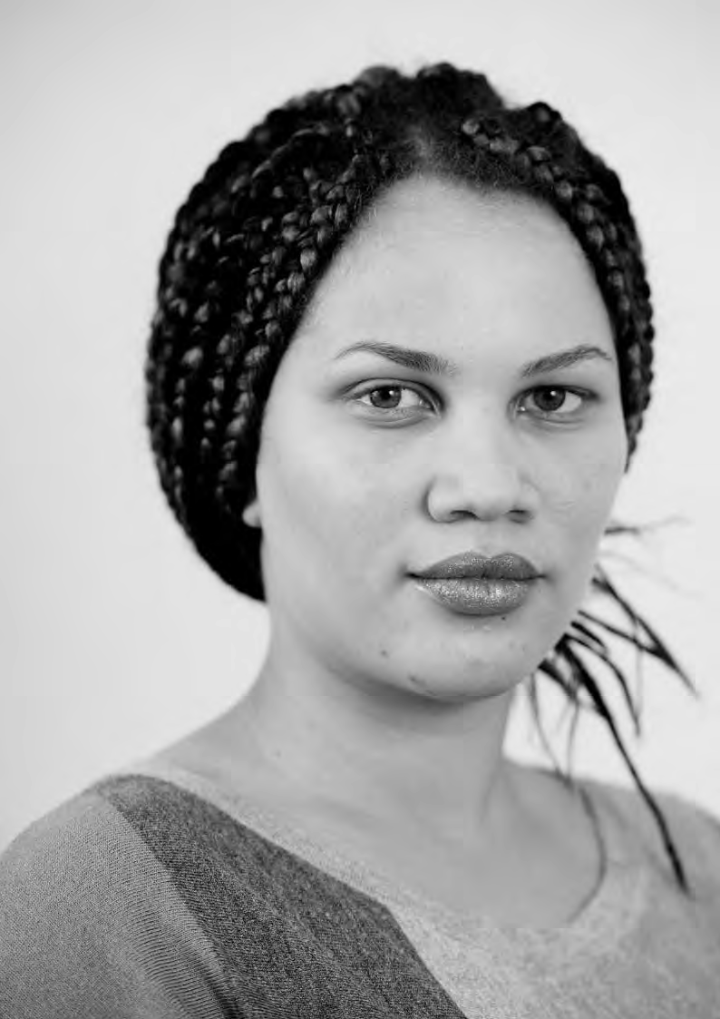

PATIENT-LED ASSESSMENTS OF THE CARE ENVIRONMENT ORGANISATIONAL QUESTIONS – FACILITIES

Organisational questions – facilities – this form to be completed by the Trust/Organisation

BUILDINGS AND FACILITIES
External Window Cleaning – the following questions for answer by all organisations | Enter Y against ONE OPTION  ONLY below
External windows are cleaned twice or more annually
External windows are cleaned once annually
External windows are not cleaned or are cleaned less than annually
Has the organisation assessed whether its signs (inside and outside the building) are appropriate for the patient population using the building – for answer by all organisations | Enter Y against ONE OPTION  ONLY below
Assessed and action taken
Assessed but no action taken yet
Not yet assessed
Access and Car Parking – the following questions for answer by all organisations | Enter Y, N or N/A
Has the organisation assessed the travel needs of patients and visitors to, and from the site and made appropriate arrangement s to provide for these e.g. through discussions with local public transport providers?
Are all spaces clearly marked and wide enough to make it easy to get into and out of vehicles?
Are spaces for disabled users appropriately located closest to building entrances?
Are spaces for patients and visitors located closer to the buildingl/entrance than staff parking? Note: “Not applicable” should be used where for any reason of security (e.g. in low, medium or secure units) visitor parking must be remote from the facility.
Are there ‘drop-off’ zones at all major entrances?
Note: N/A should only be used where due to the location of the building, it is not possible to provide drop off zones
Does the organisation charge for patient and visitor parking? If No, leave all others blank.
Is payment by Pay on Exit (i.e. only the actual parking time used is paid for)?
Is there clear information relating to parking charges and any management schemes, for example Parking Charge Notices that are in operation?
Is there clearly displayed information on parking charges?
Does the organisation provide car parking charge concessions in accordance with the NHS patient, visitor and staff car parking principles:-
https://www.gov.uk/government/publications/nhs-patient-visitor-and-staff-car- parking-principles/nhs-patient-visitor-and-staff-car-parking-principles
Is information about the concessionary scheme prominently publicised (e.g. on entry to car parks, adjacent to pay machines) and include details of how to apply/ who to contact?
Can payment be made by debit/credit card?
Can payment be made using notes?

Where pay machines only accept coins, do they give change?
Where pay machines only accept coins and do not provide change, can change be obtained, and is there clear information on how to do so?
Where Pay and Display is not in use, are payment facilities available inside or close to the main entrance?
Where pay machines are located outside, are they covered?
Safety for visually impaired patients/visitors – the following questions for answer by all organisations | Enter Y, N or N/A below
Where main entrance doors are glass, are there high-contrast markings?
Do all external steps have high visibility nosing?
Do all internal stairs have high visibility nosing?
PRIVACY, DIGNITY AND WELL-BEING
Internet Access – the following question to be answered by all organisations | Enter Y against ONE OPTION  ONLY below
Patients have free access to wifi throughout the building (except where not safe
for clinical care)
Patients have access to wifi throughout the building (except where not safe for
clinical care) but at a cost
Patients have access to the internet in designated areas only, either by wifi or
computers provided by the organisation
Patients do not have access to the internet
Access to the internet is inappropriate for all patients in the hospital/unit.
NOTE: This option should only be used where, due to the status of all patients (e.g. in a dementia unit) it would be inappropriate to provide internet access.
Television Subtitles | Enter Y or N below
Do all patient televisions (including those provided through third party contracts but excluding patients’ own TVs) have subtitle facilities?
Telephone Access – the following questions for answer by all organisations | Enter Y against ONE OPTION  ONLY below
All patients have access to a telephone for incoming and outgoing calls
All patients have access to a telephone for outgoing calls only
Note: this excludes patients own mobile phones
Recreation/Activity areas – the following questions for answer by all organisations | Enter Y, N or N/A below
Is/are there area(s)/room(s) designated exclusively for use as family/visiting? (N/A if 100% single rooms)
If No above, is/are there area(s)/room(s) not designated exclusively for family use but available for use as such? (if No, leave next blank)
Where Yes to either above, does/do the room(s)/area(s) provide an appropriate environment – for example appropriately furnished and decorated?
Is there a multi-faith/prayer room available? (N/A if 100% single rooms)

Is there a quiet room available (N/A if 100% single rooms)
Note: For multi-faith and quiet rooms, this doesn’t need to be a room dedicated for these specific purposes, but it must be appropriate and available on request (this would not include for example staff offices).
Recreation/Activity areas – the following questions for answer by Mental Health/Learning Disabilities organisations only | Enter Y, N or N/A below
Is there an internal area designated for and accessible only by women? (where the unit is women only, enter N/A)
Is/are there room(s)/area(s) designated for the purpose of activities and therapies?
Is there a quiet room available (if 100% single room provision select yes)?
Is/are there on-site indoor facilities dedicated for the purpose of physical activities (for example gym, games room)?
Note: where these would be inappropriate for all patients, N/A may be selected
Is/are there on-site outdoor facilities dedicated for the purpose of physical activities (for example football, basketball)?
Note: where these would be inappropriate for all patients, N/A may be selected
Is/are there off-site indoor areas (for example local recreational facilities) used for the purpose of physical activities (for example gym, games room)?
Note: where these would be inappropriate for all patients, N/A may be selected
Is/are there off-site outdoor areas (for example local recreational facilities) used for the purpose of physical activities (for example football, basketball)?
Note: where these would be inappropriate for all patients, N/A may be selected
Children’s In-patient Services – the following question to be answered by all organisations providing children’s in-patient services
Facilities for parents (including guardians) to stay overnight | Enter Y against ONE OPTION  ONLY below
Parents can choose to stay at the bedside or in a separate area
Parents facilities are only in areas away from the ward/area
Parents can only stay at the bedside
There are no facilities
 | Enter Y, N or N/A below
Are parents, relatives, guardians or carers able to access meals/snacks within the building at all times of the day and night?
Note: Availability of snacks, for example sandwiches/salads through vending machines is acceptable, but availability of confectionery/crisps etc only would not allow a Yes response)
Where the patient is a breast feeding baby – is the mother provided with food free of charge?
Is/are there indoor room(s)/area(s) either within wards or elsewhere (other than emergency department) dedicated to and equipped with age-appropriate equipment for the purpose of children’s activities and education?
Is/are there outdoor area(s) dedicated to and equipped with age-appropriate equipment for the purpose of children’s activities and education?
Are children provided with a range of equipment appropriate to their age, including a bedside TV, radio and telephone? (if No, answer next question N/A)

Where Yes above, are these provided free of charge?
Children’s emergency department – to be answered only by organisations which provide emergency department services | Enter Y against ONE OPTION  ONLY below
There is a dedicated children’s emergency department with its own entrance, reception and waiting area?*
There is a dedicated, separate children’s area within the emergency department with a separate waiting area?*
There is an area within the emergency department set aside for children, but this shares the main waiting area?*
There is no specific provision for children who use the same reception and waiting
area as all others
Where Yes to any marked * above, is the area appropriately decorated and equipped for the purpose of children’s activities?
Other – the following questions for answer by all organisations
Note: It is not the expectation that such facilities be available on every ward, but organisations should provide such a facility within, or close to, the building
Facilities for family, relatives, guardians or carers to stay overnight | Enter Y against ONE OPTION  ONLY below
Family, relatives, guardians or carers can choose to stay at the bedside or in a separate area
Family, relatives, guardians or carers can only stay in areas away from the ward/ area.
Family, relatives, guardians or carers can stay at the bedside only
There are no facilities
Due to the nature of the facility it is not appropriate for family, relatives, guardians or carers to stay overnight
 | Enter Y, N or N/A below
Are family, relatives, guardians or carers able to access meals/snacks within the building at all times of the day and night?
Note: Availability of snacks, for example sandwiches/salads through vending machines, is acceptable, but availability of confectionery/crisps etc only would not allow a Yes response
Equality Act 2010 – Equality Duty  Note: The Act places a legal duty on all service providers to take steps or make “reasonable adjustments” in order to avoid putting a disabled person at a substantial disadvantage when compared to a person who is not disabled | Enter Y against ONE OPTION  ONLY below
The organisation has undertaken an assessment of its environment, made all reasonable adjustments, and this has been signed off at Board level
The organisation has undertaken an assessment of its environment and is in the process of making all reasonable adjustments, and this has been signed off at Board level

The organisation has not undertaken an assessment of its environment, or has undertaken an assessment but is not actively working to make all reasonable adjustments
Note: For the purposes of the PLACE assessments, all organisations should answer these questions regardless of whether or not the requirements of the Public Sector Equality Duty apply to them, since the requirements are deemed to represent good practice for all healthcare providers. The Equality Act 2010 supersedes the Disability Discrimination
Act 1995.

