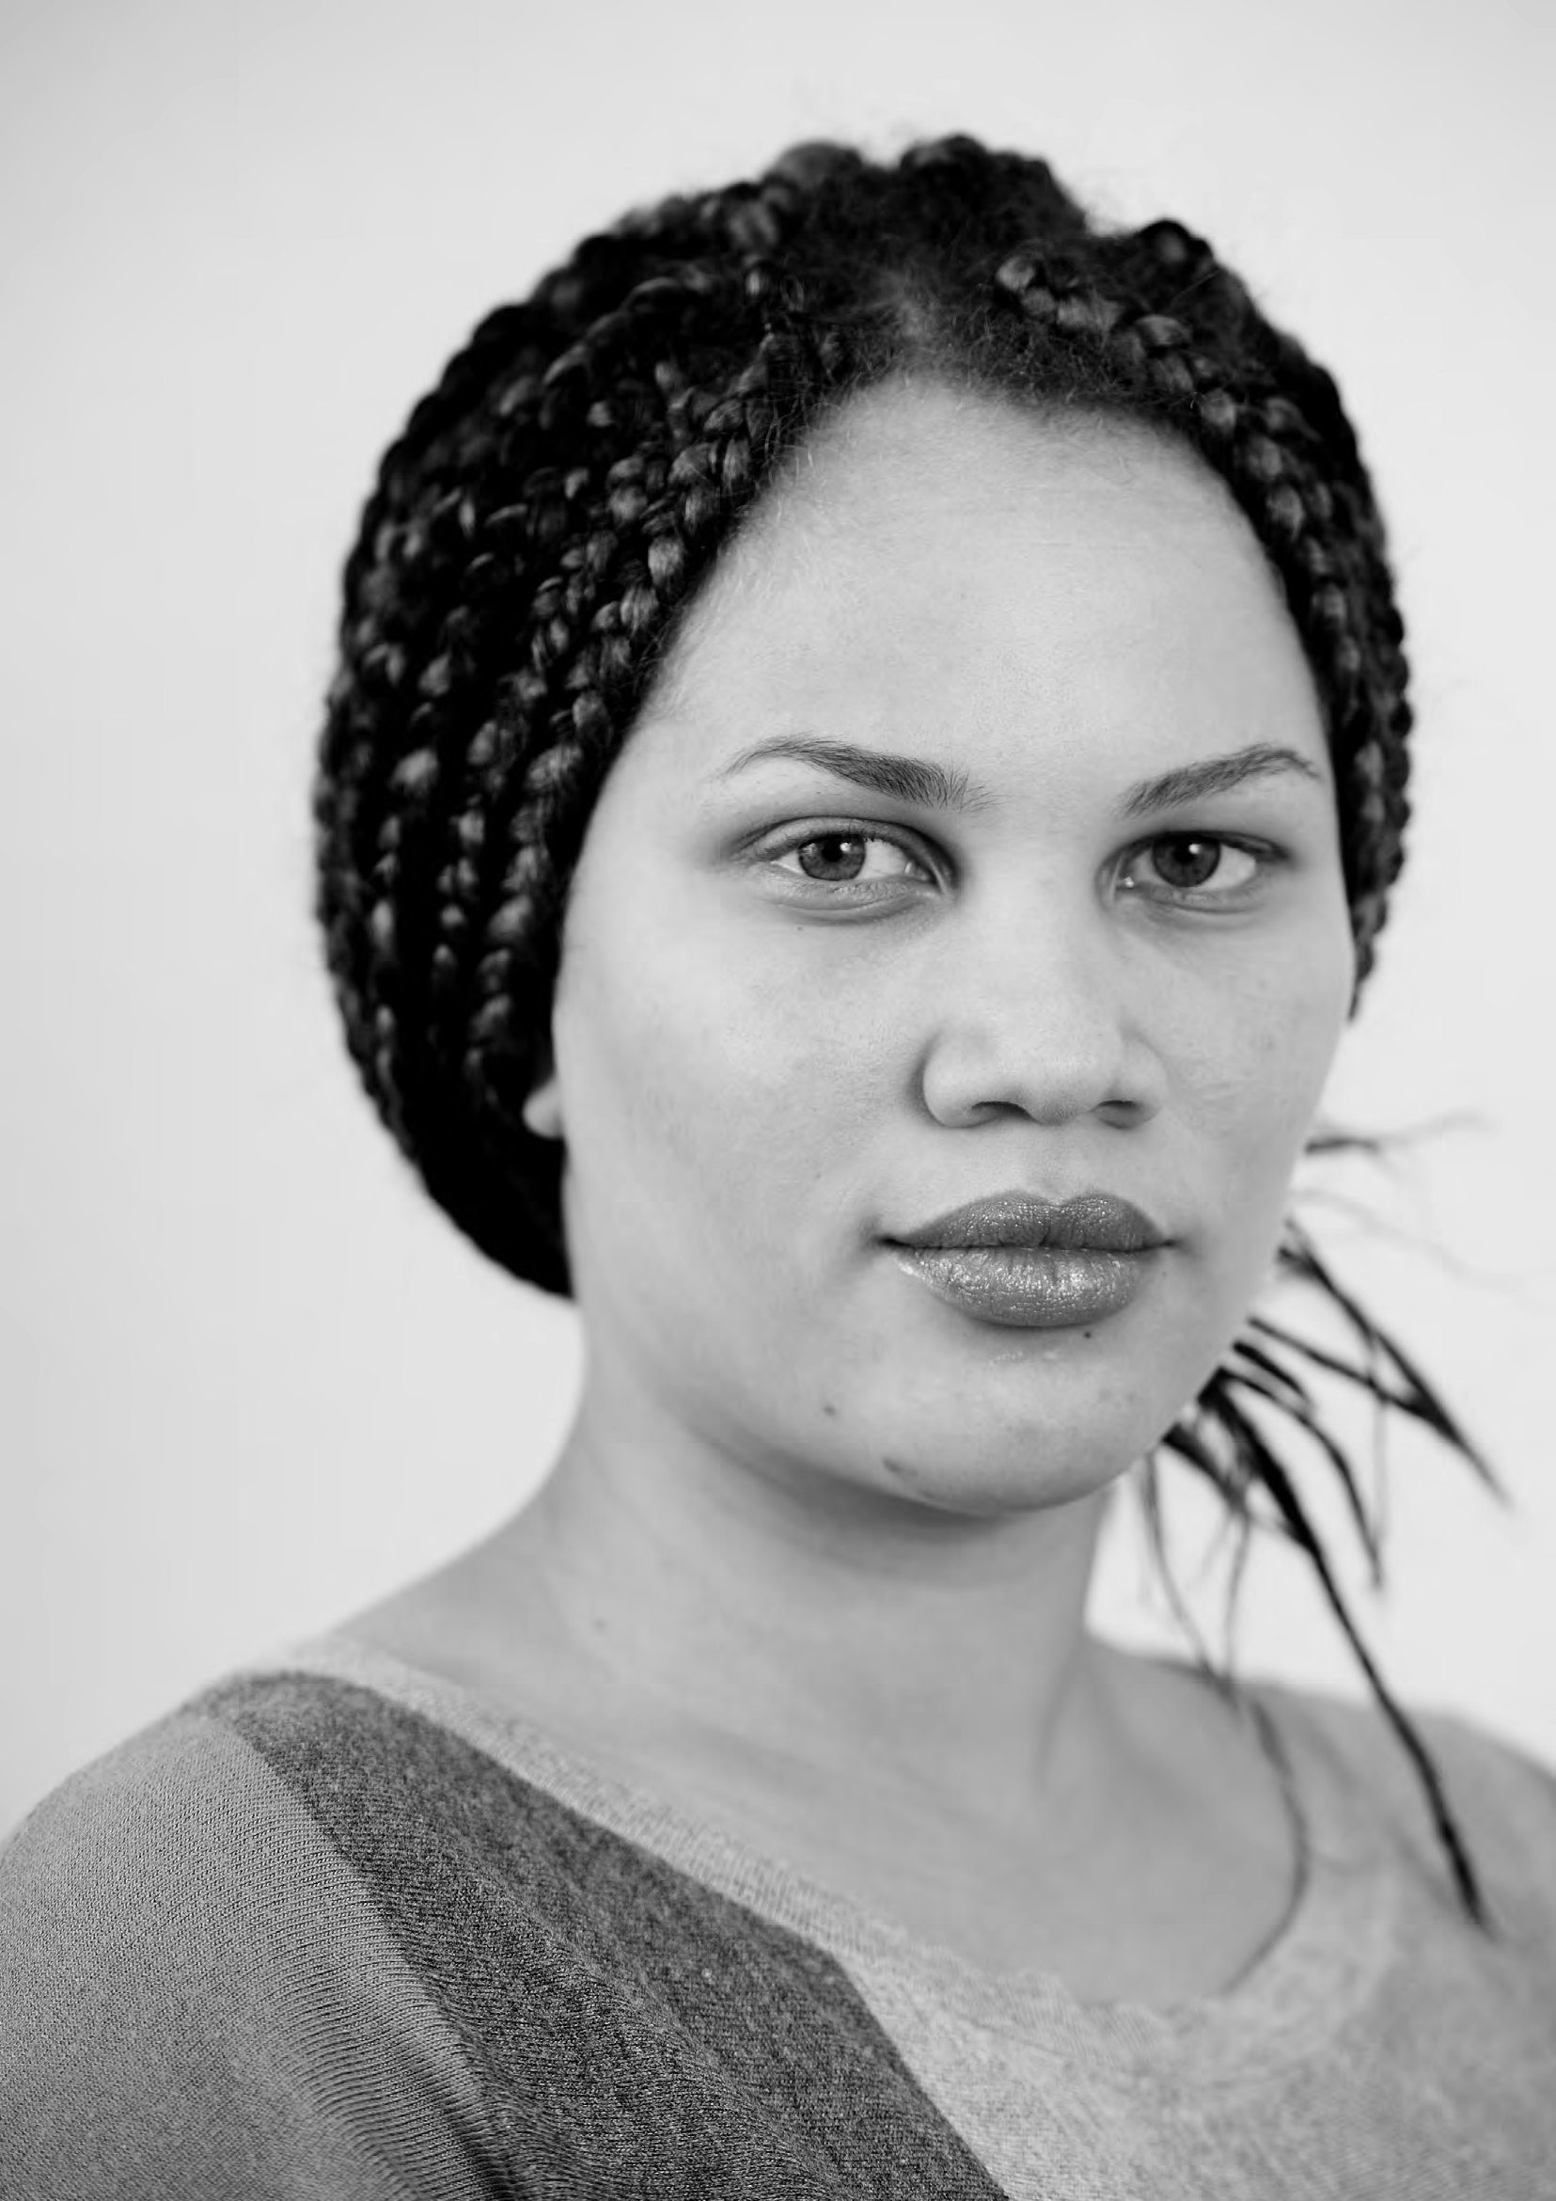

PATIENT-LED ASSESSMENTS OF THE CARE ENVIRONMENT PATIENT ASSESSMENT SUMMARY SHEET

Patient Assessment Summary Sheet

For completion by Patient Assessors only

Name of Trust/organisation

Name of hospital/site

About the assessment
- Do you feel that sufficient time was allowed to undertake a thorough assessment? | Yes/No | If No, please provide brief details here
- Do you feel that staff took notice of your views and comments? | Yes/No | If No, please provide brief details here
- Were you at any time put under pressure to agree with something that you did not agree with? | Yes/No | If Yes, please provide brief details here
- Did you feel sufficiently prepared to undertake the assessment? | Yes/No | If No, please provide brief details here

About the building
Thinking about the cleanliness of the building, is there anything you would like to say which the assessment form did not allow for? This would include any specific improvements you would like to see take place in the coming year.
Thinking about the tidiness of the building, is there anything you would like to say which the assessment form did not allow for? This would include any specific improvements you would like to see take place in the coming year.
Thinking about the general condition of the inside areas of the building – things like decoration, the condition of floors and floor covering, general maintenance – is there anything you would like to say which the assessment form did not allow for? This would include any specific improvements you would like to see take place in the coming year.

Thinking about the general condition of the outside areas of the building – things like maintenance of the buildings and grounds/ gardens, or the condition of paths or roads around the site – is there anything you would like to say which the assessment form did
not allow for? This would include any specific improvements you would like to see take place in the coming year.
Thinking about the way in which the organisation ensures that patients and visitors are treated with dignity (for example how they are dressed) and that they are provided with appropriate privacy (for example things like personal conversations with staff or their family), is
there anything you would like to say which the assessment form did not allow for? This would include any specific improvements you would like to see take place in the coming year.
Thinking about the food and drinks available, is there anything you would like to say which the assessment form did not allow for? This might include things like having an extra hot dish available at mealtime, or a wider range of drinks. This would include any specific
improvements you would like to see take place in the coming year.

Summary statement
Finally, in as few words as possible, please write a summary statement which you feel accurately reflects the building/site as a whole. There is no need to go into specific details here. Some examples are included below to assist you.

Examples

A modern building with good cleanliness, well maintained and where patients are treated with dignity and respect, and where the food service is generally good.

A hospital with a number of buildings of different ages and where standards of cleanliness vary. Some of the older buildings are not in a good state of repair, and signage is poor. The food service is excellent.

An old building that faces considerable challenges in maintaining the fabric of the building, but where nevertheless standards of cleanliness and maintenance are high and the food service is good. However, the age of the building(s) means it is difficult to provide a suitable environment in which to respect patients’ privacy and dignity.

Anything else?
During the course of the assessment, you may have seen other things that you wish to draw to the site/organisation’s attention, but which do not form part of the PLACE process.

There could be something good you have seen, or something that you saw that upset you or that you didn’t like. Please use the box below to report this. Please try to be specific about what you saw and where you saw it.

This form, once completed, should be signed by one patient assessor on behalf of all others. The completed form should then be handed to the hospital for entry into the reporting system. If desired, a copy may also be sent to the PLACE team at the address below.

Signed
Print Name

If there is anything else you would like to say about any aspect of the assessment you were part of, but which you did not want or feel able to say at the time, you can write to us in complete confidence either by email to place@ic.nhs.uk or in writing to:

Place team
Health and social care information centre Trevelyan Square
Leeds Ls1 6AE

