Standard narrative for Trust’s own Open and Honest Care webpage where monthly reports will be uploaded:

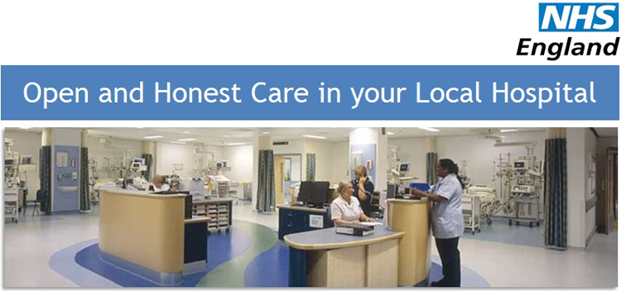
We are one of a number of NHS organisations who want to be open and honest with our patients. This is how a modern NHS hospital should be – open and accountable to the public and patients and always driving improvements in care. As a member of the Open and Honest Care: Driving Improvement programme we continue to work with patients and staff to provide open and honest care, and through implementing quality improvements, further reduce the harm that patients sometimes experience when they are in our care. We have made a commitment to publish a set of patient outcomes, patient experience and staff experience measures so that patients and the public can see how we are performing in these areas. Each month we collaborate with other care providers to share what we have learned and to use this information to identify where changes can be made to improve care.
Please click on the links below to view our monthly reports:

