Publication of 2014/15 CCGC data set
August 2015
Background to publication of data
The National Information Infrastructure project aims to make data from across government available to the public via the data.gov website wherever possible. NHS England is publishing information from the Clinical Commissioning Group Consolidation (CCGC) files for the first time in 2014/15. The information published is from the CCGC files for 2014/15 as submitted to us by Clinical Commissioning Groups on 29 May 2015.
What is being published
The CCGC files contain a Clinical Commissioning Groups’ accounts data, together with other information to aid our consolidation of the accounts, and additional information required by the Department of Health. Where a Clinical Commissioning Group prepares consolidated accounts the CCGC contains only the group figures from the Clinical Commissioning Groups’ consolidated accounts. The data set published here is limited to the CCGC information that Clinical Commissioning Groups are required to include in their annual accounts. The information contained in this file is already available in individual Clinical Commissioning Groups’ annual reports as laid before Parliament and published on the Clinical Commissioning Groups’ website. The intention of this data file is to make this data easier to locate and manipulate.
This file does not contain consolidation adjustments we make in preparing the consolidated accounts. Upon consolidation NHS England makes adjustments including eliminating income and expenditure between CCG’s. For this reason the totals of the data included in this file will not agree to the NHS England Consolidated Group Accounts.
How to use this data file
Two files have been published, which should be used together:
- the data file, containing all of the CCGC data published in the accounts of the 211 Clinical Commissioning Groups as at 31 March 2015; and
- an illustrative CCGC file to assist the user in understanding the data being presented.
Every item of data in a CCGC file is uniquely referenced by its MainCode and SubCode. These can be seen in the illustrative CCGC file: MainCode appear at the top of the columns in each table, and SubCode appears at the right of each row. Data can also be filtered by WorksheetName and Table ID, only a MainCode and SubCode are required as a minimum to identify a piece of data. The TableID identifies each table on a particular sheet. This is useful if the user wishes to view a whole table of data for a particular Clinical Commissioning Group. The data for each MainCode and SubCode combination is presented for each of the 211 Clinical Commissioning Group.

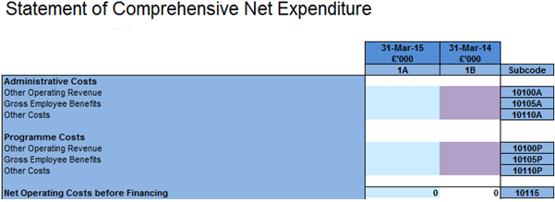
SubCode
MainCode
The data file contains a tab of all the data which can be filtered as required. The data file also provides two pivot tables which provide alternative ways of viewing the same data set. These are explored further below.
This method of presenting the data is required given the need to present both rows and columns of data for multiple Clinical Commissioning Groups.
Example 1: Viewing a table of data for a particular Clinical Commissioning Group
- Use the Illustrative CCGC file to identify the desired table. For example the table of Comprehensive Net Expenditure is on worksheet ‘SoCNE’ and on that worksheet it has the TableID ‘1’.
- Alternatively the MainCode of 1A, 1Bcould be selected instead of the TableID.
- In the data file, the tab ‘Pivot – whole table for one CCG is used, with the following parameters:
- WorkSheetName is set to ‘SoCNE’
- TableID is set to ‘1’.
- The desired Clinical Commissioning Group is selected from ‘OrganisationName’.
- Check that the MainCode and SubCode fields are set to ‘select all’.
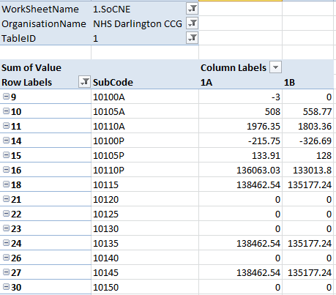
The RowID field represents the order in which the rows of data appear in the CCGC file, and its inclusion helps ensure that the data is shown in the same order as the physical file. Data should not be selected based on row ID but inclusion of this field in the pivot table is useful where SubCode is not used in sequential order in the CCGC file.
Example 2: Viewing data items for all Clinical Commissioning Groups
- Use the Illustrative CCGC file to identify the desired data item(s). For example if we want to see Clinical Commissioning Groups’ Net operating costs before finance, 2014/15, this is on worksheet ‘SoCNE’ with MainCode ‘01A’ and SubCode ‘10115’. The TableID is not required as the MainCode and SubCode combination is sufficient.
- In the data file, the tab ‘Pivot – data item(s) for all CCGs’ is used, with the following parameters:
- MainCode is set to ‘01A’
- SubCode is set to ‘10115’
