My Care (Education) and Treatment Review
Planner

This planner belongs to …
(You can write, type or put your photo here)

What is this information about?
C(E)TR | This information is to help you plan for your Care (Education) and Treatment Review.
 | Your Care (Education) and Treatment Review should be a good experience for you and a chance for you to have your voice heard.
 | Filling out this planner will help you to speak up about what is important to you, your care and your future.
 | In your Care (Education) and Treatment Review your voice is the one that matters the most.
What you say will be listened to.

You can share what is working well or if you have any worries about your care and safety.

What is a Care (Education)and Treatment Review?
A Care (Education) and Treatment Review is called a C(E)TR for short.

If a child or young person has a C(E)TR, this will include education.

C(E)TRs are for people with a learning disability and autistic people with mental health issues who live in the community or in learning disability or mental health hospitals.

C(E)TRs help to make care better for people with a learning disability and autistic people.
A C(E)TR is a review, or check, to support people with a learning disability and autistic people with mental health issues to get:
- the right care
- at the right time
- in the right place

You can use the policy and guide to help plan for your C(E)TR-
NHS England » Dynamic support register and Care (Education) and Treatment Review policy and guide

The full link is on the last page of this planner.

The policy and guide will help you understand more about C(E)TRs and why they are important for you.

You can also find the policy and guide on NHS England’s website.

You can ask someone who supports you to help you with the information.

What happens in a Care (Education) and Treatment Review?
CTR | You are the most important person in your C(E)TR, so it is good to be there if you can.
The C(E)TR panel review your care and support.

The people on the panel are not involved in your everyday care.

The panel need to know if you are getting good care and support, so it is important that they know what you think about it.

They will ask other people involved in your care too.

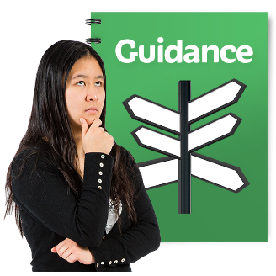 | The C(E)TR panel is there to offer advice and guidance.  They cannot make decisions like deciding to change your medication or legal restrictions.
The panel will look at information about you.

This will include:
- your care
- the people that are supporting you
- plans for your future
 | If you are under 25 years old the C(E)TR will also include your education.
You can bring a copy of this planner to your C(E)TR.

It will help you remember what you want to say.
You can decide on the day if you want to be there or not.

If you don’t want to attend, someone can take your planner into the C(E)TR for you.

The panel will write a report after your C(E)TR to say what should happen next.

You should get your report within 2 weeks of the C(E)TR.

 | There is space at the end of this planner for you to write down any questions.

Ask, Listen, Do- feedback, concerns and complaints
You might want to give some feedback or raise a concern or a complaint before or after your C(E)TR.
‘Ask, Listen, Do’ can make it easier for you to tell people what you think about your care, support, or a service.
You can find out more about ‘Ask, Listen, Do’ using this link-

NHS England » Ask Listen Do – feedback, concerns and complaints
‘Ask, Listen, Do’ is about people listening to you to make your care, support or education better.
You can ask someone you trust to help you if you want to give feedback or raise a concern or complaint.

Giving Your Consent
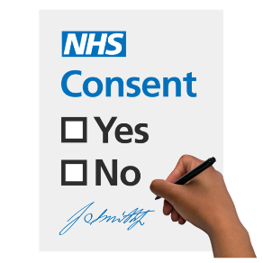 | Consent means giving permission for something to happen.  The person arranging your C(E)TR must ask if you are happy for the C(E)TR to happen.
You should be given all the help you need to decide if you want to have a C(E)TR.

If you say no this means you do not give your consent.

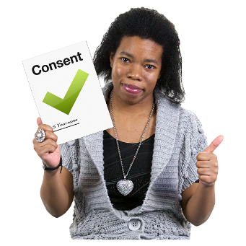 | Every time you have a C(E)TR you will be asked for your permission.
 | If you can’t make the decision yourself someone else might have to decide if you should have a C(E)TR.
 | If you are younger than 16 years old a parent or guardian will make the decision about a C(E)TR for you.
You can read more about what consent means in the policy and guide-
NHS England » Dynamic support register and Care (Education) and Treatment Review policy and guide
Planning your C(E)TR
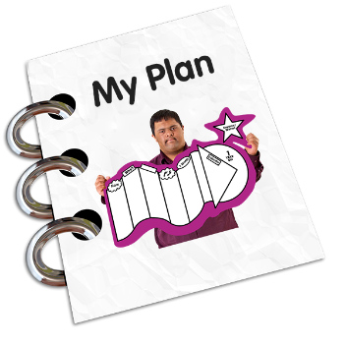
The panel want to know what YOU think about your care and treatment. You can use the next few pages to plan for your C(E)TR.
Some of the questions might be hard to answer but you can ask someone you trust to help you.

If someone is helping you fill out this planner, they can put their name and the date below.
Supporters name:

Date:

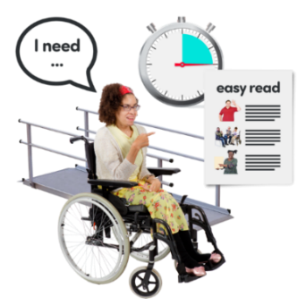
Do you need any support in your C(E)TR?
This might be things like having information in Easy Read, having a supporter, or meeting the panel members on their own.

There might be things that you do in the week that you don’t want to miss.
Please tell us in the box below what days and times work best for you.

 | Monday | Tuesday | Wednesday | Thursday | Friday
Morning
Afternoon

Where would be the best place to have the C(E)TR? This could be in a meeting room or on a virtual meeting.

You might have a lot of meetings about your care and treatment.
Do you want your C(E)TR on the same day as another meeting?
No ☐
Yes ☐
If you answered ‘yes’, which meeting do you want to have on the same day?

The people arranging your C(E)TR will try to make this happen for you.

You can invite people to your C(E)TR if you would like, this might be family members, someone else important to you or an advocate.
An advocate is someone who can support you to say what is important to you.
You can add the details of people you would like to invite in this box.
Person | Contact Number | Contact Email

Finding out about you and what is important in your life

Who is important to you? This could be people in your family, your friends or people who support you.

What things are important to you? This could be things like your religion, your pets, your diet or your hobbies.

Are you able to do the things that are important to you? Answer by marking a box.

Never | Sometimes | Most of the time | All of the time
What support do you need to help you do what is important to you?

Plans and hopes for your future
This is where you can think about your future and the things that you would like to do.
What are your hopes and dreams for the future? This could be where you want to live, education, work or what you want to achieve in your life.

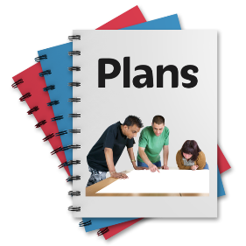
What plans are in place for your future?

What do you think about the plans that are in place?

Feeling safe
Everyone has the right to feel safe. If you feel unsafe or worried about anything, you should tell someone you trust.
What helps you feel safe? This could be things that make you feel happy and relaxed.

Are you worried about anything at the moment?

Your Care
It is important that you get good care and feel supported.

Do you feel you are getting the right care and support from the services that help you to live a good life? Answer by marking a box.

Never | Sometimes | Most of the time | All the time

Is there anything you would like to say about your care and support? This could be what you are pleased with, what you are struggling with or what you would like to happen.

How do you feel physically? This could be around feeling unwell, being in pain or if something doesn’t feel right in your body.

Is there anything else you would like to say or ask?

More Information
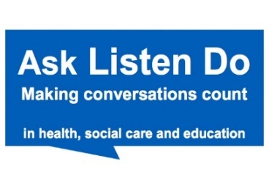 | Ask Listen Do  https://www.england.nhs.uk/learning-disabilities/about/ask-listen-do/
Dynamic Support Register and Care (Education) and Treatment Review policy and guide

https://www.england.nhs.uk/publication/dynamic-support-register-and-care-education-and-treatment-review-policy-and-guide/#heading-1

We hope that this planner helps you to have a good C(E)TR.
This planner was co-produced by Experts by Experience from Inclusion North.

