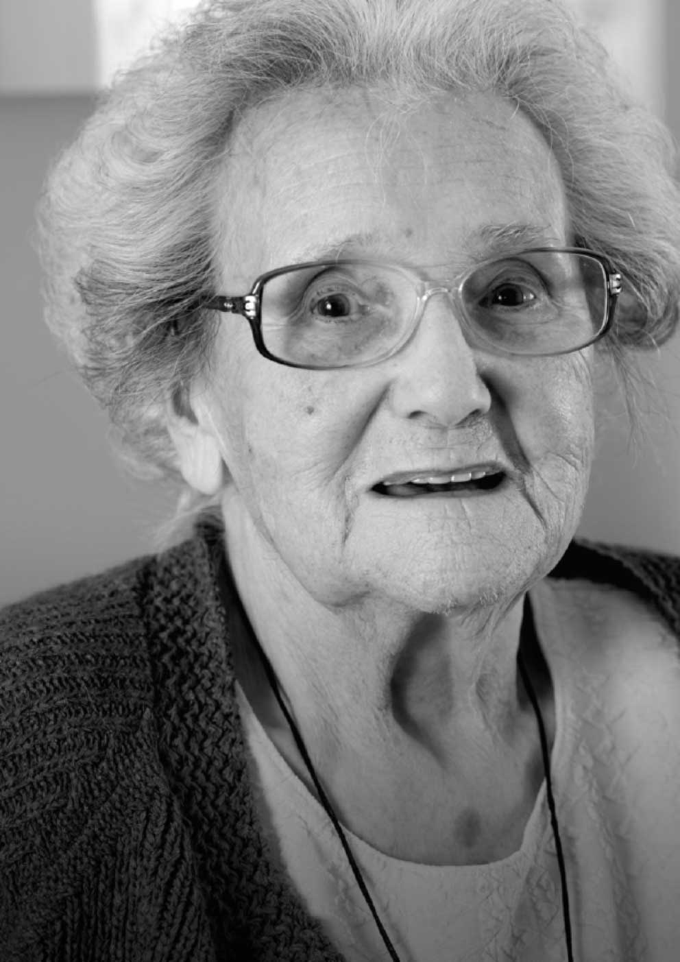

Terms of reference
Standard Setting for Accessible Information Advisory Group
Document filename:
Standard Setting for Accessible Information Advisory Group Terms of Reference
Directorate / programme | Nursing | Project | Accessible Information Standard
Document reference
Project manager | Sarah Marsay | Status | Final
Owner | Olivia Butterworth | Version | 1.3
Author | Sarah Marsay | Version issue date | 07/02/2017

Terms of reference

Standard Setting for Accessible Information
Advisory Group

Contents
Contents 3
1 Document management 4
1.1 Revision history 4
1.2 Approved by 4
1.3 Document control 4
2 Introduction and context 5
3 General responsibilities of the advisory group 5
4 Governance, leadership and accountability 6
4.1 Accountability 6
4.2 Senior responsible owner (SRO) 6
5 Membership 6
5.1 Membership of the group 6
5.2 Expectations of members, quoracy and co-option 7
5.3 Skills and attributes of members 7
6 Meeting arrangements 8
6.1 Frequency of meetings 8
6.2 Standing agenda 8
6.3 Secretariat 8
6.4 Location of meetings 8

Document management

Revision history
Version | Date | Summary of changes
0.1 | April 2013 | Initial version
0.2 | May 2013 | Second draft following first meeting of the Group
0.3 | June 2013 | First approved version
0.4 | December 2013 | Revised to reflect changes in membership
0.5 | March 2014 | Revised to reflect changes in membership
0.6 | August 2015 | Reformatted and revised to reflect approval of the Accessible Information Standard
0.7 | August 2015 | Revised following input from the Group
0.8 | September 2015 | Revised following input from the Group
0.9 | September 2015 | Version as approved by the Group
1.0 | February 2016 | Revised to reflect changes in membership
1.1 | October 2016 | Revised to reflect changes in membership
1.2 | November 2016 | Revised to reflect changes in membership
1.3 | February 2017 | Revised to reflect change in membership

Approved by
This document must be approved by the following people:
Name | Signature | Title | Date | Version
Standard Setting for Accessible Information Advisory Group | N/A | N/A | 07.02.17 | 1.3
Olivia Butterworth | Olivia Butterworth | Head of Public Participation, NHS England | 07.02.17 | 1.3

Document control
The controlled copy of this document is maintained by NHS England. Any copies of this document held outside of that area, in whatever format (e.g. paper, email attachment), are considered to have passed out of control and should be checked for currency and validity.

Introduction and context

The Standard Setting for Accessible Information Advisory Group was initially established in spring 2013. Its founding purpose was to guide the development and implementation of an Information Standard or programme of Standards for the provision of appropriate communications support, advocacy, and personalised, accessible information to disabled people by health and care organisations.

Following approval of SCCI1605 Accessible Information – the ‘Accessible Information Standard’ – the Group will focus on supporting and assuring implementation of the Standard, ongoing maintenance and review. It will also make recommendations to NHS England and others with regards to developing and promoting the role of high quality, accessible information as a key driver in ensuring that patients are able to be active participants in their own health and care.

Further detail about the role and remit of the Group is outlined below.

General responsibilities of the advisory group

The Advisory Group is responsible for:

- Determining the scope of the standard(s) required to deliver accessible, personalised information, communications support and advocacy for disabled patients, service users and carers, and supporting rationale;

- Representing the views of affected groups, including disabled people and people with experience of sensory loss, their families and carers;

- Advising on the prioritisation of key aspects of the programme and timetable for rollout;

- Providing a forum for critical challenge of key assumptions and recommendations associated with the provision of appropriate communications support, advocacy, and personalised, accessible information to disabled people by health and care organisations;

- Sharing specialist expertise, knowledge and insight to enable the Accessible Information Standard to be effectively developed and implemented;

- Overseeing maintenance and review of the Accessible Information Standard and inputting into key documents prior to submission to the Standardisation Committee for Care Information / other relevant bodies;

- Acting as an initial reference point and source of expertise to inform other relevant NHS England initiatives and programmes, providing advice and insight around accessible information and communication support.

Governance, leadership and accountability

Accountability
As an advisory body, the role of the group will include making recommendations for consideration by NHS England and others.

The Accessible Information Standard programme will follow the formal approvals process of the Standardisation Committee for Care Information.

The Group will be formally accountable to the Board of NHS England through the Patient and Public Participation Oversight Group.

Senior responsible owner (SRO)
The Senior Responsible Owner (SRO) is responsible for:
- Chairing meetings and deciding upon the frequency of meetings required;

- Providing strategic direction and decision making;

- Ensuring the group achieves its overall objectives and delivers the anticipated benefits;

- Monitoring the progress of the programme;

- Escalating issues as necessary and in a timely manner.

Membership

Membership of the group
Representing NHS England:

- Olivia Butterworth, Head of Public Participation (Senior Responsible Owner).
- Sarah Marsay, Public Engagement Manager (Business Lead for SCCI1605 Accessible Information).

Representing public sector partners:

- Stuart Cameron-Strickland, Head of Policy Performance and Improvement – Adult Social Care, Leeds City Council (representing the Association of Directors of Adult Social Services (ADASS)).
- Margaret Flaws, Senior Equality and Human Rights Officer, Care Quality Commission (CQC).
- Toto Gronlund, Business Intelligence and Benefits, NHS Digital.
- Rob Dickman, Senior Policy Manager, Department of Health.

Representing professional bodies:

- Helene Feger, Director of Strategy, Communications and Engagement, Professional Records Standards Body (PRSB).
- Mohamed Jogi, Deputy Head of Diversity and Inclusion, NHS Employers (representing the NHS Confederation).

Representing voluntary sector organisations working with affected groups:

- Tom Bailey, Research and Policy Officer, Action on Hearing Loss.
- Philipa Bragman, Chief Executive Officer, CHANGE.
- Catherine Carter , Lead Trainer, CHANGE.
- Hugh Huddy, Policy and Campaigns Manager, Royal National Institute of Blind people (RNIB).
- Sarah White, Policy and Partnerships Manager (Health), Sense.

Patient and Public Involvement (PPI) members:

- Dr Howard Leicester.
- John Taylor.

Expectations of members, quoracy and co-option
Consideration will be given by the Group to the co-option or involvement of additional members, identified for their particular expertise in a relevant area at appropriate times.

The Group will be chaired by Olivia Butterworth in her role as Senior Responsible Owner for the Accessible Information Standard. Secretarial support for the Group will be provided by Sarah Marsay in her role as Business Lead for the Standard.

A meeting of the Group will be considered quorate when a minimum of 50% of members are in attendance, including at least one representative from each of NHS England, public sector partners, PPI and the voluntary sector.

Members of the Group identified as representing an organisation will be expected to input views on behalf of their organisation and the group(s), communities and / or members that the organisation represents.

PPI Members will be expected to input views from a ‘patient / carer’ perspective, as well as to contribute their own experience and opinions. In particular, PPI Members will be expected to input views on behalf of groups not otherwise represented on the Group.

All members will be expected to disseminate relevant information to their members (where applicable) and networks, and to support wider engagement.

Skills and attributes of members
Members should be able to:
- Demonstrate a personal commitment to improving the accessibility of NHS and adult social care information and communication;

- Understand and act on those factors that affect the provision of accessible information and communication by NHS and adult social care providers;

- Develop and support relationships with colleagues and stakeholders with an interest in accessible information and communication;

- Be aware of the broader agenda with regards to accessibility within the NHS and beyond.

Meeting arrangements

Frequency of meetings
Meetings will usually be held on a bimonthly basis. However, the frequency of meetings will vary to enable flexibility in order to effectively progress with relevant objectives or actions.
Teleconferencing facilities will be utilised wherever possible, and input sought from members electronically where this is appropriate.

Standing agenda
The standing agenda for meetings will include:

- Welcome, introductions and apologies;

- Declaration of interests as relevant to the agenda;

- Minutes of the previous meeting – for approval;

- Matters arising from the previous meeting;

- Updates on agreed actions;

- Any other business;

- Next steps.

Secretariat
Secretariat support for the group will be provided by Sarah Marsay, Public Engagement Manager, NHS England.

Location of meetings
During 2016 / 2017, meetings of the Group will be held wherever possible at NHS England, Quarry House, Leeds.

