Our shared purpose

Leadership by all
Spread and adoption
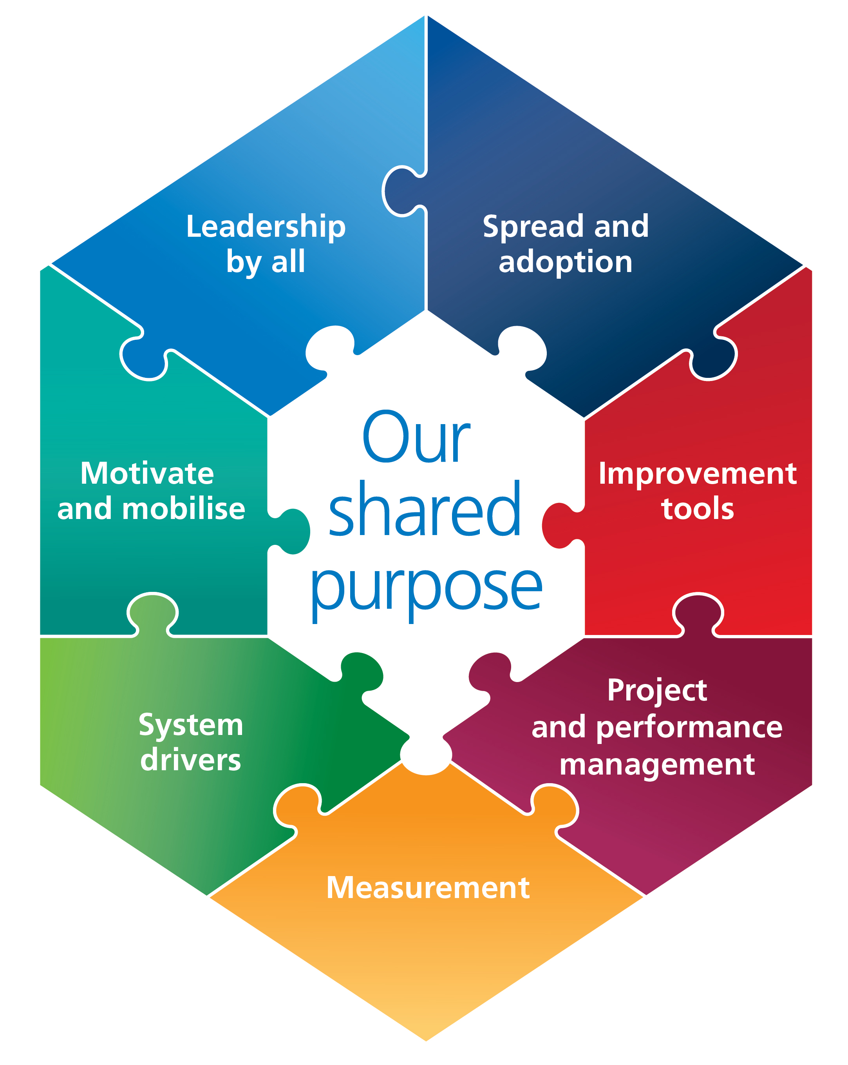

Motivate and mobilise

Measurement
Improvement tools
System Drivers
Project and performance management

