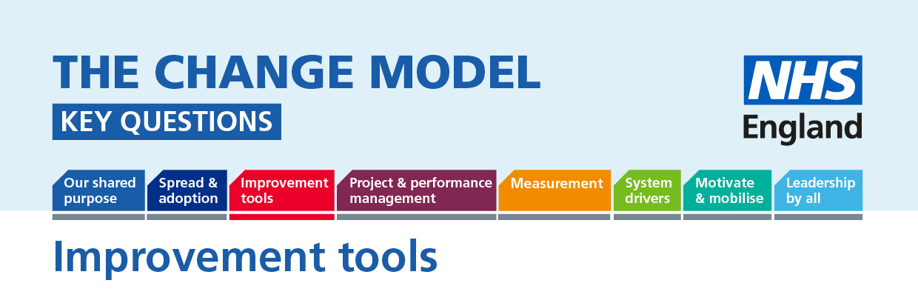

Improvement tools: The evidence suggests that using an evidence-based improvement tools improves the likelihood that a change programme will be successful. There are a number of improvement tools available (Lean, model for improvement etc) and they will often include elements from other parts of the NHS Change Model e.g. measurement, engagement, leadership. All elements of the model work best when integrated together.
The following questions will help to understand or inform the thinking around the planned change.
Question | Answer (to be completed)
Key Question:
How are we enabling patients to challenge our improvement method?
How are we helping patients to become effective ambassadors for change?
How are patients’ experiences reflected in our approach to change?
How do we know we are using the right evidence based improvement tools for our change and how can patients influence this?
How would you describe the NHS Change Model? – think about other innovations in the community that are non NHS.

