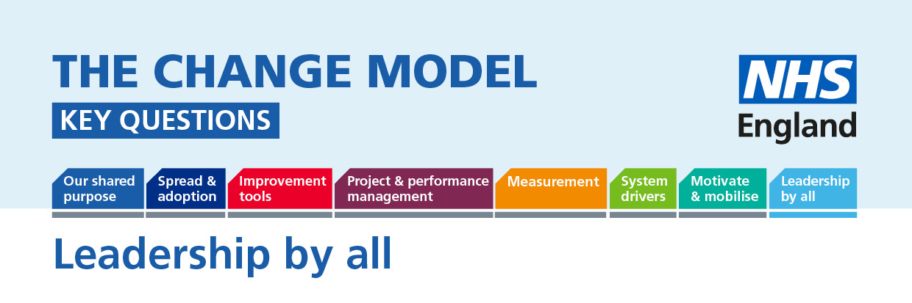

Leadership by all: A truly patient-centred NHS will require involvement of patients not just in their own care but in changing the way care is received by everyone. Patients and the public can guide us to the most effective service models from their perspective but need to be empowered and supported to lead. The following questions will help to understand or inform the thinking around the planned change.
Question | Answer (to be completed)
Key Question:
How do I become part of the shared leadership of change?
How are we enabling shared leadership?
How are we enabling patients who want to become leaders to drive change?
How do I (as a leader) demonstrate that I value my staff and users of the service?
What support do staff and the public need to lead change?
How do leaders communicate the need for change in a way that creates trust?
How do I challenge leaders on the need for change in a way that creates trust?
How do I (as a leader) guarantee that the patient voice will have equal value in the change process?
How are we able to demonstrate where the public (patients and their families) are influencing decisions?
How will people tell the difference they have made to the change, the influence they have had?

