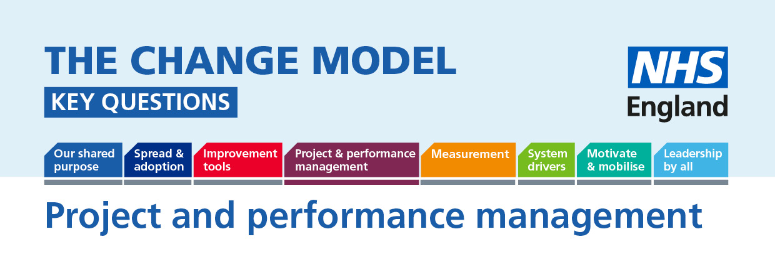

Project and performance management: To ensure that the changes we plan get delivered we must have ways of making sure that the change is happening and early warning systems for any problems or barriers to our agreed plans for change.
The following questions will help to understand or inform the thinking around the planned change.
Question | Answer (to be completed)
Key Question:
What is our road map for improvement and change (achieving our shared purpose) and how will we know how far down the road we are?

Are we really just trying to hit targets or do more?
How can we use the system drivers that we have to make sure the change is sustainable?
What are we going to do together to review and realign if we are going off-track?
How will we know they are still the right milestones for our change?
How do we ensure that all stakeholders retain buy in to the change?

