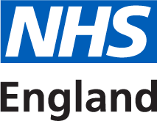

SUGAR-SWEETENED BEVERAGE SALES REDUCTION COMMITMENT
This document sets how ___________________________ (Trust/Retailer Name) will reduce the volume sales of sugar-sweetened beverages on NHS premises.
Please complete and return to england.healthyworkforce@nhs.net.
- COMMITMENT
  - _____________________________ (Trust/Retailer Name) agrees to:
    - Reduce the total volume of monthly sugar-sweetened beverage sales per NHS outlet, aiming for a target of 10% or less of total volume of drinks sales;
    - In agreeing to this goal provide NHS England with quarterly self-reported data;
    - This data should comprise total monthly beverage sales by volume (litres), including the total number of sugar-sweetened beverage sales, on a site-by-site or outlet-by-outlet basis;
DECLARATION
Signed on behalf of [Trust/Retailer]:

Name:

Position:

Date:

