Patient and Public Voice (PPV) Partners and Chairs Survey 2018 – Report

Patient and Public Voice (PPV) Partners and Chairs Survey 2018 – Report

Version number: 0.1

First published: June 2018

Prepared by: Public Participation team, NHS England

Classification: OFFICIAL

Equality and Health Inequalities Statement

Promoting equality and addressing health inequalities are at the heart of NHS England’s values. Throughout the development of the policies and processes cited in this document, we have:

- had due regard to the need to eliminate discrimination, harassment and victimisation, to advance equality of opportunity, and to foster good relations between people who share a relevant protected characteristic (as cited under the Equality Act 2010) and those who do not share it; and

- had regard to the need to reduce inequalities between patients in access to, and outcomes from, healthcare services and to ensure services are provided in an integrated way where this might reduce health inequalities.

This information can be made available in alternative formats, such as easy read or large print, and may be available in alternative languages, upon request. Please contact 0300 311 22 33 or email england.contactus@nhs.net stating that this document is owned by the Public Participation team in the Directorate of Nursing.

Contents

Contents 3
1 Executive summary 4
2 Purpose 5
3 Methodology 5
4 Summary of feedback from Patient and Public Voice (PPV) Partners 6
5 Summary of feedback from committee chairs 8
6 Next steps – the impact of feedback 9
7 Contacts and alternative formats 10
Appendix 1 – Note on free text responses 11
Appendix 2 – Responses from PPV Partners 12
Appendix 3 – Responses from committee chairs 50
Appendix 4 – Comparison between 2016-17 and 2017-18 headline survey responses from PPV Partners 61

Executive summary

During February and March 2018, NHS England surveyed Patient and Public Voice (PPV) Partners and chairs of committees, working groups and forums with PPV Partner members about their views and experiences. This report summarises the responses to the two surveys and actions taken or proposed in response. ‘Free text’ responses from both surveys are presented at appendices two and three, with an explanatory statement at appendix one. In appendix four, some of the headline results from the 2017/18 PPV Partner survey are compared with those of the 2016/17 survey.

A total of 58 PPV Partner surveys were completed and received during the review period, with 57 completed online and one easy read printed survey. A total of 32 chair surveys were completed and returned, all of which were submitted online.

The key themes identified from responses from PPV Partners are that:

- Most PPV Partners (45 respondents (78%)) believe that NHS England values patient and public involvement ‘to some or a great extent’, however, in free text comments, many raise concerns about the level of influence that they have or that pubic participation more widely has on decision-making. Some respondents are concerned about the impact of financial constraints on taking forward the outcomes of public participation.

- It is clear that many PPV Partners are very committed to public participation in the NHS, and to their involvement in NHS England’s work, however, experiences are mixed, and there remain some ongoing challenges, for example around processing expenses and communication.

- Several free text comments also share views about the level of commitment to public participation amongst NHS professionals, with some very positive feedback about individual members of staff and some concerns about lack of engagement – including suggestions of a need for a ‘culture change’.

With regards to responses from committee chairs:

- A total of 32 completed surveys were received, all completed online. This is a significant increase on last year’s survey (when only seven responses were received) and would seem to suggest that public participation has a higher profile and / or that it is increasingly valued.

- With regards to what extent NHS England values patient and public involvement, 30 respondents (94%) of committee chairs felt that it was valued ‘to some or a great extent’.

- Key themes from ‘free text’ responses are that participation is highly valued and has had significant impact in some areas, with many respondents’ commitment very clear, and a range of involvement activity underway in addition to PPV Partner representation. However, challenges in working effectively with PPV Partners and with ensuring meaningful participation are also highlighted.
NHS England values the feedback received and is committed to taking action to improve areas of concern. Further detail about responses and actions is outlined in the report below.

Purpose

The purpose of surveying NHS England Patient and Public Voice (PPV) Partners was to find out about their experiences of involvement with NHS England, including induction, information, training and expenses reimbursement, how valued they felt public participation was and areas for improvement.

The survey for chairs of NHS England committees with PPV Partner representatives aimed to better understand their views about the role of PPV Partners and about the impact of their involvement.

It is intended that the surveys will be repeated on an annual basis to enable monitoring of trends and continual improvement in response to feedback.

Methodology

The survey for PPV Partners was sent to NHS England’s ‘Patient and Public Voice Partners’ (also commonly known as ‘lay representatives’ or ‘Patient and Public Involvement members’) who were identified as being members of NHS England’s committees, task forces or regular / formal working groups / forums as at January 2018. Dissemination was via the Public Participation team directly, through regional colleagues and through other colleagues supporting key committees / programmes of work known to involve a significant number of PPV Partners, for example Specialised Commissioning.

The survey for chairs of committees with PPV Partner members was sent to chairs of an NHS England group, board or committee that had one or more Patient and Public Voice (PPV) Partner members.

The surveys were distributed during February and March 2018 for response by early April 2018.

Both surveys were available for completion online through NHS England’s ‘Citizen Space’ consultation hub, with paper copies and electronic Word document versions also available to improve accessibility. An easy read version of the PPV Partner survey was also available.

The surveys (when completed online) were anonymous and completion of all questions was optional and / or there was a ‘prefer not to say’ option.

The key findings from the surveys are summarised in sections four and five, with ‘free text’ responses received as part of completed surveys presented as appendices.

Summary of feedback from Patient and Public Voice (PPV) Partners

A total of 58 completed surveys were received during the review period – 57 completed online and one easy read printed survey. Headline findings are as follows (to note that not all respondents answered all questions and for ‘free text’ questions responses have been categorised into themes):

- Respondents were part of a wide range of different committees and groups, with many part of other NHS groups beyond NHS England. Many respondents are part of multiple committees and groups for different NHS organisations, including NHS England committees, GP Practice Patient Participation Groups (PPGs) and local Healthwatch.

- With regards to what extent NHS England values patient and public involvement, 45 respondents (78%) felt that it was valued ‘to some or a great extent’ compared to 83% in 2016/17. 10 respondents (17%) felt that it was valued ‘hardly’ or ‘not at all’. This is a slight increase from 2016/17 (13.6%). Key themes from ‘free text’ responses to this question related to limited ability to influence decision-making (6 respondents), that it is valued and supported (5 respondents), that feedback is not being heard / there is a lack of communication (3 respondents) and the impact of funding cuts on involvement (3 respondents). Many respondents made comments about whether they felt that the wider NHS / their local NHS organisations valued patient and public involvement instead of or in addition to NHS England.

- With regards to the extent to which the group they were a part of valued patient and public involvement, 22 respondents (38%) felt that it was valued ‘to a great extent’ and 29 respondents (50%) ‘to some extent’. Key themes from ‘free text’ responses to this question were that input and views were listened to (8 respondents), that there was no chance for input or the input was not listened to (8 respondents) and feeling valued / supported (7 respondents).

- Just under half of respondents (28 / 48%) rated the induction process for NHS England Patient and Public Voice Partners as ‘very good’ or ‘good’, 13 respondents (22%) rated it as ‘acceptable’, and 12 respondents (21%) rated it as ‘poor’ or ‘very poor’.

- Just under half of respondents (28 / 48%) also rated the induction and information for new Patient and Public Voice Partners as ‘very good’ or ‘good’, 13 respondents (22%) rated it as ‘acceptable’ and 11 respondents (19%) rated them as ‘poor’ or ‘very poor’. Some PPV Partners feel frustrated with the lack of information / feedback given to them at the induction stage.

- With regards to training for Patient and Public Voice Partners to develop, 21 respondents (37%) rated this as ‘very good’ or ‘good’, 13 rated it ‘acceptable’, (22%) and 17 respondents (29%) rated it as ‘poor’ or ‘very poor’.

- With regards to claiming expenses, 28 respondents (48%) rated this as ‘very good’ or ‘good’, 13 (22%) respondents rated it as ‘acceptable’, and 8 respondents (13%) rated it as ‘poor’ or ‘very poor’. For some PPV Partners, it is clear there could be improvements in the consistency and timeliness of reimbursing their expenses, with some experiencing significant delays.

- Free text responses to the question ‘how do you stay in touch with the views of patients and the public in order to reflect their views on this group?’ can be categorised as being a member of (other) patient groups and programmes / support group meetings / charities / patient forums (41 respondents), social media (14 respondents), being involved in the local area / listening to other people / local news / newsletters (13 respondents), personal experience (6 respondents), links with local GP’s and Trusts (5 respondents) and friends, family and colleagues (3 respondents).

- With regards to their contribution as a Patient and Public Voice Partner having an impact on the work area, the majority of respondents (26 / 45%) responded ‘to some extent’, 9 respondents (16%) ‘to a great extent’, 13 respondents (22%) ‘hardly at all’, 2 respondents (3%) ‘not at all’, 7 respondents (12%) did not know.

- In terms of examples of how their views had been listened to, taken into account and acted on, and the difference this has made, key themes from free text comments were around input being listened to and influencing decisions / ideas being accepted (19 respondents), too early to tell (4 respondents) and ideas not being listened to / accepted (3 respondents).

- With regards to other ways currently used to involve patients and the public in the group's areas of work, the most popular methods were consultations / meetings / groups / events (9 respondents), social media / websites (6 respondents), newsletters / emails / webinars (6 respondents), none (4 respondents), surveys (2 respondents) and local Healthwatch (2 respondents).

- Respondents’ ‘free text’ suggestions for other ways which could be used to involve patients and the public in the group’s area of work included more involvement of people (10 respondents), providing more information / communication (7 respondents), too early to say / not sure (5 respondents), social media (4 respondents) and surveys (3 respondents).

- When asked for ‘any other comments’, respondents commonly referred to feeling valued / enjoying their involvement (7 respondents), being valued (or not) by NHS England (9 respondents), communication issues (5 respondents) and not satisfactory (5 respondents). Many other respondents made a variety of ‘uncategorised’ comments.

- Looking across all of the ‘free text’ comments, additional themes were that:

  - Many PPV Partners are passionate in their involvement with NHS England and it is clear that they are committed to ensuring genuine patient involvement takes place.
  - There are some concerns that commitment to public engagement is not universal across NHS England. Several PPV Partners commented around the need for ‘culture change’.
  - Some respondents call for greater co-production and a more joined up approach between different regions, groups and boards, both at a local and national level.
  - Some PPV Partners have expressed concern that they feel that involvement is not as meaningful as it could be and / or that financial constraints can restrict tangible progress.
  - Several comments suggest that social media is increasingly being used for engagement.

Summary of feedback from committee chairs

A total of 32 completed surveys were received from NHS England committee chairs, all completed online. This is a significant increase on responses to last year’s survey (seven responses) and would seem to indicate that participation is increasingly valued.

Headline findings are as follows (to note that not all respondents answered all questions and for ‘free text’ questions responses have been categorised into themes):

- With regards to what extent NHS England values patient and public involvement, 30 respondents (94%) felt that it was valued ‘to some or a great extent’. Key themes from ‘free text’ responses to this question were that patient and public involvement provides patient perspectives (6 respondents) and that it is highly valued / a vital asset (6 respondents).

- Free text responses to the question ‘in addition to the contribution of the PPV Partner(s), what other ways are currently used to involve patients and the public in this group's area of work?’ can be categorised as public consultations / stakeholder meetings / events (8 respondents), listening to / working with patient groups including to access expert advice (7 respondents), general involvement (4 respondents), charity / professional society links (2 respondents) and none (3 respondents).

- Free text responses to the question ‘in addition to the contribution of the PPV Partner(s), what other ways could be used to involve patients and the public in this group's area of work?’ can be categorised as greater involvement (6 respondents), more use of technology / social media (4 respondents), open / public meetings (3 respondents), focus groups / roadshows (3 respondents), none / happy with current involvement (3 respondents), earlier input (2 respondents) and support required to ‘seldom heard’ groups (2 respondents).

- Respondents provide a range of examples of ways in which the views of Patient and Public Voice Partners have been listened to, taken into account and acted on, and the difference this has made, including providing a ‘patient perspective’ and ensuring that the committee focuses on impact for patients.

- With regards to receipt of help or support from the Public Participation team, 43% (13 respondents) had received support, whereas 57% (17 respondents) had not.

- Looking across all of the ‘free text’ comments, key themes are that:

  - Participation is highly valued amongst many respondents and their associated committees;
  - The involvement of PPV Partners has had significant impact in some areas, with some specific examples including influencing patient-facing information and guiding approaches so that they are ‘patient-centred’;
  - A range of involvement activities are underway in addition to PPV Partner representation, with plans in place in some areas to expand on this;
  - There are challenges in working effectively with PPV Partners and with ensuring effective participation.

Next steps – the impact of feedback

As a result of feedback received as part of last year’s surveys, NHS England took a number of actions including improving induction for new PPV Partners and providing additional training and development opportunities. A learning and networking event for PPV Partners also took place in March 2018, attended by 156 people – a summary of the presentations used and feedback from the workshops has been shared with participants via email.

In response to feedback received as part of the 2018 surveys, the Public Participation team will:

- Take steps to raise awareness and increase uptake of online and face-to-face public participation learning and development opportunities, for both NHS England colleagues and for PPV Partners, as outlined on the Involvement Hub.

- Undertake additional internal communications activity to highlight the PPV Partners Policy, PPV Partners Expenses and Involvement Payments Policy and associated resources – supporting positive experiences for PPV Partners in being involved in NHS England’s work.

- Work with colleagues to support access to induction for new PPV Partners and provision of appropriate information about expenses processes and training opportunities.

- Continue to work increasingly closely with NHS England regional and local colleagues, to support a more joined up approach to participation.

- Identify and take forward opportunities to increase subscription to the InTouch e-bulletin for patients, carers and members of the public.

- Showcase and promote the impact of patient and public participation, internally and externally.

Feedback will also be used to inform review of the PPV Partners Policy and PPV Partners Expenses and Involvement Payments Policy, which is due to take place in 2019.

It is intended that the surveys will be repeated on an annual basis to enable monitoring of trends and continual improvement in response to feedback.

Contacts and alternative formats

If you wish to request a copy of the report, or if you have a query about its contents, please email england.nhs.participation@nhs.net or write to Public Participation team, NHS England, 7E56, Quarry House, Quarry Hill, Leeds, LS2 7UE.

Patients, carers and members of the public can also contact the NHS England Customer Contact Centre by telephone on 0300 311 22 33.

To receive regular updates about engagement activities and opportunities to get involved in the work of NHS England, sign up to receive our newsletter ‘InTouch’.

Appendix 1 – Note on free text responses

Appendices two and three contain ‘free text’ responses. In the interest of transparency, the ‘free text’ responses are published verbatim and do not therefore represent the view of NHS England.

Responses appear in “speech or quotation marks” to indicate that they are a quote from a survey participant and not a statement from NHS England.

Responses are unedited except:

- where information identifies, or is likely to identify, an individual or organisation (other than NHS England);
- references to brand, company, trade or product names;
- details of websites / blogs;
- text copied from other documents in full;
- language or opinion which may cause offence;
- comments which are irrelevant to patient and public participation in health and care.

Wherever text has been removed for one or more of these reasons, this is indicated by way of square brackets […]

Obvious spelling and grammatical errors have also been corrected for ease of reading. In all cases ‘NHSE’ has been written out in full (as ‘NHS England’). Where words have been inserted to aid understanding this is indicated by way of square brackets [around the inserted word].

Effort has been made to indicate quotes which relate to a single response, however, individual responses may be split where their attribution is unclear.

In the interests of document length, in longer responses, text which has been separated by spaces is listed as part of a paragraph, with appropriate punctuation.

Appendix 2 – Responses from PPV Partners

Question 1. Name of Group / Committee / Board you are a member of?
Respondents are / were part of a wide range of groups, committees, boards and programmes of work including *:

*Note that, to prevent identification of individuals, not all answers to this question have been included here, and responses have been split and titles formalised (where possible) in the interests of clarity.

- Cancer Steering Group.
- Clinical Commissioning Group (CCG) assurance.
- Clinical Commissioning Group (CCG) patient representation roles on committees, ‘patient cabinets’, patient reference groups, user panels, patient engagement forums and boards.
- Clinical Reference Groups (CRGs).
- Clinical Senate.
- Dental Performance Advisory Group.
- Gender Identity Programme Board.
- Hospital Trust / Foundation Trust ‘patient partners’ and ‘patient council’ members, as well as involvement in decision-making bodies and specific programmes of work.
- Learning Disability and Autism Advisory Group.
- Learning from Deaths Family Involvement Steering Group.
- Learning from Deaths Programme Board.
- Local Healthwatch.
- National Programme of Care Boards.
- NHS Citizen Advisory Group.
- NHS Digital.
- NHS England ‘patient representatives’ / Patient and Public Voice (PPV) Partners / representatives.
- NHS England Learning Disability and Autism Advisory Group.
- Patient Participation Group members and chairs.
- Performers List Decision Panel.
- Public Health.
- Quality Surveillance Groups.
- Sexual Assault Referral Centre Partnership Group.
- Specialised Commissioning Oversight Groups.
- Specialised Commissioning Patient and Public Voice Assurance Group (PPV AG).
- Specialised Commissioning programme boards.
- Women's Secure Mental Health Core Strategy Group.

Question 2. Please select the category most relevant to your role with NHS England, or "national" as appropriate? If you work with NHS England both nationally and regionally you can select two options
Response | Total | Percentage of responses
London | 4 | 7%
Midlands and East | 4 | 7%
North | 1 | 2%
South | 5 | 9%
National | 33 | 57%
National & London | 2 | 3%
National & Midlands and East | 2 | 3%
National & North | 2 | 3%
National & South | 2 | 3%
Prefer not to say | 2 | 3%
Not Answered | 1 | 2%
Grand Total | 58 | 100%

Question 3. NHS England Directorate, if known?
Response | Total | Percentage of responses
Don’t know | 27 | 47%
Finance, Commercial and Specialised Commissioning Group | 17 | 29%
Medical Directorate | 6 | 10%
Nursing Directorate | 3 | 5%
Transformation and Corporate Operations Directorate | 1 | 2%
Operations and Information Directorate | 0 | 0%
Strategy and Innovation Directorate | 1 | 2%
Prefer not to say | 2 | 3%
Not Answered | 1 | 2%
Grand Total | 58 | 100%

Question 4. Broadly speaking, to what extent do you feel that patient and public involvement is valued by NHS England?
Response | Total | Percentage of responses
To a great extent | 15 | 26%
To some extent | 30 | 52%
Hardly at all | 2 | 17%
Don’t Know | 0 | 3%
Not Answered | 1 | 2%
Grand Total | 58 | 100%

- “CCG [Clinical Commissioning Group] funding cuts have meant support for people with disabilities to speak up is less and in some cases stopped. The direct engagement for service users has gone.”

- “I think everyone at NHS England is more than accommodating and ready and willing to listen to what our points of view are, however, the lack of funding and apparent awareness of issues (especially in my locality in […]) stilts any real and tangible progress.”

- “If we were serious about PP [patient and public] involvement then the approach would be more professional with investment in research and focus groups around specific areas followed by demonstrated use of this input in the service regarding design.

Private companies outside of healthcare live and die by their ability to understand their customers, making decisions on what services to provide and communications to use to optimise consumer offering. They view any comments from them as valuable insights to help develop improved services. The public / patient as a consumer is a concept that is hard for the NHS to grasp and even harder to actively go out and engage with. The best loved companies and products consumers use are often from companies that have a very large engagement programmes, often using professional agencies to understand consumer needs and look for future opportunities. Just imagine how services might be designed and delivered if we really understood patient and carer behaviour. […]

Also the valuable knowledge and opinions of those acting as Lay Members and NEDs [Non-Executive Directors] could be used to inform decision making in the wider NHS, instead there appears no formal engagement with this group let alone listening to their views and suggestions on how to improve the efficiency and effectiveness of services.”

- “It seems that most decisions are cost-driven and by the time PPV [Patient and Public Voice] partners have a chance to input to the process, the die is cast. I think that the lead officers on the […] Programme are conscientiously trying to frame the programme outputs in a way which will best reflect the comments and views of the PPV [Patient and Public Voice] partners, but the outcomes never seem to change. My impression of the senior people at the centre of operations is that they tolerate the involvement of members of the public but they don't value their input to the decision-making process.”

- “I think one has to consider actions taken over rhetoric and exhortations. So as can be seen from our CRG [Clinical Reference Groups] / NHS England actions, which speak volumes with more emphasis upon the illusion of patient engagement rather than the actual involvement, which should be achieved through the delivery of co-production and equality as a cultural norm.

I have and continue to be treated differently despite raising these concerns with senior NHS England officers and not in a positive way as I am generally 'forced' to shout ever higher, if only in an attempt to actually be heard. As such I believe I am seen as the aggressor because I dare to question and challenge the status quo. I would add that my questioning and challenge is generally of the onerous systems, processes and bureaucracy as I support the 7 principles of public life but generally I feel ignored, overlooked, patronised and generally dictated to. I should add that the status quo is no longer affordable so I would have thought NHS England would relish and want to support patients that dare to support collaborative change.

The patient can be the arbiter to real and sustainable change but only if they are allowed to. A significant cultural shift is still required within NHS England groups and leaders, I won’t go on but dare I suggest that given what I have alluded to above that one doesn't shoot the messenger as I am only trying to be frank in order to help, improve opportunities for the future and provide for the best possible use of vital and finite (tax payer) resources.”

- “It is hard to see if PPV [Patient and Public Voice] can make a difference - I think this is lip service.”

- “It is valued as a concept but the NHS is still wondering exactly what PPI [Patient and Public Involvement] is, what it can offer, how it should be supported and what exactly do we do with it. Much the same goes for PPV [Patient and Public Voice] representatives - they want to be more involved but need to feel that what they do has an impact.”

- “It would make a tremendous difference if failure to comply with PPI [Patient and Public Involvement] was enforceable. As things stand, Trusts and CCGs [Clinical Commissioning Group] can mess up on this even when big changes are in the offing, and 'get away with it'. Sometimes they have a token of PPI [Patient and Public Involvement] so it looks good on paper. Also, involving the public is not done to the same standard around the country. That is another challenge."

- “Patient and public involvement is often talked about, but rarely is a member of the public ever involved in real power decisions.”

- “I'm really waiting to notice genuine changes in the NHS through patient and public voice being heard and understood.”

- “NHS England does not make it very clear what they want information for.”

- “Systems are in place, but though [they] appear to be working, actually are not in reality. An example is a GP practice with over 100 patients registered as PRG [Patient Reference Group] members, but have never been communicated with or come to a meeting. Yet the Practice can state they have this many members. There are other instances where NHS organisations have asked for interest and then people heard no further.”

- “As meetings take place about 4 times per year it takes a considerable time to embed and have a useful voice.”

- “Sometimes staff don’t understand or are unaware of the relevant obligations and statutory requirements set out in section 13 of the Health and Social Care Act.”

- “Hard to tell how our input impacts services without tangible evidence.”

- “I have stated on a number of occasions that there needs to be a significant level of culture change nationally to improve the relationship between Trusts and families / carers. Whilst there is evidence of a degree of change in some Trusts, culture change will take a significant amount of time to achieve and an awful lot of training and effort. It will first require strong and committed leadership, not least from NHS England as well as within Trusts.”

- “I hear lots of nice noises, but see little change.”

- “I think it is very much on NHS England’s terms. The question’s asked by NHS England and the way the dialogue is organised is all chosen by NHS England. I also think the NHS needs to make more serious efforts to engage with the 25% or so of the population with limited education. At the moment the presumption built in is that you will be talking to very articulate people who are willing to engage and are not always making sure that those who are not are given a voice.”

- “I think patient and public involvement is valued by NHS England and strenuous efforts have been made to encourage participation and feedback. However, this doesn't always translate into views and opinions that can be acted on due to other considerations.”

- “In the […], we have certainly seen some changes of attitude and practice within CCGs [Clinical Commissioning Groups]. There is more reference to patient benefits and we have pushed to have any service changes describe how patients in particular might benefit from the changes / inceptions. Having said that I firmly believe that there is a long way to go culturally to gain acceptance for the input of well trained and rounded patient leaders who have a holistic and broad view of their roles, not single interest campaigners but strategically aware individuals.”

- “Patient or 'lay' voice largely swamped by specialist or clinical members.”

- “Recent experience in joining a new group was less than satisfactory.”

- “The analogy I would use to sum up my experience of the NHS England culture around patient engagement would be that of an opera singer who had learned the tune and the words but now needs to finesse the performance.”

- “The involvement is good but they need to work in partnership with local authorities as well.”

- “There is plenty of evidence that NHS England wants public participation at a corporate level; the resource being put into it is evidence of this. But whether PPV [Patient and Public Voice] can have real influence over issues such as the STP [Sustainability and Transformation Partnership] process and the newly proposed Accountable [Care] Organisations, or levels of funding or safe staffing, remains to be seen.”

- "We were well trained and supported for our work as lay members of […]. This work came to an end and we felt let down. However the officers [are] keen to involve us in new roles."

- “While NHS England invites public voices on consultations etc., the end result is generally already set / designed / commissioned before the public get asked for their input. It would be a more genuine involvement if the public were invited to have input into the initial idea / project design phase rather than quality checking at the end of it.”

- “From my involvement with NHS England I fear that patient and public involvement is something that is treated as a 'tick box' exercise so that you can say we have been involved and consulted. I do not feel our views are respected, still less do they get acted on. Perhaps things are different where there are large numbers of patients involved e.g. cancer, diabetes, but I represent people with […] and we do not have enough voting power to get our voices heard.”

- “Lot of box ticking, lack of continuity.”

- “Whenever I attend any NHS England meeting, I am impressed by the sheer commitment and good will of the NHS England staff. They are clearly very dedicated and hard-working individuals and highly aware of the value of gaining patient and carer perspectives.”

- “I always feel valued and equal to other panel members.”

- "It varies - the above score is an average, from my perspective. I think Specialised Commissioning values, and supports, PPV [Patient and Public Voice] more than some other directorates."

- “The […] CRG [Clinical Reference Group] is relatively new and I have always found NHS England take a great interest in the views of the PPV [Patient and Public Voice] representatives. It has run alongside the […] Programme Board and the members of that team have been excellent in ensuing that the PPV [Patient and Public Voice] voice is heard.”

- “Very supportive patient engagement unit. Very new to this, but splendid induction last week and excellent and informative seminar this week.”

Question 5. To what extent do you feel that patient and public involvement is valued by the group you are a member of?
Response | Total | Percentage of responses
To a great extent | 22 | 38%
To some extent | 29 | 50%
Hardly at all | 3 | 5%
Not at all | 1 | 2%
Don’t know | 3 | 5%
Prefer not to say | 0 | 0%
Grand Total | 58 | 100%

- “This last year or so has been very disappointing and frustrating through pretty much not being allowed and enabled to have any input / interaction.”

- “I have only attended two meetings of the […] since my appointment, both of which were blighted by issues with the technology being used. At present I do feel something of an intruder and I know my fellow PPV [Patient and Public Voice] Partner feels similarly. The […] is much more welcoming, perhaps because its focus is on family involvement and there are more family representatives.”

- “I would refer you to my points in 4 above and the many instances of patients being overlooked as decisions have and / or seemingly [been] taken elsewhere regardless of the NHS Constitution and any obligations to ensure the widest engagement, which should again be co-produced.
An example could include the reality that one of our services is supposedly having a national service review ahead of any work. NHS England committed to meeting with national patient stakeholders to agree Terms of Reference and co-produce the work to ensure the maximum benefit for all including the patient, the service, the providers and of course NHS England making an even better use of tax payers finite resources, anyway cutting to the chase little happened and NHS England crack on regardless and despite patients raising genuine concerns about an update it was issued regardless. The choice clearly is for patients despite government and NHS England’s exhortations to the contrary but is generally made and dictated for and by NHS England, a sad but frank reality!”

- “I think that some of the CRG [Clinical Reference Groups] members value our input; I think for a number of them they would rather we weren't there!”

- “Sometimes NHS England does not take real notice of what is said.”

- “I feel about 2 years ago things seemed more optimistic and I was hopeful of a genuine impact at a local NHS level. Unfortunately I haven't seen real evidence of this happening yet.”

- “Language and culture expressed, particularly acronyms used by staff and clinicians can be divisive and exclusionary to lay people. Despite excellent intentions this remains a significant issue.”

- "As above. I feel that the group with which I am involved views the PPV [Patient and Public Voice] representatives as a necessary evil that has to be tolerated. I do not think this applies so much to the clinicians on my CRG [Clinical Reference Groups], who do treat us with respect, but to the NHS England personnel involved in it that appear quite arrogant and to generally not respect the clinicians, let alone the PPV [Patient and Public Voice]. I also have concerns that meetings are not correctly minuted."

- “The regions are a law to themselves. There appears to be a disconnect between national and regional NHS England. PPV [Patient and Public Voice] can suffer because of this - i.e. design PPV [Patient and Public Voice] in at national level, but something different gets delivered at regional/local level.”

- “Amongst the officers there is a deal of respect and support.”

- “We are made to feel that our ideas are useful and we are listened to, but again, it only goes as far as the pot of funding allocated by central government and I think that this needs addressing.”

- “Our expert contribution is valued and sought out.”

- “I feel feedback given has been valued and included in the work of the group.”

- "The chair […] is very inclusive in CRG [Clinical Reference Group] meetings as well as ensuring that PPV [Patient and Public Voice] members are afforded every opportunity to clarify any clinical / technical matters that arise in discussion. […] who supports the CRG has been extremely helpful in enabling me to settle into the CRG and is very inclusive and supportive of PPV member’s contribution."

- “PPV [Patient and Public Voice] Member comment / feelings / involvement is always requested and I believe it to be valued.”

- “Great energy displayed from the staff that actively supports the members of the group.”

- “Individuals have found our input useful, but not sure how far it has gone.”

- "Our commissioning lead and health professionals on the […] CRG [Clinical Reference Groups] - and its sub-committees - listen to my comments and are very respectful of views I express. They are tolerant in explaining any medical matters or jargon that I do not understand. Generally, I offer comments sparingly because, when you are in a room where people are saying, 'we want to improve […] outcomes for our population', 'we want to adopt best practice across the country', 'we want the safest […] to be commissioned,' etc. I am not one of those people who say, 'I agree with everything that has been said!”

- “The group do take notice of my views but as to how much weight they are given this is difficult to judge.”

- “I felt able to express my views and participate in consultation on documents - people were always encouraging”

- “[…] - chair and […] - always seek PPV [Patient and Public Voice] views through CRG [Clinical Reference Group] meetings and other work areas.”

- “It is my privilege to work with […] and […] who are two of the most competent and committed members of NHS England staff who I have ever met. They are also 2 of the nicest people you could ever meet, and have the acuity to recognise the value of PPI [Patient and Public Involvement] and to support 100%.”

- “Now have a place on the agenda as well as having informed discussions.”

- “They were keen to find new and innovative ways to involve patients.”

- “As above, the team with direct contact genuinely value our involvement and seem to share our frustration at the intransigence of the national NHS machine and the extremely slow pace of real change.”

- “Apart from some 'teething problems' and a failure to genuinely keep the members in the loop, I am trusting that things will get better in the next few months. Staffing has been a major challenge, which complicates the opportunities to make a real difference in the PPI [Patient and Public Involvement] strategy.”

- “I think that the […] team we joined were entirely bought into the idea of patient leaders, but pressures and changing landscapes have detracted from that initial enthusiasm. We are currently in the process of realigning patient leaders given the changes to CCG [Clinical Commissioning Group] roles and advent of STPs [Sustainability and Transformation Partnerships] and ACS' [Accountable Care Systems].”

- “My group meeting in May that will be my first meeting so cannot comment but already included in email iterations.”

Question 6. How would you rate your experience of being a PPV Partner in the following categories?

Induction process

Response | Total | Percentage of responses
Very good | 14 | 24%
Good | 14 | 24%
Acceptable | 13 | 22%
Poor | 7 | 12%
Very poor | 5 | 9%
Don't know | 3 | 5%
Prefer not to say | 1 | 2%
Not answered | 1 | 2%
Grand Total | 58 | 100%

Induction and information for new PPV (Patient and Public Voice) Partners

Response | Total | Percentage of responses
Very good | 15 | 26%
Good | 13 | 22%
Acceptable | 13 | 22%
Poor | 6 | 10%
Very poor | 5 | 9%
Don't know | 3 | 5%
Prefer not to say | 1 | 2%
Not answered | 2 | 3%
Grand Total | 58 | 100%

Training for Patient and Public Voice (PPV) Partners to develop

Response | Total | Percentage of responses
Very good | 12 | 21%
Good | 9 | 16%
Acceptable | 13 | 22%
Poor | 11 | 19%
Very poor | 6 | 10%
Don't know | 6 | 10%
Not answered | 1 | 2%
Grand Total | 58 | 100%

Claiming expenses

Response | Total | Percentage of responses
Very good | 13 | 22%
Good | 15 | 26%
Acceptable | 13 | 22%
Poor | 2 | 3%
Very poor | 6 | 10%
Don't know | 7 | 12%
Prefer not to say | 1 | 2%
Not answered | 1 | 2%
Grand Total | 58 | 100%

- “Had to chase a travel claim for 5 months.”

- “I am happy with all of the above and any issues I have are always taken on board and addressed promptly by the team. Perhaps one item would be the clarity of what meetings are paid for and which do not include accommodation expenses - I do need to know this as my travel anywhere in the country tends to run well over three hours by train.”

- “Expenses get paid months late, in some cases up to 6+ months. No reasons for this were given. Absolutely shocking! Wrong trains were booked, in some cases only half travel was booked and a nightmare receiving monies back for out of pocket travel expenses, let alone for anything else. Unacceptable."

- “Invites to events should state the expenses process.”

- “I haven't taken part in any PPV [Patient and Public Voice] induction process so I could not comment. As for claiming expenses and any fee I have asked my commissioner a number of times as to how this could be done, as I also asked if it was possible to consider donating the fee to a charity then it would be doubly beneficial. I gave up asking so I have never claimed either. Recently asked again about the possibility of staying overnight as the next meeting is 230 miles away etc., but little has happened to my knowledge.”

- “I make a point of not claiming expenses. I felt that the materials I received were 'politically correct' and again aimed at ticking boxes.”

- “Do not claim expenses. Remuneration set is sufficient for me personally.”

- “This may change after the coming PPV [Patient and Public Voice] event but as yet, we have had no induction or information.”

- “Why is there no induction process for Lay Members of CCGs [Clinical Commissioning Group] (or NEDs [Non-Executive Directors] of Trusts)? I would expect either an induction course run a couple of times a year in say 3 locations of the country or a session a couple of times a year where Lay Members and NEDs could receive latest training and also [be] thoughtfully engaged on their learnings and views. […] Lay members group has been trying to improve the situation but looking at the private sector you would not have someone joining the board of organisations managing hundreds of millions without a professional induction after a professional selection process looking widely to find candidates who have the right skill set and experience.”

- “I made similar comments in the 2016 survey. Induction, information, engagement letter processes were non-existent. However, after joining my group in March 2016, I finally got my letter of engagement and induction pack in February 2018, following an NHS internal audit of procedures. I notice PPV [Patient and Public Voice] policies have now been extensively rewritten in light of comments made, so improvements are in place for new PPV [Patient and Public Voice] representatives, which is progress.”

- “While it may be something of a cliché the dilemma for any external board member is 'you don't know what you don't know.' As external members we are entering a new world with its own language and we only have limited knowledge and understanding of that world. Anything that can be done to support [us] perform our roles effectively is to be welcomed.”

- “Little background assistance provided before first meeting and led to doubts about further engagement.”

- “I've not yet been to any events or had more than communication with the interview panel and HR [Human Resources].”

- “This last year has been very frustrating through lack of being able to engage despite my efforts and online patient engagement qualification, now I'm self-funding [my] […] mainly through this frustration whilst also wondering why I have to hopefully gain yet another qualification to enable my voice to be heard on behalf of the public and potential patients and patients.”

- “Many of the […] and the […] Groups have lots of management experience and so the constant encouragement to focus on leadership (a skill many already possess) rather than getting to know the logistics of provision and complexities of NHS service delivery seemed somewhat ‘wrong-headed’.”

- “I've only recently found out about training opportunities, but came across the information myself.”

- “I felt welcomed into the group and that time was taken to include me. As I am CEO [Chief Executive Officer] of an umbrella agency, it may not have been thought necessary to offer training.”

- "I have been encouraged, by internal NHS England managers, to explore and take on new opportunities. I'm now being encouraged to do […] review work, because of my CRG [Clinical Reference Group] role. But that takes me to six roles - when the PPV [Patient and Public Voice] 'policy' is to do no more than 3. I actually have three distinct roles, which have 'grown' into 6, the second three being natural extensions to the first three. I'm not sure the PPV Policy recognises that this is a 'good' thing, although I and the NHS England people I work with do."

- “[…] is an excellent chair and very helpful in constructively suggesting how PPV [Patient and Public Voice] representatives could effectively contribute to their CRGs [Clinical Reference Groups].”

- “The last training course I went on veered form the laughably amateur to the humiliating - a cross between a progressive primary school and [a holiday camp].”

- “Except for the times when staffing is an issue, it is always without much hassle.”

- “Two years ago I felt much more connected to by NHS England. I was sought out at NHS England events beginning / end by my main contact and then I gave written feedback and was followed up with a phone call which enabled further feedback which I was surprised how that enabled aspects I hadn't written on the other feedback. Unfortunately my recent email and events haven't been as well connected.”

Question 7. How do you stay in touch with the views of patients and the public in order to reflect their views on this group?
Response | Total | Percentage of responses
Member of other groups | 35 | 61%
Social media | 14 | 25%
Direct contact | 10 | 18%
Email | 10 | 18%
Personal experience | 6 | 11%
Charity | 6 | 11%
Links with local GP, Trusts | 5 | 9%
Reading (publications) | 5 | 9%
New in role / would like support | 4 | 7%
Friends, family, colleagues | 3 | 5%
Newsletters | 3 | 5%
Telephone / helpline | 3 | 5%
No answer | 1
Grand Total | 58 | 100%
Note: this table shows the categorisation of free text responses.

- “[Social media] and also email.”

- “Email groups, [social media] local group meetings, I run a local group meeting and a support organisation.”

- “Email, [social media] and telephone.”

- “I am well networked with charities and other groups, mainly social media based, to gather views.”
- “I have an extensive network of colleagues, peers, friends and families, who give me first hand feedback on their personal experiences. I have a large social media […] network which reflect and inform on a more regional and national perspective.
I also work with a Clinical Commissioning Group as a Public and Patient Engagement Advisor where I chair a monthly committee on the subject attended by many patient and carer representatives”

- “Our [social media] work page.”

- “I'm chair of a very active PPG [Patient Participation Group] and we have a network of PPGs in the locality with the chairs meeting every six weeks. I'm also a PPIR [Patient and Public Involvement Representative] with the CCG [Clinical Commissioning Group] and Chair of our STP [Sustainability and Transformation Partnership] Public Engagement Group. I also use [social media] as a source of input, following organisations and individuals in the health and social care sector.”

- “As a Board member of the only national charity for adults with […] I have a lot of resources available to me. Our helpline provides feedback to me on issues and I watch the closed [social media] group page where issues are raised and discussed between patients. Being someone with the condition too enables me to have first-hand and up to date experience.”

- “Social media, member newsletters and electronic alerts.”

- “I represent a very active patient community we have a good website with a 'members only' area where we can discuss matters, similarly a closed [social media] page and we communicate with our members by newsletter, phone and e-mail.”

- “Social media and 1-2-1 conversations.”

- “Through social networking.”

- “[Social media] is very helpful as is visiting surgeries, visiting self-help groups and community groups.”

- “Face to face with many through my work and social [networks]; NHS England events though I think there's only been one over the last year or so, so that feels minimal; local Patient Participation Group; emails / social media etc.”

- “Actually being in my own local community including through Patient Participation Group at my local medical surgery and supposedly through local hospital, though that doesn't seem to be happening in more than a year. Also with family and friends, in various ways and […] and various other roles. Now becoming increasingly frustrated through lack of involvement and lack of progress e.g. to get other than clinical involvement in local healthcare […] Why are [GP Practices] not really connecting with their patients? Lack of time and other pressures including justifying their time / paperwork, etc. I engage with my communities and know that each NHS member of staff I meet is actually usually very stressed and so how on earth can they genuinely care for their patients.”
- “To date through conferences and other meetings where families are represented, the charity […] and in working with the Trust that was responsible in terms of caring for a member of our family. In terms of the guidance we are working on in the […] Group there are a large number of families assisting with reviewing it. Sadly there cannot be any experiential patient involvement for obvious reasons.”

- “I am in regular contact with most major patient stakeholders but as a patient with an array of life long conditions I also come into contact with a range of patients from a range of centres. Patients and patient groups often contact me to feedback, inform and share, what I may describe as a form of intelligence gathering. I am also involved with the [other groups], which further allows me to bring intelligence, experience and an awareness of what is going on across a range of arm’s length bodies.”

- “Personally I am a […] Chair and also involved with my local CCG [Clinical Commissioning Group], Patient Involvement Group and also attend my local Healthwatch Groups. I additionally volunteer for project work with the CCG and our local hospital. I have also been a […] patient myself and read […] and patient group forums online.”

- “Mainly networking in the community in various volunteer groups. Healthwatch volunteer.”

- “Regular meetings.”

- “I am part of a National Patient Group.”

- “Through my role as CEO [Chief Executive Officer] of a specialist umbrella agency, I am in contact with patients and specialist voluntary sector services and hear directly from them about their current experiences.”

- “I am Chief Executive of a large patient support group with over 800 members all of whom are […]. It is reasonably easy for me to gauge opinion and ask for feedback.”

- “I am a CEO [Chief Executive Officer] of a patient group and a trustee of two umbrella patient groups. These responsibilities enable me to garner the views not only of the patients and carers associated with my charity, but also of the many other charities involved in the umbrella organisations.”

- “Personal and email contact with […] support group members.”

- “Reading, listening to members of voluntary groups.”

- “In addition to the patient reference group I would like to have more time to engage with the public at the point of use of services, however this needs NHS resources to help enable this. At every opportunity I engage with public in waiting rooms and asking people about their views and issues with regards to services.”

- “Regularly meet with other people with same disease for informal coffee meetings, reading material from national charity and acting as a volunteer ‘contact’ for them.”

- “Until […] weeks ago, I was a hospital inpatient, and I currently live in [...] I have many patient representative roles and work with many patient and carer groups and associated organisations. This allows me to remain informed and represent patient and public views.”

- “Trustee of […] and member of their online forum. Member of […] Patient and Carer Network. Regular emails from […] and […] website. Member of local surgery PPG [Patient Participation Group] and talk a lot to friends.”

- “Extensive coverage across the borough working with local hospital, hospice and […] council. Direct contact with all of the GP Practices via Practice Managers meetings, and their in-house Patient Groups. Regularly attend Patient Group meetings. Chair of […], seeking and getting views, before we proceed with change. Healthwatch […] is invited to many of our committees. Partnership working with […] Hospital Governors.”

- “Directly! By talking with them face to face.”

- “Through membership of other groups.”

- “Belong to a number of local groups, receive updates from my foundation trust (am a […]) and read a variety of professional publication.”

- “Attendance at other PPV [Patient and Public Voice] meetings; email discussions.”

- “Involved with local patient / carer groups and links into local development special programmes.”

- “In my role working with various voluntary groups and other patient groups in primary care and other stakeholders.”

- “I am an involved member with my local NHS Trust, with the PPI [Patient and Public Involvement] department of a trio of universities, with my CCG [Clinical Commissioning Group], as well as a carers group.”

- “Patient Groups. Patient Group network. Healthwatch. Database. Emails. Circulars. Voluntary organisations.”

- “I don’t. It would be very beneficial to have an internet link to chatrooms / [social media] pages for this sort of communication.”

- “I have a good network with […] patients (150), members of the […] User Panel, many of whom give feedback about their role as chairs of their PPG [Patient Participation Groups]; as ongoing member of initially PPI [Patient and Public Involvement] for […], then […], now […]. On the Advisory Panel for […], […], […].
I send out information (e.g. food banks, help with heating) to over 300 local groups.”

- “Some of the main factors include: 1. I receive daily e-bulletins from […]. These often include news items about […]. 2. There is occasional coverage in national and local newspapers about […] treatments - often, in controversial circumstances. 3. I am a member of the NHS England […] Group. I attended a […] meeting' at the […] in […] and am due to attend the next event shortly. 4. I have attended the last 5 […] 4 day conferences. These events are attended by dozens of patients and relatives who […] (their main interest is in research). I attend many of their discussions and chat informally over meals. 5. I attend the […] Group within […] and […]. Agenda items include quality, safety, complaints, etc. 6. I attend numerous events within the ambit of the […] CCG [Clinical Commissioning Group] […]. One project included a campaign to improve early […] and there were a range of members of the public including [people from] BAME [Black Asian and Minority Ethnic] [communities]. 7. There are generic matters relating to […] policy - patient information; consent to treatment; professional communications of […] and prognosis, etc. that inform my background and ability to contribute to the CRG [Clinical Reference Group]. 8. I accompanied a friend to hospital […] while he was attending for […]. All these items help me reflect on […] for […]; safety; consistency; equity of access; etc.”

- “I represent […]. We are developing a system whereby local groups as well as […] staff are: aware of the general work programme and timescales where known; can contact me with their views and any matters of significant concern.
I provide updates and summaries for […] staff / managers. My volunteer manager maintains regular contact with me and connects me with key individuals within […].”

- “By connecting with relevant networks and personal direct experience.”

- “I am new to my role so I am trying to develop a system. I think we may be quite siloed so I think this could be a challenge.”

- “This is an area I find very difficult and I would welcome some support to develop this as I think it is important. I do though remember noting that in the information for PPV [Patient and Public Voice] partners it does state that you are there based on your experiences rather than trying to represent other people’s experiences and views.”

- “Until very recently, I was a Lay Member for a local CCG [Clinical Commissioning Group] with responsibility for patient and public involvement. I am currently awaiting the outcome of an election process through which I have volunteered to become a […] of my local NHS […].”

- “1. I attend my local PPG [Patient Participation Groups]. 2. I attend my local CCG [Clinical Commissioning Group], STP [Sustainability and Transformation Partnership] and ICS [Integrated Care System] public engagement events. 3. I attend, and value, NHS England networking and training events relevant to my roles. 4. And I keep in touch, via email, with other PPV [Patient and Public Voice] representatives I get to know from the above.”

- “Member of relevant organisations, updates and newsletters. Direct questioning on specific issues.”

- “New in post.”

- “Networking and on relevant local and national patient associations.”

- “As a relatively new CRG [Clinical Reference Group] representative for […] I am setting up a communication system to receive and seek views from people with […].”

- “Networks and contacts with 3rd sector, patient groups, Healthwatch and personal contacts. Use of patient experience data in the public domain, in particular triangulation of the various data sets.”

- “CEO [Chief Executive Officer] of a charity with many online channels.”

- “Quarterly […] at Governing Board Meetings.”

- “Listening, reading, attending conferences and personal experience.”

- “We do this by working with local focus groups and it is a two way conversation.”

Question 8. To what extent do you feel that your contribution as a PPV Partner has had an impact on the work area?
Response | Total | Percentage of responses
To a great extent | 9 | 16%
To some extent | 26 | 45%
Hardly at all | 13 | 22%
Not at all | 2 | 3%
Don’t know | 7 | 12%
Not answered | 1 | 2%
Total |  | 100.0%

- “Seems little link. Issues brought up at a recent NHS meeting for lay partners, has resulted in no satisfactory result, although numerous follow up calls / emails.”

- “I would hope it has impact but I have yet to experience tangible positive change.”

- “CCG [Clinical Commissioning Group] […] was to my mind an almost fruitless exercise, with the exception of aforementioned attitude changes regarding speaking more about patients.[...]”

- “By trying to hold whomever to be open, transparent, responsible and accountable, but as CRGs [Clinical Reference Groups] and the like only offer advice, which is used or ignored as deemed appropriate it is not surprising that the impact of any advice is difficult to measure.”

- “As I said previously, I do not think we are valued as contributing, the attitude of some of the NHS England personnel we have to deal with makes it plain we are viewed as a necessary evil -'we've ticked that box'. It is a very sad culture within the NHS and I fear that so many of these groups and committees are providing a gravy train for some NHS employees […] some of the people I deal with in NHS England do not respect ones outside experience.”

- “It's down to the relationship between me on the one hand and the NHS England people I work with on the other hand. It takes time to make that relationship work - and there has to be 'willingness' to make it work on both sides. Sometimes there isn't - and you look for another role.”

- “As per previous comments - the voice of Lay Members is little heard beyond their organisations and within their organisations they are seen by some as non NHS people....rather than a Non-Executive Board Member.”

- “Frustrating to not feel as positive and supportive over the last 1-2 years.”

- “I'm eternally hopeful; I've contacted the […] organisers and still awaiting an update as to the focus for 2018. I've promoted the need for at least some involvement of […] including and particularly as the conference is based in […] and the local […] should be well placed to give at least some input to encourage the genuine integration […]”

- “Our involvement in CCG [Clinical Commissioning Group] assurance changed the language and emphasis of the meetings.”

- “I think that just the inclusion of PPV [Patient and Public Voice] considerations has made a difference. The technical nature of the group I am on means decisions are strongly based on clinical evidence, rather than opinions, but we are consulted in a meaningful way.”

- “As a member of the […] panel I often find myself as the only member with no specific clinical knowledge but I am able to reflect the voice of reason and common sense. I often find my input prompts debate about the difference between cost and value, and short and long term efficiencies.”

- “I feel there has been an impact on the strategy for delivering services for […]. The experiences of patients, good and bad, and how services can be adjusted to meet different needs I feel have been taken into account as much as they can. There is still more to do to ensure that therapy and support services are designed to meet specific needs and to encourage greater partnership working between statutory and voluntary sector specialist services.”

- “Collectively with local and national members have a voice that can have impact and credence.”

- “Our Partners are now saying we, instead of us.”

- “I have been involved in the formulation of service specifications, policies, research and staff training. Workshops and the implementation of new initiatives.”

- “I was not allowed to see the quality dashboards which are crucial to the work in this area.”

- “I really think it is too soon to say.”

- “As I joined the […] in September/October 2017 it is too early to comment.”

- “New in post.”

- “Don't know as so new to this.”

- “Absence of feedback prevents an accurate response.”

- “Lack of feedback on how PPV [Patient and Public Voice] input has made a change or impact is hard to get but would be greatly valued by PPV [Patient and Public Voice] representatives.”

- “Uncertain.”

- “Not yet had the opportunity to contribute.”

- “This is hard to answer when I agree in general terms with the direction of travel of that […] policy.”

- “This is partly my own fault as I have missed two […] meetings in the last year, due to holiday commitments.”

- “It would be wrong to overstate the impact; however, I do not just sit back and listen.”

- “One can never categorically state that their role brought certain changes, as staff may very well pick the same thoughts from other members, or event interactions.”

Question 9. Please provide any examples you have of how your views have been listened to, taken into account and acted on, and the difference this has made.
Response | Total | Percentage of responses
Input was listened to and influenced decisions / ideas accepted | 19 | 43%
None | 4 | 9%
Too early to tell | 4 | 9%
Ideas not listened to/accepted | 3 | 7%
Other | 14 | 32%
Total | 44 | 100%
Note: this table shows the categorisation of free text responses.

- “Sorry this last year I really don't feel I have been listened to or involved which is very disappointing and frustrating.”

- “Sadly I can't, but I could write pages on when they haven't been heard. Please note the difference between being listened to and being heard, they are different and when not heard any result comes across as being dictated as little changes and generally the status quo or something worse prevails. It is such a shame as I am such a constructive innovative individual who is able to bring along a range of stakeholders to inspire, challenge, evolve, empower and diffuse sustainable change that really improves patients’ outcomes.”

- “I do not think my views have been listened to nor acted upon. For example, I have raised with my CRG [Clinical Reference Group] the failure to provide proper minutes, and am told this is what all the CRGs do. I dread the day someone does an FOI [Freedom of information] request.”

- “Too early to say except that I have been asked to provide a brief account of the Specialised Commissioning structure and interrelationships for the […]. Apart from this, keeping everyone informed and updated it is too early to provide any examples.”

- “Too early to say.”

- “Too soon to tell.”

- “New in post.”

- “None.”

- “Don’t know of any.”

- “Nothing recent.”

- “None.”

- “Production of Implementation Plan.”

- “I think that individuals listen and take our ideas forward, culture change is slow.”

- “Determining the KPI [Key Performance Indictor] measures for the specialty took into account the PPV [Patient and Public Voice] members. We tend to naturally agree on the angle from the patient’s point of view and have made significant influence over the KPIs. Most importantly we elevated the seriousness of an issue with one of the specialist centres and the lack of proper service for the patients. Clinicians are wary of stepping into issues where fellow clinicians might be criticised and without our significant intervention it was unlikely that the CRG [Clinical Reference Group] would have taken the action to investigate that it did.”

- “Questioning data accuracy and providing a patient experience angle to discussion or topic surveys.”

- “[…] with community work; locality working […] Hospital, getting to recognise that partnership working benefits all, with new services suggested and taken up by the Trust. Involving Healthwatch in all of our proposals, maximising the benefits to be gained. Too many to list.”

- “Proposal for piece of work on self-care adopted and then delivered by the council. Co-production principles agreed.”

- “On the […] Group I argued that a 'one size fits all' approach, providing a combined guidance document […] simply would not work. This was accepted. The […] seems to have accepted that getting these documents right is more important than meeting arbitrary deadlines.”

- “On one particular […] panel the cost of the treatment being applied for, which was backed up by a significant body of evidence of clinical effectiveness was £x, the cost of not approving the treatment was significantly higher. By nature of the expensive and intensive treatment that would have had to be provided anyway. I had to argue that in cases like this the importance of analysing cost effectiveness was highly relevant to the panel’s decision making and should carry significant weight in the decision making process. Colleagues were swayed by my input.”

- “I think this is easier to evidence from the previous […] CRG [Clinical Reference Group], I can clearly see comments I made translated into guidelines for practitioners. I am hopeful that we can develop a […] toolkit which should be helpful to families.”

- “Suggested changes to documentation were noted and incorporated.”

- “On an assured basis this is evident from the determinations of the Group. Passed comment on recent video regarding background music and commented that it was intrusive and this was addressed.”

- “As a […] member, when the first iteration of the […] Plan came to us for approval I was able to input my views regarding the need for further consideration of the plan; better liaison with Department of Health [and Social Care] over their portion of the Implementation Plan, and further consultation with the umbrella charity. My colleagues on the […] agreed with this perspective and denied approval of the plan at this junction, which resulted in the steps we were recommending being adopted, and a much better plan ultimately being produced.”

- “As a board member with wide business experience including transformation my views are often listened to around change and delivery however when dealing with patient matters it is hard to take some groups on the path of listening to patients may improve out comes and even reduce costs of providing services. For example […].”

- “Through expression of my own and fellow patients' views I have influenced the funding and implementation of various research studies and service initiatives which has had a direct result on the nature and quality of other patients' care and treatment.”

- “When sitting on a research funding panel I have managed to convince academics that the applications for research related to […] should have equal opportunity for funding as applications into well-known or high profile […].”

- “I have been listened to regarding easy read material and information - the majority of my group can read quite well. I need a reasonable adjustment which NHS England has done.”

- “With regard to the […] strategy, my comments were taken on board and included in particular in relation to […] therapy ensuring greater awareness of the issues around this.”

- “At an NHS England level it isn't noticeable. At a local level I have been able to get the language used changed and to get people thinking about the concerns of the people they are communicating with. Dialogue involves an exchange of value between those involved in both directions. Too often the NHS indulges in one way megaphone conversations.”

- “Presentation at a local Patient Participation Group about […]; NHS England events over 2 years ago e.g. on interview panel for Vanguards; active involvement in local PLACE Patient Led [Assessments] of the [Care] Environment - as I was new to this role I was told I gave a new view to this process though I was surprised how little 'patient led' it was as we tended to be directed by the NHS staff as to where they felt we would benefit from visiting rather than us as patients really leading on the decision-making; unfortunately more recently little involvement.”

- “Difficult to assess once the recipients have left the meeting.”

- “Input into national work impacting on good practices e.g. Transforming Care.”

- “Per number 1 gradually CCG's [Clinical Commissioning Group’s] embedded patient concerns when designing or presenting new services.”

- “CCG [Clinical Commissioning Group] was keen to explain their links with other faith groups but hadn't considered talking to local churches.”

- “Again, this is hard to answer when I agree in general terms with the direction of travel of the […] policy. But I do have a few 'bees in my bonnet'. 1. I refer to age-appropriate patient and relative information. 2. The importance of safety within […]. This includes the adoption of best practice and protocols. 3. Consent to treatment needs to be improved, including when recruiting into clinical trials.”

- “What not to say to an autistic person who is non-verbal. Psychiatric staff should be trained [to support people with] Autism […].”

- “[…] is poorly organised and as yet has not provided information that can be disseminated to the public, and in fact, we are told that things are happening that we can’t hear about, or talk about.”

- “As a PPV [Patient and Public Voice] Member I often have to temper the views of the medical consultants in the group to get them to think ‘what impact would this have on the patients’.”

- “1. […] - getting a meaningful PPV [Patient and Public Voice] role written into the NHS England national guidance on regional planning boards. It's in there now - but the next battle will be to 'persuade' the NHS England regional people to act on it. 2. Speaking at national NHS England events about the role of the lay chair on […] - to underline the need to be as 'professional' as the real professionals and take the right decisions in doing the job. We are core members, our voice counts, we are appraised by the practitioners, and we are making a difference to patient safety. 3. […] - talking to the new chair and persuading him to have a standing PPV [Patient and Public Voice] item on all CRG [Clinical Reference Group] agendas - and that item comes first and the PPV [Patient and Public Voice] representatives write the papers and lead the discussion. We are equal partners in a new […] initiative.”

- “Providing results of patient surveys on specific issues - used in reports to CCG [Clinical Commissioning Group].”

- “The benefit of centres of excellence was in danger of ignoring the patient's journey into and out of the system, with the neglect of need to have responsible personnel dealing in the community before admission and after care. Consideration that there is a difference between rural and urban planning care models.”

- “Pressing to get at least some allergy on the agenda.”

- “Cancelling meetings without sufficient notice, involving members in other events, and offering training opportunities outside the areas directly to do with the role.”

Question 10. In addition to your role as a PPV Partner, what other ways are used to involve patients and the public in this group's areas of work?
Response | Total | Percentage of responses
Don’t know/too soon to tell | 13 | 28%
Consultations/meetings/groups/events | 9 | 20%
Social media/websites | 6 | 13%
Newsletters/emails/webinars | 3 | 7%
None | 4 | 9%
Surveys | 2 | 4%
Healthwatch | 2 | 4%
Own contacts | 2 | 4%
Charities | 1 | 2%
Other | 4 | 9%
Total | 46 | 100%
Note: This table shows the categorisation of free text responses.

- “Through the charity website and social media we share information and ask for feedback.”

- “Online via different social media channels, and at workshops.”

- “Newsletters, websites.”

- “Patient surveys and polls, conference calls, feedback collected via websites and articles in academic research journals.”

- “Events and online data.”

- “Through the charity website and social media we share information and ask for feedback.”

- “Newsletters, emails, networking locally in […].”

- “Newsletters, websites.”

- “1. Webinars […], stakeholder registers […], nothing […]. 2. We don't do enough of this. I have argued for a long time for some form of annual report on the […] work - to reassure the public that their interests are being looked after, but there is little response. 3. I think we should use informal PPV [Patient and Public Voice] reference groups more - e.g. to support the […] CRG [Clinical Reference Group] work. There must be 20 […] PPV [Patient and Public Voice] representatives out there - it makes sense to seek their input to some of the work. I don't think we need to formally 'appoint' them to this role, they would willingly do it.”

- “Patient group networks, Healthwatch, [internet] sites, local voluntary / specialist groups.”

- “Hold events to share information and get the views of people who use the services.”

- “Forums - local. Specific involvement as part of consultations.”

- “The […] scrutinises new policies and procedures and where it judges necessary, requires further consultation with patient stakeholders.”

- “Doctors etc. are happy to consult patients, support groups and willing to express views on their behalf at meetings.”

- “[…] - proactive monthly meetings. Regular contact with […]. Encouraging the general public to attend our Governing Body meetings, we get good attendance, and we move around the Borough. Involving and encouraging patient groups to participate in procurement(s). Weekly information is sent out via our […] network. […].”

- “Countless ways including in my local community such as Patient Participation Group, local shops, pub, church etc. Just chatting informally. Also of course as a […] […] member of a family, having friends and others I talk to in daily life.”

- “The assurance of CCGs [Clinical Commissioning Groups] did not lend itself well to engaging with other patient groups. It was more a matter of ensuring that CCG patient involvement activities were robust and well used.”

- “When new treatments or policies are made, relevant patient groups, charities etc. are invited to make submissions via a consultation process.”

- “We have undertaken surveys with our Healthwatch, STP [Sustainability and Transformation Partnership] footprint partners to gauge the public knowledge and understanding of the STP - the results were dire. We have tried to educate the public around the STP but, with little information being shared with us, this is proving difficult.”

- “Surveys and members seeking local information from specialist services locally and cancer survey.”

- “Patient group networks, Healthwatch and [internet] sites.”

- “Local voluntary/specialist groups.”

- “Healthwatch, specialist patient groups .PPGs [Patient Participation Groups].”

- “Through in our own links.”

- “Representatives from other voluntary sector groups are also members of the group, with their own contacts with patients and the public.”

- “Through our charity.”

- “Some clinical members specifically champion patients' views.”

- “I do not think the NHS really wants the views of patients and public, or perhaps I should say that the NHS' political masters do not want the views. I know that I am sounding very cynical and jaundiced about this but it is very plain to me from my involvement that the NHS England personnel in charge have their agenda (mostly cost saving, but in fact as the […] debacle has shown, and also the commissioning of […] savings are relative!) and they are not prepared to listen to the views of clinicians or PPV [Patient and Public Voice]. Our role, as far as they are concerned, is to rubberstamp their diktats.”

- “The group are trying to involve [a charity] in developing a toolkit for families.”

- “Don’t understand the question.”

- “I don’t know what a PPG [Patient Participation Group] partner is, let alone that I am one.”

- “At this stage I am not aware of any I have.”

- “I am not exactly sure what this means.”

- “I am not aware that they are.”

- “Unsure.”

- “None known.”

- “New in post.”

- “None.”

- “N/A.”

- “Too soon to tell.”

- “Too early for me to say.”

- “Not yet had the opportunity to do anything formally.”

Question 11. What other ways could be used to involve patients and the public in this group’s area of work?
Response | Total | Percentage of responses
More involvement of people | 10 | 22%
Provide more information/communication | 7 | 16%
Too early to say/not sure | 5 | 11%
Social Media | 4 | 9%
Surveys | 3 | 7%
Other | 16 | 36%
Total | 45 | 100%
Note: this table shows the categorisation of free text responses.

- “Survey and go on to another NHS event that you can choose on the website.”

- “Online surveys and focus groups.”

- “Depends on topic and relevance. More information should be able to be collected and available on the dashboard. Further survey requests. Also to cost [and compare] actual patient journeys […].”

- “Overt advertising in local press. Social media. Capturing email addresses for instant information. Out and about in the town. Changing negative attitudes towards the NHS into real positives. Weekly contact with local journalists to keep our message on target.”

- “Social media.”

- “Give the topic a higher profile with CCGs [Clinical Commissioning Groups], hospitals and primary care service delivery sites. Make public leaflets user friendly. Use media / TV / radio / social media etc.”

- “The technical nature of the decisions makes this hard to answer. However wider circulation of the Impact Report and updates on the new Implementation Plan, would be helpful.”

- “Reducing the limits to membership of the group - at this stage it is only Healthwatch that is invited, and no information given to gather public views.”

- “Following on from question 6 I would find it really useful to have a group of carers and young people to consult with. Not only would this be helpful in gaining a range of views but also it is quite difficult being the only […] in a group of senior clinicians (although there is someone who experienced services as a […]).”

- “More involvement in sub groups and discussion forums where the actual decision-making and policy formulation take place. Bi-monthly updates and board meetings don't seem very productive in terms of positive forward movement.”

- “More events as it seem they are more likely to attract higher numbers than the usual online applications. I suspect after the recent [social media] scandal, more and more people may opt out of using this platform.”

- “Why not have a stage panel made up of invited patients and community groups rather than selected prominent people?”

- “Genuine dialogue and valued input […].”

- “Better communication.”

- “Targeted and specific communications with relevant patient cohorts.”
- “Make the current system work properly. Better communication and recording of discussions.”

- “This is a difficult area as each CRG [Clinical Reference Group] will have 2-3 PPV [Patient and Public Voice] members and therefore random throughout England. We are therefore sparse on the ground. Therefore have to try to ensure that advances and changes in patient care are well published by the Trusts.”

- “Too early for me to comment.”

- “Too early to say but lots of good ideas came out of yesterday's seminar including increasing networking communication within the […] directorate.”

- “New in post.”

- “Not sure what you are asking.”

- “Some chairs of GP practices [Patient Participation Groups] are giving up because of lack of support from the Practice, though others show a great patient involvement and additional services, (e.g. talks on […]). […] seem to have little interest in following up the service with the local 32 GP's, saying it is up to the Practice Manager.”

- “For goodness sake get out into the local home and work communities including schools […].”

- “The […] is no longer in existence and we work with our NHS team to scope new opportunities currently. Personally I believe that using well rounded PL's [Patient Leaders] to work with providers, STP [Sustainability and Transformation Partnership] Groups and ACS' [Accountable Care Systems] to ensure that their service delivery and design is always for the benefit of all patients. Inserting PL's into service reviews normally involving single interest groups may well provide better balance within those groups.”

- “We would like to be involved in assurance of the new […] process.”

- “More ongoing consultation.”

- “More involvement at consultation stages.”

- “I have already explained why it would be difficult to involve patients in this work. For families / carers some sort of online forum might be helpful. Many families / carers may not wish to be involved in this area of work but local Trusts plus groups like […] and […] might be able to assist identifying people who might wish to be involved.”

- “Nurses have the 6 C's so why can patients have the 3 C's those being, Co-production, Co-production, Co-production?”

- “Do you mean NHS England or me? The other two PPV [Patient and Public Voice] members are from […] and […]. They have wide potential access to patient stories and experience. Personally, I have some key contacts, and, for example, visit the […] in […] occasionally and attended a […] Support Group last year. (I took a friend with […] the following month.) But I would like greater access to individual […] support groups within my region and also to generic organisations such as […] or […] support groups. There is both a time and cost to this potential activity.”

- “It may be worth considering PPV [Patient and Public Voice] input at […] initial panel hearing stage.”

- “Our CCG [Clinical Commissioning Group] is very active in this field; others I've come across are not. It requires belief and leadership to encourage it and willing and able patients and the public to take the opportunities.”

- “It is very difficult to involve them. Most of them do not want to be involved; they just want to know that someone is doing it for them. That said we are involved with setting up regional PPV [Patient and Public Voice] representatives to be available to the regional networks to enable closer the locality representation.”

- “It would help if our views were respected and acted upon if well presented, argued and proved.”

- “There needs to be a better linkage between the […] and the rest of the PPV [Patient and Public Voice] structures in […]. As a new member, I'm unable to offer views with regard to […].”

- “Not sure.”

- “Workshops, involvement in developing outcome measures. Consultation on policies in draft form.”

- “Very difficult from an assurance remit.”

- “Better.”

- “The quality assurance aspects of all areas of NHS England should be made publicly available.”

- “As previously mentioned a more professional approach to public / patient and carer research where deep understanding of behaviours, values and issues could significantly improve outcomes and often reduce costs e.g. […].”

- “Use national charities as they have resources and people with disease registered.”

- “I think they could try harder to get the views of people who have difficulty in verbal communication and written communication. Reasonable adjustments.”

Question 12. How many NHS England committees or groups are you currently a part of?
Response | Total | Percentage of responses
Zero | 3 | 5%
One | 33 | 57%
Two | 9 | 16%
Three | 6 | 10%
Four | 2 | 3%
Five | 0 | 0%
Six or more | 2 | 3%
Prefer not to say | 3 | 5%
Not answered | 0 | 0%
Total | 58 | 100%

Question 13. Are you currently subscribed to InTouch?
Response | Total | Percentage of responses
Yes | 24 | 41%
No | 32 | 55%
Prefer not to say | 1 | 2%
Not answered | 1 | 2%
Total | 58 | 100%

Question 14. If you are not currently subscribed to InTouch, what has stopped you from subscribing?
Response | Total | Percentage of responses
Unaware of existence of InTouch | 22 | 67%
Only learned about it recently/ at the interview | 3 | 9%
New in post | 2 | 6%
Other | 6 | 18%
Total | 33 | 100%

- “Not heard of it.”

- “No idea what it is.”

- “?”

- “Did not know about it.”

- “Not aware of it.”

- “I have never heard of it.”

- “Don't know what it is.”

- “I don't know what this again. Given that I was out of the loop on things like induction process and welcome packs, I suspect I have missed out on this as well.”

- “I don't know what it is.”

- “I am unaware about this.”

- “Have no idea what it is.”

- “Never heard of it.”

- “I don't know what InTouch is.”

- “Was not aware of its existence.”

- “Never heard of InTouch?”

- “Never heard of it or been asked to subscribe to my knowledge.”

- “Not previously aware.”

- “Never heard of it.”

- “I was unaware of it.”

- “Did not know about it.”

- “I've never heard of it.”

- “I did not know about it.”

- “Only learnt about it yesterday.”

- “Was not aware of its existence until recently.”

- “Was told about it at interview but not received any details about it subsequently.”

- “New in post.”

- “I must have missed the opportunity to join it - sorry!”

- “Suffering from information overload.”

- “New in post.”
- “I subscribe to many NHS and external items about the NHS. I don't believe I subscribe to InTouch, but it may be one of many I do.”

- “I don't recall coming across this except perhaps in print.”

- “I find these questions frustrating as I continue to get communications but I feel these are only one way at the moment - from NHS England yet only trivial supposed acknowledgement is given for me to communicate back and then I feel I'm just a tick box communication rather than genuine engagement and influence NHS England committees and groups: hmmm I can't be involved if you don't seem to allow me to be.”

- “I have just subscribed.”

Question 15. If you are subscribed to InTouch, what do you think of it?
Response | Total | Percentage of responses
Helpful/ Good/ Useful | 11 | 35%
Haven’t used it | 7 | 23%
Informative/ Information | 6 | 19%
Not very relevant | 1 | 3%
Other | 6 | 19%
Total | 31 | 100%
Note: this table shows the categorisation of free text responses.

- “Helpful.”

- “Helpful to find out about events e.g. Expo18.”

- “Good.”

- “A good vehicle for updating me.”

- “Interesting and has some useful material I've not come across elsewhere.”

- “I am a fan and think it is useful.”

- “Very useful.”

- “It's useful as an update vehicle and keeps me abreast of developments and opportunities.”

- “Very useful.”

- “Very useful and is a compulsory read.”

- “Somewhat interesting and useful for involvement opportunities.”

- “Interesting and informative but pretty dull!”

- “It does not really cover my very niche area, but generally quite informative.”

- “Generally quite informative but is limited in its scope due to the number of items it can focus on in each issue.”

- “Highly informative in a useful and pragmatic sense.”

- “Informative, timely and easy to navigate.”

- “It has various opportunities for PPV [Patient and Public Voice] and quality information.”

- “N/A.” [Five (5) responses].

- “Don't know what it is.”

- “New in post.”

- “Will let you know.”

- “See above - what is the purpose - two way conversations and supporting each other or just being told what's happening?”

- “Clunky and not easy to get what I need from it.”

- “It is quite light on substance - very much a marketing tool rather than an information provision.”

- “I must admit I don't give it much more than a quick glance, but your question has made me think I need to give it more attention.”

- “Too passive, people will not react to anything if they cannot see a benefit to be gained.”

- “Not very relevant.”

- “You need to upgrade the registration process for the InTouch mailing list to reflect the [updated Information Governance legal] requirements […].”

Question 16. Do you have any further comments about your involvement with NHS England?

- “As a person with a learning disability I have worked alongside NHS England for many years and many projects but it is very frustrating to be explaining the same things / information over and over again. Possibly because you change personnel and departments frequently. Also you do not communicate and liaise between department and personnel when setting up new projects - risk of duplication - £££.”

- “Exciting involvement but daunting initially due to the strategic role, various groups, getting to know names / positions and their interrelationship.”

- “I am totally committed to PPV [Patient and Public Voice] in health service delivery and health research, without the PPI [Patient and Public Involvement] perspective commissioners / academics cannot get the services improved for patient experience and outcomes unless PPI has been consulted.”

- “I believe that the staff are very keen to get PPI [Patient and Public Involvement] members involvement going, but I suspect buy in from the top is not as enthusiastic.”

- “I enjoy being engaged with my NHS colleagues and feel that I am at least trying to influence direction and patient involvement in the provision of services which will have the patient central to their design and implementation. There is much to do to get the NHS to embed patient input, feedback and advice in its whole organisation and believe that the patient leader model as put in place within […] is a vital and viable means of doing this.”

- “I feel that far too much emphasis is made on having PPV [Patient and Public Voice] members as part of the groups but not enough is done to give those PPV members access to all the information.”

- “I have thoroughly enjoyed the work that I do with NHS England. Most of the people I have come into contact with are genuinely keen to increase public and patient views and opinions in their decision making which I find really encouraging. I have experienced difficulties in establishing clear lines of communication with […] managers and staff. Simple things like central points of contact for all my communications would be really helpful. I never know who picks up my emails or who I can phone. May be due to the fact you still have a number of […] teams across the country that seem to take things in turn. This leads to ambiguity and things falling between the cracks.”

- “I think it's really important to involve people who have experienced the services in the CRGs [Clinical Reference Groups]. I really value being given the opportunity to contribute as I am very motivated to try and improve the services for future children and their families.”

- “I think there is a certain amount of organisational disingenuousness with regard to the involvement of patients and the public in determining policy for the NHS. It would seem from national documentation that patients are at the centre of all decision-making. In fact, my experience, both personal and via conversations with others, paints a very different picture, where arrogance, indifference and downright neglect seem to feature regularly in patient stories. There is a massive disconnect between the stated intention and the final delivery. This could be due to the fact that Government and senior leaders don't really want to take the views and needs of members of the public into account when allocating limited resources.”

- “I value the opportunity to contribute to the work of NHS England and to represent the needs and views of […].”

- “I was appointed in January 2018 but so far there are no dates for meetings: so I have no feedback to give. Sorry.”

- “I was really excited to be appointed to the CRG [Clinical Reference Group]. I come from a family […] some of whom were involved in the NHS from its inception. I have a huge love and admiration for the NHS and I really want to be able to help improve it. But the attitudes of some of the personnel from all levels of the organisation make this very difficult and being treated as an inconvenient but negligible member is galling.”

- “I'll keep doing it, or something like, as long as I can. I get a lot out of it. I hope NHS England does too.”

- “Increasing meaningful and genuine involvement, with realistic timelines for participation and feedback would increase the value of PPV [Patient and Public Voice] events and enhance the public perception of the genuineness of NHS requests for input. As it is, the public voice feels like a tick box, bolt-on, exercise rather than authentically seeking to put the patient at the heart of the NHS.”

- “Individuals are very helpful and considerate enough but as an organisation, NHS England seems to be dominated by a few powerful individuals and limited by financial constraints.”

- “Involvement does not mean that there is value put on input or opinions given, and it does not often feel like engagement. Frequently there is only token non NHS/ Lay Member membership or patient membership of groups (very often a few familiar voices). Very difficult to say involvement with NHS England, various groups’ impact of various parts of the NHS but It would be hard to say what is NHS England let alone how we as Lay Members impact on it.
The NHS is a great organisation but needs to look at how world class organisations learn from customer engagement and co-develop solutions rather than ‘we know best’. (For example […]). I am very happy to give further input to help the NHS develop the right services for the future especially with the workforce constraints we will have to live with.”

- “It has been enjoyable and stimulating.”

- “It takes a little time to understand the structure, interrelationships and how […] works. It takes a little longer to explain this in a meaningful way to […]. However there is an opportunity to have a direct impact in individual lives and if a new service is funded to make a major difference to future services.”

- “It's NHS England missed opportunity.”

- “No.”

- “No.”

- “None. Very positive first few weeks with the CRG [Clinical Reference Groups] and SC [Specialised Commissioning] generally.”

- “Please see above - this last 2 years have been increasingly frustrating and I don't feel involved / listened to.”

- “PPV [Patient and Public Voice] day was invaluable for networking and also increased awareness of what is happening in the wider specialised commissioning and CRG [Clinical Reference Group] arena.”

- “Proper secretariat support to specialised clinical commissioning groups would be enormously helpful.”

- “So far disappointing.”

- “Thank you, my involvement has helped me to help others. This has given a significant degree of positive meaning to my experience as a patient.”

- “The application process is flawed. It is far too much like dealing with potential candidates for a high-powered executive position in the corporate sector. At the end of the day these are voluntary PPV [Patient and Public Voice] roles, and if selection criteria have to be applied it should be on the basis of a brief (but relevant) CV. The application forms and subsequent interview approach are inappropriate, too stressful, and they risk missing out on some able PPV [Patient and Public Voice] members who decline to apply because of the process.”

- “The NHS is being developed into a 21st century healthcare, which includes but it does lack the vision of getting joining up social care and of course it does require additional funding to make the investment for the future generations.”

- “They have too much time on their hands and are inefficient and not effective”

- “This appears to be the most heavily funded area of the NHS that I have experienced in the last 12 months. I'm interested to see if it is value for money in terms of NHS spend.”

- “Too many of the events are in places with poor accessibility.”

- “We got off to a very shaky start, so hopefully things will now improve.”

- “We need more events and to be encouraged / enabled to network to support each other - frustrating at the recent event that we weren't allowed to have list of other attendees and there was no real networking with fellow PPVs [Patient and Public Voice partners] particularly to enable local people to make connections; Perhaps some local events could be arranged to support this process?”

- “Yes, I don’t have any. How can this be rectified?”

- “Yes. After all of the meetings, all of the words generated, all of the edicts, we must all remember that there is a customer at the end of our endeavours; yes I said customer.”

Appendix 3 – Responses from committee chairs

Question 1. Name of Group / Committee / Board you are a chair of?
Responses to this question are not included because of the high risk of identifying individuals.

Question 2. Please select the category most relevant to your role with NHS England, or ‘national’ as appropriate? If you work with NHS England both nationally and regionally you can select two options.
Response | Total | Percentage of responses
London | 0 | 0%
Midlands and East | 0 | 0%
North | 0 | 0%
South | 1 | 3%
National | 30 | 94%
National and London | 1 | 3%
Total | 32 | 100%

Question 3. NHS England Directorate, if known?
Response | Total | Percentage of responses
Finance, Commercial and Specialised Commissioning Group | 15 | 47%
Medical Directorate | 11 | 34%
Nursing Directorate | 0 | 0%
Operations and Information Directorate | 0 | 0%
Strategy and Innovation Directorate | 0 | 0%
Transformation and Corporate Operations Directorate | 0 | 0%
Not answered | 4 | 13%
Total | 32 | 100%

Question 4. Broadly speaking, to what extent do you feel that patient and public involvement is valued by NHS England?
Response | Total | Percentage of responses
To a great extent | 18 | 56%
To some extent | 12 | 38%
Hardly at all | 1 | 3%
Not at all | 0 | 0%
Don’t know | 0 | 0%
Not Answered | 1 | 3%
Total | 32 | 100%

- “Clearly formal arrangements to involve people exist and have been valuable in setting up the CRG [Clinical Reference Group]. Not sure if this is consistent across all NHS England areas.”

- “Do feel that they ensure 'patient perspective' is included in discussion and any decision and as Chair really try to ensure that this is a part of every process.”

- “I believe the commitment is held by those with whom I am in contact. However, there is some ambiguity as to our status in relation to the executive team which makes it hard to judge the extent to which our input is taken on board. I do not think this is intentional.”

- “I think that Specialised Commissioning has recognised the value of PPV [Patient and Public Voice] involvement by embedding engagement within the directorate and looking at how meaningful engagement can be embedded in the day to day business of the directorate and there is always a pro-active discussion as to how PPV views can be captured in an appropriate way. This is demonstrated through consultation and engagement plans and PPV representation at different levels across the directorate. Additionally this is the only directorate to actively provide an assurance function around PPV and the 13Q duty.”

- “It is valued but has potential for greater value. Some still find this a new approach.”

- “It’s valued but sometimes our processes can be interpreted as not valuing the PPI [Patient and Public Involvement] appropriately.”

- “NHS England values the involvement but underestimate the difficulty of proper engagement.”

- “Our CRG [Clinical Reference Group] benefits enormously from our PPV [Patient and Public Voice] members. They are collaborative, informed and help clinical and managerial members keep focussed on patients and their interests.”

- “Patients and public voices bring often their own perspective to a problem or a policy viewing the same through the patient prism.”

- “PPV [Patient and Public Voice] is much valued in the […] CRG [Clinical Reference Group] as contribution is great and the PPV connects very well to the multitude of […] charities.”

- “The patients provide some useful insight and perspectives. However for most the terminology and concepts are challenging. It is not easy to discuss the disease that may kill you and look at mortality rates etc. in public.”

- “The value is vital and in the CRG [Clinical Reference Group] the PPV [Patient and Public Voice] members are highly valued and provide insightful input. At the national level I am unable to say but they do appear to be valued.”

- “The voice of patient and parent experience is extremely powerful. Experts by experience can give a unique perspective of what works well and what doesn't work well in service provision. It is gratifying that they are increasingly being given a voice, and at times listened to, but we still have a way to go to fully act on what we hear.”

- “This is genuinely valued although NHS employees cannot be appointed and vacancies should be filled more quickly.”

- “Very limited priority on lived experience. I hear a lot of excuses and few solutions.”

- “Vital asset.”

- “We have […] PPV [Patient and Public Voice] representatives on the CRG [Clinical Reference Group] who are all excellent. They all respond quickly to topics and offer a very different (but complementary) view on the clinical issues discussed. They help focus the CRG on how proposed strategic changes will impact on patients on a day to day basis.”

Question 5. If possible, please provide examples of how the views of the Patient and Public Voice Partner have been listened to, taken into account and acted on, and the difference this has made?
- “The development of NHS England […] patient experience questions which will be mandated for inclusion in all NHS England […] experience surveys: PPVs [Patient and Public Voice partners] developed and refined the questions in collaboration [with] […] CRG [Clinical Reference Group] it has resulted in core questions which reflect PPV priorities with regard to patient experience.”

- “At CRG [Clinical Reference Group], for example […] and […] review working group, PPPs [Patient and Public Partners] key to programme.”

- “Comments on the […] service specification were useful and re-enforced some of our assumptions.”

- “Examples from over the last 5 years I have worked in NHS England […]:
1. PPV [Patient and Public Voice] involved in specifications surrounding centralisation; PPV views were very positive and enabled change. 2. PPV involved in regional system change e.g. […] 3.PPV in setting policies, especially in difficult areas e.g. […], I was heartened by their will to explore the balance between economy and local need. […] - Similar balance.”

- “Have been central to the development of community teams and the new inpatient units. Part of the steering group and the CRG [Clinical Reference Group]. Everything is passed by this group to ensure that it is being considered from all relevant perspectives.”

- “Helped steer the approach to policy and guideline development to ensure they reflect the experiences of patients.”

- “In the group I chair I have heard powerful accounts from […] giving stories of not being included or listened to in the care of […]. As a result we are developing guidance and another CQUIN [Commissioning for Quality and Innovation] [measures] to facilitate further patient and […] involvement in care and treatment. I hope the […] and patient included in my CRG [Clinical Reference Group] feel they have had an equal voice in the development of service specifications, although I know that at times they have felt isolated as there were only […] of them. I have subsequently increased the PPV [Patient and Public Voice] numbers to […] in my group, but this is beyond NHS England’s guidance on the constitution of the group.”

- “Looking at project development the patient perspective and values has helped alter the outcome domains form purely medical to quality of life and values that may be more important to patients. It helps develop a genuine two way relationship between patient and professional and moves away from the traditional clinician know best and dictates management. They ask the questions health care professionals assume or do not consider. This opens more appropriate avenues of discussion and thought.”

- “On the […] CRG [Clinical Reference Group], the […] patient representatives with […] have ensured that patient views have been considered when advising on the findings of the service review and potential reconfiguration.”

- “Our PPV [Patient and Public Voice] members have made an active contribution to clinical policies.”

- “Patient reported outcome measures for […] - improving audit and the service.”

- “Patients attend the meetings and have actively modified proposals and documents. However the input has been relatively modest and they are dominated by the 'professional advocates'. A comment from a patient was insightful – […] finds it difficult to review information about a disease which is likely to kill him.”

- “Procurement and development of services. Made professionals behave [in] ways that could be understood, and challenged, by service users.”

- “Provide a patient perspective and focus on patient priorities. Guide when discussion is heading in a non-patient focused direction. Keen to emphasise quality, timely care and that that has an impact on ensuring costs are managed better by reducing unwarranted referrals, investigations etc. Emphasise need to signpost patients to the correct specialist.”

- “Regarding […] national service review really good input from patient and carer stakeholders, re […] studies very much involvement and conflict at times with patient and carer representatives which was well managed and constructive as part of debate.”

- “The PPV [Patient and Public Voice] members of the CRG [Clinical Reference Group] have been incredible. They always attend and come along to additional events. They offer essential insights into how services work and it is evident that some clinicians are not used to the level of involvement that NHS England expects. The PPV [Patient and Public Voice] members influence decisions and lead discussion about service improvements.”

- “The PPV [Patient and Public Voice] [Partner(s)] on our CRG [Clinical Reference Group] have been very proactive and helpful in the CRG. Their help has led to change in our service specification and directed our choice of metric for our dashboard.”

- “The PPV [Patient and Public Voice] team were central to developing the aims and recommendations for the […] review.”

- “This is demonstrated by inclusive consultation and engagement activities linked to developing service specifications and I would cite examples such as […] […] detail plans for engagement and a further assessment takes place to identify how the views of users of the service have influenced and shaped specifications and policy. Additionally PPV [Patient and Public Voice] representation at the […] has evidenced that the directorate is more aware of its legal duties and responsibilities and willing to defer decisions if PPV [Patient and Public Voice] involvement has not been undertaken.”

- “Frequently with respect to the wording of documents and ensuring they are written in forms which are understandable to non-specialists. Our PPV [Patient and Public Voice] members often ask questions which help clarify the reasons why we are unable to progress some work but are able to progress others.”

- “They act as a reality check for the work/views of the CRG [Clinical Reference Group].”

- “They always make sure we stay patient focused but understand that with limited resources, so value judgements have to be made.”

- “Difficult to say. Huge difficulty in appointing PPV [Patient and Public Voice] [Partner(s)] […]. They lack knowledge of the system and need some support to allow them to act in the role to which they were appointed. I am not sure that they have had a chance to make a difference yet.”

- “[…]. Policies with […]”

- “Focus groups. Consultations. Attendance and meetings. Majority of PPV [Patient and Public Voice] [Partners] are positive. Some are destructive, uncooperative and foul the playing field for patients that need help.”
- “How the […] has assessed […]. […] access and variation. Structure of […] services. […] dashboard. […]”

- “Multiple workshops. Discussions. Representatives on committees. Engagement events.”

Question 6. In addition to the contribution of the PPV Partner, what other ways are currently used to involve patients and the public in this group's area of work?
- “All […] Networks when set up had PPVs [Patient and Public Voice] [Partners] and a full public consultation exercise. PPV [Partners] involved in research prioritisation and oversight. PPV [Partner] used to author or review ‘patient friendly’ versions [of] reports etc.”

- “Focus groups, stakeholder meetings, communication team and third sector organisations.”

- “Just public consultations.”

- “National service review currently underway has invited patients and societies to stakeholder events and also produced communication documents. PPV [Patient and Public Voice] representatives participate in a wider group of PPV meetings.”

- “Public and stakeholder consultation exercises help. Some other organisations also have patient representatives that are also used beneficially in NICE [National Institute for Health and care Excellence] and other guidance development.”

- “Public consultation, stake holder meetings.”

- “Stakeholder meetings.”

- “Stakeholders will include other patients and interested organisations which often represent a large number of patients.”

- “1. We try to involve other patients other than PPV [Patient and Public Voice] [Partners] in expert advisory groups. 2. We especially listen to patient support organisations.”

- “Close working with patient / parent advocate groups – […] and […]. [Social media] live events were held with parents and patients as part of the […] review process.”

- “Communication with patient groups, third sector, engagement event and blogs.”

- “Consultations. Direct events organised with patient groups and charities.”

- “Listen to and include guidance from patient groups, either independent or facilitated by NHS England initiatives.”
- “Regular contact with the service user groups representing each of the […]. This means the regional representatives have direct from feedback from service users in all areas.”

- “Taking time to attend additional workshops, surveys, supporting other experts by experience.”

- “Dissemination of information and contributing to the development of strategies/ policies etc.”

- “Reporting of […], […] and […] in the registry. Involvement in redesigning service specifications.”

- “They feedback on all policy development and are encouraged to bring relevant issues to the discussion. No question is unreasonable.”

- “We try and present feedback from the patients that we see.”

- “Through our professional society links.”

- “We have regular contact with major charities, such as the […] and specialist professional societies such as […].”

- “None.”

- “None.”

- “None other than contact in clinical areas.”

- “I do not know.”

- “13Q focus and board attendance.”

- “In developing our pipeline proposals and dashboards.”

- “[…] [Patient and Public Voice Partner] is an excellent and challenging person.”

- “Representation throughout the directorate. Bespoke communications and engagement plans for each service which include plans for engaging with specific cohorts of patients, groups and organisations and include a strong focus on equality and diversity groups. Webinars and online activities. Information sharing via bulletins and the NHS England website. Engagement with wider stakeholders via the Stakeholder Forum.”

- “They are involved via the CRG [Clinical Reference Group]. Across the CRG many PPV [Patient and Public Voice] [Partners] are excellent, but again struggled to understand the system or their role.”

Question 7. In addition to the contribution of the PPV Partner(s), what other ways could be used to involve patients and the public in this group's area of work?
- “At regional level they should be involved more in service design and commissioning.”

- “In […] we can also involve the PPV [Patient and Public Voice] [Partners] at […] level.”

- “Involvement in the design of future national patient experience surveys
involvement in policy / service specification development.”

- “[…] board PPV [Patient and Public Voice] [Partners] should interface with CRG [Clinical Reference Group] PPV [Partners].”

- “Support working across other areas e.g. other CRGs [Clinical Reference Groups].”

- “They should be involved and contribute to all areas of the CRG’s [Clinical Reference Group’s] work.”

- “Get smarter with technology. Use [tablet] participation. This is especially relevant to children and young people.”

- “More [social media] interaction. A website. Probably better to ask the PPV [Patient and Public Voice] group?”

- “More use of social media especially […].”

- “Much more use of e-surveys.”

- “1. Public road shows; if we get the public on side with change it becomes easier. 2. Have a bank of patient organisations that can be called upon dependent on expertise required.”

- “Consultations.”

- “Open public meetings may be helpful and private conversations with individuals and their families would be helpful.”

- “Contribute to workshops and roadshows.”

- “Focus groups. Stakeholder meetings. Communication team. Third sector organisations on advisory panels as expert patients.”

- “Hold events and focus groups to consult on certain issues.”

- “I am happy with the current level of involvement.”
- “I think the current PPV [Patient and Public Voice] [Partners] involvement and stakeholder testing is a balance between input and making progress.”

- “None.”

- “Earlier input form PPV [Patient and Public Voice] [Partners] at concept stage. Active involvement with all higher panel workings.”

- “I think improvements may be more about timing that quantum i.e. at an earlier stage and not for comment on matters well advanced. I would also welcome a better understanding of and transparency of the role of the assurance group including how policy input is taken on board.”

- “In my experience it is often difficult to find good PPV [Patient and Public Voice] representation. Work to increase the pool of available members would be helpful.”

- “The views from relatives […] would be insightful, albeit difficult to obtain. I think the views of those treated in local, rather than specialised hospitals may be more useful - we tend to talk to patients who have been successfully managed. Failure is often more instructive.”

Question 8. Have you received any help or support from the Public Participation team at NHS England? For example, training, advice or using template documents.
Response | Total | Percentage of responses
Yes - Advice | 5 | 17%
Yes - Help with events/involving patients | 2 | 7%
Yes - Support from another team | 1 | 3%
Yes - Support for new members | 1 | 3%
Yes | 4 | 13%
No | 17 | 57%
Total | 30 | 100%
Note: This table shows the categorisation of free text responses.

- “Advice.”

- “Advice and templates and protocols for payment.”

- “Advice on divisive PPV [Patient and Public Voice] representative.”

- “Only for recruitment, and as a advice portal for PPV [Patient and Public Voice] representatives.”

- “Previously yes. Advice on PPV [Patient and Public Voice] survey.”

- “Yes, help in involving patients and their families in the service review.”
- “Yes, they have helped run engagement events.”

- “Not personally but they have supported our PPV [Patient and Public Voice] members when new.”

- “Not personally but the PPV [Patient and Public Voice] members have all had access as I understand it.”

- “Yep.”

- “Yes.”

- “Yes.”

- “No.” [Twelve (12) respondents].

- “No, not really.”

- “Not personally.”

- “Not that I am aware of.”

- “Not to my knowledge.”

Question 9. Do you have any final comments?
- “No.” [Six (6) respondents].

- “I think the PPV [Patient and Public Voice] work is very important and has helped improve services.”

- “It is vital to keep a PPV [Patient and Public Voice] membership and input. They do need support and time to adjust to the role in its broad sense rather than a personal sometimes single disease focus. When the change has been made the positive contribution is significant.”

- “The PPV [Patient and Public Voice] [Partners] remain very important to the […] CRG [Clinical Reference Group].”

- “Very important that; [1] Patients and public voices are represented on decision making groups are supported so that they are empowered and have a strong voice with the groups they work in; sets the tone of the group that we are here for our patients and should contribute directly to patient centric decision making, [2] PPV [Patient and Public Voice] [Partners] are supported with regard training, visits to departments, attendance at seminars study days etc. so that they have the necessary knowledge to contribute in an informed way to discussions and decision making within the group, [3] Chairs and other members within decision making groups are acknowledged when there is demonstration that the PPV [Patient and Public Voice] is taken into account.”
- “Really committed to PPV [Patient and Public Voice] involvement in commissioning - need more joined up approach to training and development for representatives through PPV [Patient and Public Voice] team please.”

- “This needs to be done but much of discussions are technical and detailed and takes a lot of time for PPV [Patient and Public Voice] representatives to get up to speed. I know that we need their input but sadly to date they have not made a significant impact in our work. Let’s not forget that we are also PPV representatives as we all use the services. Don't put too much resource into this […].”

- “The majority of PPV [Patient and Public Voice] representatives are positive, helpful and constructive. Others come with their own agenda and slow any possible progress down.”

- “The vast majority of engagement is extremely helpful and positive. Some representatives come with their own agenda and can be disruptive and negative.”

- “I think it would be useful to recognise that there is a large amount of organisational learning to be gained from looking at the systems and processes used by Specialised Commissioning rather than consistently attempting to reinvent the wheel from a central perspective and there needs to be greater recognition that due to the nature of its work specialised commissioning needs to adopt different ways of working and will not automatically fit into national templates and processes.”

- “There is not a full appreciation that patient experience has a significant impact on outcome but also that patient experience is rarely driven by clinical excellence but by psychosocial factors plus their experience of the things they understand that are part of their daily life.”

Appendix 4 – Comparison between 2016-17 and 2017-18 headline survey responses from PPV Partners

Broadly speaking, to what extent do you feel that patient and public involvement is valued by NHS England?

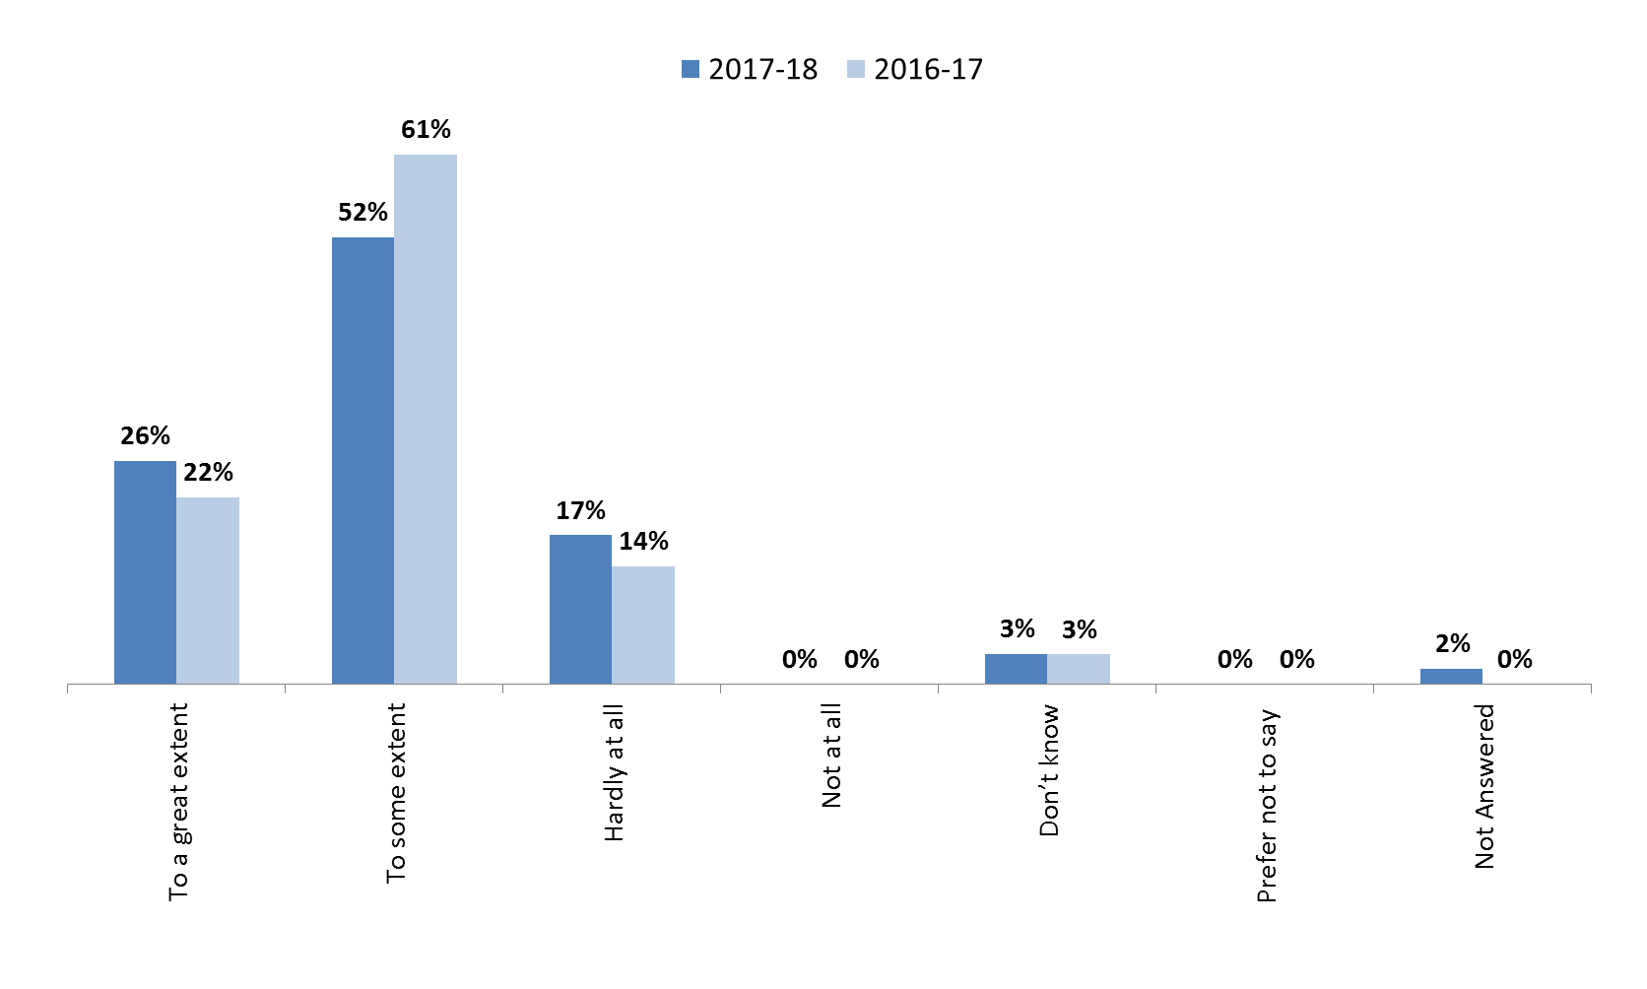To what extent do you feel that patient and public involvement is valued by the group you are a member of? 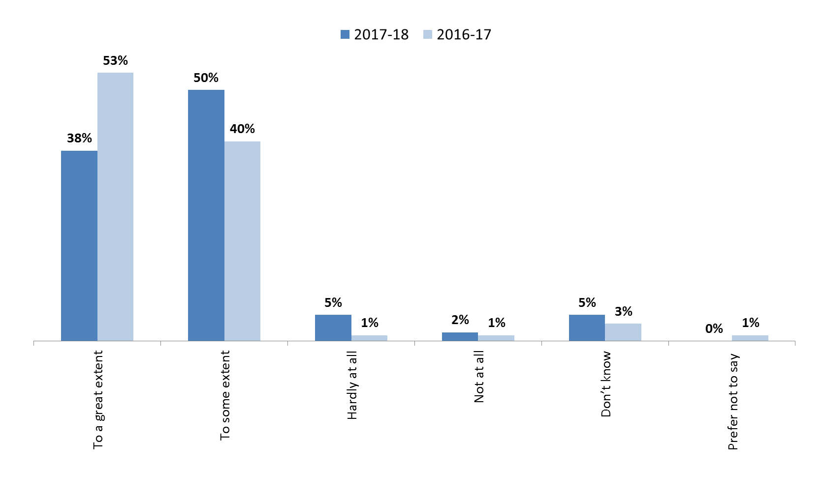

To what extent do you feel that your contribution as a PPV Partner has had an impact on the work area?

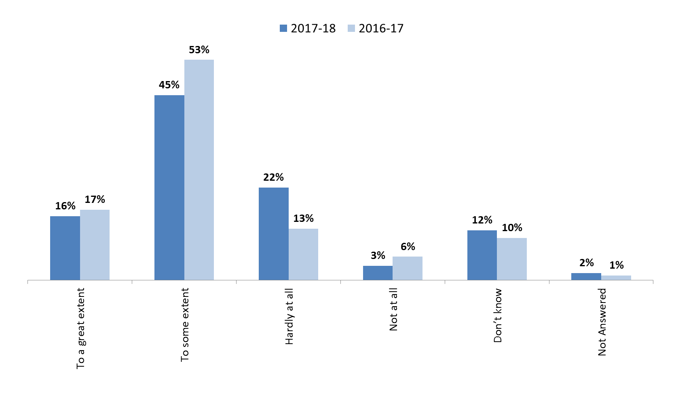

How would you rate your experience of being a PPV partner in the following categories? – Induction process
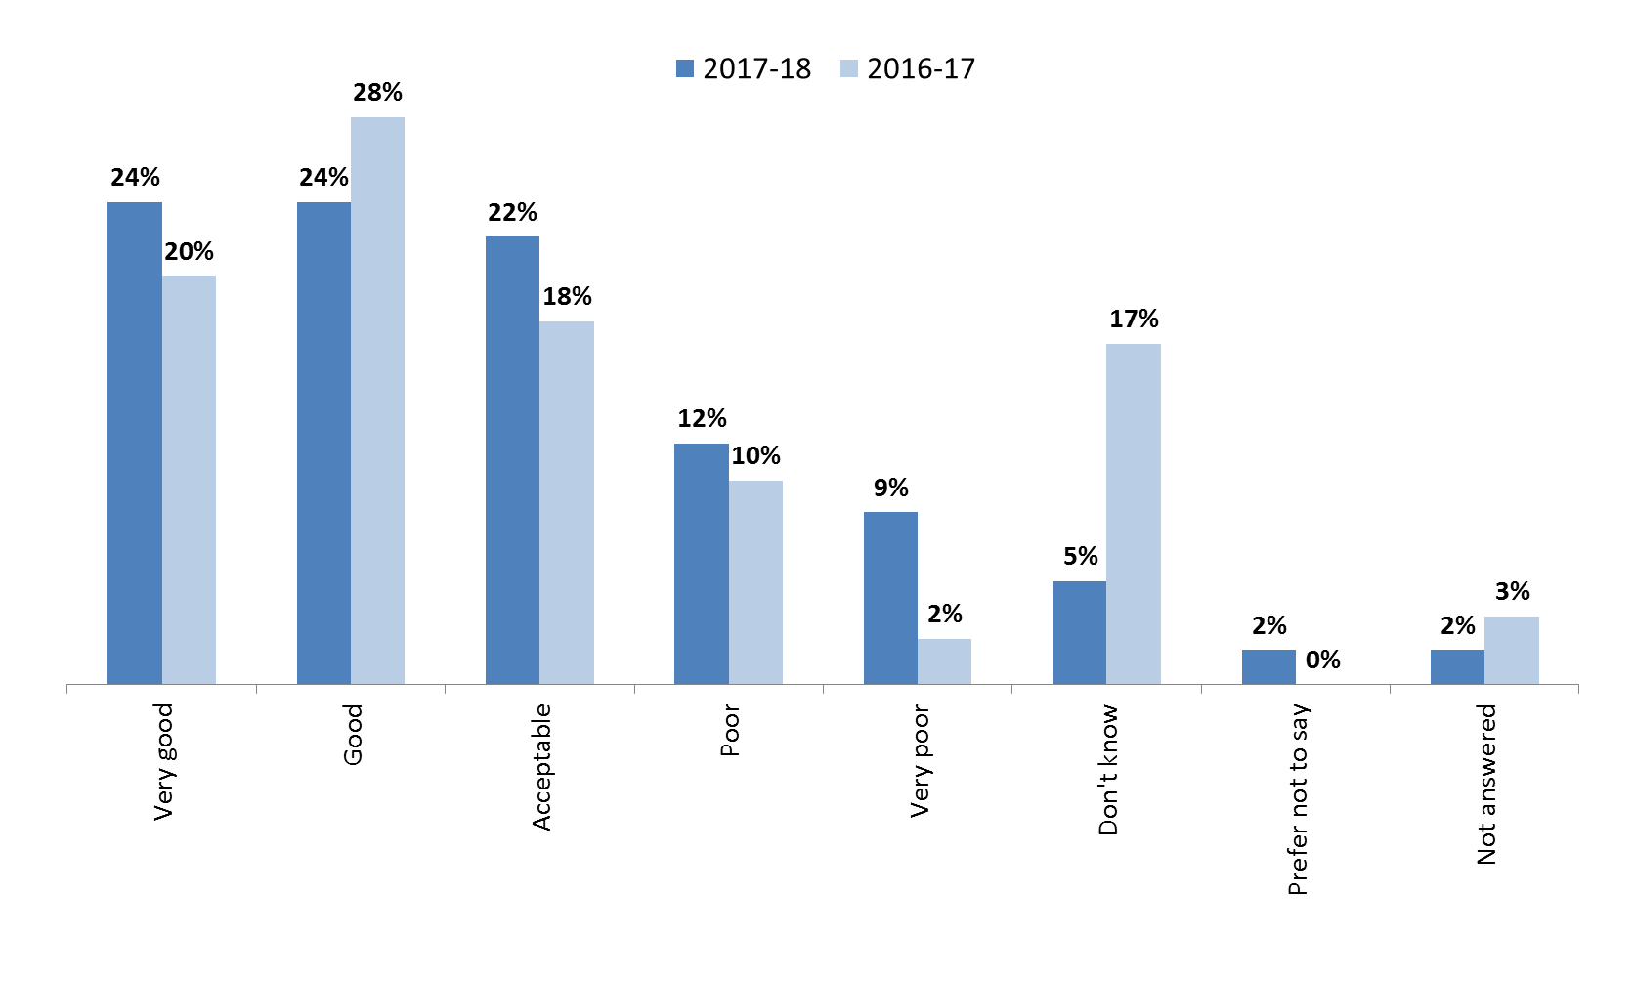
How would you rate your experience of being a PPV partner in the following categories? – Induction and information for new PPV Partners

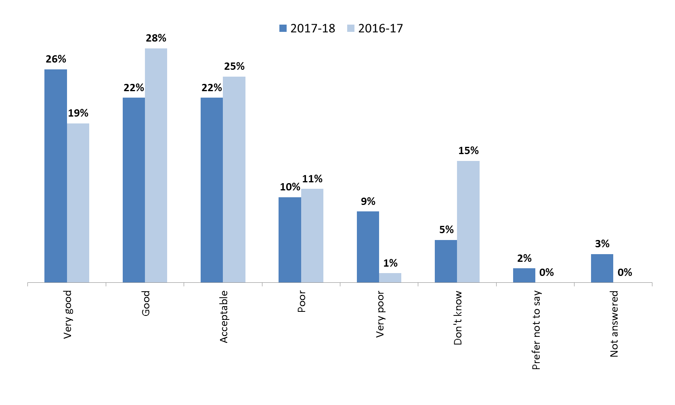
How would you rate your experience of being a PPV partner in the following categories? – Training for PPV Partners to develop in their current role and take on new opportunities

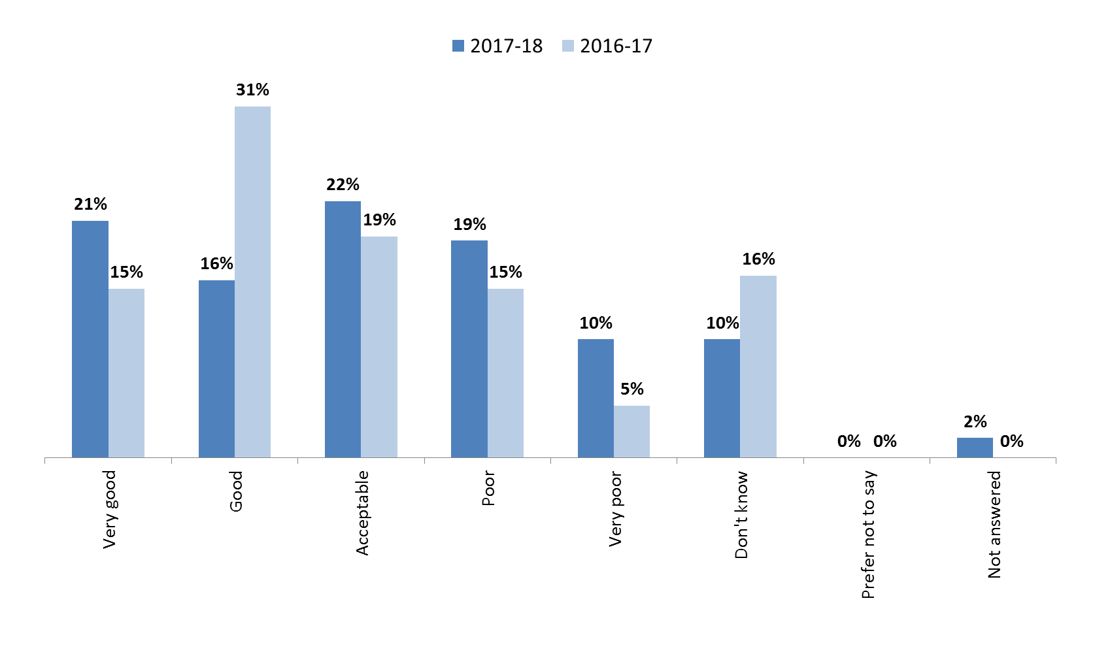

How would you rate your experience of being a PPV partner in the following categories? – Claiming Expenses

