Patient and Public Voice (PPV) Partners

Application Form to become a PPV Partner
Please read the Application Information Pack before filling in this form.
This is to make sure you understand how to apply.
It will help you decide whether you have the skills, experience and time to become a PPV member.
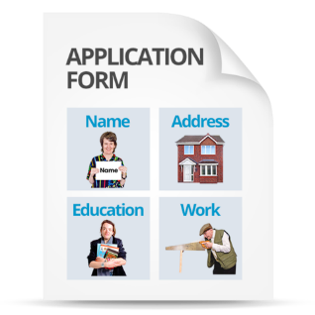 | Please submit only one application form for each person applying per role.  You can apply yourself, or on behalf of another person (as long as they agree).
 | The closing date for applications is Monday 10th September.
Fill in and return this application form, with the Equality Opportunity Monitoring Form to:
By email: england.digitalhealth@nhs.net
By post:
Coral Pearce, 6th Floor,
Zone D,
Skipton House,
NHS England,
80 London Road,
SE1 6LH

Personal Details
 |  | Full name:
 |  | Mr/Ms/Mrs/Miss:
 |  | The name you prefer:
 |  | Are you 18 or older? | Yes / No
 |  | Your address:
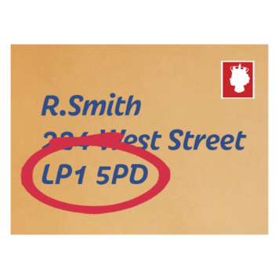 |  | Your postcode:
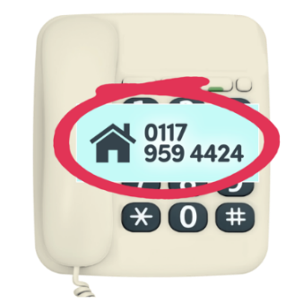 |  | Your daytime phone number:
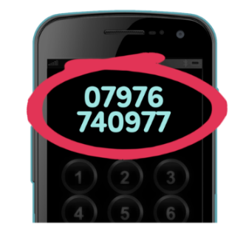 |  | Your mobile number:
 |  | Your email address:  Can you access email?  If not, how you would like us to contact with you? | Yes / No
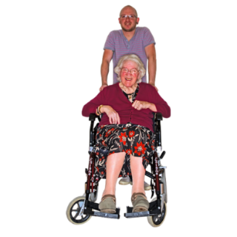  ? |  | Are you:  A carer of a patient who has used, or is using healthcare services  A representative of a patient organisation  (Please tell us which one)  Other  (Please tell us what) | ☐  ☐  ☐
 |  | Are you able to take part in meetings during the day?  Meetings will usually be between 8am and 6pm. | Yes / No
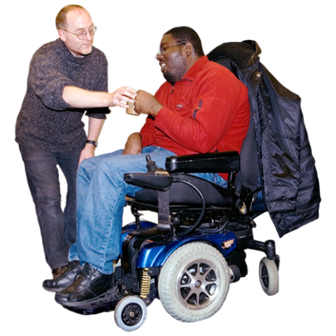 |  | Do you have any support needs in order to apply for this role?  If yes, please tell us about them. | Yes / No

Skills and experience
Tell us why you want to apply for the role.
What relevant skills and experience do you have?
(No more than 600 words).
This could include:
- organisations you have been part of
- personal experiences
- being involved with healthcare organisations.

See sections 8 and 9 of the Application Information Pack.
Please write your answer here:

 |  | Which group you are applying for?

Thank you for filling in this form.
Pictures by Photosymbols
Easy read by otherness

